FILED BY BITFARMS LTD.

PURSUANT TO RULE 425 UNDER THE SECURITIES ACT OF 1933

AND DEEMED FILED PURSUANT TO RULE 14a-12

UNDER THE SECURITIES EXCHANGE ACT OF 1934

SUBJECT COMPANY: STRONGHOLD DIGITAL MINING, INC.

COMMISSION FILE NO. 001-40931

LinkedIn: August 21, 2024
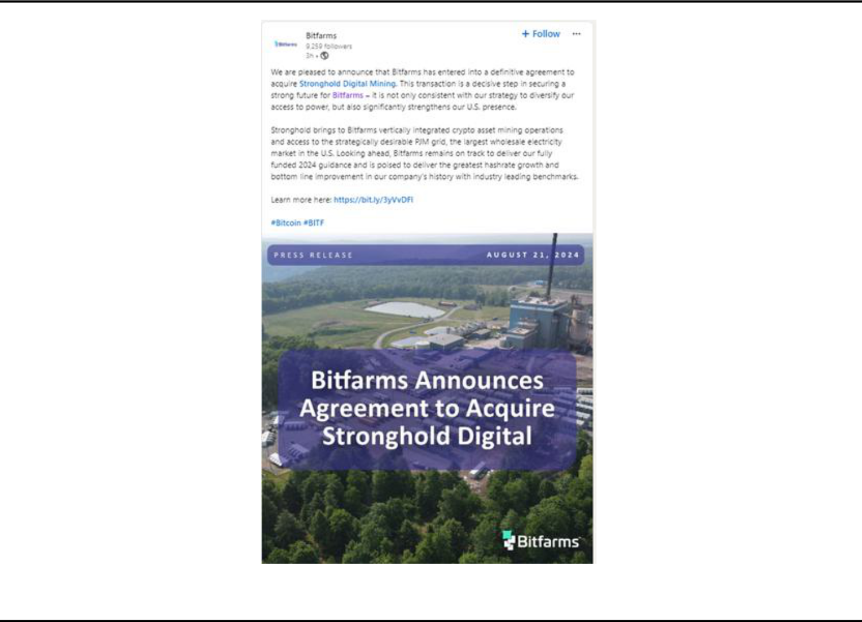

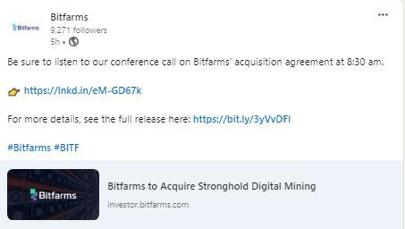

X/Twitter: August 21, 2024
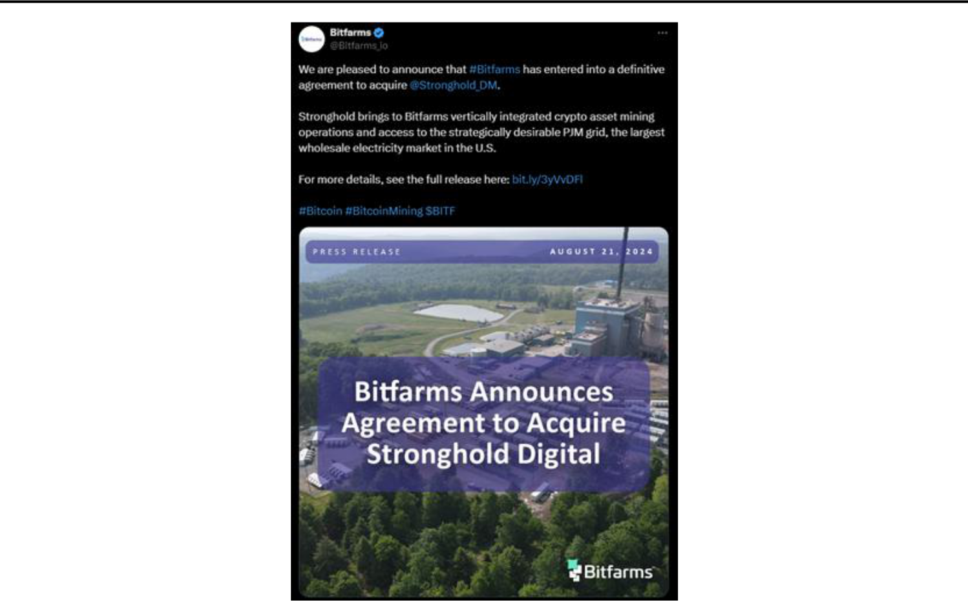

2

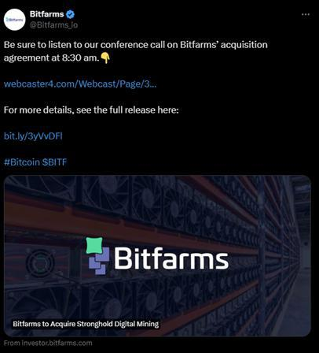

3

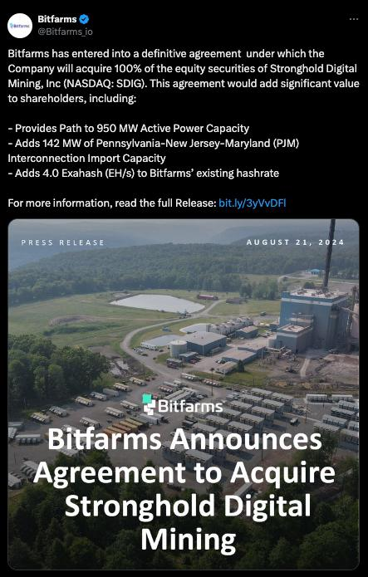

4

Forward-Looking Statements

This communication contains certain “forward-looking information” and “forward-looking statements” (collectively, “forward-looking information”) that are based on expectations, estimates and projections as at the date of this communication and are covered by safe harbors under Canadian and United States securities laws. The statements and information in this communication regarding receipt of the approval of the shareholders of Stronghold Digital Mining, Inc. (“Stronghold”) for the proposed acquisition (the “Transaction”) by Bitfarms Ltd. (“Bitfarms” or the “Company”) as well as all other applicable regulatory approvals, closing of the Transaction on a timely basis and on the terms as announced, the benefits of the Transaction, the ability to gain access to additional electrical power and grow the hashrate of the Stronghold business, performance of the plants and equipment upgrades and the impact on operating capacity including the target hashrate to take the Stronghold business to 10 EH/s in 2025, to increase the Bitfarms energy portfolio to 950 MW by year-end 2025 and multi-year expansion capacity up to 1.6 GW, the opportunities to leverage Bitfarms’ proven expertise to successfully enhance energy efficiency and hashrate, reclamation and environmental benefits in general, the synergies of the combined business, carbon capture potential, hashrate growth in general, energy efficiency and cost savings in general, and the benefits of the growth strategy including to merge HPC / AI with Bitcoin mining operations and other statements regarding future plans and objectives of the Company are forward-looking information. Any statements that involve discussions with respect to predictions, expectations, beliefs, plans, projections, objectives, assumptions, future events or performance (often but not always using phrases such as “expects”, or “does not expect”, “is expected”, “anticipates” or “does not anticipate”, “plans”, “budget”, “scheduled”, “forecasts”, “estimates”, “prospects”, “believes” or “intends” or variations of such words and phrases or stating that certain actions, events or results “may” or “could”, “would”, “might” or “will” be taken to occur or be achieved) are not statements of historical fact and may be forward-looking information.

This forward-looking information is based on assumptions and estimates of management of the Company at the time they were made, and involves known and unknown risks, uncertainties and other factors which may cause the actual results, performance, or achievements of the Company to be materially different from any future results, performance or achievements expressed or implied by such forward-looking information. Such factors include, among others, risks relating to: receipt of the approval of the shareholders of Stronghold and the Toronto Stock Exchange for the Transaction as well as other applicable regulatory approvals; that the Transaction may not close within the timeframe anticipated or at all or may not close on the terms and conditions currently anticipated by the Company for a number of reasons including, without limitation, as a result of a failure to satisfy the conditions to closing of the Transaction; the inability of the Company to operate the plants as anticipated following consummation of the Transaction; failure of the equipment upgrades to be installed and operated as planned; the availability of additional power may not occur as currently planned, or at all; expansion may not materialize as currently anticipated, or at all; the power purchase agreements and economics thereof may not be as advantageous as expected; potential environmental cost and regulatory penalties due to the operation of the Stronghold plants which entail environmental risk and certain additional risk factors particular to the business of Stronghold including, land reclamation requirements may be burdensome and expensive, changes in tax credits related to coal refuse power generation could have a material adverse effect on the business, financial condition, results of operations and future development efforts, competition in power markets may have a material adverse effect on the results of operations, cash flows and the market value of the assets, the business is subject to substantial energy regulation and may be adversely affected by legislative or regulatory changes, as well as liability under, or any future inability to comply with, existing or future energy regulations or requirements, the operations are subject to a number of risks arising out of the threat of climate change, and environmental laws, energy transitions policies and initiatives and regulations relating to emissions and coal residue management, which could result in increased operating and capital costs and reduce the extent of business activities, operation of power generation facilities involves significant risks and hazards customary to the power industry that could have a material adverse effect on our revenues and results of operations, and there may not have adequate insurance to cover these risks and hazards, employees, contractors, customers and the general public may be exposed to a risk of injury due to the nature of the operations, limited experience with carbon capture programs and initiatives and dependence on third-parties, including consultants, contractors and suppliers to develop and advance carbon capture programs and initiatives, and failure to properly manage these relationships, or the failure of these consultants, contractors and suppliers to perform as expected, could have a material adverse effect on the business, prospects or operations; the digital currency market; the ability to successfully mine digital currency; revenue may not increase as currently anticipated, or at all; it may not be possible to profitably liquidate the current digital currency inventory, or at all; a decline in digital currency prices may have a significant negative impact on operations; an increase in network difficulty may have a significant negative impact on operations; the volatility of digital currency prices; the anticipated growth and sustainability of hydroelectricity for the purposes of cryptocurrency mining in the applicable jurisdictions; the inability to maintain reliable and economical sources of power to operate cryptocurrency mining assets; the risks of an increase in electricity costs, cost of natural gas, changes in currency exchange rates, energy curtailment or regulatory changes in the energy regimes in the jurisdictions in which the Company operates and the potential adverse impact on profitability; future capital needs and the ability to complete current and future financings, including the Company’s ability to utilize an at-the-market offering program (the “ATM Program”) and the prices at which securities may be sold in the ATM Program, as well as capital market conditions in general; share dilution resulting from the ATM Program and from other equity issuances; volatile securities markets impacting security pricing unrelated to operating performance; the risk that a material weakness in internal control over financial reporting could result in a misstatement of the Company’s financial position that may lead to a material misstatement of the annual or interim consolidated financial statements if not prevented or detected on a timely basis; historical prices of digital currencies and the ability to mine digital currencies that will be consistent with historical prices; and the adoption or expansion of any regulation or law that will prevent Bitfarms from operating its business, or make it more costly to do so. For further information concerning these and other risks and uncertainties, refer to the Company’s filings on www.sedarplus.ca (which are also available on the website of the U.S. Securities and Exchange Commission (the “SEC") at www.sec.gov), including the MD&A for the year-ended December 31, 2023, filed on March 7, 2024 and the MD&A for the three and six months ended June 30, 2024 filed on August 8, 2024. Although the Company has attempted to identify important factors that could cause actual results to differ materially from those expressed in forward-looking statements, there may be other factors that cause results not to be as anticipated, estimated or intended, including factors that are currently unknown to or deemed immaterial by the Company. There can be no assurance that such statements will prove to be accurate as actual results and future events could differ materially from those anticipated in such statements. Accordingly, readers should not place undue reliance on any forward-looking information. The Company undertakes no obligation to revise or update any forward-looking information other than as required by law.

5

Additional Information about the Merger and Where to Find It

This communication relates to a proposed merger between Stronghold and Bitfarms. In connection with the proposed merger, Bitfarms intends to file with the SEC a registration statement on Form F-4, which will include a proxy statement of Stronghold that also constitutes a prospectus of Bitfarms. After the registration statement is declared effective, Stronghold will mail the proxy statement/prospectus to its shareholders. This communication is not a substitute for the registration statement, the proxy statement/prospectus or any other relevant documents Bitfarms and Stronghold has filed or will file with the SEC.

Investors are urged to read the proxy statement/prospectus (including all amendments and supplements thereto) and other relevant documents filed with the SEC carefully and in their entirety if and when they become available because they will contain important information about the proposed merger and related matters.

Investors may obtain free copies of the registration statement, the proxy statement/prospectus and other relevant documents filed by Bitfarms and Stronghold with the SEC, when they become available, through the website maintained by the SEC at www sec.gov. Copies of the documents may also be obtained for free from Bitfarms by contacting Bitfarms' Investor Relations Department at investors@bitfarms.com and from Stronghold by contacting Stronghold's Investor Relations Department at SDIG@gateway-grp.com.

No Offer or Solicitation

This communication is not intended to and does not constitute an offer to sell or the solicitation of an offer to buy, sell or solicit any securities or any proxy, vote or approval, nor shall there be any sale of securities in any jurisdiction in which such offer, solicitation or sale would be unlawful prior to registration or qualification under the securities laws of any such jurisdiction. No offer of securities shall be deemed to be made except by means of a prospectus meeting the requirements of Section 10 of the Securities Act of 1933, as amended.

Participants in Solicitation Relating to the Merger

Bitfarms, Stronghold, their respective directors and certain of their respective executive officers may be deemed to be participants in the solicitation of proxies from Stronghold's shareholders in respect of the proposed merger. Information regarding Bitfarms’ directors and executive officers can be found in Bitfarms’ annual information form for the year ended December 31, 2023, filed on March 7, 2024, as well as its other filings with the SEC. Information regarding Stronghold’s directors and executive officers can be found in Stronghold’s proxy statement for its 2024 annual meeting of stockholders, filed with the SEC on April 29, 2024, and supplemented on June 7, 2024, and in its Form 10-K for the year ended December 31, 2023, filed with the SEC on March 8, 2024. This communication may be deemed to be solicitation material in respect of the proposed merger. Additional information regarding the interests of such potential participants, including their respective interests by security holdings or otherwise, will be set forth in the proxy statement/prospectus and other relevant documents filed with the SEC in connection with the proposed merger if and when they become available. These documents are available free of charge on the SEC’s website and from Bitfarms and Stronghold using the sources indicated above.

6

