UNITED STATES
SECURITIES AND EXCHANGE COMMISSION
Washington, D.C. 20549

FORM 6-K

REPORT OF FOREIGN PRIVATE ISSUER
PURSUANT TO RULE 13a-16 OR 15d-16
UNDER THE SECURITIES EXCHANGE ACT OF 1934

For the month of April 2024

Commission File Number: 001-40370

BITFARMS LTD.
(Exact Name of Registrant as Specified in Its Charter)

110 Yonge Street, Suite 1601, Toronto, Ontario, Canada M5C 1T4
(Address of principal executive offices)

Indicate by check mark whether the registrant files or will file annual reports under cover of Form 20-F or Form 40-F.

Form 20-F ☐ Form 40-F ☒

DOCUMENTS INCLUDED AS PART OF THIS FORM 6-K

On April 12, 2024, the Registrant filed with the Canadian Securities Regulatory Authorities on the System for Electronic Data Analysis and Retrieval + (SEDAR +) a material change report that includes a copy of a press release, a copy of which is attached hereto as Exhibit 99.1, and which is incorporated by reference to the Company’s Registration Statement on Form F-10 (File No. 333-272989).

See the Exhibits listed below.

Exhibits

Exhibit No. |  | Description
99.1 |  | Material Change Report dated April 12, 2024

1

SIGNATURE

Pursuant to the requirements of the Securities Exchange Act of 1934, the registrant has duly caused this report to be signed on its behalf by the undersigned, thereunto duly authorized.

 | BITFARMS LTD.
 | By: | /s/ L. Geoffrey Morphy
 |  | Name: | L. Geoffrey Morphy
 |  | Title: | President and Chief Executive Officer

Date: April 12, 2024

2

Exhibit 99.1

FORM 51-102F3
MATERIAL CHANGE REPORT

 | Item 1 | Name and Address of Company

Bitfarms Ltd. (“Bitfarms” or the “Company”)
110 Yonge Street, Suite 1601
Toronto, Ontario M5C 1T4

 | Item 2 | Date of Material Change

April 12, 2024.

 | Item 3 | News Release

The press release attached as Schedule “A” was released on April 12, 2024, by a newswire company in Canada.

 | Item 4 | Summary of Material Change

The material change is described in the press release attached as Schedule “A”.

 | Item 5 | Full Description of Material Change

The material change is described in the press release attached as Schedule “A”.

 | Item 6 | Reliance of subsection 7.1(2) of National Instrument 51-102

Not applicable.

 | Item 7 | Omitted Information

Not applicable.

 | Item 8 | Executive Officer

Geoffrey Morphy
President & Chief Executive Officer
Bitfarms Ltd.
gmorphy@bitfarms.com

 | Item 9 | Date of Report

April 12, 2024.

Schedule “A”



Bitfarms Reaches 7 EH/s with Completion of Fleet Upgrade at Garlock and Farnham Facilities

– Corporate energy efficiency improves 9% to 31 w/TH –

This news release constitutes a “designated news release” for the purposes of the Company’s prospectus supplement dated March 8, 2024, to its short form base shelf prospectus dated November 10, 2023.

Toronto, Ontario and Brossard, Québec (April 12, 2024) - Bitfarms Ltd. (NASDAQ/TSX: BITF), a global vertically integrated Bitcoin mining company, today announced the completion of its first two farm upgrades with over 5,000 Bitmain T21 miners installed and operating in Québec.

“Our Bitmain miner installations kickstart our transformative fleet upgrade and have improved energy efficiency by approximately 51% at both our Garlock and Farnham farms,” said Geoff Morphy, President and CEO of Bitfarms. “The 51% improvement in site energy efficiency demonstrates the transformative nature of our upgrade plan and how well it positions Bitfarms leading into and after the upcoming halving event.”

Upgrade Highlights:

 | - | At Garlock, the Company installed 3,168 T21s.

 | - | At Farnham, the Company installed 1,710 T21s and 100 M53S+ hydro miners.

 | - | In Q2 2024, more than 30,000 additional T21s are scheduled to be delivered to the Company’s existing locations including its newest development in Paso Pe, Paraguay.

Bitfarms’ Chief Mining Officer, Ben Gagnon, stated, “Leveraging our existing facilities and the strength of our operations team, Bitfarms has already energized over 5,000 T21s with installations at our third location underway. As we deploy an additional 30,000 miners this quarter, we expect to drive rapid increases in both our hashrate and energy efficiency, while executing towards our 12 EH/s and 21 EH/s targets in 2024.”

2

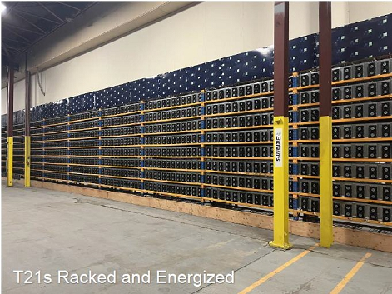

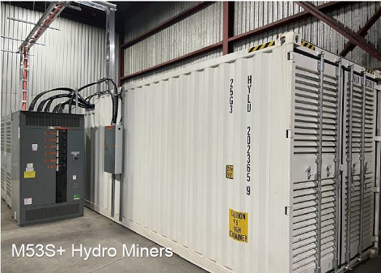

About Bitfarms Ltd.

Founded in 2017, Bitfarms is a global Bitcoin mining company that contributes its computational power to one or more mining pools from which it receives payment in Bitcoin. Bitfarms develops, owns, and operates vertically integrated mining farms with in-house management and company-owned electrical engineering, installation service, and multiple onsite technical repair centers. The Company’s proprietary data analytics system delivers best-in-class operational performance and uptime.

3

Bitfarms currently has 11 operating Bitcoin mining facilities and two under development situated in four countries: Canada, the United States, Paraguay, and Argentina. Powered predominantly by environmentally friendly hydro-electric and long-term power contracts, Bitfarms is committed to using sustainable and often underutilized energy infrastructure.

To learn more about Bitfarms’ events, developments, and online communities:

www.bitfarms.com
https://www.facebook.com/bitfarms/
https://twitter.com/Bitfarms_io
https://www.instagram.com/bitfarms/
https://www.linkedin.com/company/bitfarms/

Glossary of Terms

 | ● | EH or EH/s = Exahash or exahash per second

 | ● | w/TH = Watts/Terahash efficiency (includes cost of powering supplementary equipment)

Cautionary Statement

Trading in the securities of the Company should be considered highly speculative. No stock exchange, securities commission or other regulatory authority has approved or disapproved the information contained herein. Neither the Toronto Stock Exchange, Nasdaq, or any other securities exchange or regulatory authority accepts responsibility for the adequacy or accuracy of this release.

Forward-Looking Statements

This news release contains certain “forward-looking information” and “forward-looking statements” (collectively, “forward-looking information”) that are based on expectations, estimates and projections as at the date of this news release and are covered by safe harbors under Canadian and United States securities laws. The statements and information in this release regarding the potential performance of new equipment purchases, projected growth, target hashrate, the benefits of upgrading and deployment of miners, the potential for improved financial performance and other statements regarding future growth, plans and objectives of the Company are forward-looking information. Any statements that involve discussions with respect to predictions, expectations, beliefs, plans, projections, objectives, assumptions, future events or performance (often but not always using phrases such as “expects”, or “does not expect”, “is expected”, “anticipates” or “does not anticipate”, “plans”, “budget”, “scheduled”, “forecasts”, “estimates”, “prospects”, “believes” or “intends” or variations of such words and phrases or stating that certain actions, events or results “may” or “could”, “would”, “might” or “will” be taken to occur or be achieved) are not statements of historical fact and may be forward-looking information and are intended to identify forward-looking information.

4

This forward-looking information is based on assumptions and estimates of management of the Company at the time they were made, and involves known and unknown risks, uncertainties and other factors which may cause the actual results, performance, or achievements of the Company to be materially different from any future results, performance or achievements expressed or implied by such forward-looking information. Such factors include, among others, risks relating to: the construction and operation of the Company’s facilities may not occur as currently planned, or at all; expansion (including through the addition of new miners) may not materialize as currently anticipated, or at all; the digital currency market; the ability to successfully mine digital currency; revenue may not increase as currently anticipated, or at all; it may not be possible to profitably liquidate the current digital currency inventory, or at all; a decline in digital currency prices may have a significant negative impact on operations; an increase in network difficulty may have a significant negative impact on operations; the volatility of digital currency prices; the anticipated growth and sustainability of hydroelectricity for the purposes of cryptocurrency mining in the applicable jurisdictions; the inability to maintain reliable and economical sources of power for the Company to operate cryptocurrency mining assets; the risks of an increase in the Company’s electricity costs, cost of natural gas, changes in currency exchange rates, energy curtailment or regulatory changes in the energy regimes in the jurisdictions in which the Company operates and the adverse impact on the Company’s profitability; the ability to complete current and future financings, including the Company’s ability to utilize the Company’s at-the-market equity offering program (the “ATM Program”) and the prices at which the Company may sell Common Shares in the ATM Program; any regulations or laws that will prevent Bitfarms from operating its business; historical prices of digital currencies and the ability to mine digital currencies that will be consistent with historical prices; and the adoption or expansion of any regulation or law that will prevent Bitfarms from operating its business, or make it more costly to do so. For further information concerning these and other risks and uncertainties, refer to the Company’s filings on www.SEDAR.com (which are also available on the website of the U.S. Securities and Exchange Commission at www.sec.gov/EDGAR), including the MD&A for the year-ended December 31, 2023, filed on March 7, 2024. Although the Company has attempted to identify important factors that could cause actual results to differ materially from those expressed in forward-looking statements, there may be other factors that cause results not to be as anticipated, estimated or intended, including factors that are currently unknown to or deemed immaterial by the Company. There can be no assurance that such statements will prove to be accurate as actual results and future events could differ materially from those anticipated in such statements. Accordingly, readers should not place undue reliance on any forward-looking information. The Company undertakes no obligation to revise or update any forward-looking information other than as required by law.

Investor Relations contacts:

Tracy Krumme (Bitfarms)
+1 786-671-5638
tkrumme@bitfarms.com

David Barnard (LHA)
+1 415-433-3777
Investors@bitfarms.com

Media contacts:

Actual Agency
Khushboo Chaudhary
+1 646-373-9946
mediarelations@bitfarms.com

Québec Media: Tact
Louis-Martin Leclerc
+1 418-693-2425
lmleclerc@tactconseil.ca

5

