UNITED STATES
SECURITIES AND EXCHANGE COMMISSION
Washington, D.C. 20549
FORM 10-Q
(Mark One)
x |  |  | QUARTERLY REPORT PURSUANT TO SECTION 13 OR 15(d) OF THE SECURITIES EXCHANGE ACT OF 1934
 |  |  | For the quarter ended June 30, 2026
or
o |  |  | TRANSITION REPORT PURSUANT TO SECTION 13 OR 15(d) OF THE SECURITIES EXCHANGE ACT OF 1934
 |  |  | For the transition period from __________ to __________

Commission File Number: 001-40370
Keel Infrastructure Corp.
(Exact name of registrant as specified in its charter)
Delaware |  |  | 41-4266374
(State or other jurisdiction of incorporation or organization) |  |  | (I.R.S. Employer Identification No.)
120 Broadway, Suite 1375, New York, NY 10004
(Address of principal executive offices) (Zip code)
(929) 264-5151
(Registrant’s telephone number, including area code)
Securities registered pursuant to Section 12(b) of the Act:
Title of each class |  |  | Trading symbol(s) |  |  | Name of each exchange on which registered
Common Stock, $0.001 par value per share |  |  | KEEL |  |  | The Nasdaq Stock Market LLC

Indicate by check mark whether the registrant (1) has filed all reports required to be filed by Section 13 or 15(d) of the Securities Exchange Act of 1934 during the preceding 12 months (or for such shorter period that the registrant was required to file such reports), and (2) has been subject to such filing requirements for the past 90 days. x Yes o No
Indicate by check mark whether the registrant has submitted electronically every Interactive Data File required to be submitted pursuant to Rule 405 of Regulation S-T (§232.405 of this chapter) during the preceding 12 months (or for such shorter period that the registrant was required to submit such files). x Yes o No
Indicate by check mark whether the registrant is a large accelerated filer, an accelerated filer, a non-accelerated filer, a smaller reporting company, or an emerging growth company. See the definitions of "large accelerated filer," "accelerated filer," "smaller reporting company," and "emerging growth company" in Rule 12b-2 of the Exchange Act.
 |  |  | Large Accelerated Filer |  |  | o |  |  |  |  |  | Accelerated Filer |  |  | x
 |  |  | Non-accelerated Filer |  |  | o |  |  |  |  |  | Smaller Reporting Company |  |  | o
 |  |  |  |  |  |  |  |  |  |  |  | Emerging Growth Company |  |  | o
If an emerging growth company, indicate by check mark if the registrant has elected not to use the extended transition period for complying with any new or revised financial accounting standards provided pursuant to Section 13(a) of the Exchange Act. o
Indicate by check mark whether the registrant is a shell company (as defined in Rule 12b-2 of the Exchange Act). o Yes x No

Number of shares of the registrant’s common stock outstanding on August 7, 2026: 617,573,212

1 |  |  | Page

KEEL INFRASTRUCTURE CORP. (formerly known as Bitfarms Ltd.)
FORM 10-Q FOR THE QUARTER ENDED JUNE 30, 2026
TABLE OF CONTENTS

 |  |  |  |  |  |  | Page
 |  |  | PART I - FINANCIAL INFORMATION
Item 1. |  |  | Financial Statements (Unaudited) |  |  |  | 7
Item 2. |  |  | Management’s Discussion and Analysis of Financial Condition and Results of Operations |  |  |  | 57
Item 3. |  |  | Quantitative and Qualitative Disclosures About Market Risk |  |  |  | 89
Item 4. |  |  | Controls and Procedures |  |  |  | 90
 |  |  | PART II - OTHER INFORMATION
Item 1. |  |  | Legal Proceedings |  |  |  | 91
Item 1A. |  |  | Risk Factors |  |  |  | 91
Item 2. |  |  | Unregistered Sales of Equity Securities and Use of Proceeds |  |  |  | 91
Item 3. |  |  | Defaults Upon Senior Securities |  |  |  | 91
Item 4. |  |  | Mine Safety Disclosures |  |  |  | 91
Item 5. |  |  | Other Information |  |  |  | 91
Item 6. |  |  | Exhibits |  |  |  | 92
 |  |  | Signatures |  |  |  | 94

2 |  |  | Page

KEEL INFRASTRUCTURE CORP. (formerly known as Bitfarms Ltd.)
FORM 10-Q FOR THE QUARTER ENDED JUNE 30, 2026
GENERAL MATTERS

In this Quarterly Report on Form 10-Q for the quarter ended June 30, 2026 (referred to herein as this "Quarterly Report") "we", "us", "our", and the "Company" refer to Keel Infrastructure Corp., a Delaware corporation ("Keel") and its consolidated subsidiaries, including Bitfarms Ltd., a corporation existing under the laws of the Province of Ontario ("Bitfarms") unless the context requires otherwise. In connection with an internal corporate reorganization completed on June 15, 2026, Bitfarms was renamed "Backbone Hosting Solutions Inc."; for continuity, we continue to refer to this subsidiary as "Bitfarms" in this Quarterly Report.

Effective as of 12:01 a.m. (Eastern Daylight Time) on April 1, 2026, Keel became the ultimate parent company of Bitfarms and its subsidiaries pursuant to a statutory plan of arrangement under Section 182 of the Business Corporations Act (Ontario) (the "Arrangement") as part of Bitfarms' previously announced intention to redomicile from Canada to the United States (the "U.S. Redomiciliation Transaction"). Pursuant to the Arrangement, Keel indirectly acquired all of the issued and outstanding common shares in the capital of Bitfarms, and in exchange, holders of the common shares of Bitfarms received one share of common stock of Keel per common share of Bitfarms. The issuance of shares of common stock of Keel pursuant to the Arrangement was exempt from registration under Section 3(a)(10) of the Securities Act of 1933, as amended (the "Securities Act").

The common shares of Bitfarms were listed on the Nasdaq Stock Market ("Nasdaq") and the Toronto Stock Exchange (the "TSX") and registered pursuant to Section 12(b) of the Securities Exchange Act of 1934, as amended (the "Exchange Act") prior to the U.S. Redomiciliation Transaction. Keel is the successor issuer to Bitfarms pursuant to Rule 12g-3(a) under the Exchange Act, and the common stock of Keel is therefore deemed to be registered under Section 12(b) of the Exchange Act. Keel reported this succession on a Form 8-K filed on April 1, 2026 in accordance with Rule 12g-3(f) under the Exchange Act. While Bitfarms was a foreign private issuer, Keel is a U.S. domestic issuer.

For accounting and financial reporting purposes, Bitfarms is the accounting predecessor of the Company, and the Company's condensed consolidated financial statements are presented as a continuation of Bitfarms' historical consolidated financial statements at historical carrying amounts. Comparative information for periods before April 1, 2026 has been presented on that basis, as described in Note 2 of the Company's unaudited condensed consolidated financial statements and its accompanying notes for the three and six months ended June 30, 2026.

This Quarterly Report on Form 10-Q is filed by Keel as successor issuer to Bitfarms, and it relates to the quarter ended June 30, 2026. References in this report to the "Annual Report" refer to Bitfarms' Annual Report on Form 10-K for the fiscal year ended December 31, 2025, filed on March 31, 2026, for which Keel is the successor issuer.

Words importing the singular, where the context requires, include the plural and vice versa and words importing any gender include all genders.

Keel and the associated Keel logo are registered trademarks of Keel Infrastructure Corp. or its subsidiaries. All other trademarks and brand names used herein are the property of their respective owners.

3 |  |  | Page

KEEL INFRASTRUCTURE CORP. (formerly known as Bitfarms Ltd.)
FORM 10-Q FOR THE QUARTER ENDED JUNE 30, 2026
Unless we indicate otherwise: (i) all dollar amounts are expressed in U.S. dollars; and (ii) all references to "USD" or "$" are to U.S. dollars and all references to "CAD" are to Canadian dollars.

Note that use of the word "including" in this Quarterly Report means "including, without limitation."

Unless we indicate otherwise, all information in this Quarterly Report is stated as of August 7, 2026.

4 |  |  | Page

KEEL INFRASTRUCTURE CORP. (formerly known as Bitfarms Ltd.)
FORM 10-Q FOR THE QUARTER ENDED JUNE 30, 2026
CAUTIONARY NOTE REGARDING FORWARD-LOOKING STATEMENTS

This Quarterly Report contains forward-looking statements within the meaning of the Private Securities Litigation Reform Act of 1995, Section 27A of the Securities Act, and Section 21E of the Exchange Act. Forward-looking statements generally are identified by words such as "seek," "anticipate," "plan," "continue," "estimate," "expect," "may," "will," "project," "predict," "potential," "targeting," "intend," "could," "might," "should," "believe," "future," "continue" or similar expressions or the negatives thereof. All statements other than statements of historical fact are statements that could be deemed forward-looking statements. Although the Company believes that the expectations reflected in such forward-looking statements are reasonable, undue reliance should not be placed on forward-looking statements since the Company can give no assurance that such expectations will prove to be correct. Such statements are based on management’s current expectations and are subject to a number of factors and uncertainties that could cause actual results to differ materially from those described in the forward-looking statements. These risks and uncertainties include, but are not limited to, the following risks, uncertainties, and other factors:

•our limited operating history and history of operating losses, which make it difficult to evaluate our business and prospects;
•our evolving business model and strategy, including our strategic transformation from Bitcoin Mining to digital infrastructure, including high-performance computing ("HPC"), which may not be successful;
•our dependence on reliable and economical sources of power, including regulated electricity rates in Québec (Canada), Pennsylvania and Washington State (United States);
•our reliance on a limited number of third-party suppliers and manufacturers, including those in foreign jurisdictions, exposing us to supply chain disruptions, trade restrictions, and tariff risks;
•delays, cost overruns, and other risks associated with the continued development of our existing and planned facilities;
•intense competition from other pivoting Bitcoin Mining companies and established data center operators, some of which may have greater resources and experience;
•the potential inadequacy of our insurance coverage to protect against all losses;
•our increased focus on developing data centers dedicated to HPC and AI workloads may not become profitable and will divert resources from our Bitcoin Mining operations;
•the capital-intensive nature of constructing data centers and our potential inability to secure financing for such efforts;
•significant competition for suitable data center sites and regulatory constraints that could adversely impact our development pipeline;
•our requirement to obtain, and to comply with, numerous permits, licenses and approvals from federal, state or provincial, and local governmental agencies in the U.S., Canada and other jurisdictions in which we may operate, including the risk that such permits or licenses may be delayed, denied, revoked or modified, or that we may fail to timely obtain or comply with their conditions;
•community opposition to the operation of our data centers, including complaints and/or community protests regarding, for example, noise, the use of electricity and water, or other quality-of-life issues, which could result in litigation, development delays, moratoria, regulatory action, fines or penalties, costly mitigation measures, restrictions on our electricity use or operating hours, reduced scale of operations, difficulty obtaining permits for expansion, or the shutdown of affected facilities;
•our dependence on significant customers for our data centers, and the risk of customer default or failure to make timely payments;
•the rapidly evolving regulatory landscape surrounding HPC, AI, and Bitcoin Mining, which may negatively impact our expansion efforts;
•the high volatility of Bitcoin prices, which has significantly affected and will continue to affect the profitability of our operations;

5 |  |  | Page

KEEL INFRASTRUCTURE CORP. (formerly known as Bitfarms Ltd.)
FORM 10-Q FOR THE QUARTER ENDED JUNE 30, 2026
•extensive environmental, energy, and climate-related regulation that could result in significant additional costs or liabilities;
•political uncertainty in the U.S. and internationally, including potential regulatory and policy changes affecting the data center and cryptocurrency industries;
•cybersecurity threats and hacking attacks that could compromise our systems and data; and
•other factors detailed under the heading "Risk Factors" in this Form 10-Q and our Annual Report.

There can be no assurance that actual results or business conditions will not differ materially from those projected or suggested in such forward-looking statements as a result of various factors, including those described in this Form 10-Q and in Part I, Item 1A, "Risk Factors" in our Annual Report and our subsequent filings with the U.S. Securities and Exchange Commission.

Should one or more of these risks or uncertainties materialize, or should underlying assumptions prove incorrect, actual results may vary materially from those described herein. This list is not exhaustive of the factors that may affect any of the Company’s forward-looking statements and information. Forward-looking statements and information are designed to help readers understand management’s views as of that time with respect to future events and speak only as of the date they are made. You should read this Quarterly Report with the understanding that our actual future results, performance and achievements may be materially different from what we expect. We qualify all of our forward-looking statements by these cautionary statements. Except as required by applicable law, we do not assume any obligation to update or revise these forward-looking statements for any reason, even if new information becomes available in the future. If the Company updates any one or more forward-looking statements, no inference should be drawn that the Company will make additional updates with respect to those or other forward-looking statements. All forward-looking statements contained in this Quarterly Report are expressly qualified in their entirety by this cautionary statement.

6 |  |  | Page

KEEL INFRASTRUCTURE CORP. (formerly known as Bitfarms Ltd.)
PART I - FINANCIAL INFORMATION

ITEM 1. FINANCIAL STATEMENTS

 |  |  |  |  | Page
 | Unaudited Financial Statements
 | Consolidated Balance Sheets as of June 30, 2026 and December 31, 2025 |  |  |  | 8
 | Consolidated Statements of Operations for the three and six months ended June 30, 2026 and 2025 |  |  |  | 9
 | Consolidated Statements of Stockholders' Equity for the three and six months ended June 30, 2026 and 2025 |  |  |  | 10
 | Consolidated Statements of Cash Flows for the six months ended June 30, 2026 and 2025 |  |  |  | 11
 | Notes to the Condensed Consolidated Financial Statements (unaudited) |  |  |  | 12

7 |  |  | Page

KEEL INFRASTRUCTURE CORP. (formerly known as Bitfarms Ltd.)
CONSOLIDATED BALANCE SHEETS
(Expressed in thousands of U.S. dollars - unaudited)
 |  |  | As of June 30, |  |  | As of December 31,
 |  |  | 2026 |  |  | 2025
Assets
Current
Cash |  |  | 715,516 |  |  | 573,462
Accounts receivable, net |  |  | 5,015 |  |  | 5,471
Digital assets |  |  | 132,384 |  |  | 174,726
Digital assets - restricted |  |  | — |  |  | 5,559
Other assets |  |  | 4,316 |  |  | 2,825
Rights to renewable energy credits and waste tax credits |  |  | 9,139 |  |  | 18,478
Assets held for sale |  |  | 15,914 |  |  | 28,664
Short-term prepaid deposits |  |  | 5,329 |  |  | 6,317
Inventories |  |  | 8,853 |  |  | 8,676
Derivative assets |  |  | — |  |  | 2,287
Total current assets |  |  | 896,466 |  |  | 826,465
Non-current
Rights to waste tax credits |  |  | 2,069 |  |  | —
Long-term derivative assets |  |  | 78,800 |  |  | 5,200
Operating lease right-of-use assets, net |  |  | 10,219 |  |  | 11,103
Finance lease right-of-use assets, net |  |  | 1,916 |  |  | 2,127
Restricted cash |  |  | 53,377 |  |  | 57,500
Long-term deposits and equipment prepayments |  |  | 81,328 |  |  | 31,033
Property, plant and equipment, net |  |  | 287,055 |  |  | 358,333
Intangible assets, net |  |  | 2,936 |  |  | 2,983
Other non-current assets |  |  | 1,600 |  |  | 1,600
Total assets |  |  | 1,415,766 |  |  | 1,296,344
Liabilities
Current
Accounts payable and accrued expenses |  |  | 46,693 |  |  | 46,443
Current portion of long-term debt |  |  | 6,754 |  |  | 97,022
Current portion of operating lease liabilities |  |  | 1,387 |  |  | 1,490
Current portion of finance lease liabilities |  |  | 288 |  |  | 235
Derivative liabilities |  |  | — |  |  | 2,922
Total current liabilities |  |  | 55,122 |  |  | 148,112
Non-current
Long-term debt |  |  | 1,019,075 |  |  | 572,447
Operating lease liabilities |  |  | 9,232 |  |  | 10,606
Finance lease liabilities |  |  | 1,619 |  |  | 1,978
Deferred tax liability |  |  | 65 |  |  | 65
Other non-current liabilities |  |  | 1,937 |  |  | 2,761
Total liabilities |  |  | 1,087,050 |  |  | 735,969
Commitments and contingencies (Note 21)
Stockholders’ equity
Preferred stock Class A - $0.001 par value; 120,000,000 shares authorized; no shares issued and outstanding |  |  | — |  |  | —
Common stock, $0.001 par value per share; 1,500,000,000 shares authorized; 616,736,107 and 601,579,999 shares issued and outstanding as of June 30, 2026 and December 31, 2025, respectively |  |  | 617 |  |  | 602
Additional paid-in capital |  |  | 1,150,928 |  |  | 1,172,254
Accumulated deficit |  |  | (822,829) |  |  | (612,481)
Total stockholders' equity |  |  | 328,716 |  |  | 560,375
Total liabilities and stockholders' equity |  |  | 1,415,766 |  |  | 1,296,344
See accompanying notes to the unaudited condensed consolidated financial statements

8 |  |  | Page

KEEL INFRASTRUCTURE CORP. (formerly known as Bitfarms Ltd.)
CONSOLIDATED STATEMENTS OF OPERATIONS
(Expressed in thousands of U.S. dollars, except per share amounts - unaudited)

 |  |  | Three months ended June 30, |  |  |  |  |  | Six months ended June 30,
 |  |  | 2026 |  |  | 2025 |  |  | 2026 |  |  | 2025
Revenues |  |  | 30,430 |  |  | 60,908 |  |  | 67,422 |  |  | 108,559
Cost of revenues |  |  | (117,183) |  |  | (64,794) |  |  | (180,480) |  |  | (112,169)
Gross loss |  |  | (86,753) |  |  | (3,886) |  |  | (113,058) |  |  | (3,610)
Operating expenses
General and administrative expenses |  |  | (31,311) |  |  | (19,384) |  |  | (58,148) |  |  | (37,002)
Change in fair value of digital assets |  |  | (9,029) |  |  | 16,283 |  |  | (50,478) |  |  | (6,750)
Realized (loss) gain on sale of digital assets |  |  | (11,180) |  |  | 16,005 |  |  | (12,990) |  |  | 20,982
(Loss) gain on disposition of property, plant and equipment and deposits |  |  | (918) |  |  | 1,791 |  |  | (919) |  |  | 2,348
Impairment of long-lived assets |  |  | (1,583) |  |  | — |  |  | (3,569) |  |  | —
Operating (loss) income |  |  | (140,774) |  |  | 10,809 |  |  | (239,162) |  |  | (24,032)
Interest income |  |  | 2,885 |  |  | 460 |  |  | 6,608 |  |  | 1,262
Interest expense |  |  | (2,114) |  |  | (1,582) |  |  | (5,714) |  |  | (1,767)
Gain on derivative assets and liabilities |  |  | 77,040 |  |  | 3,784 |  |  | 75,476 |  |  | 70
Loss on extinguishment of long-term debt |  |  | — |  |  | — |  |  | (21,596) |  |  | —
Other expenses |  |  | (971) |  |  | (275) |  |  | (7,123) |  |  | (488)
Total other income (expense) |  |  | 76,840 |  |  | 2,387 |  |  | 47,651 |  |  | (923)
(Loss) income before taxes from continuing operations |  |  | (63,934) |  |  | 13,196 |  |  | (191,511) |  |  | (24,955)
Income tax expense |  |  | (17) |  |  | — |  |  | (14) |  |  | (222)
(Loss) income from continuing operations |  |  | (63,951) |  |  | 13,196 |  |  | (191,525) |  |  | (25,177)
Loss from discontinued operations |  |  | (1,044) |  |  | (18,697) |  |  | (18,823) |  |  | (35,877)
Net loss |  |  | (64,995) |  |  | (5,501) |  |  | (210,348) |  |  | (61,054)
Earnings (loss) per common share
Basic earnings (loss) per share from continuing operations |  |  | (0.11) |  |  | 0.02 |  |  | (0.32) |  |  | (0.05)
Diluted earnings (loss) per share from continuing operations |  |  | (0.11) |  |  | 0.02 |  |  | (0.32) |  |  | (0.05)
Basic and diluted loss per share from discontinued operations |  |  | — |  |  | (0.03) |  |  | (0.03) |  |  | (0.07)
Basic and diluted loss per share |  |  | (0.11) |  |  | (0.01) |  |  | (0.35) |  |  | (0.12)
Weighted average number of common shares outstanding
Basic |  |  | 605,370,634 |  |  | 555,843,347 |  |  | 603,983,769 |  |  | 528,157,206
Diluted - continuing operations |  |  | 605,370,634 |  |  | 560,569,145 |  |  | 603,983,769 |  |  | 528,157,206
Diluted - discontinued operations |  |  | 605,370,634 |  |  | 555,843,347 |  |  | 603,983,769 |  |  | 528,157,206
See accompanying notes to the unaudited condensed consolidated financial statements

9 |  |  | Page

KEEL INFRASTRUCTURE CORP. (formerly known as Bitfarms Ltd.)
CONSOLIDATED STATEMENTS OF STOCKHOLDERS' EQUITY
(Expressed in thousands of U.S. dollars, except number of shares - unaudited)

 |  |  | Number  of shares |  |  | Common stock |  |  | Additional paid-in capital |  |  | Accumulated deficit |  |  | Total stockholders’ equity
Three Months Ended June 30, 2026
Balance as of March 31, 2026 |  |  | 602,851,137 |  |  | 603 |  |  | 1,176,366 |  |  | (757,834) |  |  | 419,135
Net loss |  |  | — |  |  | — |  |  | — |  |  | (64,995) |  |  | (64,995)
Stock-based compensation |  |  | — |  |  | — |  |  | 9,848 |  |  | — |  |  | 9,848
Purchase of capped calls, including transaction costs |  |  | — |  |  | — |  |  | (41,840) |  |  | — |  |  | (41,840)
Settlement of restricted share units |  |  | 882,258 |  |  | 1 |  |  | (1) |  |  | — |  |  | —
Settlement of performance share units |  |  | 77,525 |  |  | — |  |  | — |  |  | — |  |  | —
Exercise of stock options and warrants |  |  | 12,925,187 |  |  | 13 |  |  | 6,555 |  |  | — |  |  | 6,568
Balance as of June 30, 2026 |  |  | 616,736,107 |  |  | 617 |  |  | 1,150,928 |  |  | (822,829) |  |  | 328,716
Six Months Ended June 30, 2026
Balance as of January 1, 2026 |  |  | 601,579,999 |  |  | 602 |  |  | 1,172,254 |  |  | (612,481) |  |  | 560,375
Net loss |  |  | — |  |  | — |  |  | — |  |  | (210,348) |  |  | (210,348)
Stock-based compensation |  |  | — |  |  | — |  |  | 13,512 |  |  | — |  |  | 13,512
Purchase of capped calls, including transaction costs |  |  | — |  |  | — |  |  | (41,840) |  |  | — |  |  | (41,840)
Settlement of restricted share units |  |  | 1,814,533 |  |  | 2 |  |  | (2) |  |  | — |  |  | —
Settlement of performance share units |  |  | 77,525 |  |  | — |  |  | — |  |  | — |  |  | —
Exercise of stock options and warrants |  |  | 13,264,050 |  |  | 13 |  |  | 7,004 |  |  | — |  |  | 7,017
Balance as of June 30, 2026 |  |  | 616,736,107 |  |  | 617 |  |  | 1,150,928 |  |  | (822,829) |  |  | 328,716
Three Months Ended June 30, 2025
Balance as of March 31, 2025 |  |  | 553,644,137 |  |  | 553 |  |  | 1,044,371 |  |  | (383,490) |  |  | 661,434
Net loss |  |  | — |  |  | — |  |  | — |  |  | (5,501) |  |  | (5,501)
Stock-based compensation |  |  | — |  |  | — |  |  | 3,500 |  |  | — |  |  | 3,500
Issuance of equity warrants |  |  | — |  |  | — |  |  | 2,715 |  |  | — |  |  | 2,715
Settlement of restricted share units |  |  | 2,347,500 |  |  | 2 |  |  | (2) |  |  | — |  |  | —
Exercise of stock options and warrants |  |  | 13,900 |  |  | — |  |  | 3 |  |  | — |  |  | 3
Settlement of share awards |  |  | 1,543,320 |  |  | 2 |  |  | (2) |  |  | — |  |  | —
Balance as of June 30, 2025 |  |  | 557,548,857 |  |  | 557 |  |  | 1,050,585 |  |  | (388,991) |  |  | 662,151
Six Months Ended June 30, 2025
Balance as of January 1, 2025 |  |  | 479,332,885 |  |  | 479 |  |  | 938,604 |  |  | (327,937) |  |  | 611,146
Net loss |  |  | — |  |  | — |  |  | — |  |  | (61,054) |  |  | (61,054)
Stock-based compensation |  |  | — |  |  | — |  |  | 7,768 |  |  | — |  |  | 7,768
Issuance of replacement stock-based compensation |  |  | — |  |  | — |  |  | 232 |  |  | — |  |  | 232
Issuance of common shares |  |  | 74,311,252 |  |  | 74 |  |  | 89,790 |  |  | — |  |  | 89,864
Issuance of equity warrants |  |  | — |  |  | — |  |  | 14,192 |  |  | — |  |  | 14,192
Settlement of restricted share units |  |  | 2,347,500 |  |  | 2 |  |  | (2) |  |  | — |  |  | —
Exercise of stock options and warrants |  |  | 13,900 |  |  | — |  |  | 3 |  |  | — |  |  | 3
Settlement of share awards |  |  | 1,543,320 |  |  | 2 |  |  | (2) |  |  | — |  |  | —
Balance as of June 30, 2025 |  |  | 557,548,857 |  |  | 557 |  |  | 1,050,585 |  |  | (388,991) |  |  | 662,151
Should be read in conjunction with the notes to the unaudited condensed consolidated financial statements

10 |  |  | Page

KEEL INFRASTRUCTURE CORP. (formerly known as Bitfarms Ltd.)
CONSOLIDATED STATEMENTS OF CASH FLOWS
(Expressed in thousands of U.S. dollars - unaudited)

 |  |  | Six months ended June 30,
 |  |  | 2026 |  |  | 2025
Cash flows used in operating activities
Net loss |  |  | (210,348) |  |  | (61,054)
Adjustments to reconcile net loss to net cash provided by (used in) operating activities:
Depreciation and amortization |  |  | 111,843 |  |  | 63,977
Impairment of long-lived assets |  |  | 17,186 |  |  | 33,696
Total other (income) expenses |  |  | (47,725) |  |  | 489
Digital assets earned and hosting revenue received in Bitcoin |  |  | (62,553) |  |  | (135,127)
Stock-based compensation |  |  | 13,512 |  |  | 7,768
Renewable energy credits earned |  |  | (6,119) |  |  | (6,540)
(Gain) loss on disposition of assets |  |  | 759 |  |  | (7,451)
Digital assets exchanged for services |  |  | — |  |  | 5,125
Realized loss (gain) on sale of digital assets |  |  | 12,990 |  |  | (20,982)
Other |  |  | 1,205 |  |  | 250
Change in fair value of digital assets |  |  | 50,478 |  |  | 6,750
Interest income received |  |  | 6,217 |  |  | 873
Interest expenses paid |  |  | (3,641) |  |  | (1,145)
Income tax paid |  |  | (877) |  |  | (237)
Proceeds from disposition of renewable energy and waste tax credits |  |  | 13,389 |  |  | 4,070
Changes in non-cash working capital components |  |  | (13,931) |  |  | 15,816
Net change in cash related to operating activities |  |  | (117,615) |  |  | (93,722)
Cash flows (used in) from investing activities
Proceeds from sale of digital assets |  |  | 47,344 |  |  | 137,734
Purchase of property, plant and equipment and intangible assets |  |  | (53,413) |  |  | (62,063)
Proceeds from sale of property, plant and equipment and assets held for sale |  |  | 2,330 |  |  | 3,045
Purchase of marketable securities |  |  | (2,783) |  |  | (9,628)
Proceeds from disposition of marketable securities |  |  | 2,828 |  |  | 10,048
Purchase of derivative assets and liabilities |  |  | — |  |  | (78,463)
Settlement of derivative assets and liabilities |  |  | 1,396 |  |  | 79,924
Equipment and construction prepayments |  |  | (51,721) |  |  | (4,771)
Proceeds from disposal of businesses |  |  | 13,129 |  |  | 47,538
Acquisition of business |  |  | — |  |  | (48,084)
Investment in equity securities |  |  | — |  |  | (1,250)
Net change in cash related to investing activities |  |  | (40,890) |  |  | 74,030
Cash flows from financing activities
Repayment of long-term debt |  |  | (113,637) |  |  | (209)
Repayment of finance lease liabilities |  |  | (280) |  |  | (394)
Issuance of common shares and warrants |  |  | — |  |  | 23,608
Proceeds from long-term debt, net of transaction costs |  |  | 445,124 |  |  | 47,544
Exercise of stock options |  |  | 7,017 |  |  | 3
Purchase of capped calls |  |  | (41,840) |  |  | —
Net change in cash related to financing activities |  |  | 296,384 |  |  | 70,552
Net increase in cash and restricted cash |  |  | 137,879 |  |  | 50,860
Cash and restricted cash, beginning of the period |  |  | 630,962 |  |  | 59,542
Exchange rates differences on currency translation |  |  | 52 |  |  | 37
Cash and restricted cash, end of the period |  |  | 768,893 |  |  | 110,439
Cash flows from discontinued operations |  |  | 11,735 |  |  | 3,806
See accompanying notes to the unaudited condensed consolidated financial statements

11 |  |  | Page

KEEL INFRASTRUCTURE CORP. (formerly known as Bitfarms Ltd.)
NOTES TO THE CONDENSED CONSOLIDATED FINANCIAL STATEMENTS
(Expressed in thousands of U.S. dollars, except data relating to number of PPE, shares, warrants, options and digital assets - unaudited)

NOTE 1: ORGANIZATION

Keel Infrastructure Corp. ("Keel" or the "Company") is a North American digital and energy infrastructure company that develops data centers and energy infrastructure to lease for high-performance computing ("HPC") and artificial intelligence ("AI") workloads. Keel was formed solely to effect the U.S. Redomiciliation Transaction described below and conducted no operations before the transaction was completed. On April 1, 2026, Keel became the ultimate parent company of Bitfarms Ltd. ("Bitfarms"), an Ontario corporation founded in 2017 that was previously the publicly traded parent of the Company's consolidated group. Bitfarms was not dissolved and, together with its subsidiaries, continues to conduct the business previously conducted as Bitfarms, now as an indirect wholly owned subsidiary of Keel. In connection with an internal corporate reorganization completed on June 15, 2026, Bitfarms was renamed "Backbone Hosting Solutions Inc."; for continuity, the Company continues to refer to this subsidiary as "Bitfarms" in these financial statements.

On April 1, 2026, Keel completed the U.S. Redomiciliation Transaction pursuant to a statutory plan of arrangement under Section 182 of the Business Corporations Act (Ontario) (the "Arrangement"). At the effective time, Keel indirectly acquired all issued and outstanding common shares of Bitfarms, and each Bitfarms common share was exchanged for one share of Keel common stock. No holder of Bitfarms common shares validly exercised dissent rights available under Section 185 of the Business Corporations Act (Ontario) in connection with the Arrangement. Keel is the successor issuer to Bitfarms under Rule 12g-3(a) under the Securities Exchange Act of 1934, as amended, and Keel common stock is deemed registered under Section 12(b) of the Exchange Act. Successor issuer status is a securities registration concept and is distinct from, and does not itself determine, the Company's basis of accounting for the U.S. Redomiciliation Transaction, which is described in Note 2.

For accounting and financial reporting purposes, the U.S. Redomiciliation Transaction is a transaction between entities under common control that resulted in a change in reporting entity. Bitfarms is the Company's accounting predecessor, and the Company's condensed consolidated financial statements are presented as a continuation of Bitfarms' historical financial statements, as described in Note 2.

In addition to its pipeline of energy assets being developed in the United States for HPC and AI workloads, Keel currently maintains its legacy Bitcoin Mining operations in Canada while working to secure the legal and regulatory approvals to convert its energy purchase agreements in the United States and Canada from Bitcoin Mining to HPC and AI workloads. As part of the Bitcoin Mining operations, the Company owns and operates data centers housing specialized computers (referred to as "Miners") designed for validating transactions on the Bitcoin Blockchain (referred to as "Mining"). Keel generally operates its Miners 24 hours per day to produce computational power (measured in hashrate) used to perform hashing calculations. The Company sells this hashrate to Mining Pool operators under a formula-derived rate commonly known in the industry as Full Pay Per Share ("FPPS"). Under FPPS, Mining Pool operators compensate Mining companies for their hashrate based on the expected value of the revenue that would be generated by that hashrate over a given period, regardless of the Mining Pool's actual results during that period. This compensation may be paid in cryptocurrency, U.S. dollar, or another currency. Keel receives payments from Mining Pool operators in Bitcoin (as defined herein) on a daily basis and accumulates the Bitcoin it receives or exchanges it for U.S. dollar through reputable and established cryptocurrency trading platforms.

12 |  |  | Page

KEEL INFRASTRUCTURE CORP. (formerly known as Bitfarms Ltd.)
NOTES TO THE CONDENSED CONSOLIDATED FINANCIAL STATEMENTS
(Expressed in thousands of U.S. dollars, except data relating to number of PPE, shares, warrants, options and digital assets - unaudited)
NOTE 1: ORGANIZATION (Continued)

Effective June 29, 2026, the Company ceased its Bitcoin Mining operations in the United States as part of its strategic transition to HPC and AI infrastructure development. The accelerated cessation is driven by HPC and AI infrastructure construction timelines as well as macro factors affecting the profitability of Bitcoin Mining.

The Company's transition from Bitcoin Mining to HPC and AI infrastructure affected all four of its United States sites during the three and six months ended June 30, 2026. On April 28, 2026, the Company ceased Bitcoin Mining operations at its Washington State site and began converting the site to an 18 gross MW HPC data center. On June 29, 2026, the Company ceased Bitcoin Mining operations at its Panther Creek, Scrubgrass and Sharon sites in Pennsylvania. The Company continues to generate revenue from the sale of energy at its Panther Creek and Scrubgrass sites, which had current gross energized capacity of approximately 60 gross MW and 63 gross MW, respectively, as of June 30, 2026, that is not yet contracted under an electric supply agreement, while the Company evaluates and develops these sites for HPC and AI workloads. The Company is planning on converting its 110 gross MW Sharon site to an HPC data center.

Terms and definitions
In these financial statements, the terms below have the following definitions:
 |  |  | Term |  |  | Definition
1 |  |  | BVVE |  |  | Blockchain Verification and Validation Equipment (primarily Miners and Mining-related equipment)
2 |  |  | MW |  |  | Megawatt
3 |  |  | CAD |  |  | Canadian dollars
4 |  |  | USD |  |  | United States dollars

13 |  |  | Page

KEEL INFRASTRUCTURE CORP. (formerly known as Bitfarms Ltd.)
NOTES TO THE CONDENSED CONSOLIDATED FINANCIAL STATEMENTS
(Expressed in thousands of U.S. dollars, except data relating to number of PPE, shares, warrants, options and digital assets - unaudited)
NOTE 2: SIGNIFICANT ACCOUNTING POLICIES

Basis of presentation and principles of consolidation
These unaudited condensed consolidated financial statements include the accounts of the Company and its wholly-owned subsidiaries. The Company also consolidates certain variable interest entities ("VIEs") for which the Company is the primary beneficiary, generally as a result of having the power to direct the activities that most significantly affect the VIE’s economic performance and holding variable interests that convey to the Company the obligation to absorb losses or the right to receive benefits that could potentially be significant to the VIEs. Subsidiaries that are not considered VIEs are consolidated if the Company owns, directly or indirectly, a controlling interest in the entities. The Company performs an assessment at inception and regularly reevaluates whether the entity is a VIE and whether the Company continues to be the primary beneficiary. All intercompany balances and transactions have been eliminated in consolidation.

The unaudited condensed consolidated financial statements are presented in USD and have been prepared in accordance with the accounting principles generally accepted in the United States of America ("U.S. GAAP") and regulations of the U.S. Securities and Exchange Commission (the "SEC") applicable to interim financial information, which permit the omission of certain information to the extent it has not changed materially since the latest audited annual financial statements.

In the opinion of the Company, the accompanying unaudited condensed consolidated financial statements contain all adjustments, consisting of only normal recurring adjustments, necessary for a fair statement of its unaudited consolidated balance sheets as of June 30, 2026 and its results of operations for the three and six months ended June 30, 2026 and 2025 and cash flows for the six months ended June 30, 2026, and 2025. The consolidated balance sheets as of December 31, 2025, was derived from the 2025 audited annual financial statements but does not contain all of the footnote disclosures from the annual financial statements.

These unaudited condensed consolidated financial statements should be read in conjunction with the annual consolidated financial statements and related notes thereto contained in the Company’s most recent Annual Report on Form 10-K for the fiscal year ended December 31, 2025, filed with the SEC on March 31, 2026 (the "Annual Report").

Additionally, since there are no differences between net income (loss) and comprehensive income (loss), all references to comprehensive income (loss) have been excluded from the unaudited condensed consolidated financial statements.

Accounting for the U.S. Redomiciliation Transaction
The U.S. Redomiciliation Transaction (Note 1) is accounted for as a transaction between entities under common control under ASC 805-50, because the same shareholder group held Bitfarms immediately before the transaction and holds Keel immediately after the transaction, in substantially the same proportions, through a one-for-one exchange of shares. The transaction is not a business combination within the scope of ASC 805-10 because there is no change in control over the underlying business, and Keel, as a newly formed entity that issued only equity to affect the transaction, is disregarded for accounting continuity purposes.

14 |  |  | Page

KEEL INFRASTRUCTURE CORP. (formerly known as Bitfarms Ltd.)
NOTES TO THE CONDENSED CONSOLIDATED FINANCIAL STATEMENTS
(Expressed in thousands of U.S. dollars, except data relating to number of PPE, shares, warrants, options and digital assets - unaudited)
NOTE 2: SIGNIFICANT ACCOUNTING POLICIES (Continued)

Accounting for the U.S. Redomiciliation Transaction (Continued)
Accordingly, the Company recognizes the assets and liabilities of Bitfarms and its subsidiaries at their historical carrying amounts, with no step-up in basis, no fair value remeasurement, and no goodwill. The Company's condensed consolidated financial statements are presented as a continuation of Bitfarms' historical consolidated financial statements, and all periods presented have been retrospectively recast to reflect Keel's capital structure as if the U.S. Redomiciliation Transaction had occurred at the beginning of the earliest period presented. The reorganization and the retrospective recast of the capital structure had no effect on previously reported revenues, operating results, net loss, accumulated deficit, or total stockholders' equity for any period presented, other than the reclassification within stockholders' equity described in Note 14.

Before the U.S. Redomiciliation Transaction, Bitfarms was authorized to issue an unlimited number of common shares without par value. Keel common stock has a par value of $0.001 per share. For all periods presented, the Company presents common stock at the aggregate par value of the equivalent number of shares of Keel common stock and presents the historical carrying amount in excess of that par value as additional paid-in capital. This reclassification did not change total stockholders' equity, accumulated deficit, or the income statement for any period presented. Note 14 presents the recast of the comparative common stock and additional paid-in capital balances.

During the three and six months ended June 30, 2026, the Company incurred $374 and $5,371, respectively, of legal, accounting, and other professional fees directly related to the U.S. Redomiciliation Transaction, which are included in general and administrative expenses. As the U.S. Redomiciliation Transaction was a one-for-one exchange with the Company's existing shareholders and did not raise new capital, these costs are expensed as incurred rather than charged against additional paid-in capital.

The U.S. Redomiciliation Transaction changed the jurisdiction of the Company's ultimate parent from Canada to the United States. Total income tax expense recognized by the Company for the three and six months ended June 30, 2026 was not material, and the U.S. Redomiciliation Transaction did not have a material effect on the Company's current or deferred income tax provision for those periods.

The Company's position with respect to the recognition of its deferred tax assets remained unchanged during the six months ended June 30, 2026. As of June 30, 2026, the Company concluded that it is not more likely than not that sufficient taxable profit is expected to utilize these deferred tax assets.

Segment Reporting
Following the cessation of Bitcoin Mining operations at the Company's United States sites described in Note 1, the Company evaluated whether its continuing energy sales activities at its Panther Creek and Scrubgrass sites, and its data center development activities, constitute operating segments separate from Bitcoin Mining. The chief operating decision maker ("CODM") does not regularly review discrete revenue, cost, or profitability information for the Company's continuing energy sales activities to assess their performance or allocate resources to them as a business line, and no segment manager is directly accountable to the CODM for the operating results of the Company's HPC development activities separately from its Bitcoin Mining operations. Accordingly, Bitcoin Mining remained the Company's only reportable segment as of June 30, 2026, and no change in the composition of the Company's reportable segments occurred during the period.

15 |  |  | Page

KEEL INFRASTRUCTURE CORP. (formerly known as Bitfarms Ltd.)
NOTES TO THE CONDENSED CONSOLIDATED FINANCIAL STATEMENTS
(Expressed in thousands of U.S. dollars, except data relating to number of PPE, shares, warrants, options and digital assets - unaudited)
NOTE 2: SIGNIFICANT ACCOUNTING POLICIES (Continued)

Use of estimates
The preparation of unaudited condensed consolidated financial statements in conformity with U.S. GAAP requires Management to make estimates and assumptions that affect reported amounts of assets and liabilities and disclosure of contingent assets and liabilities at the date of the unaudited consolidated balance sheets and the reported amounts of revenue and expenses during the reporting periods. Actual results may differ materially from those estimates. The most significant accounting estimates inherent in the preparation of the Company’s unaudited condensed consolidated financial statements include revenue recognition; measurement of digital assets; determination of the useful lives, residual values, depreciation method and recoverability of long-lived assets; impairment analysis of property, plant and equipment; allocating the fair value of purchase consideration to assets acquired and liabilities assumed in business combinations and measurement of financial instruments.

Adopted accounting pronouncements
In July 2025, the FASB issued ASU 2025-05, Financial Instruments—Credit Losses (Topic 326): Measurement of Credit Losses for Accounts Receivable and Contract Assets ("ASU 2025-05"). ASU 2025-05 provides an optional practical expedient when applying the guidance related to the estimate of expected credit losses for current accounts receivable and current contract assets resulting from transactions arising from contracts with customers. The Company adopted ASU 2025-05 effective January 1, 2026 and had elected to apply the practical expedient related to the estimation of expected credit losses for current accounts receivable and current contract assets. The adoption of ASU 2025-05 did not have a material impact on the Company's consolidated financial statements.

In November 2024, the FASB issued ASU 2024-04, Debt—Debt with Conversion and Other Options (Subtopic 470-20): Induced Conversions of Convertible Debt Instruments ("ASU 2024-04"). ASU 2024-04 clarifies the accounting for induced conversions of convertible debt instruments and improves the consistency of accounting for settlements of convertible debt that occur at terms different from those specified in the original contract. The Company adopted ASU 2024-04 effective January 1, 2026. The adoption of the ASU 2024-04 did not have a material impact on the Company’s consolidated financial statements.

Recently issued accounting pronouncements not yet adopted

In May 2026, the FASB issued ASU 2026-02, Environmental Credits and Environmental Credit Obligations (Topic 818) ("ASU 2026-02"). ASU 2026-02 establishes a comprehensive accounting model for the recognition, measurement, presentation and disclosure of environmental credits and environmental credit obligations. The new standard is effective for the Company for its annual and interim periods beginning January 1, 2028, is to be applied using a modified retrospective transition method through a cumulative-effect adjustment as of the beginning of the period of adoption, and permits early adoption. The Company is currently evaluating the impact of adopting the standard.

In September 2025, the FASB issued ASU 2025-06, Intangibles-Goodwill and Other - Internal-Use Software (Subtopic 350-40): Targeted Improvements to the Accounting for Internal Use Software ("ASU 2025-06"). ASU 2025-06 eliminates the distinction between software project development stages and clarifies the threshold applied to begin capitalizing costs. The new standard is effective for the Company for its annual and interim periods beginning January 1, 2028, and permits prospective, modified prospective, retrospective or early adoption. The Company is currently evaluating the impact of adopting the standard.

16 |  |  | Page

KEEL INFRASTRUCTURE CORP. (formerly known as Bitfarms Ltd.)
NOTES TO THE CONDENSED CONSOLIDATED FINANCIAL STATEMENTS
(Expressed in thousands of U.S. dollars, except data relating to number of PPE, shares, warrants, options and digital assets - unaudited)
NOTE 2: SIGNIFICANT ACCOUNTING POLICIES (Continued)

Recently issued accounting pronouncements not yet adopted (Continued)

In May 2025, the FASB issued ASU 2025-03, Business Combinations (Topic 805) and Consolidation (Topic 810): Determining the Accounting Acquirer in the Acquisition of a Variable Interest Entity ("ASU 2025-03"), which amends the guidance for identifying the accounting acquirer in transactions involving the acquisition of a variable interest entity that meets the definition of a business. The guidance is intended to reduce diversity in practice and improve consistency in the application of acquisition accounting. The new standard is effective for the Company for its annual periods beginning January 1, 2027, with early adoption permitted. The Company is currently evaluating the impact of adopting the standard.

In November 2024, the FASB issued ASU No. 2024-03, Income Statement - Reporting Comprehensive Income - Expense Disaggregation Disclosures (Subtopic 220-40): Disaggregation of Income Statement Expenses ("ASU 2024-03"). ASU 2024-03 requires additional disclosures of certain expenses in the notes of the financial statements, to provide enhanced transparency into the expense captions presented on the condensed consolidated statements of operations. Additionally, in January 2025, the FASB issued ASU 2025-01, Income Statement - Reporting Comprehensive Income - Expense Disaggregation Disclosures (Subtopic 220-40): Clarifying the Effective Date ("ASU 2025-01"), to clarify the effective date of ASU 2024-03. The new standard is effective for the Company for its annual periods beginning January 1, 2027 and for interim periods beginning January 1, 2028, with early adoption permitted. The Company is currently evaluating the impact of adopting the standard.

NOTE 3: BUSINESS COMBINATION

On March 14, 2025 (the "Acquisition Date"), the Company acquired 100% of the issued share capital of Stronghold Digital Mining, Inc. ("Stronghold") in a stock-for-stock merger transaction. Under the terms of the merger agreement, each Stronghold shareholder received 2.52 shares of Bitfarms for each Stronghold share they owned. A total of 59,866,609 common shares and 12,893,650 warrants were issued. In addition, the Company paid $51,060 on closing to retire Stronghold's outstanding loans and other closing costs. The acquisition was accounted for as a business combination using the acquisition method of accounting in accordance with ASC 805, Business Combinations. The fair value of the 59,866,609 shares issued as part of the consideration paid for Stronghold was based on the published share price on March 14, 2025 of $1.11 per share. Issuance costs of $196, which were directly attributable to the issuance of the shares, were netted against the deemed proceeds.

As a result of the business combination, the pre-existing hosting agreements between the Company and Stronghold were effectively settled. A gain of $945 was recognized on the settlement of the Refundable Hosting Deposits.

Stronghold is a vertically integrated power generation and data center company focused on environmental remediation and reclamation services in Pennsylvania, United States. The Stronghold transaction is aligned with the Company's strategic objectives to diversify its operations and expand its presence in the United States through vertical integration of power generation and energy arbitrage capabilities.
17 |  |  | Page

KEEL INFRASTRUCTURE CORP. (formerly known as Bitfarms Ltd.)
NOTES TO THE CONDENSED CONSOLIDATED FINANCIAL STATEMENTS
(Expressed in thousands of U.S. dollars, except data relating to number of PPE, shares, warrants, options and digital assets - unaudited)
NOTE 3: BUSINESS COMBINATION (Continued)

Details of the final purchase price allocation and the fair value of the net assets acquired on March 14, 2025 are as follows:
 |  |  |  | As of March 14,
 |  |  |  | 2025
Purchase consideration
Cash paid through repayment of debts |  |  |  | 44,982
Reimbursement of Stronghold's acquisition-related costs |  |  |  | 6,078
Fair value of shares issued |  |  |  | 66,452
Fair value of warrants issued |  |  |  | 11,477
Fair value of replacement stock-based compensation |  |  |  | 232
Settlement of Refundable Hosting Deposits |  |  |  | 15,474
Fair value of consideration transferred |  |  |  | 144,695
Net identifiable assets acquired
Cash |  |  |  | 2,976
Accounts receivable |  |  |  | 1,095
Short-term prepaid deposits |  |  |  | 1,732
Other assets (current) |  |  |  | 118
Rights to renewable energy credits and waste tax credits |  |  |  | 8,989
Inventories |  |  |  | 3,269
Property, plant and equipment |  |  |  | 152,264
Intangible assets |  |  |  | 51
Operating and finance lease right-of-use assets |  |  |  | 1,594
Other non-current assets |  |  |  | 1,550
Accounts payable and accrued expenses |  |  |  | (23,488)
Current portion of long-term debt |  |  |  | (420)
Current portion of operating and finance lease liabilities |  |  |  | (800)
Long-term debt |  |  |  | (460)
Non-current operating and finance lease liabilities |  |  |  | (756)
Other non-current liabilities |  |  |  | (3,019)
Total net identifiable assets acquired |  |  |  | 144,695

Total acquisition-related costs that were not directly attributable to the issuance of shares amounted to $7,081, of which $1,571 were incurred during the first quarter of 2025, and $5,510 were expensed during the year ended December 31, 2024. These amounts were included in general and administrative expenses in the consolidated statements of operations.
The following table presents the supplemental cash flow information:
 |  |  |  | Year ended December 31,
 |  |  |  |  | 2025
Cash outflow, net of cash acquired
Cash consideration |  |  |  |  | 51,060
Less: cash balances acquired |  |  |  |  | (2,976)
Net cash outflow related to investing activities |  |  |  |  | 48,084

18 |  |  | Page

KEEL INFRASTRUCTURE CORP. (formerly known as Bitfarms Ltd.)
NOTES TO THE CONDENSED CONSOLIDATED FINANCIAL STATEMENTS
(Expressed in thousands of U.S. dollars, except data relating to number of PPE, shares, warrants, options and digital assets - unaudited)
NOTE 4: RIGHTS TO RENEWABLE ENERGY CREDITS ("RECs") AND WASTE TAX CREDITS ("WTCs")

 |  |  |  | As of June 30, |  |  |  |  |  |  |  |  | As of December 31,
 |  |  |  | 2026 |  |  |  |  |  |  |  |  | 2025
 |  |  |  | RECs |  |  | WTCs |  |  | Total |  |  | RECs |  |  | WTCs |  |  | Total
Balance as of January 1, |  |  |  | 6,906 |  |  | 11,572 |  |  | 18,478 |  |  | — |  |  | — |  |  | —
Additions related to business combination |  |  |  | — |  |  | — |  |  | — |  |  | 3,104 |  |  | 5,885 |  |  | 8,989
Additions during the period |  |  |  | 4,201 |  |  | 1,918 |  |  | 6,119 |  |  | 17,076 |  |  | 5,687 |  |  | 22,763
Less: sale of credits to third parties |  |  |  | (9,098) |  |  | (4,291) |  |  | (13,389) |  |  | (13,274) |  |  | — |  |  | (13,274)
Balance as of period end |  |  |  | 2,009 |  |  | 9,199 |  |  | 11,208 |  |  | 6,906 |  |  | 11,572 |  |  | 18,478
Less: current portion |  |  |  | (2,009) |  |  | (7,130) |  |  | (9,139) |  |  | (6,906) |  |  | (11,572) |  |  | (18,478)
Non-current portion |  |  |  | — |  |  | 2,069 |  |  | 2,069 |  |  | — |  |  | — |  |  | —

NOTE 5: DIGITAL ASSETS

Bitcoin transactions and the corresponding values for the three and six months ended June 30, 2026 and 2025 were as follows:

 |  |  | Three months ended June 30,
 |  |  | 2026 |  |  |  |  |  | 2025
 |  |  | Quantity |  |  | Value ($) |  |  | Quantity |  |  | Value ($)
Balance of digital assets including restricted digital assets as of April 1, |  |  | 2,469 |  |  | 168,481 |  |  | 1,492 |  |  | 123,232
Bitcoin earned* |  |  | 354 |  |  | 25,495 |  |  | 556 |  |  | 54,456
Bitcoin earned from discontinued operations |  |  | 18 |  |  | 1,296 |  |  | 162 |  |  | 15,874
Hosting revenue received in Bitcoin |  |  | 2 |  |  | 54 |  |  | 15 |  |  | 379
Bitcoin received in exchange for goods |  |  | — |  |  | — |  |  | 2 |  |  | 181
Change in Bitcoin earned, not received |  |  | 3 |  |  | 238 |  |  | 1 |  |  | 12
Bitcoin exchanged for cash |  |  | (585) |  |  | (42,971) |  |  | (1,052) |  |  | (100,471)
Realized (loss) gain on disposition of digital assets |  |  | — |  |  | (11,180) |  |  | — |  |  | 16,005
Unrealized (loss) gain on digital assets |  |  | — |  |  | (9,029) |  |  | — |  |  | 16,283
Balance of digital assets including restricted digital assets as of June 30, |  |  | 2,261 |  |  | 132,384 |  |  | 1,176 |  |  | 125,951
Less: Restricted digital assets as of June 30,** |  |  | — |  |  | — |  |  | (625) |  |  | (66,922)
Balance of digital assets excluding restricted digital assets as of June 30, |  |  | 2,261 |  |  | 132,384 |  |  | 551 |  |  | 59,029

19 |  |  | Page

KEEL INFRASTRUCTURE CORP. (formerly known as Bitfarms Ltd.)
NOTES TO THE CONDENSED CONSOLIDATED FINANCIAL STATEMENTS
(Expressed in thousands of U.S. dollars, except data relating to number of PPE, shares, warrants, options and digital assets - unaudited)
NOTE 5: DIGITAL ASSETS (Continued)

 |  |  |  | Six months ended June 30,
 |  |  |  | 2026 |  |  |  |  |  | 2025
 |  |  |  | Quantity |  |  | Value ($) |  |  | Quantity |  |  | Value ($)
Balance of digital assets including restricted digital assets as of January 1, |  |  |  | 2,060 |  |  | 180,285 |  |  | 1,285 |  |  | 120,124
Bitcoin earned* |  |  |  | 742 |  |  | 54,921 |  |  | 1,048 |  |  | 99,562
Bitcoin earned from discontinued operations |  |  |  | 96 |  |  | 7,378 |  |  | 363 |  |  | 34,843
Hosting revenue received in Bitcoin |  |  |  | 9 |  |  | 254 |  |  | 21 |  |  | 722
Bitcoin received in exchange for goods |  |  |  | — |  |  | — |  |  | 2 |  |  | 181
Change in Bitcoin earned, not received |  |  |  | 3 |  |  | 358 |  |  | (8) |  |  | (800)
Bitcoin exchanged for cash |  |  |  | (649) |  |  | (47,344) |  |  | (1,480) |  |  | (137,734)
Bitcoin exchanged for services |  |  |  | — |  |  | — |  |  | (55) |  |  | (5,179)
Realized (loss) gain on disposition of digital assets |  |  |  | — |  |  | (12,990) |  |  | — |  |  | 20,982
Unrealized loss on digital assets |  |  |  | — |  |  | (50,478) |  |  | — |  |  | (6,750)
Balance of digital assets including restricted digital assets as of June 30, |  |  |  | 2,261 |  |  | 132,384 |  |  | 1,176 |  |  | 125,951
Less: Restricted digital assets as of June 30,** |  |  |  | — |  |  | — |  |  | (625) |  |  | (66,922)
Balance of digital assets excluding restricted digital assets as of June 30, |  |  |  | 2,261 |  |  | 132,384 |  |  | 551 |  |  | 59,029

The Company's Bitcoin, including restricted digital assets, had a cost basis of $205,946 as of June 30, 2026 (June 30, 2025: $102,852).

* Management estimates the fair value of Bitcoin earned on a daily basis as the quantity of cryptocurrency received multiplied by the price quoted on Coinbase Prime on the day it was received. Management considers the prices quoted on Coinbase Prime to be a Level 1 input under ASC 820, Fair Value Measurement.

** As of June 30, 2025, the digital assets comprise i) 198 Bitcoin for the Bitcoin payment ("Bitcoin Pledged") to a third party as deposits of Miners presented as restricted digital assets. As the Company has the right to redeem the Bitcoin Pledged, the ability of the third party to control the asset is limited, and the Bitcoin Pledged does not meet the definition of a sale; and ii) 427 Bitcoin held by a financial institution in connection with Bitcoin selling contracts.

20 |  |  | Page

KEEL INFRASTRUCTURE CORP. (formerly known as Bitfarms Ltd.)
NOTES TO THE CONDENSED CONSOLIDATED FINANCIAL STATEMENTS
(Expressed in thousands of U.S. dollars, except data relating to number of PPE, shares, warrants, options and digital assets - unaudited)
NOTE 6: DERIVATIVE ASSETS AND LIABILITIES

Bitcoin option and selling contracts
The Company purchased Bitcoin option contracts that provide it with the right, but not the obligation, to sell digital assets at a fixed price. The Company also entered into contracts and earned premiums by agreeing to sell Bitcoin if the Bitcoin price reached specific targets.

On March 16, 2026, Reliz Ltd., the operating entity of BlockFills, a Chicago-based cryptocurrency brokerage, trading platform, and liquidity provider, filed voluntary petitions for relief under Chapter 11 restructuring proceedings of the United States Bankruptcy Code. Prior to March 16, 2026, in connection with its Bitcoin option and selling contracts, the Company closed all outstanding contracts with BlockFills. During the six months ended June 30, 2026, the Company recorded a credit loss expense for the $4,218 receivable from BlockFills related to the closed contracts and was recorded in Other Expenses in the unaudited condensed consolidated statements of operations.
Bitcoin redemption options
Starting in November 2024, the Company entered into purchase orders of Miners with a supplier which allows the Company to pay for the Miners in cash, Bitcoin or a combination of both. The right to redeem the Bitcoin ("Bitcoin Redemption Option") meets the definition of an embedded derivative. As of December 31, 2025, the Company no longer held any Bitcoin Redemption Options.

Capped call transactions
In October 2025, in connection with the 2025 Convertible Notes (as defined in Note 13 below), the Company entered into capped call transactions ("2025 Capped Calls"), with a cap price of $11.88 per share (representing a 125% premium over the reference price). The 2025 Capped Calls do not meet the scope exception from derivative accounting, as they fail the equity classification requirements as the Company cannot settle these transactions by means other than cash and are therefore treated as a derivative asset, which are measured at fair value.

In connection with the U.S. Redomiciliation Transaction, the reference security under the 2025 Capped Calls became Keel common stock on the same one-for-one basis applicable to the exchange of Bitfarms common shares for Keel common stock. The number of underlying shares, strike price, cap price, and other substantive economic terms of the 2025 Capped Calls were unchanged. The Company evaluated the conformed terms under ASC 815 and concluded that the substitution did not change the existing derivative-asset classification or valuation model and did not result in a modification gain or loss.

21 |  |  | Page

KEEL INFRASTRUCTURE CORP. (formerly known as Bitfarms Ltd.)
NOTES TO THE CONDENSED CONSOLIDATED FINANCIAL STATEMENTS
(Expressed in thousands of U.S. dollars, except data relating to number of PPE, shares, warrants, options and digital assets - unaudited)
NOTE 6: DERIVATIVE ASSETS AND LIABILITIES (Continued)

The following table summarizes the derivatives and reconciles the fair value measurement, which are classified within Level 2 of the fair value hierarchy:
 |  |  | As of June 30, |  |  |  |  |  |  |  |  | As of December 31,
 |  |  | 2026 |  |  |  |  |  |  |  |  | 2025
 |  |  | six-month period |  |  |  |  |  |  |  |  | twelve-month period
 |  |  | 2025 Capped Calls |  |  | Bitcoin option and selling contracts |  |  |  |  |  | 2025 Capped Calls |  |  | Bitcoin redemption options |  |  | Bitcoin option and selling contracts
 |  |  | Derivative Assets |  |  | Derivative Assets |  |  | Derivative Liabilities |  |  | Derivative Assets |  |  | Derivative Assets |  |  | Derivative Assets |  |  | Derivative Liabilities
Balance as of January 1, |  |  | 5,200 |  |  | 2,287 |  |  | (2,922) |  |  | — |  |  | 3,418 |  |  | — |  |  | (128)
Initial recognition |  |  | — |  |  | — |  |  | — |  |  | 69,090 |  |  | 1,072 |  |  | — |  |  | —
Purchases |  |  | — |  |  | — |  |  | 4,122 |  |  | — |  |  | — |  |  | 89,478 |  |  | 64,965
Settlement |  |  | — |  |  | (5,363) |  |  | — |  |  | — |  |  | — |  |  | (73,659) |  |  | (99,256)
Remeasurement recognized in statement of operations |  |  | 73,600 |  |  | 3,076 |  |  | (1,200) |  |  | (63,890) |  |  | (4,490) |  |  | (13,532) |  |  | 31,497
Balance as of period end |  |  | 78,800 |  |  | — |  |  | — |  |  | 5,200 |  |  | — |  |  | 2,287 |  |  | (2,922)
Total derivative assets |  |  | — |  |  |  |  |  |  |  |  | 2,287
Total long-term derivative assets |  |  | 78,800 |  |  |  |  |  |  |  |  | 5,200
Total derivative liabilities |  |  | — |  |  |  |  |  |  |  |  | (2,922)

The following Gain on derivative assets and liabilities is recognized in the unaudited consolidated statements of operations:
 |  |  |  | Three months ended June 30, |  |  |  |  |  | Six months ended June 30,
 |  |  |  | 2026 |  |  | 2025 |  |  | 2026 |  |  | 2025
Gain (loss) on Bitcoin options and selling contracts
Unrealized change in fair value of outstanding contracts |  |  |  | — |  |  | 6,566 |  |  | (1,553) |  |  | 228
Realized (loss) gain on settled contracts |  |  |  | — |  |  | (4,564) |  |  | 3,429 |  |  | 225
 |  |  |  | — |  |  | 2,002 |  |  | 1,876 |  |  | 453
Gain (loss) on Bitcoin redemption options
Unrealized change in fair value |  |  |  | — |  |  | 1,672 |  |  | — |  |  | (1,508)
Realized gain on settled options |  |  |  | — |  |  | 110 |  |  | — |  |  | 1,125
 |  |  |  | — |  |  | 1,782 |  |  | — |  |  | (383)
Gain on 2025 Capped Calls
Unrealized change in fair value |  |  |  | 77,040 |  |  | — |  |  | 73,600 |  |  | —
Gain on derivative assets and liabilities |  |  |  | 77,040 |  |  | 3,784 |  |  | 75,476 |  |  | 70

Refer to Note 16 for more details of derivative instruments.

22 |  |  | Page

KEEL INFRASTRUCTURE CORP. (formerly known as Bitfarms Ltd.)
NOTES TO THE CONDENSED CONSOLIDATED FINANCIAL STATEMENTS
(Expressed in thousands of U.S. dollars, except data relating to number of PPE, shares, warrants, options and digital assets - unaudited)
NOTE 7: RESTRICTED CASH

 |  |  |  | As of June 30, |  |  | As of December 31,
 |  |  |  | 2026 |  |  | 2025
Restricted cash as covenant for the Credit Facility |  |  |  | — |  |  | 57,500
Restricted cash as collateral for the letters of credit |  |  |  | 53,377 |  |  | —
 |  |  |  | 53,377 |  |  | 57,500

In February 2026, the Credit Facility was fully repaid and the cash balance of $57,500 is no longer restricted. Refer to Note 13 for more details.

In March 2026, the Company issued two letters of credit requiring a total of $41,075 of restricted cash pledged as collateral as of June 30, 2026. Refer to Note 21 for more details.

In June 2026, the Company issued one letter of credit requiring $12,302 of restricted cash pledged as collateral as of June 30, 2026. Refer to Note 21 for more details.

NOTE 8: ASSETS HELD FOR SALE AND DISCONTINUED OPERATIONS

Miners and Mining electrical components
As of June 30, 2026 and December 31, 2025, the Company determined it had surplus Miners and Mining electrical equipment that met the criteria as "assets held for sale" under ASC 360-10-45 as of the respective balance sheet dates. These assets were measured at the lower of their carrying amount and fair value less costs to sell at the time of the classification. These surplus assets are not determined to be discontinued operations as their planned sale did not represent a strategic shift on the Company's operations and financial results.

The significant net increase in surplus Miners and Mining electrical components classified as held for sale as of June 30, 2026 compared to December 31, 2025 is primarily attributable to the Company's cessation of Bitcoin Mining operations at its United States sites. Following the shutdown of the Washington State site in April 2026 and the subsequent cessation of operations at Panther Creek, Scrubgrass, and Sharon in Pennsylvania effective June 2026, the associated Miners and electrical equipment were no longer required for ongoing Bitcoin Mining operations and were identified for sale.

The fair value of these assets was determined using the market approach, which is based on recent sales prices for similar Miners and equipment. Such fair value measurements are a non-recurring Level 3 measurement under the fair value hierarchy. The key assumption used by Management to determine fair value is the most recent amount contracted with a third party for a comparable Miner or equipment sold.
23 |  |  | Page

KEEL INFRASTRUCTURE CORP. (formerly known as Bitfarms Ltd.)
NOTES TO THE CONDENSED CONSOLIDATED FINANCIAL STATEMENTS
(Expressed in thousands of U.S. dollars, except data relating to number of PPE, shares, warrants, options and digital assets - unaudited)
NOTE 8: ASSETS HELD FOR SALE AND DISCONTINUED OPERATIONS (Continued)

Assets of disposal group classified as held for sale
In addition to surplus Miners and equipment, the Company classified assets in Paraguay which met the criteria as "assets held for sale" during the year ended December 31, 2025, which have been classified as discontinued operations as detailed in this note. The Paraguay disposal group included the Paso Pe Bitcoin data center which met the "held for sale" criteria during the third quarter of 2025 and was sold during the three and six months ended June 30, 2026, as further described below.

The following table provides the components of the assets or disposal groups that either met the criteria of "assets held for sale" as of June 30, 2026 or December 31, 2025.

 |  |  |  | As of June 30, |  |  | As of December 31,
 |  |  |  | 2026 |  |  | 2025
Miners |  |  |  | 13,013 |  |  | 166
Mining electrical components |  |  |  | 2,901 |  |  | 3,198
Assets of disposal group classified as held for sale:
Other assets |  |  |  | — |  |  | 1,404
Inventories - electronic and networking components |  |  |  | — |  |  | 426
Property, plant and equipment |  |  |  | — |  |  | 17,168
Long-term deposits and equipment prepayments |  |  |  | — |  |  | 1,145
Refundable deposits - security deposits for energy |  |  |  | — |  |  | 5,157
 |  |  |  | 15,914 |  |  | 28,664

24 |  |  | Page

KEEL INFRASTRUCTURE CORP. (formerly known as Bitfarms Ltd.)
NOTES TO THE CONDENSED CONSOLIDATED FINANCIAL STATEMENTS
(Expressed in thousands of U.S. dollars, except data relating to number of PPE, shares, warrants, options and digital assets - unaudited)
NOTE 8: ASSETS HELD FOR SALE AND DISCONTINUED OPERATIONS (Continued)

Discontinued operations
In 2025, the Company began a significant transformation of its corporate strategy, exiting its Latin American Bitcoin Mining operations in Paraguay and Argentina to fully concentrate on the U.S. and Canadian HPC infrastructure markets. As a result of these strategic decisions, the Company classified certain of its Latin American asset groups as "held for sale" and its operations as discontinued operations. As discussed below, the Argentina asset group was abandoned, and therefore its assets were not classified as "held for sale". The Company sold Backbone Argentina during the three and six months ended June 30, 2026, as further described below and completed the sale and discontinuation of the Company's South American operations.

The combined results of the Company's Argentina and Paraguay operations for the three and six months ended June 30, 2026 and 2025 are presented below:

 |  |  | Three months ended June 30,
 |  |  | 2026 |  |  |  |  |  |  |  |  | 2025
 |  |  | Argentina |  |  | Paraguay |  |  | Total |  |  | Argentina |  |  | Paraguay |  |  | Total
Revenues* |  |  | — |  |  | 1,296 |  |  | 1,296 |  |  | 3,657 |  |  | 12,217 |  |  | 15,874
Cost of revenues |  |  | — |  |  | (1,287) |  |  | (1,287) |  |  | (5,775) |  |  | (12,430) |  |  | (18,205)
Gross profit (loss) |  |  | — |  |  | 9 |  |  | 9 |  |  | (2,118) |  |  | (213) |  |  | (2,331)
Operating expenses
General and administrative expenses |  |  | (572) |  |  | (343) |  |  | (915) |  |  | (1,438) |  |  | (575) |  |  | (2,013)
Gain (loss) on disposition of property, plant and equipment and deposits |  |  | (287) |  |  | 128 |  |  | (159) |  |  | 70 |  |  | 4 |  |  | 74
Impairment of long-lived assets |  |  | — |  |  | — |  |  | — |  |  | (14,872) |  |  | — |  |  | (14,872)
Operating loss |  |  | (859) |  |  | (206) |  |  | (1,065) |  |  | (18,358) |  |  | (784) |  |  | (19,142)
Interest expense |  |  | — |  |  | — |  |  | — |  |  | — |  |  | (29) |  |  | (29)
Other (expense) income |  |  | (9) |  |  | (23) |  |  | (32) |  |  | 22 |  |  | 106 |  |  | 128
Total other (expense) income |  |  | (9) |  |  | (23) |  |  | (32) |  |  | 22 |  |  | 77 |  |  | 99
Loss before income taxes |  |  | (868) |  |  | (229) |  |  | (1,097) |  |  | (18,336) |  |  | (707) |  |  | (19,043)
Income tax recovery (expense) |  |  | — |  |  | 53 |  |  | 53 |  |  | 457 |  |  | (111) |  |  | 346
Loss from discontinued operations |  |  | (868) |  |  | (176) |  |  | (1,044) |  |  | (17,879) |  |  | (818) |  |  | (18,697)
*Revenues are presented based on the geographical contribution of computational power used for hashing calculations (measured by hashrate) or sales to external customers.

25 |  |  | Page

KEEL INFRASTRUCTURE CORP. (formerly known as Bitfarms Ltd.)
NOTES TO THE CONDENSED CONSOLIDATED FINANCIAL STATEMENTS
(Expressed in thousands of U.S. dollars, except data relating to number of PPE, shares, warrants, options and digital assets - unaudited)
NOTE 8: ASSETS HELD FOR SALE AND DISCONTINUED OPERATIONS (Continued)

Discontinued operations (Continued)
 |  |  | Six months ended June 30,
 |  |  | 2026 |  |  |  |  |  |  |  |  | 2025
 |  |  | Argentina |  |  | Paraguay |  |  | Total |  |  | Argentina |  |  | Paraguay |  |  | Total
Revenues* |  |  | — |  |  | 7,378 |  |  | 7,378 |  |  | 10,612 |  |  | 24,231 |  |  | 34,843
Cost of revenues |  |  | — |  |  | (7,149) |  |  | (7,149) |  |  | (13,828) |  |  | (24,084) |  |  | (37,912)
Gross profit (loss) |  |  | — |  |  | 229 |  |  | 229 |  |  | (3,216) |  |  | 147 |  |  | (3,069)
Operating expenses
General and administrative expenses |  |  | (4,420) |  |  | (1,302) |  |  | (5,722) |  |  | (3,001) |  |  | (1,454) |  |  | (4,455)
Gain (loss) on disposition of property, plant and equipment and deposits |  |  | 37 |  |  | 123 |  |  | 160 |  |  | (126) |  |  | 4 |  |  | (122)
Impairment of long-lived assets |  |  | (811) |  |  | (12,806) |  |  | (13,617) |  |  | (33,696) |  |  | — |  |  | (33,696)
Operating loss |  |  | (5,194) |  |  | (13,756) |  |  | (18,950) |  |  | (40,039) |  |  | (1,303) |  |  | (41,342)
Interest income |  |  | — |  |  | — |  |  | — |  |  | — |  |  | 74 |  |  | 74
Interest expense |  |  | — |  |  | — |  |  | — |  |  | — |  |  | (62) |  |  | (62)
Other income |  |  | 70 |  |  | 4 |  |  | 74 |  |  | 386 |  |  | 36 |  |  | 422
Total other income |  |  | 70 |  |  | 4 |  |  | 74 |  |  | 386 |  |  | 48 |  |  | 434
Loss before income taxes |  |  | (5,124) |  |  | (13,752) |  |  | (18,876) |  |  | (39,653) |  |  | (1,255) |  |  | (40,908)
Income tax recovery (expense) |  |  | — |  |  | 53 |  |  | 53 |  |  | (1) |  |  | (193) |  |  | (194)
Loss from discontinued operations |  |  | (5,124) |  |  | (13,699) |  |  | (18,823) |  |  | (39,654) |  |  | (1,448) |  |  | (41,102)
Gain on disposition of Yguazu Bitcoin data center |  |  | — |  |  | — |  |  | — |  |  | — |  |  | 5,225 |  |  | 5,225
(Loss) gain from discontinued operations |  |  | (5,124) |  |  | (13,699) |  |  | (18,823) |  |  | (39,654) |  |  | 3,777 |  |  | (35,877)
*Revenues are presented based on the geographical contribution of computational power used for hashing calculations (measured by hashrate) or sales to external customers.

The net cash flows incurred by Argentina's and Paraguay's operations are, as follows:
 |  |  | Six months ended June 30,
 |  |  | 2026 |  |  | 2025
Net change in cash related to operating activities |  |  | (7,220) |  |  | (16,698)
Net change in cash related to investing activities |  |  | 19,105 |  |  | 20,730
Net change in cash related to financing activities |  |  | (150) |  |  | (226)
Net change in cash generated by the discontinued operations |  |  | 11,735 |  |  | 3,806
26 |  |  | Page

KEEL INFRASTRUCTURE CORP. (formerly known as Bitfarms Ltd.)
NOTES TO THE CONDENSED CONSOLIDATED FINANCIAL STATEMENTS
(Expressed in thousands of U.S. dollars, except data relating to number of PPE, shares, warrants, options and digital assets - unaudited)
NOTE 8: ASSETS HELD FOR SALE AND DISCONTINUED OPERATIONS (Continued)

Discontinued operations (Continued)

i.Argentina's operations as discontinued operations
During the second quarter of 2025, the Company's energy supplier halted the supply of electricity to the Company's Rio Cuarto, Argentina Bitcoin data center. Following this event, on August 11, 2025, the Company determined that it would discontinue and abandon its operations in Rio Cuarto, Argentina. The Company negotiated to eliminate its asset retirement obligation and reduced the reserved power to a minimum. As of September 30, 2025, the Company's Argentina operations were abandoned and classified as a discontinued operation. As these operations represent an asset group that was abandoned, it is not classified as "held for sale" of a disposal group. Notwithstanding, commencing in the second quarter of 2025, the Company also identified certain electrical equipment and BVVE that could be sold separately and not abandoned.

Impairment on Argentina asset group in the first quarter of 2025
During the first quarter of 2025, due to indicators of impairment that included the decline of the Company's market capitalization and Bitcoin price, the Company performed recoverability tests for operating Bitcoin data centers in Canada, United States, Paraguay and Argentina. The Company also experienced an increase in gas prices which affected the Company's cost of energy in Argentina.

In performing a recoverability test, the Company calculated the sum of the estimated undiscounted future cash flows from continued use and eventual disposition for the Argentina asset group, and determined it was lower than its carrying amount, therefore the Argentina asset group was not recoverable, and an impairment loss in the amount of $17,504 was recognized to write down the carrying amount of the asset group to its fair value.

To measure the impairment loss, fair value was determined using an income approach under ASC 820 based on a discounted cash flow model incorporating management’s estimates of future cash flows, expected Bitcoin prices, projected operating expenses, and a market-based discount rate. Due to the use of significant unobservable inputs, the fair value measurement was classified within Level 3 of the fair value hierarchy.

Also, the Company wrote down the carrying amount of Miners held for sale to their fair value less costs to sell for $1,320.

Impairment in Argentina asset group in the second quarter of 2025
Management considered the suspension of the Bitcoin Mining activities in Argentina as an indicator of impairment and performed a recoverability test for its operating Bitcoin data center in Argentina. The sum of the estimated undiscounted future cash flows for the Argentina asset group was determined to be lower than its carrying amount, therefore the Argentina asset group is not recoverable and an impairment loss in the amount of $14,872 was recognized to write down the carrying amount of the asset group to its fair value less cost to sell. Fair value was determined using an income approach under ASC 820 based on a discounted cash flow model as previously described above.

27 |  |  | Page

KEEL INFRASTRUCTURE CORP. (formerly known as Bitfarms Ltd.)
NOTES TO THE CONDENSED CONSOLIDATED FINANCIAL STATEMENTS
(Expressed in thousands of U.S. dollars, except data relating to number of PPE, shares, warrants, options and digital assets - unaudited)
NOTE 8: ASSETS HELD FOR SALE AND DISCONTINUED OPERATIONS (Continued)

Discontinued operations (Continued)

i.Argentina's operations as discontinued operations (Continued)
Sale of Argentina Subsidiary
On May 8, 2026, the Company entered into a definitive share purchase agreement for the sale of its wholly-owned Argentina subsidiary, Backbone Hosting Solutions SAU ("Backbone Argentina"). The agreement included the transfer of all assets and liabilities of Backbone Argentina, which previously operated the Company’s Bitcoin mining data center in Rio Cuarto, Argentina. The total cash consideration received on June 24, 2026 ("Closing Date") was $129.

As of the Closing Date, the Backbone Argentina asset group subject to the proposed sale agreement had a carrying value of $781 in total assets (excluding cash) and $452 in total liabilities recorded on the Company’s consolidated balance sheets, resulting in a loss of $200 during the three and six months ended June 30, 2026.

ii. Paraguay's operations as discontinued operations and assets held for sale
During the first quarter of 2025, the Company finalized the sale of its Yguazu Bitcoin data center in Paraguay. Subsequently, during the third quarter of 2025, the Company determined that the Paso Pe Bitcoin data center met the criteria to be classified as "held for sale", and that all operations in Paraguay should be classified as discontinued operations as the Company makes a strategic shift towards HPC data center projects in North America.
Sale of the Yguazu Bitcoin Data Center
On March 17, 2025, the Company completed the sale of its 200 gross MW Bitcoin data center under development in Yguazu, Paraguay to HIVE Digital Technologies Ltd. ("HIVE") pursuant to a January 24, 2025 share purchase agreement. The transaction involved the sale of the Company's 100% ownership stake in the Yguazu Bitcoin data center and resulted in the derecognition of the subsidiary’s assets and liabilities. The transaction details are as follows:
 |  |  |  | As of March 17,
 |  |  |  | 2025
Consideration
Advance received in January 2025 upon signing the LOI |  |  |  | 20,000
Cash received upon closing |  |  |  | 12,038
Receivable over 6 equal monthly payments following the closing date* |  |  |  | 31,000
Other costs assumed by HIVE |  |  |  | 222
Total consideration received |  |  |  | 63,260
Net assets transferred
Current assets |  |  |  | 2,590
Property, plant and equipment |  |  |  | 34,006
Intangible asset |  |  |  | 309
Long-term deposits and equipment prepayments |  |  |  | 18,321
Security deposit for energy |  |  |  | 2,809
Total net assets transferred |  |  |  | 58,035
Gain on disposal of subsidiary |  |  |  | 5,225
* The $31,000 interest-free receivable was fully collected by the end of the third quarter of 2025.

28 |  |  | Page

KEEL INFRASTRUCTURE CORP. (formerly known as Bitfarms Ltd.)
NOTES TO THE CONDENSED CONSOLIDATED FINANCIAL STATEMENTS
(Expressed in thousands of U.S. dollars, except data relating to number of PPE, shares, warrants, options and digital assets - unaudited)
NOTE 8: ASSETS HELD FOR SALE AND DISCONTINUED OPERATIONS (Continued)

Discontinued operations (Continued)

ii. Paraguay's operations as discontinued operations and assets held for sale (Continued)

Impairment during the first quarter of 2026
During the first quarter of 2026, the Company used the most recent agreed upon selling price to estimate the fair value less costs to sell of the Paso Pe Bitcoin data center and recognized a further impairment loss of $12,806. This impairment loss is presented within loss from discontinued operations in the consolidated statements of operations.

Sale of the Paso Pe Bitcoin data center
On April 21, 2026, the Company completed the sale of Paso Pe Bitcoin data center pursuant to a January 2026 definitive share purchase agreement. The transaction involved the sale of the Company's 100% ownership stake in the Company's subsidiary, D&N Ingeniería S.A. The total agreed purchase price was approximately $13,000, which was fully received as of April 21, 2026.

The transaction details are as follows:
 |  |  |  | As of April 21,
 |  |  |  | 2026
Consideration
Cash received upon closing |  |  |  | 13,000
Total consideration received |  |  |  | 13,000
Net assets transferred
Other assets |  |  |  | 1,435
Inventories - electronic and networking components |  |  |  | 426
Property, plant and equipment |  |  |  | 4,503
Long-term deposits and equipment prepayments |  |  |  | 1,414
Other non-current assets |  |  |  | 5,157
Accounts payable and accrued expenses |  |  |  | (59)
Total net assets transferred |  |  |  | 12,876
Gain on disposal of subsidiary |  |  |  | 124

29 |  |  | Page

KEEL INFRASTRUCTURE CORP. (formerly known as Bitfarms Ltd.)
NOTES TO THE CONDENSED CONSOLIDATED FINANCIAL STATEMENTS
(Expressed in thousands of U.S. dollars, except data relating to number of PPE, shares, warrants, options and digital assets - unaudited)
NOTE 9: IMPAIRMENT FROM CONTINUING OPERATIONS

The following table summarizes the impairment loss in the unaudited consolidated statements of operations:
 |  |  | Three months ended June 30, |  |  |  |  |  | Six months ended June 30,
 |  |  | 2026 |  |  | 2025 |  |  | 2026 |  |  | 2025
Impairment of assets held for sale* |  |  | 698 |  |  | — |  |  | 2,684 |  |  | —
Property, plant and equipment |  |  | 885 |  |  | — |  |  | 885 |  |  | —
Impairment from continuing operations |  |  | 1,583 |  |  | — |  |  | 3,569 |  |  | —
* Upon classification as "held for sale", the assets were measured at the lower of carrying amount or fair value less cost to sell.

Impairment loss
During the three and six months ended June 30, 2026, the Company recognized a write-off of $885 (three and six months ended June 30, 2025: nil), related to non-functional Miners at the Panther Creek and Scrubgrass sites that were retired during the period.

During the three and six months ended June 30, 2026, the Company recognized $698 and $2,684, respectively (three and six months ended June 30, 2025: nil), of impairment on Miners "held for sale" as a result of the reassessment of the fair value less costs to sell.

30 |  |  | Page

KEEL INFRASTRUCTURE CORP. (formerly known as Bitfarms Ltd.)
NOTES TO THE CONDENSED CONSOLIDATED FINANCIAL STATEMENTS
(Expressed in thousands of U.S. dollars, except data relating to number of PPE, shares, warrants, options and digital assets - unaudited)
NOTE 10: PROPERTY, PLANT AND EQUIPMENT, NET

As of June 30, 2026 and December 31, 2025, property, plant and equipment ("PPE") consisted of the following:

 |  |  |  |  |  | As of June 30, |  |  | As of December 31,
 |  |  |  |  |  | 2026 |  |  | 2025
BVVE |  |  |  |  |  | 193,762 |  |  | 344,075
Energy infrastructure |  |  |  |  |  | 102,925 |  |  | 102,133
Leasehold improvements |  |  |  |  |  | 14,381 |  |  | 14,538
Buildings |  |  |  |  |  | 11,432 |  |  | 13,536
Machinery and equipment |  |  |  |  |  | 12,682 |  |  | 11,989
Vehicles |  |  |  |  |  | 1,485 |  |  | 1,544
Land |  |  |  |  |  | 51,758 |  |  | 48,119
Construction in progress |  |  |  |  |  | 64,781 |  |  | 12,169
 |  |  |  |  |  | 453,206 |  |  | 548,103
Accumulated depreciation |  |  |  |  |  | (166,151) |  |  | (189,770)
Carrying amount |  |  |  |  |  | 287,055 |  |  | 358,333

Assets not subject to depreciation
As of June 30, 2026, property, plant and equipment that are not yet placed into service amounted to $64,781 (December 31, 2025: $12,169) and land was $51,758 (December 31, 2025: $48,119). These assets are not depreciated. Depreciation begins when assets are ready and available for their intended use; land is not depreciated.

Changes in the useful life, residual value
During the three and six months ended June 30, 2026, the Company continued its strategic transition from Bitcoin Mining operations to HPC and AI workloads infrastructure and ceased Bitcoin Mining operations at its Washington State, Panther Creek, Scrubgrass and Sharon sites, as described in Note 1. This change in operations caused management to evaluate the estimated useful lives and residual values of certain long-lived assets with an aggregate carrying value of $82,880 immediately before the revision. This constitutes a change in accounting estimate under ASC 250-10-45-17.

Management revised the useful lives and residual values of the affected assets to align with the decommissioning dates, which resulted in accelerated depreciation to ensure the carrying value is reduced to residual value by the end of each asset's service period. This change in estimate was applied prospectively effective June 29, 2026. As a result, the Company recognized additional depreciation expense of approximately $62,993 and $67,662 for the three and six months ended June 30, 2026, respectively. The impact on basic and diluted loss per share was $(0.10) and $(0.11) for the three and six months ended June 30, 2026, respectively.

31 |  |  | Page

KEEL INFRASTRUCTURE CORP. (formerly known as Bitfarms Ltd.)
NOTES TO THE CONDENSED CONSOLIDATED FINANCIAL STATEMENTS
(Expressed in thousands of U.S. dollars, except data relating to number of PPE, shares, warrants, options and digital assets - unaudited)
NOTE 11: LONG-TERM DEPOSITS, EQUIPMENT PREPAYMENTS AND OTHER

 |  |  |  | As of June 30, |  |  | As of December 31,
 |  |  |  | 2026 |  |  | 2025
Equipment and construction prepayments* |  |  |  | 71,885 |  |  | 20,164
Insurance prepaids, security deposits for energy and rent |  |  |  | 9,443 |  |  | 9,199
Deferred transaction fees - undrawn tranche of the credit facility |  |  |  | — |  |  | 1,670
 |  |  |  | 81,328 |  |  | 31,033
*Deposits for construction work and materials mainly related to the development of HPC data centers.

NOTE 12: ACCOUNTS PAYABLE AND ACCRUED EXPENSES

 |  |  | As of June 30, |  |  | As of December 31,
 |  |  | 2026 |  |  | 2025
Accounts payable |  |  | 18,281 |  |  | 16,271
Accrued expenses |  |  | 16,675 |  |  | 18,703
Government remittances payable |  |  | 11,737 |  |  | 11,469
 |  |  | 46,693 |  |  | 46,443

NOTE 13: LONG-TERM DEBT

The Company's long-term debt is as follows:
 |  |  | As of June 30, |  |  | As of December 31,
 |  |  | 2026 |  |  | 2025
Building financing |  |  | 1,679 |  |  | 1,704
Equipment financing |  |  | 2,058 |  |  | 1,642
Credit Facility |  |  | — |  |  | 104,857
Unamortized transaction costs - Credit Facility |  |  | — |  |  | (10,049)
2025 Convertible Notes |  |  | 593,607 |  |  | 589,565
Unamortized debt discount - 2025 Convertible Notes |  |  | (16,323) |  |  | (18,250)
2026 Convertible Notes |  |  | 458,334 |  |  | —
Unamortized debt discount - 2026 Convertible Notes |  |  | (13,526) |  |  | —
Total long-term debt, net of transaction cost and debt discount |  |  | 1,025,829 |  |  | 669,469
Current portion of long-term debt |  |  | (6,754) |  |  | (97,022)
Non-current portion of long-term debt |  |  | 1,019,075 |  |  | 572,447

32 |  |  | Page

KEEL INFRASTRUCTURE CORP. (formerly known as Bitfarms Ltd.)
NOTES TO THE CONDENSED CONSOLIDATED FINANCIAL STATEMENTS
(Expressed in thousands of U.S. dollars, except data relating to number of PPE, shares, warrants, options and digital assets - unaudited)
NOTE 13: LONG-TERM DEBT (Continued)

Movement in long-term debt is as follows:
 |  |  | As of June 30, |  |  | As of December 31
 |  |  | 2026 |  |  | 2025
Balance as of January 1, |  |  | 669,469 |  |  | 1,576
Issuance of long-term debt |  |  | 458,650 |  |  | 689,306
Addition from business combination |  |  | — |  |  | 880
Repayments |  |  | (117,194) |  |  | (1,930)
Interest on long-term debt |  |  | 5,975 |  |  | 7,841
Transaction costs and debt discount |  |  | (13,526) |  |  | (31,447)
Amortization of transaction costs and debt discount |  |  | 2,656 |  |  | 3,148
Loss on extinguishment of long-term debt |  |  | 19,858 |  |  | —
Foreign exchange |  |  | (59) |  |  | 95
Balance as of period end |  |  | 1,025,829 |  |  | 669,469

Credit Facility
In April 2025, the Company signed a credit facility for up to $300,000 (the ''Credit Facility'') with Macquarie.

An initial $50,000 was drawn (the ''Initial Tranche''), bearing interest at 8% per annum, with monthly payments and a term of two years. Interest for the first three months was paid in kind and added to the loan. The payments shall be solely interest until the Initial Tranche maturity date, April 1, 2027, at which time the principal debt of $50,000 and interest paid in kind would be payable in full. In connection with the Initial Tranche, Macquarie received 5,330,946 equity warrants convertible for common shares of the Company with an initial fair value of $2,900. Refer to Note 14 for more details. The $50,000 proceeds from the Initial Tranche were allocated to the equity warrants and debt based on relative fair value. Therefore, a discount on debt of $2,711 is deducted from the carrying amount of the debt and is amortized over the term of the Initial Tranche.

An additional $250,000 (''Second Tranche'') was made available to the Company as it achieves specific development milestones at the Panther Creek, Pennsylvania, United States location.

In October 2025, the Company converted the entirety of the loan into a $300,000 project debt facility for the development of the Panther Creek property and secured at the project level with a parent company guarantee, with the Initial Tranche rolled into the project debt facility. The Company drew an additional $50,000 from the converted facility, for a total of $100,000 drawn and issued an additional 2,197,127 equity warrants convertible for common shares of the Company with an initial fair value of $7,093. Refer to Note 14 for more details. The $50,000 proceeds from the Second Tranche were allocated to the equity warrants and debt based on relative fair values. Therefore, a discount on debt of $5,899 is deducted from the carrying amount of the debt and is amortized over the term of the Second Tranche.

In February 2026, the Credit Facility was fully repaid for a total of $116,855, including interest, principal and additional base return fees and the cash balance of $57,500 is no longer restricted. The Company recorded a total $21,596 loss related to the termination of the Credit Facility, which included $19,858 from the extinguishment itself and $1,738 in transaction costs recorded in long-term deposits and other related fees. These amounts are presented within Loss on extinguishment of long-term debt in the unaudited consolidated statements of operations.

33 |  |  | Page

KEEL INFRASTRUCTURE CORP. (formerly known as Bitfarms Ltd.)
NOTES TO THE CONDENSED CONSOLIDATED FINANCIAL STATEMENTS
(Expressed in thousands of U.S. dollars, except data relating to number of PPE, shares, warrants, options and digital assets - unaudited)
NOTE 13: LONG-TERM DEBT (Continued)

2025 Convertible Notes
In October 1, 2025, the Company issued $588,000 aggregate principal amount of convertible senior notes (the "2025 Convertible Notes"), which included the full exercise of the purchasers’ option to purchase up to an additional $88,000 principal amount of 2025 Convertible Notes. The 2025 Convertible Notes are unsecured, bear interest at 1.375% per annum, payable semi-annually and mature on January 15, 2031, unless earlier converted, redeemed or repurchased. The Company purchased the 2025 Capped Calls to reduce the potential dilution to its common stock (or reduce the Company's cash payment obligation if the 2025 Convertible Notes are settled in cash) if the trading price of the Company's common stock price exceeds the conversion price of the 2025 Convertible Notes at the time of conversion. The 2025 Capped Calls are a legally separate derivative instrument which is accounted for separately from the 2025 Convertible Notes. Refer to Notes 6 and 16 for more details.

Prior to October 15, 2030, the 2025 Convertible Notes may be converted only upon the occurrence of certain events, including: (i) during specified periods when the market price of the Company’s common shares exceeds 130% of the applicable conversion price, (ii) during specified periods when the trading price of the 2025 Convertible Notes is less than 98% of the product of the last reported sale price of the Company’s common shares and the applicable conversion rate, (iii) following a notice of redemption by the Company, or (iv) upon the occurrence of specified corporate events. On or after October 15, 2030 and until the close of business on the second scheduled trading day immediately preceding the maturity date, holders may convert their 2025 Convertible Notes at any time, regardless of these conditions.

Upon conversion, the Company may settle the obligation in cash, common shares, or a combination of both, at its discretion. The initial conversion rate is 145.6876 common shares per $1 principal amount, which is equivalent to an initial conversion price of approximately $6.86 per share, representing a 30% premium over the $5.28 reference price. The $5.28 reference price is the last reported sale price of the Company's common shares on Nasdaq on October 16, 2025. The conversion rate is subject to customary anti-dilution adjustments and, in certain circumstances, may be increased for conversions in connection with a make-whole fundamental change or following a notice of redemption.

The 2025 Convertible Notes are not redeemable prior to October 20, 2028, except upon the occurrence of certain changes in laws governing Canadian withholding taxes. On or after October 20, 2028, the Company may redeem the 2025 Convertible Notes, in whole or in part, for cash if the last reported sale price of its common shares has been at least 130% of the conversion price for at least 20 trading days, whether or not consecutive, during any 30 consecutive trading day period ending on, and including, the trading day immediately preceding the date on which the Company provides notice of redemption. In the event of a fundamental change, holders may require the Company to repurchase their 2025 Convertible Notes for cash at 100% of the principal amount thereof, plus accrued and unpaid interest, if any, up to, but excluding, the repurchase date.

Transaction costs of $18,937 relating to agent fees and legal fees were capitalized and deducted from the carrying amount of the 2025 Convertible Notes. Net proceeds from the offering were $569,063.

As of June 30, 2026, none of the conditions permitting the holders of the 2025 Convertible Notes to convert their notes early or to require the Company to repurchase the 2025 Convertible Notes for cash have been met. Accordingly, the 2025 Convertible Notes are classified as long-term debt.

34 |  |  | Page

KEEL INFRASTRUCTURE CORP. (formerly known as Bitfarms Ltd.)
NOTES TO THE CONDENSED CONSOLIDATED FINANCIAL STATEMENTS
(Expressed in thousands of U.S. dollars, except data relating to number of PPE, shares, warrants, options and digital assets - unaudited)
NOTE 13: LONG-TERM DEBT (Continued)

U.S. Redomiciliation Transaction
On April 1, 2026, the Company, Bitfarms, and the trustee entered into a supplemental indenture in connection with the U.S. Redomiciliation Transaction. Under the supplemental indenture, the Company became a co-obligor with Bitfarms for the payment, performance, and conversion-delivery obligations under the indenture governing the 2025 Convertible Notes. Bitfarms remains the issuer of the 2025 Convertible Notes and remains fully liable for its obligations under the indenture. Following the U.S. Redomiciliation Transaction, the reference property deliverable upon conversion of the 2025 Convertible Notes changed from Bitfarms common shares to Keel common stock. The supplemental indenture did not change the principal amount, interest rate, maturity date, conversion rate, or other economic terms of the 2025 Convertible Notes. The Company concluded that the addition of a co-obligor did not change the substantive terms or contractual cash flows of the 2025 Convertible Notes as between the Company and the note holders and, accordingly, did not result in a debt extinguishment or a substantial modification under ASC 470-50. The existing carrying amount, unamortized debt discount, and effective interest rate of the 2025 Convertible Notes continued without adjustment.

2026 Convertible Notes
In June 2026, the Company issued $458,000 aggregate principal amount of 1.250% convertible senior notes due 2032 (the "2026 Convertible Notes"), which included the full exercise of the purchasers’ option to purchase up to an additional $58,000 principal amount of 2026 Convertible Notes. The 2026 Convertible Notes are senior, unsecured obligations of the Company and are fully and unconditionally guaranteed, on a senior unsecured basis, by Bitfarms Ltd., a consolidated subsidiary of the Company. The 2026 Convertible Notes bear interest at 1.250% per annum, payable semi-annually, and mature on January 15, 2032, unless earlier converted, redeemed or repurchased. In connection with the offering, the Company entered into privately negotiated capped call transactions (the "2026 Capped Calls") to reduce the potential dilution to its common shares (or to reduce the Company's cash payment obligation if the 2026 Convertible Notes are settled in cash) to the extent the trading price of the Company's common shares exceeds the conversion price of the 2026 Convertible Notes at the time of conversion, subject to a cap. The 2026 Capped Calls are freestanding instruments entered into separately from, and accounted for separately from, the 2026 Convertible Notes. Refer to Notes 14 and 17 for more details.
Prior to October 15, 2031, the 2026 Convertible Notes may be converted only upon the occurrence of certain events, including: (i) during specified periods when the market price of the Company's common shares exceeds 130% of the applicable conversion price, (ii) during specified periods when the trading price of the 2026 Convertible Notes is less than 98% of the product of the last reported sale price of the Company's common shares and the applicable conversion rate, (iii) following a notice of redemption by the Company, or (iv) upon the occurrence of specified corporate events. On or after October 15, 2031 and until the close of business on the second scheduled trading day immediately preceding the maturity date, holders may convert their 2026 Convertible Notes at any time, regardless of these conditions.
35 |  |  | Page

KEEL INFRASTRUCTURE CORP. (formerly known as Bitfarms Ltd.)
NOTES TO THE CONDENSED CONSOLIDATED FINANCIAL STATEMENTS
(Expressed in thousands of U.S. dollars, except data relating to number of PPE, shares, warrants, options and digital assets - unaudited)
NOTE 13: LONG-TERM DEBT (Continued)

2026 Convertible Notes (Continued)
Upon conversion, the Company may settle the obligation in cash, common shares, or a combination of both, at its discretion. The initial conversion rate is 134.9073 common shares per $1 principal amount, which is equivalent to an initial conversion price of approximately $7.41 per share, representing a 25% premium over the $5.93 reference price. The $5.93 reference price is the last reported sale price of the Company's common shares on Nasdaq on June 4, 2026. The conversion rate is subject to customary anti-dilution adjustments and, in certain circumstances, may be increased for conversions in connection with a make-whole fundamental change or following a notice of redemption, subject to a maximum conversion rate of 168.6340 common shares per $1 principal amount.
The 2026 Convertible Notes are not redeemable prior to July 20, 2029. On or after July 20, 2029, the Company may redeem the 2026 Convertible Notes, in whole or in part, at its option, for cash if the last reported sale price of its common shares has been at least 130% of the conversion price for at least 20 trading days, whether or not consecutive, during any 30 consecutive trading day period ending on, and including, the trading day immediately preceding the date on which the Company provides notice of redemption. No sinking fund is provided for the notes. In the event of a fundamental change, holders may require the Company to repurchase their 2026 Convertible Notes for cash at 100% of the principal amount thereof, plus accrued and unpaid interest, if any, up to, but excluding, the fundamental change repurchase date.

Transaction costs of $13,526 relating to agent fees and legal fees were capitalized and deducted from the carrying amount of the 2026 Convertible Notes. Net proceeds from the offering were $444,474.

NOTE 14: STOCKHOLDERS' EQUITY

Common and Preferred shares
Before the U.S. Redomiciliation Transaction, Bitfarms Ltd. was authorized to issue an unlimited number of common shares without par value. At the effective time of the U.S. Redomiciliation Transaction on April 1, 2026, 602,851,137 issued and outstanding Bitfarms common shares were exchanged, on a one-for-one basis, for 602,851,137 shares of Keel common stock. No holder of Bitfarms common shares validly exercised dissent rights available under Section 185 of the Business Corporations Act (Ontario) in connection with the U.S. Redomiciliation Transaction. Accordingly, no dissenting-shareholder liability or temporary equity was recognized, and the full population of Bitfarms common shares outstanding was exchanged for Keel common stock.

As a result of the U.S. Redomiciliation Transaction, on April 1, 2026, the Company's authorized share capital became the authorized share capital of Keel, which consists of 1,500,000,000 shares of Common Stock, with a par value of $0.001 per share, and 120,000,000 shares of Class A Preferred Stock, with a par value of $0.001 per share. Each share entitles the holder to one vote per share and to receive equally any dividends declared by the Company and the remaining property and assets of the Company in the event Keel undergoes a liquidation, dissolution or winding up. As of June 30, 2026, the Company did not have any outstanding Class A Preferred Stock.

36 |  |  | Page

KEEL INFRASTRUCTURE CORP. (formerly known as Bitfarms Ltd.)
NOTES TO THE CONDENSED CONSOLIDATED FINANCIAL STATEMENTS
(Expressed in thousands of U.S. dollars, except data relating to number of PPE, shares, warrants, options and digital assets - unaudited)
NOTE 14: STOCKHOLDERS' EQUITY (Continued)

Common and Preferred shares (Continued)
The aggregate par value of the Keel common stock issued in the exchange was $603 (602,851,137 shares at $0.001 par value). For financial reporting purposes, the U.S. Redomiciliation Transaction and the related legal-capital presentation have been retrospectively reflected for all periods presented, as described in Note 2. The historical carrying amount of Bitfarms' common share capital in excess of the aggregate par value of the equivalent number of shares of Keel common stock is presented as additional paid-in capital. This reclassification did not change accumulated deficit or total stockholders' equity for any period presented. The one-for-one share exchange and the related reclassification within stockholders' equity were noncash transactions and are not reflected in the accompanying unaudited condensed consolidated statement of cash flows.

The following table presents the effect of the reclassification on the Company's stockholders' equity within the consolidated balance sheets as of December 31, 2025:

 |  |  | As Previously Reported |  |  | Reclassification |  |  | As Recast
Common stock |  |  | 1,064,572 |  |  | (1,063,970) |  |  | 602
Additional paid-in capital |  |  | 108,284 |  |  | 1,063,970 |  |  | 1,172,254
Accumulated deficit |  |  | (612,481) |  |  | — |  |  | (612,481)
Total stockholders' equity |  |  | 560,375 |  |  | — |  |  | 560,375

The following table details the movement in number of common shares:
 |  |  | Six months ended June 30,
 |  |  | 2026 |  |  | 2025
Outstanding, January 1, |  |  | 601,579,999 |  |  | 479,332,885
Issuance through at-the market equity offering program |  |  | — |  |  | 14,444,643
Issuance through business combination |  |  | — |  |  | 59,866,609
Exercise of options |  |  | 3,738,563 |  |  | 13,900
Exercise of warrants |  |  | 9,525,487 |  |  | —
Settlement of share awards |  |  | — |  |  | 1,543,320
Settlement of restricted share units |  |  | 1,814,533 |  |  | 2,347,500
Settlement of performance share units |  |  | 77,525 |  |  | —
Outstanding, June 30, |  |  | 616,736,107 |  |  | 557,548,857

Corporate Share Buyback Program
On July 22, 2025, the Company announced that the Toronto Stock Exchange ("TSX") had approved a normal course issuer bid ("NCIB"), for twelve months, under which the Company may repurchase up to 49,943,031 of its common shares, representing approximately 10% of the Company’s public float as of July 14, 2025. Purchases under the NCIB commenced on July 28, 2025. All common shares purchased on the TSX or Nasdaq under the NCIB were cancelled. Following the U.S. Redomiciliation Transaction, Keel is continuing the NCIB under the same terms.

37 |  |  | Page

KEEL INFRASTRUCTURE CORP. (formerly known as Bitfarms Ltd.)
NOTES TO THE CONDENSED CONSOLIDATED FINANCIAL STATEMENTS
(Expressed in thousands of U.S. dollars, except data relating to number of PPE, shares, warrants, options and digital assets - unaudited)
NOTE 14: STOCKHOLDERS' EQUITY (Continued)

Equity warrants
Details of the outstanding number of warrants are as follows:
 |  |  | Six months ended June 30,
 |  |  | 2026 |  |  |  |  |  | 2025
 |  |  | Number of Warrants |  |  | Weighted Average Exercise Price ($) |  |  | Number of Warrants |  |  | Weighted Average Exercise Price ($)
Outstanding, January 1, |  |  | 13,907,295 |  |  | 1.97 |  |  | 10,841,482 |  |  | 1.17
Granted |  |  | — |  |  | — |  |  | 18,224,596 |  |  | 1.20
Exercised |  |  | (11,680,913) |  |  | 1.18 |  |  | — |  |  | —
Expired |  |  | (29,255) |  |  | 35.89 |  |  | — |  |  | —
Outstanding, June 30, |  |  | 2,197,127 |  |  | 5.69 |  |  | 29,066,078 |  |  | 1.19

The weighted average contractual life of the warrants as of June 30, 2026, was 4.3 years (December 31, 2025: 2.2 years).

On March 14, 2025, the Company issued 12,893,650 warrants at an average exercise price of $1.30 as part of the consideration paid to acquire Stronghold. The total value was $11,477 using the Black-Scholes valuation model. Refer to Note 3 for more details. The warrants are convertible into a fixed number of common shares of the Company, which are classified as equity instruments.

In April 2025, in connection with the Credit Facility, the Company granted Macquarie 5,330,946 warrants (the "2025 Warrants") with an exercise price of $1.17. The holder has the right to exercise the warrants before 2030 to subscribe for and purchase common shares from the Company. These warrants are classified as equity instruments.

In October 2025, in connection with the Credit Facility with Macquarie (see Note 13 for more details), the Company granted Macquarie 2,197,127 warrants with a strike price of $5.69 and a term of 5 years. The holder has the right to exercise the warrants before 2030 to subscribe for and purchase common shares from the Company. These warrants are classified as equity instruments.

On April 1, 2026, 24,676 warrants issued as part of the consideration paid to acquire Stronghold expired unexercised. These warrants had a strike price of $34.44 and were classified as equity instruments.

On May 14, 2026, 4,579 warrants issued as part of the consideration paid to acquire Stronghold expired unexercised. These warrants had a strike price of $43.69 and were classified as equity instruments.

On June 3, 2026, 2,061,653 warrants issued in connection with the Stronghold acquisition were exercised on a cashless basis. These warrants had a strike price of $1.24 and resulted in the issuance of 1,630,469 common shares. These warrants were classified as equity instruments.
38 |  |  | Page

KEEL INFRASTRUCTURE CORP. (formerly known as Bitfarms Ltd.)
NOTES TO THE CONDENSED CONSOLIDATED FINANCIAL STATEMENTS
(Expressed in thousands of U.S. dollars, except data relating to number of PPE, shares, warrants, options and digital assets - unaudited)
NOTE 14: STOCKHOLDERS' EQUITY (Continued)

Equity warrants (Continued)
On June 8, 2026, 360,000 broker warrants issued in connection with the 2023 private placement warrants were exercised on a cashless basis. These warrants had a strike price of $1.23 and resulted in the issuance of 286,153 common shares. These warrants were classified as equity instruments.

On June 30, 2026, 9,259,260 warrants issued in connection with the 2023 private placement were exercised. These warrants had a strike price of $1.17 and resulted in the issuance of 7,608,865 common shares. These warrants were classified as equity instruments.

The Black-Scholes option-pricing model utilized the following weighted-average inputs to determine the fair values of the warrants granted during the year ended December 31, 2025:

Dividend yield (%) |  |  | — |  | %
Expected share price volatility (%)* |  |  | 98 |  | %
Risk-free interest rate (%) |  |  | 4.03 |  | %
Expected life of warrants (years) |  |  | 5.61
Share price (USD) |  |  | $1.41
Exercise price (USD) |  |  | $1.74
Fair value of warrants (USD) |  |  | $1.05
Number of warrants issued |  |  | 20,421,723
* Expected share price volatility is estimated based on a combination of the Company’s stock price and Bitcoin price data.

2026 Capped Calls
In connection with the issuance of the 2026 Convertible Notes, the Company entered into privately negotiated capped call transactions with five financial institutions. The 2026 Capped Calls are generally expected to reduce potential dilution to the Company's common shares upon any conversion of the 2026 Convertible Notes, and to offset any cash payments the Company is required to make in excess of the principal amount of converted notes, with such reduction and offset subject to a cap. The 2026 Capped Calls have an initial strike price of $7.4125 per share, equal to the initial conversion price of the 2026 Convertible Notes, and an initial cap price of $11.86 per share, representing a 100% premium over the $5.93 reference price. The 2026 Capped Calls cover, subject to customary anti-dilution adjustments, the number of common shares initially underlying the 2026 Convertible Notes, or 61,787,543 common shares. The 2026 Convertible Notes expire on January 15, 2032, concurrently with the maturity of the 2026 Convertible Notes, subject to earlier exercise.

The Company paid aggregate premiums, including transaction fees of $41,840 for the 2026 Capped Calls. The 2026 Capped Calls are freestanding instruments that are indexed to the Company's own common shares and meet the criteria for equity classification under ASC 815-40. Accordingly, they qualify for the scope exception from derivative accounting in ASC 815-10-15-74(a), and the aggregate premium paid was recorded as a reduction of additional paid-in capital within stockholders' equity. Consistent with equity classification, the 2026 Capped Calls are not remeasured in subsequent periods.
39 |  |  | Page

KEEL INFRASTRUCTURE CORP. (formerly known as Bitfarms Ltd.)
NOTES TO THE CONDENSED CONSOLIDATED FINANCIAL STATEMENTS
(Expressed in thousands of U.S. dollars, except data relating to number of PPE, shares, warrants, options and digital assets - unaudited)
NOTE 14: STOCKHOLDERS' EQUITY (Continued)

2026 Capped Calls (Continued)
The 2026 Capped Calls are settled by net share settlement by default, or otherwise in accordance with the settlement method the Company elect for the 2026 Convertible Notes, which may be physical settlement, cash settlement, or a combination thereof, in each case an election with the Company's control.

NOTE 15: STOCK-BASED COMPENSATION

Assumption of Equity Incentive Plans and Awards
In connection with the U.S. Redomiciliation Transaction, the Company assumed the Bitfarms 2021 Long-Term Incentive Plan, and the Bitfarms 2025 Long-Term Incentive Plan (the "2025 LTIP"), together with each award outstanding under those plans. Each outstanding Stock Option ("Option"), Restricted Share Unit ("RSU"), and Performance Share Unit ("PSU") relating to Bitfarms common shares was assumed and converted into a corresponding award relating to Keel common stock on the same one-for-one basis as the exchange of common shares, with no change to vesting conditions, expiration dates, or other substantive terms. The Company concluded that the assumption of these awards was not a modification under ASC 718 because it did not change the fair value, vesting conditions, or other terms of the awards; accordingly, no incremental compensation cost was recognized.

Stock-based compensation expense is recognized within general and administrative expenses in the unaudited condensed consolidated statements of operations. The stock-based compensation expense related to Options, RSUs and PSUs for employees, directors, consultants and former employees and share awards for a former executive of Stronghold were as follows:

 |  |  | Three months ended June 30, |  |  |  |  |  | Six months ended June 30,
 |  |  | 2026 |  |  | 2025 |  |  | 2026 |  |  | 2025
Options |  |  | 5,169 |  |  | 1,431 |  |  | 6,783 |  |  | 3,494
RSUs |  |  | 2,811 |  |  | 440 |  |  | 3,402 |  |  | 2,345
PSUs |  |  | 1,868 |  |  | — |  |  | 2,369 |  |  | —
Share awards |  |  | — |  |  | 1,555 |  |  | — |  |  | 1,713
 |  |  | 9,848 |  |  | 3,426 |  |  | 12,554 |  |  | 7,552

2025 LTIP
The 2025 LTIP Plan was adopted in July 2025 and provides the Company with the ability to grant various share-based compensation such as, but not limited to, Options, RSUs and PSUs. The 2025 LTIP was a 10% rolling plan, permitting the issuance of up to 10% of the Company's outstanding shares in respect of the awards granted. In April 2026, the 2025 LTIP was amended to eliminate the rolling plan feature and fix the number of shares available for issuance under the 2025 LTIP as of the date of such amendment.

40 |  |  | Page

KEEL INFRASTRUCTURE CORP. (formerly known as Bitfarms Ltd.)
NOTES TO THE CONDENSED CONSOLIDATED FINANCIAL STATEMENTS
(Expressed in thousands of U.S. dollars, except data relating to number of PPE, shares, warrants, options and digital assets - unaudited)
NOTE 15: STOCK-BASED COMPENSATION (Continued)

Options
Under 2025 LTIP
During the six months ended June 30, 2026, the Board approved Options grants to purchase 5,600,050 common shares in accordance with the 2025 LTIP (for June 30, 2025: nil common shares). All Options issued according to the 2025 LTIP become exercisable when they vest and can be exercised for a maximum period of 5 years from the date of the grant.

Under 2021 LTIP
During the six months ended June 30, 2025, the Board approved Options grants to purchase 2,536,227 common shares in accordance with the 2021 Long Term-Incentive Plan (the "2021 LTIP") adopted on May 18, 2021. All Options issued according to the 2021 LTIP become exercisable when they vest and can be exercised for a maximum period of 5 years from the date of the grant. As part of the options granted during the six months ended June 30, 2025, the Company granted 302 Options to certain employees of Stronghold as part of the business combination described in Note 3.

Details of the outstanding Options are as follows:
 |  |  | Six months ended June 30,
 |  |  | 2026 |  |  |  |  |  | 2025
 |  |  | Number of Options |  |  | Weighted Average Exercise Price (CAD) |  |  | Number of Options |  |  | Weighted Average Exercise Price (CAD)
Outstanding, January 1, |  |  | 16,696,665 |  |  | 2.67 |  |  | 26,865,764 |  |  | 2.64
Granted |  |  | 5,600,050 |  |  | 3.51 |  |  | 2,536,227 |  |  | 1.40
Exercised |  |  | (3,738,563) |  |  | 2.61 |  |  | (13,900) |  |  | 0.55
Forfeited |  |  | (92,198) |  |  | 2.30 |  |  | (60,000) |  |  | 3.09
Expired |  |  | (103,075) |  |  | 3.05 |  |  | (55,000) |  |  | 3.25
Outstanding, June 30, |  |  | 18,362,879 |  |  | 2.94 |  |  | 29,273,091 |  |  | 2.53
Exercisable, June 30, |  |  | 12,934,734 |  |  | 2.77 |  |  | 2,100,000 |  |  | 0.54

The weighted-average inputs used to value the Options grants using the Black-Scholes model are as follows:
 |  |  | Six months ended June 30,
 |  |  | 2026 |  |  | 2025
Dividend yield (%) |  |  | — |  |  | —
Expected share price volatility (%)* |  |  | 76 |  | % | 80 |  | %
Risk-free interest rate (%) |  |  | 3.80 |  | % | 4.46 |  | %
Expected life of Options (years) |  |  | 3.0 years |  |  | 3.0 years
* Expected share price volatility is estimated based on a combination of the Company’s stock price and Bitcoin price data.

41 |  |  | Page

KEEL INFRASTRUCTURE CORP. (formerly known as Bitfarms Ltd.)
NOTES TO THE CONDENSED CONSOLIDATED FINANCIAL STATEMENTS
(Expressed in thousands of U.S. dollars, except data relating to number of PPE, shares, warrants, options and digital assets - unaudited)
NOTE 15: STOCK-BASED COMPENSATION (Continued)

RSUs
Details of the RSUs are as follows:
 |  |  | Six months ended June 30,
 |  |  | 2026 |  |  |  |  |  | 2025
 |  |  | Number of RSUs |  |  | Weighted Average Grant Price (CAD) |  |  | Number of RSUs |  |  | Weighted Average Grant Price (CAD)
Outstanding, January 1, |  |  | 4,847,575 |  |  | 1.56 |  |  | 897,666 |  |  | 3.61
Granted |  |  | 7,391,366 |  |  | 2.73 |  |  | 2,783,425 |  |  | 1.43
Settled |  |  | (1,814,533) |  |  | 1.35 |  |  | (2,347,500) |  |  | 2.15
Forfeited |  |  | (27,688) |  |  | 1.11 |  |  | (10,500) |  |  | 1.59
Outstanding, June 30, |  |  | 10,396,720 |  |  | 2.43 |  |  | 1,323,091 |  |  | 1.63

Under the 2025 LTIP
During the six months ended June 30, 2026, the Board approved the grant of 7,391,366 RSUs to certain Members of Management and to the independent directors of the Board. Management's RSUs vest 1/3 annually over three years and the Board's RSUs vest over one year.

Under the 2021 LTIP
During the six months ended June 30, 2025, the Board approved the grant of 1,890,000 RSUs to certain employees and executive Management of Stronghold as part of the business combination described in Note 3. 1,631,700 RSUs were fully vested upon grant and 258,300 RSUs vest in equal quarterly installments over approximately 18 months. The fair value of the RSUs is based on the Company's share price at the date of grant. In addition, the Company granted 893,425 RSUs to the independent directors of the Board. These RSUs fully vest in 9 months. The fair value of the RSUs is based on the Company's share price at the date of grant.

42 |  |  | Page

KEEL INFRASTRUCTURE CORP. (formerly known as Bitfarms Ltd.)
NOTES TO THE CONDENSED CONSOLIDATED FINANCIAL STATEMENTS
(Expressed in thousands of U.S. dollars, except data relating to number of PPE, shares, warrants, options and digital assets - unaudited)
NOTE 15: STOCK-BASED COMPENSATION (Continued)

PSUs
Details of the PSUs are as follows:
 |  |  | Six months ended June 30,
 |  |  | 2026
 |  |  | Number of PSUs |  |  | Weighted Average Grant Price (CAD)
Outstanding, January 1, |  |  | 3,508,275 |  |  | 1.41
Granted |  |  | 5,494,362 |  |  | 2.73
Settled |  |  | (77,525) |  |  | 1.52
Forfeited |  |  | (63,178) |  |  | 2.73
Outstanding, June 30, |  |  | 8,861,934 |  |  | 2.22

PSUs vest in a single tranche at the end of the performance cycle, contingent upon the attainment of certain corporate objectives. Upon vesting, each PSU converts into one common share of the Company, subject to a multiplier based on the level of achievement. The actual number of shares awarded may be 0%, 50%, 100% or 200% of the target award.

During the six months ended June 30, 2026, the Company granted 5,494,362 PSUs to senior executives as part of the 2025 LTIP, which may or upon attainment of performance criteria vest at the end of the three years (six months ended June 30, 2025: nil).

Share awards
During the six months ended June 30, 2025, following the Stronghold transaction, the Company entered into a stock award agreement as well as a consulting agreement with a former executive of Stronghold and granted 1,543,320 share awards with a grant-date fair value of $1.11 per award. The share awards fully vested in September 2025, subject to continued provision of services through this date. Notwithstanding the foregoing, the share awards can be accelerated and fully vested if certain conditions are met. In April 2025, the conditions were met and the share awards were settled.

43 |  |  | Page

KEEL INFRASTRUCTURE CORP. (formerly known as Bitfarms Ltd.)
NOTES TO THE CONDENSED CONSOLIDATED FINANCIAL STATEMENTS
(Expressed in thousands of U.S. dollars, except data relating to number of PPE, shares, warrants, options and digital assets - unaudited)
NOTE 16: FINANCIAL INSTRUMENTS
a.Measurement categories and fair value
The following table presents the fair values of the Company’s financial instruments, excluding accounts receivable, net and accounts payable and accrued expenses and their level within the fair value hierarchy:
 |  |  |  |  |  | As of June 30, |  |  | As of December 31,
Measurement |  |  |  |  |  | 2026 |  |  | 2025
Financial assets at amortized cost
Cash |  |  | Level 1 |  |  | 715,516 |  |  | 573,462
Restricted cash |  |  | Level 1 |  |  | 53,377 |  |  | 57,500
Other receivables |  |  | Level 2 |  |  | 1,820 |  |  | 1,405
Security deposits for energy |  |  | Level 2 |  |  | — |  |  | 5,157
Other refundable deposits |  |  | Level 3 |  |  | 350 |  |  | 350
Financial assets at fair value through profit and loss
Derivative assets |  |  | Level 2 |  |  | 78,800 |  |  | 7,487
Total fair value of financial assets |  |  |  |  |  | 849,863 |  |  | 645,361
Financial liabilities at amortized cost
Long-term debt* |  |  | Level 2 |  |  | 1,055,678 |  |  | 699,657
Financial liabilities at fair value through profit and loss
Derivative liabilities |  |  | Level 2 |  |  | — |  |  | 2,922
Total fair value of financial liabilities |  |  |  |  |  | 1,055,678 |  |  | 702,579
Net fair value |  |  |  |  |  | (205,815) |  |  | (57,218)
*The Credit Facility and the 2025 Convertible Notes are recognized at amortized cost using the effective interest rate method. As of December 31, 2025, their carrying amounts amounted to $94,808 and $571,315, respectively, whereas their fair values, which are based on discounted cash flows using a current borrowing rate, amounted to $106,060 and $590,252, respectively. As of June 30, 2026, the carrying amount and the fair value of the Convertible Notes amounted to $1,022,092 and $1,051,941, respectively.

There were no transfers between Level 1, 2 or 3 of the fair value hierarchy during the six months ended June 30, 2026 and 2025.

In addition to assets and liabilities that are measured at fair value on a recurring basis, the Company also measures certain assets and liabilities at fair value on a non-recurring basis. The Company’s long-lived assets, including intangible assets, operating lease right-of-use assets, and property, plant and equipment, are measured at fair value when there is an indication of impairment and the carrying amount exceeds the asset’s projected undiscounted cash flows. These assets are measured at fair value only when an impairment loss is recognized.

The carrying amounts of cash, restricted cash, other receivables, security deposits for energy, and other refundable deposits presented in the table above are a reasonable approximation of their fair value due to their short-term maturity or they are valued using the income approach valuation technique.
44 |  |  | Page

KEEL INFRASTRUCTURE CORP. (formerly known as Bitfarms Ltd.)
NOTES TO THE CONDENSED CONSOLIDATED FINANCIAL STATEMENTS
(Expressed in thousands of U.S. dollars, except data relating to number of PPE, shares, warrants, options and digital assets - unaudited)
NOTE 16: FINANCIAL INSTRUMENTS (Continued)
a.Measurement categories and fair value (Continued)

Derivative assets and liabilities
The fair value of derivatives is categorized as Level 2 as applicable, in the fair value hierarchy and is presented under derivative assets and liabilities in the unaudited consolidated balance sheets when there is an outstanding contract at period end. The derivatives are measured at fair values on a recurring basis. Refer to Note 6 for more details.

i.Bitcoin option and selling contracts (derivatives)
Fair value of derivative financial instruments generally reflects the estimated amounts that the Company would receive or pay, taking into consideration the counterparty credit risk or the Company’s credit risk at each reporting date. The Company uses market data such as Bitcoin option futures to estimate the fair value of option contracts at each reporting date. Refer to Note 6 for more details.

Bitcoin Redemption Options (embedded derivatives)
The purchase order agreements explained in Note 6 provide the Company with the option to redeem the Bitcoin Pledged at a market price determined when the Bitcoin was first pledged ("Agreed Bitcoin Price").

The right to redeem the Bitcoin Pledged meets the definition of an embedded derivative as the derivative that is embedded in the non-financial contract is not closely related to the economic characteristics and risks of the host non-financial contract. The fair value of the embedded derivative is determined using a combination of the Monte Carlo simulation model to simulate future Bitcoin prices based on probability factors and the Black-Scholes Model to estimate the value of each Bitcoin Redemption Option.

At each reporting date, the fair value is determined by multiplying the number of redeemable Bitcoin pledged by the present value of the difference between the Agreed Bitcoin Price and the simulated spot price of Bitcoin while considering the likelihood of exercising the quarterly installments. Change in fair value is recognized in Other expenses.

ii.Capped call transactions (derivative assets)
In October 2025, the Company entered into the 2025 Capped Calls in connection with the issuance of the 2025 Convertible Notes. The fair value of the 2025 Capped Calls is determined using an option pricing model that incorporates observable market inputs, including the Company’s share price, expected volatility, risk-free interest rate, expected term and contractual terms of the instruments. As the valuation primarily incorporates observable inputs, the fair value measurement is classified within Level 2 of the fair value hierarchy. The most significant input in the model is the Company's share price and expected volatility. Due to the increase in the share price, there was a gain of $77,040 and $73,600 during the three and six months ended June 30, 2026, respectively (three and six months ended June 30, 2025: nil), presented within gain from derivative assets and liabilities in the unaudited consolidated statements of operations.

45 |  |  | Page

KEEL INFRASTRUCTURE CORP. (formerly known as Bitfarms Ltd.)
NOTES TO THE CONDENSED CONSOLIDATED FINANCIAL STATEMENTS
(Expressed in thousands of U.S. dollars, except data relating to number of PPE, shares, warrants, options and digital assets - unaudited)
b. Risk management policy

The Company is exposed to liquidity risk. The Company's Management monitors this risk.

Liquidity risk
Liquidity risk is a risk that the Company will not be able to meet its financial obligations as they become due. The Company manages liquidity risk by monitoring its cash balances and forecasted cash flows generated from operations to ensure that sufficient liquidity is maintained to meet projected financial liabilities.

The following table presents the future principal capital payment of long-term debt and the future minimum lease payments required under non-cancellable leases as of June 30, 2026:
 |  |  | 2026 |  |  | 2027 |  |  | 2028 |  |  | 2029 |  |  | 2030 + |  |  | Total
Long-term debt |  |  | 383 |  |  | 744 |  |  | 716 |  |  | 601 |  |  | 1,049,158 |  |  | 1,051,602
Lease liabilities |  |  | 2,504 |  |  | 3,758 |  |  | 3,769 |  |  | 3,673 |  |  | 13,337 |  |  | 27,041
 |  |  | 2,887 |  |  | 4,502 |  |  | 4,485 |  |  | 4,274 |  |  | 1,062,495 |  |  | 1,078,643
Management has evaluated the Company’s liquidity position, including contractual obligations due within 12 months from the date the condensed consolidated financial statements are issued.

46 |  |  | Page

KEEL INFRASTRUCTURE CORP. (formerly known as Bitfarms Ltd.)
NOTES TO THE CONDENSED CONSOLIDATED FINANCIAL STATEMENTS
(Expressed in thousands of U.S. dollars, except data relating to number of PPE, shares, warrants, options and digital assets - unaudited)
NOTE 17: LOSS PER SHARE

In connection with the U.S. Redomiciliation Transaction, each outstanding Bitfarms common share was exchanged for one share of Keel common stock on a one-for-one basis, and no shares were subject to dissent rights, see Note 14 for more details. Because the exchange ratio was one-for-one, the U.S. Redomiciliation Transaction did not change the number of common shares used to compute basic or diluted loss per share. Share and per-share amounts for all periods presented are stated on the basis of Keel common stock.

The following table presents the computation of basic and diluted loss per share from continuing operations:

 |  |  | Three months ended June 30, |  |  |  |  |  | Six months ended June 30,
From continuing operations: |  |  | 2026 |  |  | 2025 |  |  | 2026 |  |  | 2025
Numerator:
(Loss) gain from continuing operations |  |  | (63,951) |  |  | 13,196 |  |  | (191,525) |  |  | (25,177)
Effect of Convertible Notes |  |  | — |  |  | — |  |  | — |  |  | —
Numerator for diluted loss per share |  |  | (63,951) |  |  | 13,196 |  |  | (191,525) |  |  | (25,177)
Denominator:
Denominator for basic loss per share - weighted average shares outstanding |  |  | 605,370,634 |  |  | 555,843,347 |  |  | 603,983,769 |  |  | 528,157,206
Dilutive impact of Options |  |  | — |  |  | 1,392,564 |  |  | — |  |  | —
Dilutive impact of Warrants |  |  | — |  |  | 215,742 |  |  | — |  |  | —
Dilutive impact of RSUs |  |  | — |  |  | 2,693,503 |  |  | — |  |  | —
Dilutive impact of PSUs |  |  | — |  |  | — |  |  | — |  |  | —
Dilutive impact of Share awards |  |  | — |  |  | 423,989 |  |  | — |  |  | —
Dilutive impact of Convertible Notes |  |  | — |  |  | — |  |  | — |  |  | —
Denominator for diluted loss per share - weighted average shares outstanding |  |  | 605,370,634 |  |  | 560,569,145 |  |  | 603,983,769 |  |  | 528,157,206
(Loss) earnings from continuing operations per common share attributable to common shareholders:
Basic |  |  | (0.11) |  |  | 0.02 |  |  | (0.32) |  |  | (0.05)
Diluted |  |  | (0.11) |  |  | 0.02 |  |  | (0.32) |  |  | (0.05)
47 |  |  | Page

KEEL INFRASTRUCTURE CORP. (formerly known as Bitfarms Ltd.)
NOTES TO THE CONDENSED CONSOLIDATED FINANCIAL STATEMENTS
(Expressed in thousands of U.S. dollars, except data relating to number of PPE, shares, warrants, options and digital assets - unaudited)
NOTE 17: LOSS PER SHARE (Continued)

The following table presents the computation of basic and diluted loss per share from discontinued operations:

 |  |  | Three months ended June 30, |  |  |  |  |  | Six months ended June 30,
From discontinued operations |  |  | 2026 |  |  | 2025 |  |  | 2026 |  |  | 2025
Numerator:
Loss from discontinued operations |  |  | (1,044) |  |  | (18,697) |  |  | (18,823) |  |  | (35,877)
Effect of Convertible Notes |  |  | — |  |  | — |  |  | — |  |  | —
Numerator for diluted loss per share |  |  | (1,044) |  |  | (18,697) |  |  | (18,823) |  |  | (35,877)
Denominator:
Denominator for basic loss per share - weighted average shares outstanding |  |  | 605,370,634 |  |  | 555,843,347 |  |  | 603,983,769 |  |  | 528,157,206
Dilutive impact of Convertible Notes |  |  | — |  |  | — |  |  | — |  |  | —
Denominator for diluted loss per share - weighted average shares outstanding |  |  | 605,370,634 |  |  | 555,843,347 |  |  | 603,983,769 |  |  | 528,157,206
Loss from discontinuing operations per common share attributable to common shareholders:
Basic |  |  | — |  |  | (0.03) |  |  | (0.03) |  |  | (0.07)
Diluted |  |  | — |  |  | (0.03) |  |  | (0.03) |  |  | (0.07)

Earnings per share
For the three and six months ended June 30, 2026 and the six months ended June 30, 2025, potentially dilutive securities were excluded from the calculation of diluted loss per share due to their anti-dilutive effect. The 2026 Capped Calls entered into in connection with the 2026 Convertible Notes were excluded from the computation of diluted loss per share because their effect would be anti-dilutive. In accordance with ASC 260-10-45-37, the common shares that may be received by the Company upon exercise of the 2026 Capped Calls are anti-dilutive and are therefore excluded from the diluted share count. The 2026 Capped Calls are expected to reduce dilution from the 2026 Convertible Notes only upon their actual conversion.

The following table presents additional potentially dilutive securities that were excluded from the calculation of diluted loss per share as their inclusion would be anti-dilutive:

 |  |  | Three months ended June 30, |  |  |  |  |  | Six months ended June 30,
 |  |  | 2026 |  |  | 2025 |  |  | 2026 |  |  | 2025
Options |  |  | 12,691,228 |  |  | — |  |  | 7,655,590 |  |  | 1,487,809
Warrants |  |  | 6,288,015 |  |  | — |  |  | 5,669,755 |  |  | 108,520
RSUs |  |  | 10,423,066 |  |  | — |  |  | 6,956,680 |  |  | 3,163,509
PSUs |  |  | 8,904,537 |  |  | — |  |  | 6,146,634 |  |  | —
Share awards |  |  | — |  |  | — |  |  | — |  |  | 666,867
Convertible notes shares |  |  | 100,601,957 |  |  | — |  |  | 93,174,397 |  |  | —
 |  |  | 138,908,803 |  |  | — |  |  | 119,603,056 |  |  | 5,426,705

48 |  |  | Page

KEEL INFRASTRUCTURE CORP. (formerly known as Bitfarms Ltd.)
NOTES TO THE CONDENSED CONSOLIDATED FINANCIAL STATEMENTS
(Expressed in thousands of U.S. dollars, except data relating to number of PPE, shares, warrants, options and digital assets - unaudited)
NOTE 18: SEGMENT AND GEOGRAPHICAL INFORMATION

Reportable segment
The Company's CEO is its CODM. The Company has aggregated all of its Bitcoin Mining operating segments into a single operating segment, which is the Company's only reportable segment, Bitcoin Mining. The CODM manages segment performance and resource allocation based upon consolidated net income (loss). The CODM uses consolidated net income (loss) to evaluate the overall financial performance of the Company, to compare actual results against internal budgets and forecasts and to inform capital allocation decisions, including the prioritization of investments across the Company's Bitcoin Mining operations and its HPC development activities. The measure of segment assets is reported on the unaudited consolidated balance sheets as total consolidated assets. Significant expenses reviewed by the CODM include those that are presented in the unaudited condensed consolidated statements of operations and the more detailed component disclosed in Note 19.

Following the cessation of Bitcoin Mining operations at the Company's United States sites described in Note 1, the Company evaluated whether its continuing energy sales activities at its Panther Creek and Scrubgrass sites constitute an operating segment separate from Bitcoin Mining. The CODM does not regularly review discrete revenue, cost, or profitability information for this activity to assess its performance or allocate resources to it as a business line. The recurring financial information the CODM reviews presents energy sales as a revenue line but organizes costs by expense type and by site rather than by activity, and does not include a discrete profit or performance measure for this activity. Accordingly, the Company's continuing energy sales activities at its Panther Creek and Scrubgrass sites did not constitute a separate operating segment as of June 30, 2026.

The Company also evaluated its HPC development activities and determined that they did not constitute a separate operating segment as of June 30, 2026. The information the CODM receives regarding these activities, including development milestones, power capacity, contractual commitments, and capital expenditures, is distinct from the discrete operating results the CODM reviews for the Company's reportable segment. Accordingly, Bitcoin Mining remained the Company's only reportable segment as of June 30, 2026, and no change in the composition of the Company's reportable segments occurred during the period. The Company expects to reassess this conclusion, and may identify a separate HPC reportable segment, if HPC capacity is placed in service under executed customer contracts and the CODM begins regularly reviewing discrete operating results for the Company's HPC activities.

49 |  |  | Page

KEEL INFRASTRUCTURE CORP. (formerly known as Bitfarms Ltd.)
NOTES TO THE CONDENSED CONSOLIDATED FINANCIAL STATEMENTS
(Expressed in thousands of U.S. dollars, except data relating to number of PPE, shares, warrants, options and digital assets - unaudited)
NOTE 18: SEGMENT AND GEOGRAPHICAL INFORMATION (Continued)

Revenues
Revenues by country are as follows:
 |  |  | Three months ended June 30, |  |  |  |  |  | Six months ended June 30,
 |  |  | 2026 |  |  | 2025 |  |  | 2026 |  |  | 2025
North America
United States |  |  | 11,354 |  |  | 31,251 |  |  | 30,650 |  |  | 49,780
Canada |  |  | 19,076 |  |  | 29,657 |  |  | 36,772 |  |  | 58,779
Total |  |  | 30,430 |  |  | 60,908 |  |  | 67,422 |  |  | 108,559

Revenues are presented based on the geographical contribution of computational power used for hashing calculations (measured by hashrate) or sales to external customers.

Property, Plant and Equipment and other non-current assets
The carrying amount of property, plant and equipment and other non-current assets (excluding financial assets, intangible assets and deferred tax assets) by country is as follows:

 |  |  | As of June 30, |  |  |  |  |  |  |  |  | As of December 31,
 |  |  | 2026 |  |  |  |  |  |  |  |  | 2025
 |  |  | PPE |  |  | Other |  |  | Total non-current assets |  |  | PPE |  |  | Other |  |  | Total non-current assets
North America
United States |  |  | 235,620 |  |  | 74,530 |  |  | 310,150 |  |  | 292,208 |  |  | 26,865 |  |  | 319,073
Canada |  |  | 51,435 |  |  | 18,933 |  |  | 70,368 |  |  | 66,125 |  |  | 17,362 |  |  | 83,487
Total |  |  | 287,055 |  |  | 93,463 |  |  | 380,518 |  |  | 358,333 |  |  | 44,227 |  |  | 402,560

50 |  |  | Page

KEEL INFRASTRUCTURE CORP. (formerly known as Bitfarms Ltd.)
NOTES TO THE CONDENSED CONSOLIDATED FINANCIAL STATEMENTS
(Expressed in thousands of U.S. dollars, except data relating to number of PPE, shares, warrants, options and digital assets - unaudited)
NOTE 19: ADDITIONAL DETAILS TO THE STATEMENTS OF OPERATIONS

Disaggregated revenues
 |  |  |  | Three months ended June 30, |  |  |  |  |  | Six months ended June 30,
 |  |  |  | 2026 |  |  | 2025 |  |  | 2026 |  |  | 2025
Bitcoin Mining |  |  |  | 25,859 |  |  | 55,418 |  |  | 55,752 |  |  | 101,312
Energy sales |  |  |  | 2,386 |  |  | 2,949 |  |  | 8,257 |  |  | 3,269
Electrical services |  |  |  | 2,006 |  |  | 1,006 |  |  | 2,543 |  |  | 2,100
Cryptocurrency Hosting |  |  |  | 179 |  |  | 1,535 |  |  | 870 |  |  | 1,878
 |  |  |  | 30,430 |  |  | 60,908 |  |  | 67,422 |  |  | 108,559

Cost of revenues
 |  |  |  | Three months ended June 30, |  |  |  |  |  | Six months ended June 30,
 |  |  |  | 2026 |  |  | 2025 |  |  | 2026 |  |  | 2025
Energy expenses |  |  |  | (19,197) |  |  | (21,411) |  |  | (40,311) |  |  | (37,411)
Depreciation and amortization |  |  |  | (84,149) |  |  | (26,439) |  |  | (111,843) |  |  | (44,887)
Infrastructure expenses |  |  |  | (12,530) |  |  | (16,114) |  |  | (26,472) |  |  | (20,429)
Electrical components and salaries |  |  |  | (1,307) |  |  | (830) |  |  | (1,854) |  |  | (1,707)
Hosting expenses |  |  |  | — |  |  | — |  |  | — |  |  | (7,735)
 |  |  |  | (117,183) |  |  | (64,794) |  |  | (180,480) |  |  | (112,169)
Accelerated depreciation
Depreciation and amortization for the three and six months ended June 30, 2026 included $62,993 and $67,662, respectively, of accelerated depreciation resulting from the change in estimated useful lives and residual values related to the Company's cessation of Bitcoin Mining operations at its Washington State, Panther Creek, Scrubgrass and Sharon sites.

Inventories
During the three and six months ended June 30, 2026, the cost of electrical component inventory and waste, limestone and fuel oil recognized as an expense and included in cost of revenues was $5,768 and $21,056, respectively (three and six months ended June 30, 2025: $15,150 and $15,828, respectively).

Energy costs are net of RECs and WTCs
During the three and six months ended June 30, 2026, RECs amounted to $3,124 and $4,201, respectively, and the WTCs amounted to $1,114 and $1,918, respectively (three and six months ended June 30, 2025: RECs amounted to $6,540, and WTCs amounted to nil for both periods), all of which offset energy expenses in the cost of revenues.
51 |  |  | Page

KEEL INFRASTRUCTURE CORP. (formerly known as Bitfarms Ltd.)
NOTES TO THE CONDENSED CONSOLIDATED FINANCIAL STATEMENTS
(Expressed in thousands of U.S. dollars, except data relating to number of PPE, shares, warrants, options and digital assets - unaudited)
NOTE 19: ADDITIONAL DETAILS TO THE STATEMENTS OF OPERATIONS (Continued)

General and administrative expenses
 |  |  |  | Three months ended June 30, |  |  |  |  |  | Six months ended June 30,
 |  |  |  | 2026 |  |  | 2025 |  |  | 2026 |  |  | 2025
Salaries and wages |  |  |  | (10,347) |  |  | (7,241) |  |  | (19,040) |  |  | (12,638)
Stock-based compensation |  |  |  | (9,848) |  |  | (3,426) |  |  | (12,554) |  |  | (7,552)
Professional services |  |  |  | (6,603) |  |  | (3,973) |  |  | (18,699) |  |  | (9,312)
Insurance, duties and other |  |  |  | (3,046) |  |  | (2,898) |  |  | (5,072) |  |  | (5,033)
Travel, motor vehicle and meals |  |  |  | (888) |  |  | (621) |  |  | (1,414) |  |  | (953)
Advertising and promotion |  |  |  | (415) |  |  | (1,090) |  |  | (1,101) |  |  | (1,205)
Telecom hosting and telecommunications |  |  |  | (164) |  |  | (135) |  |  | (268) |  |  | (309)
 |  |  |  | (31,311) |  |  | (19,384) |  |  | (58,148) |  |  | (37,002)

Other expenses
 |  |  |  | Three months ended June 30, |  |  |  |  |  | Six months ended June 30,
 |  |  |  | 2026 |  |  | 2025 |  |  | 2026 |  |  | 2025
Credit loss expense on derivatives receivable |  |  |  | — |  |  | — |  |  | (4,218) |  |  | —
Amortization of transaction costs and debt discount |  |  |  | (916) |  |  | (491) |  |  | (2,538) |  |  | (491)
Gain (loss) on exchange rates |  |  |  | 160 |  |  | (180) |  |  | 10 |  |  | (248)
Other financial (expenses) income |  |  |  | (215) |  |  | 396 |  |  | (377) |  |  | 251
 |  |  |  | (971) |  |  | (275) |  |  | (7,123) |  |  | (488)

52 |  |  | Page

KEEL INFRASTRUCTURE CORP. (formerly known as Bitfarms Ltd.)
NOTES TO THE CONDENSED CONSOLIDATED FINANCIAL STATEMENTS
(Expressed in thousands of U.S. dollars, except data relating to number of PPE, shares, warrants, options and digital assets - unaudited)
NOTE 20: ADDITIONAL DETAILS TO THE STATEMENTS OF CASH FLOW

 |  |  | Six months ended June 30,
 |  |  | 2026 |  |  | 2025
Changes in non-cash working capital components:
Increase in accounts receivable, net |  |  | (3,895) |  |  | (374)
Decrease in other current assets |  |  | 3 |  |  | 7,121
Increase in inventories |  |  | (177) |  |  | (2,663)
(Increase) decrease in deposits |  |  | (730) |  |  | 8,569
(Decrease) increase in accounts payable and accrued expenses |  |  | (7,222) |  |  | 1,576
(Decrease) increase in operating lease liabilities |  |  | (1,056) |  |  | 1,883
Decrease in other non-current liabilities |  |  | (854) |  |  | (296)
 |  |  | (13,931) |  |  | 15,816
Significant non-cash transactions:
Issuance of common shares, warrants and RSUs in connection with the acquisition of Stronghold |  |  | — |  |  | 78,161
Issuance of warrants in connection with debt issuance |  |  | — |  |  | 2,900
Equipment prepayments realized as additions to PPE |  |  | 474 |  |  | 41,045
Capitalization of interest relating to construction in progress |  |  | 757 |  |  | —
Addition of ROU assets and related lease liabilities |  |  | — |  |  | 239
Purchase of PPE financed by short-term credit |  |  | 7,270 |  |  | 934
Computational power revenue and its related service expense |  |  | 831 |  |  | 1,750
Depreciation and amortization*
Property, plant and equipment, net |  |  | 111,478 |  |  | 63,158
Finance lease right-of-use assets |  |  | 197 |  |  | 482
Intangible assets, net |  |  | 168 |  |  | 337
 |  |  | 111,843 |  |  | 63,977
*Depreciation and amortization expenses are part of the non-cash adjustments in the cash flow statement, and these amounts also include figures from discontinued operations. See Note 8 for more details.

The following table provides a reconciliation of cash and restricted cash reported within the unaudited consolidated balance sheets that sum to the total of the same amounts shown in the unaudited consolidated statements of cash flows:

 |  |  | Six months ended June 30,
 |  |  | 2026 |  |  | 2025
Cash |  |  | 715,516 |  |  | 85,439
Restricted cash |  |  | 53,377 |  |  | 25,000
Total cash and restricted cash |  |  | 768,893 |  |  | 110,439

As of June 30, 2026, restricted cash represents letters of credit contractually required by electric service arrangements. Refer to Note 21 for more details.

53 |  |  | Page

KEEL INFRASTRUCTURE CORP. (formerly known as Bitfarms Ltd.)
NOTES TO THE CONDENSED CONSOLIDATED FINANCIAL STATEMENTS
(Expressed in thousands of U.S. dollars, except data relating to number of PPE, shares, warrants, options and digital assets - unaudited)
NOTE 21: COMMITMENTS AND CONTINGENCIES

Contingent Liability
As the Company continues to periodically import products into the United States, it is subject to review by the Customs and Border Protection ("CBP") regarding the classification and origin of such imports. Refer to Note 25 of the consolidated financial statements in the Annual Report for more details regarding the Company's Miners imported in 2021. There were no Miners imported into the United States in 2022, 2023 or during the three and six months ended June 30, 2026; and for 2024 and 2025, the Company has not received any assessment or communication of a potential assessment.

Furthermore, the Company took several steps to ensure compliance with CBP rules and regulations by sourcing non-Chinese origin equipment including, but not limited to, the specifications of which non-Chinese production facilities could be supplied under our purchase agreements with Bitmain Development PTE. Ltd., in person factory inspections by the Company's employees to verify production, and the collection of various importation documents that confer non-Chinese origin. While the Company has addressed certain concerns related to previous importations, additional assessments may be made by the CBP in connection with other importations.

The Company imported 34,179 Miners in the United States during 2025 (2024: 9,399) and had delivered asset values of $130,698 (2024: $25,782). Importation tariffs from China fluctuated between 22.4% and 150.5% in 2025 (2024: 22.4%). Any assessments made on previous importations by the CBP could also include penalties and interest.

In March 2026, the U.S. Supreme Court IEEPA Tariff Ruling determined that certain tariffs previously imposed under the International Emergency Economic Powers Act were not lawful. Based on currently available guidance, the tariff rate for imports of Chinese origin is expected to be approximately 27.6%. However, the timing, scope, and implementation of such changes remain subject to regulatory interpretation and potential further governmental action.

The Company will apply a gain model in accordance with Accounting Standards Codification Topic 450, Contingencies, to account for potential refunds of previously paid IEEPA tariffs. Under this model, a gain contingency is not recognized in the unaudited condensed consolidated financial statements until the gain is realized or realizable. Any refunds, when recognized, would be reflected as a reduction of property, plant and equipment on the unaudited consolidated balance sheets to the extent the related Miners remain on hand, or as a reduction of cost of sales in the condensed consolidated statements of operations for the amounts related to Miners already depreciated or sold.

During the three and six months ended June 30, 2026, the Company has received and recognized IEEPA tariff refunds totaling $908, $583 of which reduced property, plant and equipment and $325 reduced cost of revenues (three and six months ended June 30, 2025: nil).

At this time, while the Company believes it has taken the appropriate steps to reduce the risk of potential exposure, the Company is unable to predict the outcome of any future assessments or to reasonably estimate the amount, if any, that may be payable in connection with these matters. The facts surrounding each importation may vary and the Company reserves the right and may challenge any assessments.

54 |  |  | Page

KEEL INFRASTRUCTURE CORP. (formerly known as Bitfarms Ltd.)
NOTES TO THE CONDENSED CONSOLIDATED FINANCIAL STATEMENTS
(Expressed in thousands of U.S. dollars, except data relating to number of PPE, shares, warrants, options and digital assets - unaudited)
NOTE 21: COMMITMENTS AND CONTINGENCIES (Continued)

Letters of Credit
In March 2026, the Company entered into an agreement with a utility provider to supply high-voltage electricity to a large-scale, energy-intensive facility to its Panther Creek property in Pennsylvania, United States. The utility provider is responsible for providing electrical power and, if necessary, designing and constructing essential infrastructure such as transmission links and substations. As part of the arrangement, the Company issued a letter of credit in the amount of $40,000 to the utility provider, which is secured by an amount of $40,200 of restricted cash pledged as collateral as of June 30, 2026. In addition, the Company is required to provide a letter of credit in the amount of $60,800 by January 31, 2027, contingent upon the utility provider’s completion of specified transmission infrastructure upgrades.

In March 2026, the Company entered into an agreement for the sale and delivery of electricity to its Sharon property in Pennsylvania, United States, over a four-year term. As part of the arrangement, the Company issued a letter of credit in the amount of $875 to the utility provider, which is secured by an equivalent amount of restricted cash pledged as collateral as of June 30, 2026.

In June 2026, the Company entered into an arrangement with a utility provider to supply high-voltage electricity to a large-scale, energy-intensive data center facility at its Panther Creek property in Pennsylvania, United States. The utility provider is responsible for providing electrical power and, if necessary, designing and constructing essential infrastructure such as transmission lines and substations. As part of the arrangement, the Company is required to provide minimum credit support of $12,241 to fund project development, engineering, permitting, regulatory, and procurement activities. Accordingly, during June 2026 the Company issued a letter of credit in the amount of $12,241 to the utility provider, which is secured by $12,302 of restricted cash pledged as collateral as of June 30, 2026. In addition, the Company is required to provide total credit support currently estimated at $82,900 prior to the commencement of construction, as set out in the electric service agreement and construction service agreement expected to be executed. The estimated total credit support is based on information available as of the reporting date and may be reduced to the extent collateral obligations are shared with other projects in the surrounding area.

55 |  |  | Page

KEEL INFRASTRUCTURE CORP. (formerly known as Bitfarms Ltd.)
NOTES TO THE CONDENSED CONSOLIDATED FINANCIAL STATEMENTS
(Expressed in thousands of U.S. dollars, except data relating to number of PPE, shares, warrants, options and digital assets - unaudited)
NOTE 21: COMMITMENTS AND CONTINGENCIES (Continued)

Lawsuits
Class Action Lawsuit
On May 9, 2025, and as amended on October 21, 2025, a purported shareholder filed a putative class action complaint in the United States District Court for the Eastern District of New York, in a case now titled In re: Bitfarms Securities Litigation, case no 1:25-cv-02630. Co-Lead Plaintiffs Zhao Jun, Gong Lanfang, Michael Pearl, Kazim Khan, and Michael Lawarre sued Bitfarms Ltd., Benjamin Gagnon, Jeffrey Lucas and Geoffrey Morphy alleging violations of Sections 10(b) and 20(a) of the Securities Exchange Act of 1934 and Rule 10b-5, promulgated thereunder. The lawsuit alleges that the Company, its current CEO, its former CFO and its former CEO made materially false and/or misleading statements regarding the Company's business, operations and internal controls over financial reporting. The Plaintiff seeks class certification, unspecified damages plus interest and attorney and expert witness fees and other costs on behalf of a purported class consisting of all persons and entities (subject to specified exceptions) that purchased or otherwise acquired Company common stock from March 21, 2023 through December 9, 2024. The lawsuit was filed by Pomerantz Law Firm. The Company cannot predict the duration or outcome of this lawsuit at this time. As a result, the Company is unable to estimate the reasonably possible loss or range of reasonably possible loss arising from this lawsuit and no provision was recognized as of June 30, 2026. The Company intends to vigorously defend itself in this matter.

Commitments

The Company is committed to purchase the following property, plant and equipment as of June 30, 2026:
 |  |  |  | 2026 |  |  | 2027
HPC data center projects |  |  |  | $ | 146,857 |  | $ | 72,745

Commitment for HPC Data Center Projects
As of June 30, 2026, the Company has entered into agreements with suppliers for the purchase and construction of property, plant and equipment related to its HPC infrastructure projects. These agreements encompass a range of services, including but not limited to engineering, project management support, procurement and manufacturing, site management, and factory acceptance testing. These commitments are related to the expansion of the Company’s HPC infrastructure across its operating sites in the United States.

56 |  |  | Page

KEEL INFRASTRUCTURE CORP. (formerly known as Bitfarms Ltd.)
ITEM 2 - MANAGEMENT’S DISCUSSION AND ANALYSIS OF FINANCIAL CONDITION AND RESULTS OF OPERATIONS
I. OVERVIEW

1. Introduction

The following Management’s Discussion and Analysis of Financial Condition and Results of Operations (the "MD&A") for Keel Infrastructure Corp. (together with its subsidiaries, "we", "our", the "Company" or "Keel") should be read in conjunction with our unaudited condensed consolidated financial statements and its accompanying notes for the three and six months ended June 30, 2026 (the "Q2 2026 Financial Statements") included elsewhere in this Quarterly Report on Form 10-Q (referred to herein as this "Quarterly Report") and with our audited annual consolidated financial statements and its accompanying notes for the year ended December 31, 2025 (the “2025 Annual Financial Statements”) included in our Annual Report on Form 10-K for the fiscal year ended December 31, 2025 (the “Annual Report”). This discussion contains forward-looking statements that involve risks and uncertainties. Our actual business, financial condition, and results of operations could differ materially from those anticipated in these forward-looking statements as a result of various factors, including those discussed below and elsewhere in this Quarterly Report on Form 10-Q, particularly under "Item 1A. Risk Factors" of Part II. See also "Cautionary Statement Regarding Forward-Looking Statements." Our historical results are not necessarily indicative of the results that may be expected for any period in the future.

Our Financial Statements and this MD&A are reported in thousands of U.S. dollars and U.S. dollars, respectively, except where otherwise noted.

In this MD&A, the following terms shall have the following definitions:

Term |  |  | Definition
Q2 2026 |  |  | Three months ended June 30, 2026
Q2 2025 |  |  | Three months ended June 30, 2025
YTD Q2 2026 |  |  | Six months ended June 30, 2026
YTD Q2 2025 |  |  | Six months ended June 30, 2025

57 |  |  | Page

KEEL INFRASTRUCTURE CORP. (formerly known as Bitfarms Ltd.)
ITEM 2 - MANAGEMENT’S DISCUSSION AND ANALYSIS OF FINANCIAL CONDITION AND RESULTS OF OPERATIONS
I. OVERVIEW (Continued)
2. Company Overview
We are a North American digital and energy infrastructure company that develops data centers and energy infrastructure to lease for HPC and AI workloads. We have a portfolio of infrastructure assets, which represents a 2.2 GW power capacity pipeline, that includes owned and operated power generation facilities with collocated Bitcoin Mining data centers, established grid interconnections within the wholesale electricity market administered by PJM Interconnection in Pennsylvania, by Hydro-Québec in Québec, Canada and by Grant County Public Utility District in Washington State, United States. We are developing our Infrastructure Assets to enable HPC data center operations, with the intention of leasing capacity to hyperscalers, cloud service providers, AI companies, and enterprises under long-term contracts, and expect to continue such development in the coming years.

We maintain our legacy Bitcoin Mining operations in Canada to maximize the value of those assets as we work to transition our Québec sites to HPC and AI. These Bitcoin Mining operations primarily comprise selling computational power that performs hashing calculations for the purpose of Bitcoin Mining. Our Bitcoin Mining operations in Paraguay concluded following the sale of our final site there on April 21, 2026. Refer to Note 8 of the Q2 2026 Financial Statements for disclosures related to discontinued operations in Paraguay and Argentina.

Effective June 29, 2026, we ceased our Bitcoin Mining operations in the United States as part of our strategic transition to HPC and AI infrastructure development.

58 |  |  | Page

KEEL INFRASTRUCTURE CORP. (formerly known as Bitfarms Ltd.)
ITEM 2 - MANAGEMENT’S DISCUSSION AND ANALYSIS OF FINANCIAL CONDITION AND RESULTS OF OPERATIONS
3. Recent Developments

U.S. Redomiciliation Transaction
On April 1, 2026, we completed our previously announced redomiciliation from Canada to the United States through a statutory plan of arrangement under the Business Corporations Act (Ontario). Keel Infrastructure Corp., a newly formed Delaware corporation, became the ultimate parent company of Bitfarms Ltd. and its subsidiaries, and each Bitfarms common share was exchanged for one share of Keel common stock. Bitfarms was not dissolved and continues to conduct our business as an indirect wholly owned subsidiary of Keel. As a result of the U.S. Redomiciliation Transaction, we became a U.S. domestic issuer and are subject to U.S. domestic reporting and disclosure requirements. In connection with an internal corporate reorganization completed on June 15, 2026, Bitfarms was renamed "Backbone Hosting Solutions Inc."; for continuity, we continue to refer to this subsidiary as "Bitfarms" in this MD&A.

The U.S. Redomiciliation Transaction did not change our underlying operating business, day-to-day operations, management, or strategy. As described in Note 2 to the Q2 2026 Financial Statements, the transaction is accounted for as a reorganization among entities under common control, and our predecessor assets and liabilities continue to be recognized at their historical carrying amounts. During Q2 2026 and YTD Q2 2026, we incurred $0.4 million and $5.4 million, respectively, of legal, accounting, and other professional fees directly related to the U.S. Redomiciliation Transaction, which are included in general and administrative expenses.

Development of HPC data center in Washington State
On April 28, 2026, we ceased Bitcoin Mining operations at our Washington State site in connection with our planned transition to developing HPC data centers. We are developing the site as an 18 gross MW HPC data center and, as of August 7, 2026, had not commenced HPC data center operations at this site or recognized any related revenue.

2026 Convertible Senior Notes
On June 9, 2026, we completed the issuance of $458.0 million aggregate principal amount of 1.250% convertible senior notes due 2032 (the "2026 Convertible Notes").

Cessation of Bitcoin Mining Operations at Panther Creek, Scrubgrass and Sharon sites
On June 29, 2026, we ceased Bitcoin Mining operations at our Panther Creek, Scrubgrass and Sharon sites in Pennsylvania. We will continue to generate revenue from the sale of energy at our Panther Creek and Scrubgrass sites, which had current gross energized capacity of approximately 60 gross MW and 63 gross MW, respectively that, as of August 7, 2026, is not yet contracted under an electric supply agreement, while we evaluate and develop these sites to support HPC data center operations. We are planning on converting our 110 gross MW Sharon site to an HPC data center. As of August 7, 2026, we had not commenced HPC data center operations at these sites or recognized any related revenue.

Appointment of Ganesh Aiyer as President
On July 6, 2026, we announced the appointment of Ganesh Aiyer as President to lead the our commercial and pipeline expansion activities.

59 |  |  | Page

KEEL INFRASTRUCTURE CORP. (formerly known as Bitfarms Ltd.)
ITEM 2 - MANAGEMENT’S DISCUSSION AND ANALYSIS OF FINANCIAL CONDITION AND RESULTS OF OPERATIONS
3. Recent Developments (Continued)

Sherbrooke, Québec Data Center Project
On July 15, 2026, we received approval from the City of Sherbrooke to enter into an agreement with Hydro-Sherbrooke for the transfer and operation of 96 gross MW of existing capacity, and to enter into a purchase agreement for a parcel of land on which to develop the data center. The agreement with Hydro-Sherbrooke will allow us to consolidate the power from three of our current Bitcoin Mining sites into a single 96 gross MW campus, without requesting additional power.

We also received local approval to change the use of the 96 gross MW from Bitcoin Mining to HPC and AI applications, subject to review and approval by Québec's Ministry of Economy, Innovation and Energy. In connection with the project, we entered into a purchase agreement to acquire a parcel of land located approximately 100 miles east of Montreal. The purchase agreement is subject to customary conditions, including site inspections, feasibility analysis and municipal approvals and is expected to close in the first quarter of 2027.

60 |  |  | Page

KEEL INFRASTRUCTURE CORP. (formerly known as Bitfarms Ltd.)
ITEM 2 - MANAGEMENT’S DISCUSSION AND ANALYSIS OF FINANCIAL CONDITION AND RESULTS OF OPERATIONS
I. OVERVIEW (Continued)

4. Factors Affecting our Performance
Ability to Secure Low-Cost Electricity
HPC and Bitcoin Mining data centers consume large amounts of energy, primarily as a result of the computation and cooling aspects of our operations. Additional energy can represent a significant portion of total operating expenses for energy-intensive compute operations like HPC and Bitcoin Mining. Given the recent and potential future growth in energy demand, largely due to global data center development and broader electrification initiatives, we believe that access to reliable, low-cost energy will become increasingly important for both HPC data centers and Bitcoin Mining operations.

Certain governments and regulators are increasingly focused on the energy and environmental impact of data centers used for HPC and Bitcoin Mining. This has led, and could lead, to new governmental measures regulating, restricting or prohibiting the use of electricity for HPC and Bitcoin Mining, or could result in increased power costs for these types of operations.

We currently maintain a portfolio of competitively priced electrical power. However, there is no guarantee that we will be able to negotiate additional power agreements on similar terms, or at all. The price we pay for electricity depends on numerous factors including sources of generation, regulatory environment, electricity market structure, commodity prices, transmission cost allocation, instantaneous supply/demand balances, counterparty consumption and procurement methods. These factors may be subject to change over time and result in increased power costs. In addition, developments in the United States, including actions by the current U.S. administration, signal a policy shift away from supporting renewable energy which could result in fewer such projects being constructed and lead to increases in electricity prices as demand increases. There have also been legislative proposals and other legal developments targeting renewable energy and large electrical loads in certain states. Any reductions or modifications to, or the elimination of laws, programs or incentives that provide electricity to HPC or Bitcoin Mining operations, support renewable energy, or result in the implementation of more arduous requirements for renewable energy projects, could potentially limit the availability of, and increase the costs we incur for, electricity in the United States and Canada.

Competitive Environment
We expect increasing global adoption of HPC and AI use cases as existing industries incorporate AI and other compute-intensive processes and as new industries emerge. We anticipate that the use of AI will expand to a broader set of enterprises that will utilize AI to drive internal efficiencies and implement AI into their products and services. As more non-AI-native organizations across a broader spectrum of industries run training and inference workloads on their own proprietary models, and as new industries with additional HPC and AI workload demands emerge, we believe we will be well-positioned to capture those workloads at our facilities given our utility relationships and power procurement capabilities, our behind-the meter power generation experience, and our experience with grid-management and flexible load operations, among other factors. Successful acquisitions of new customers will depend on our ability to provide sufficient, cost-competitive high-uptime supply for HPC and AI workload demands, demand from end-users of AI-enabled products and services, demand from end-users for HPC workloads, our overall pricing relative to competition, and the location and efficiency of our HPC data centers. If AI and other compute-intensive use cases are not broadly adopted by enterprises to the extent we expect, or if new use cases do not emerge, our market opportunity may be smaller than we expect.
61 |  |  | Page

KEEL INFRASTRUCTURE CORP. (formerly known as Bitfarms Ltd.)
ITEM 2 - MANAGEMENT’S DISCUSSION AND ANALYSIS OF FINANCIAL CONDITION AND RESULTS OF OPERATIONS
I. OVERVIEW (Continued)

4. Factors Affecting our Performance (Continued)
Competitive Environment (Continued)
We compete with a variety of Bitcoin Mining companies globally, including individual hobbyists, Mining Pools and public and private companies. We also compete with HPC data center operators, which include large and well-funded companies. We believe that, even if the price of Bitcoin decreases, the Bitcoin Mining market will continue to draw new Mining companies, potentially increasing the scale and sophistication of competition in the Bitcoin Mining industry, which could result in an increase to the global hashrate, leading to a reduction in the percentage share of the fixed Bitcoin network rewards that Bitcoin Mining companies, including Keel, would earn. We believe that the digital infrastructure sector will continue to draw companies with significant resources to dedicate to growing their HPC data center business as well as expertise in the industry, which could make it more difficult for us to be competitive, including in attracting and retaining customers.

Expansion into HPC Data Center Development and Operations
A key factor affecting our performance is our ability to expand into HPC data center development and operation. We are leveraging our existing development and operational expertise to develop HPC data centers that support specialized workloads for enterprise and hyperscale customers and other next-generation, energy-intensive use cases. Success in this area depends on various factors, including our ability to secure and retain customers, manage capital efficiently, develop future sites, and compete effectively in emerging technology markets. While this expansion may increase operating and capital costs and expose us to execution and market risks, management believes our experience in power origination, development, and management in large-scale digital infrastructure development position us to capture long-term growth opportunities in the evolving data center landscape.

Market Value of Bitcoin
We primarily derive our revenues from Bitcoin Mining. We earn Bitcoin in exchange for computational power used for hashing calculations that we sell to Mining Pool operators. We currently liquidate Bitcoin earned into fiat currencies such as U.S. dollars or Canadian dollars as needed. Because the compensation received for computational power used for hashing calculations is paid in Bitcoin, our operating and financial results are tied to fluctuations in the value of Bitcoin. In addition, positive or negative changes in the global hashrate impact Mining difficulty and therefore the quantity of Bitcoin earned from our computational power used for hashing calculations, and as a result, materially affect our revenue and margins.

In a declining Bitcoin price environment, the Bitcoin Mining protocol may provide natural downside protection for low-cost Bitcoin Miners through an adjustment to the number of Bitcoin Mined. For example, when the Bitcoin price falls, the ability for higher cost Mining companies to pay their operating costs may be impacted, which in turn may lead to higher cost Mining companies switching off their operations (for example, if their marginal cost of power makes it unprofitable to continue Mining, they may exit the network). As a result, in such circumstances the global hashrate may fall, and remaining low-cost Mining companies may benefit from an increased percentage share of the fixed Bitcoin network rewards. Conversely, in a rising Bitcoin price environment, additional Mining-related equipment may be deployed by Mining companies, leading to increased global hashrate in the overall network.

62 |  |  | Page

KEEL INFRASTRUCTURE CORP. (formerly known as Bitfarms Ltd.)
ITEM 2 - MANAGEMENT’S DISCUSSION AND ANALYSIS OF FINANCIAL CONDITION AND RESULTS OF OPERATIONS
I. OVERVIEW (Continued)

4. Factors Affecting our Performance (Continued)
Market Value Bitcoin (Continued)
While the total supply of Bitcoin is capped at 21 million, the price of Bitcoin fluctuates because of the dynamic nature of the market for Bitcoin. The market for Bitcoin is rapidly changing and subject to global regulatory, tax, political, environmental, cybersecurity, and market factors beyond our control. For a discussion of other factors that could lead to material adverse changes in the market value of Bitcoin, which could in turn result in substantial damage to or even the failure of our Bitcoin business, see "Item 1A. Risk Factors—Risks Related to Our Business and Operations" in our Annual Report.

Furthermore, the rewards for each Bitcoin mined are subject to "halving" adjustments at predetermined intervals. At the inception of Bitcoin, the reward for Mining each block was set at 50 Bitcoin and this was cut in half to 25 Bitcoin on November 28, 2012 at block 210,000, cut in half to 12.5 Bitcoin on July 9, 2016 at block 420,000, cut in half to 6.25 Bitcoin on May 11, 2020 at block 630,000, and cut in half again to 3.125 Bitcoin on April 19, 2024 at block 840,000. The next halving event for Bitcoin is expected to take place in 2028 at block 1,050,000 (when the reward will reduce to 1.5625 Bitcoin).

Ability to Procure Data Center Equipment
As we plan to operate our facilities to support HPC and AI uses, our future performance and success will depend in part on our ability to procure latest-generation electrical, cooling, networking, and other equipment required to operate HPC data centers.

From time-to-time, disruption in global supply chains may result in shortages of advanced HPC and AI infrastructure components and Mining-related equipment that meet our standards of quality and efficiency.

63 |  |  | Page

KEEL INFRASTRUCTURE CORP. (formerly known as Bitfarms Ltd.)
ITEM 2 - MANAGEMENT’S DISCUSSION AND ANALYSIS OF FINANCIAL CONDITION AND RESULTS OF OPERATIONS
II. RESULTS OF OPERATIONS

1. Production and Mining Operations1

Key Performance Indicators for HPC Data Center Projects

The following table presents our key performance indicators as of June 30, 2026 and 2025:

 |  |  | As of June 30,
 |  |  | 2026 |  |  | 2025 |  |  |  | % Change
Current Energized Capacity (gross MW) |  |  | 341 |  |  | 330 |  |  |  | 3 |  | %
Current Energized Capacity without energy service agreements (gross MW)* |  |  | (123) |  |  | (123) |  |  |  | — |  | %
Secured Growth Capacity (gross MW) |  |  | 430 |  |  | 354 |  |  |  | 21 |  | %
Secured Data Center Capacity (gross MW) |  |  | 648 |  |  | 561 |  |  |  | 16 |  | %
Expansion Capacity (gross MW) |  |  | 1,513 |  |  | — |  |  |  | 100 |  | %
Total Pipeline (gross MW) |  |  | 2,161 |  |  | 561 |  |  |  | 285 |  | %
*The current energized capacity at the Panther Creek and Scrubgrass site of 60 gross MW and 63 gross MW, respectively, are not under an energy service agreement. The capacity is therefore excluded from Secured Gross Data Center Capacity.

Current Energized Capacity
Current Energized Capacity represents the gross power capacity provided by utilities being used at our U.S. Sites and Québec Sites.

Secured Growth Capacity
Secured Growth Capacity represents gross power capacity that is not currently available on site but for which we have executed an electric supply agreement with a utility, whereby the utility agrees to provide that power capacity at a specified future date.

Secured Data Center Capacity
Secured Data Center Capacity represents the total amount of gross power capacity that is subject to electric supply agreements with utilities, including both power capacity currently available on site and power capacity that utilities have agreed to deliver at a future date.

Expansion Capacity
Gross power capacity that has not been contracted under an electric supply agreement but is currently being evaluated at the U.S. Sites and Québec Sites. This includes capacity that is currently under utility load studies as well as potential on-site, behind-the-meter natural gas power generation at Scrubgrass.

Total Pipeline
Total Pipeline represents the sum of Secured Gross Data Center Capacity and Expansion Capacity. This measure encompasses both committed capacity and early-stage opportunities under evaluation. Management monitors the total pipeline to understand the full spectrum of current and potential future growth and to prioritize development efforts aligned with strategic objectives.

1 |  |  | Excluding discontinued operations in Rio Cuarto, Argentina, which have been abandoned due to the halting of the energy supply since May 12, 2025 and economic uncertainty in the region, and in Paso Pe, Paraguay, for which its sale was completed on April 21, 2026, as we make a strategic shift towards HPC data center projects in North America.

64 |  |  | Page

KEEL INFRASTRUCTURE CORP. (formerly known as Bitfarms Ltd.)
ITEM 2 - MANAGEMENT’S DISCUSSION AND ANALYSIS OF FINANCIAL CONDITION AND RESULTS OF OPERATIONS
II. RESULTS OF OPERATIONS (Continued)
1. Production and Mining Operations1 (Continued)

Key Performance Indicators for Legacy Mining Operations
In addition to our financial results and U.S. GAAP financial measures, we use certain key performance indicators to evaluate our business, identify trends, and make strategic decisions.

The following table presents our key performance indicators for the three and six months ended June 30, 2026 and 2025:

 |  |  | Three months ended June 30, |  |  |  |  |  |  |  |  | Six months ended June 30,
 |  |  | 2026 |  |  | 2025 |  |  | % Change |  |  | 2026 |  |  | 2025 |  |  |  | % Change
Total Bitcoin earned through Bitcoin Mining |  |  | 354 |  |  | 556 |  |  | (36) |  | % | 742 |  |  | 1,048 |  |  |  | (29) |  | %
Bitcoin received through hosting revenue1 |  |  | 2 |  |  | 15 |  |  | (87) |  | % | 9 |  |  | 21 |  |  |  | (57) |  | %
Cost per kWh |  |  | $ | 0.054 |  | $ | 0.053 |  | 2 |  | % | $ | 0.052 |  | $ | 0.051 |  |  | 3 |  | %
Average Watts/Average TH efficiency* |  |  | 19 |  |  | 19 |  |  | — |  | % | 19 |  |  | 20 |  |  |  | — |  | %
Installed Watts/TH efficiency |  |  | 18 |  |  | 19 |  |  | (5) |  | % | 18 |  |  | 19 |  |  |  | (5) |  | %
* Average Watts represents the average energy consumption of deployed Miners

Total Bitcoin earned
Total Bitcoin earned represents the aggregate number of Bitcoin received in exchange from its computational power used for hashing calculations during the period. This metric is a key indicator of our operational performance and Mining productivity, as it reflects uptime, fleet efficiency, network difficulty, and deployed hashrate.

During Q2 2026, we earned 354 Bitcoin, compared to 556 Bitcoin earned during Q2 2025, representing a decrease of 36% from the prior period as a result of a 10% higher average Network Difficulty, curtailment events that prompted more energy sales to the market and the shut down of the Bitcoin Mining operations in Washington State in April 2026 for the construction of the HPC data center.

During YTD Q2 2026, we earned 742 Bitcoin, compared to 1,048 Bitcoin earned during YTD Q2 2025, representing a decrease of 29% from the prior period as a result of an 18% higher average Network Difficulty, and the factors mentioned above.

1 |  |  | Excluding discontinued operations in Rio Cuarto, Argentina, which have been abandoned due to the halting of the energy supply since May 12, 2025 and economic uncertainty in the region, and in Paso Pe, Paraguay, for which its sale was completed on April 21, 2026, as we make a strategic shift towards HPC data center projects in North America.

65 |  |  | Page

KEEL INFRASTRUCTURE CORP. (formerly known as Bitfarms Ltd.)
ITEM 2 - MANAGEMENT’S DISCUSSION AND ANALYSIS OF FINANCIAL CONDITION AND RESULTS OF OPERATIONS
II. RESULTS OF OPERATIONS (Continued)

1. Production and Mining Operations1 (Continued)
Key Performance Indicators for Legacy Mining Operations (Continued)
Cost per kWh
Cost per kWh represents the average electricity price incurred to power our Mining operations. This metric allows users to assess our operational energy efficiency. Power cost is a key driver of Mining profitability.

During Q2 2026 the cost per kWh was $0.054 compared to $0.053 in Q2 2025. The 2% increase is mainly due to higher generation costs in the United States.

During YTD Q2 2026 the cost per kWh was $0.052 compared to $0.051 in YTD Q2 2025. The 3% increase is mainly due to higher electricity costs in Canada and the acquisition of Stronghold, late in the first quarter of 2025.

Average Watts/Average TH
Average watts/Average TH measures the energy efficiency of our active Mining fleet by calculating the average power consumption in watts required to generate one TH per second of computational capacity. Lower Watts/TH indicates greater fleet efficiency, which directly impacts operating costs and Mining margins.

Ending energy efficiency remained stable at 18 Watts/TH as of June 30, 2026, compared to June 30, 2025. This stability was supported by the average efficiency also holding constant at 19 average Watts/TH across both periods.

1 |  |  | Excluding discontinued operations in Rio Cuarto, Argentina, which have been abandoned due to the halting of the energy supply since May 12, 2025 and economic uncertainty in the region, and in Paso Pe, Paraguay, for which its sale was completed on April 21, 2026, as we make a strategic shift towards HPC data center projects in North America.

66 |  |  | Page

KEEL INFRASTRUCTURE CORP. (formerly known as Bitfarms Ltd.)
ITEM 2 - MANAGEMENT’S DISCUSSION AND ANALYSIS OF FINANCIAL CONDITION AND RESULTS OF OPERATIONS
II. RESULTS OF OPERATIONS (Continued)

2. Financial Performance

Consolidated Financial & Operational Results1
 |  |  | Three months ended June 30, |  |  |  |  |  |  |  |  |  |  |  | Six months ended June 30,
(U.S.$ in thousands except where indicated) |  |  | 2026 |  |  | 2025 |  |  | $ Change |  |  | % Change |  |  | 2026 |  |  | 2025 |  |  |  | $ Change |  |  | % Change
Revenues |  |  | 30,430 |  |  | 60,908 |  |  | (30,478) |  |  | (50) |  | % | 67,422 |  |  | 108,559 |  |  |  | (41,137) |  |  | (38) |  | %
Cost of revenues |  |  | (117,183) |  |  | (64,794) |  |  | (52,389) |  |  | 81 |  | % | (180,480) |  |  | (112,169) |  |  |  | (68,311) |  |  | 61 |  | %
Gross loss |  |  | (86,753) |  |  | (3,886) |  |  | (82,867) |  |  | nm |  |  | (113,058) |  |  | (3,610) |  |  |  | (109,448) |  |  | nm
Gross margin |  |  | (285) |  | % | (6) |  | % | — |  |  | — |  |  | (168) |  | % | (3) |  | % |  | — |  |  | —
Operating expenses
General and administrative expenses |  |  | (31,311) |  |  | (19,384) |  |  | (11,927) |  |  | 62 |  | % | (58,148) |  |  | (37,002) |  |  |  | (21,146) |  |  | 57 |  | %
Change in fair value of digital assets |  |  | (9,029) |  |  | 16,283 |  |  | (25,312) |  |  | (155) |  | % | (50,478) |  |  | (6,750) |  |  |  | (43,728) |  |  | 648 |  | %
Realized (loss) gain on sale of digital assets |  |  | (11,180) |  |  | 16,005 |  |  | (27,185) |  |  | (170) |  | % | (12,990) |  |  | 20,982 |  |  |  | (33,972) |  |  | (162) |  | %
(Loss) gain on disposition of property, plant and equipment and deposits |  |  | (918) |  |  | 1,791 |  |  | (2,709) |  |  | (151) |  | % | (919) |  |  | 2,348 |  |  |  | (3,267) |  |  | (139) |  | %
Impairment of long-lived assets |  |  | (1,583) |  |  | — |  |  | (1,583) |  |  | (100) |  | % | (3,569) |  |  | — |  |  |  | (3,569) |  |  | (100) |  | %
Operating (loss) income |  |  | (140,774) |  |  | 10,809 |  |  | (151,583) |  |  | nm |  |  | (239,162) |  |  | (24,032) |  |  |  | (215,130) |  |  | 895 |  | %
Operating margin |  |  | (463) |  | % | 18 |  | % | — |  |  | — |  |  | (355) |  | % | (22) |  | % |  | — |  |  | —
Interest income |  |  | 2,885 |  |  | 460 |  |  | 2,425 |  |  | 527 |  | % | 6,608 |  |  | 1,262 |  |  |  | 5,346 |  |  | 424 |  | %
Interest expense |  |  | (2,114) |  |  | (1,582) |  |  | (532) |  |  | 34 |  | % | (5,714) |  |  | (1,767) |  |  |  | (3,947) |  |  | 223 |  | %
Gain on derivative assets and liabilities |  |  | 77,040 |  |  | 3,784 |  |  | 73,256 |  |  | nm |  |  | 75,476 |  |  | 70 |  |  |  | 75,406 |  |  | nm
Loss on extinguishment of long-term debt |  |  | — |  |  | — |  |  | — |  |  | — |  | % | (21,596) |  |  | — |  |  |  | (21,596) |  |  | (100) |  | %
Other expenses |  |  | (971) |  |  | (275) |  |  | (696) |  |  | 253 |  | % | (7,123) |  |  | (488) |  |  |  | (6,635) |  |  | nm
Total other income (expense) |  |  | 76,840 |  |  | 2,387 |  |  | 74,453 |  |  | nm |  |  | 47,651 |  |  | (923) |  |  |  | 48,574 |  |  | nm
(Loss) income before taxes from continuing operations |  |  | (63,934) |  |  | 13,196 |  |  | (77,130) |  |  | (584) |  | % | (191,511) |  |  | (24,955) |  |  |  | (166,556) |  |  | 667 |  | %
Income tax expense |  |  | (17) |  |  | — |  |  | (17) |  |  | (100) |  | % | (14) |  |  | (222) |  |  |  | 208 |  |  | (94) |  | %
(Loss) income from continuing operations |  |  | (63,951) |  |  | 13,196 |  |  | (77,147) |  |  | (585) |  | % | (191,525) |  |  | (25,177) |  |  |  | (166,348) |  |  | 661 |  | %
Loss from discontinued operations |  |  | (1,044) |  |  | (18,697) |  |  | 17,653 |  |  | (94) |  | % | (18,823) |  |  | (35,877) |  |  |  | 17,054 |  |  | (48) |  | %
Net loss |  |  | (64,995) |  |  | (5,501) |  |  | (59,494) |  |  | nm |  |  | (210,348) |  |  | (61,054) |  |  |  | (149,294) |  |  | 245 |  | %
nm: not meaningful

The financial performance discussed below for continuing operations does not include our Argentina and Paraguay operations.

1 |  |  | Excluding discontinued operations in Rio Cuarto, Argentina, which have been abandoned due to the halting of the energy supply since May 12, 2025 and economic uncertainty in the region, and in Paso Pe, Paraguay, for which its sale was completed on April 21, 2026, as we make a strategic shift towards HPC data center projects in North America.

67 |  |  | Page

KEEL INFRASTRUCTURE CORP. (formerly known as Bitfarms Ltd.)
ITEM 2 - MANAGEMENT’S DISCUSSION AND ANALYSIS OF FINANCIAL CONDITION AND RESULTS OF OPERATIONS
II. RESULTS OF OPERATIONS (Continued)

2. Financial Performance (Continued)

A.Revenues from continuing operations
Q2 2026 v. Q2 2025
Revenues were $30.4 million in Q2 2026 compared to $60.9 million in Q2 2025. The decrease of $30.5 million, or 50% was mainly due to a $29.6 million decrease in Bitcoin Mining revenue resulting from the decrease in average Bitcoin price and higher Network Difficulty. During Q2 2026, we mined 354 Bitcoins at an average Bitcoin price of $72,020, compared to 556 Bitcoins with an average Bitcoin price of $97,942 in Q2 2025. In addition, energy revenue decreased by $0.6 million.

We earned our revenues during Q2 2026 from our North American operations. Canada and the United States accounted for 63% and 37% of total revenues, respectively, compared to 49% and 51% in Q2 2025, respectively.

In Q2 2026, revenues from our operations in the United States decreased by $19.9 million, compared to Q2 2025 due to the decrease in average Bitcoin price, the higher Network Difficulty and the shut down of Bitcoin Mining operations in Washington in April 2026 for the construction of the HPC data center. Revenues from our continuing operations in Canada decreased by $10.6 million, compared to Q2 2025 due to the factors mentioned above.

YTD Q2 2026 v. YTD Q2 2025
Revenues were $67.4 million in YTD Q2 2026 compared to $108.6 million in YTD Q2 2025. The decrease of $41.1 million, or 38% is mainly due to a $45.6 million decrease in Bitcoin Mining revenue resulting from the decrease in average Bitcoin price and higher Network Difficulty. During YTD Q2 2026, we mined 742 Bitcoins at an average Bitcoin price of $74,018, compared to 1,048 Bitcoins with an average Bitcoin price of $95,002 in YTD Q2 2025. The decrease was partially offset by a $5.0 million increase in energy revenue due to the timing of the Stronghold acquisition, late in the first quarter of 2025, which contributed only one full quarter to YTD Q2 2025 compared to two full quarters in YTD Q2 2026, as well as curtailment events which prompted a reduction in energy consumption in the United States. The surplus energy was redirected and sold back to the market.

We earned our revenues during YTD Q2 2026 from our North American operations. Canada and the United States accounted for 55% and 45% of total revenues, respectively, compared to 54% and 46% in YTD Q2 2025, respectively.

In YTD Q2 2026, revenues from our continuing operations in Canada decreased by $22.0 million, compared to YTD Q2 2025. The decrease is mainly due to the decrease in average Bitcoin price and higher Network Difficulty. Revenues from our continuing operations in the United States decreased by $19.1 million compared to YTD Q2 2025. The decrease is mainly due to the factors mentioned above, and the shut down of Bitcoin Mining operations in Washington in April 2026 for the construction of the HPC data center, partially offset by the increase in energy sales as explained above.

68 |  |  | Page

KEEL INFRASTRUCTURE CORP. (formerly known as Bitfarms Ltd.)
ITEM 2 - MANAGEMENT’S DISCUSSION AND ANALYSIS OF FINANCIAL CONDITION AND RESULTS OF OPERATIONS
II. RESULTS OF OPERATIONS (Continued)

2. Financial Performance (Continued)

B.Cost of Revenues from continuing operations

Q2 2026 v. Q2 2025
Our cost of revenues was $117.2 million for Q2 2026 compared to $64.8 million for Q2 2025. The higher cost of revenues was mainly due to an increase in non-cash depreciation and amortization expense of $57.7 million primarily due to the accelerated depreciation related to the cessation of Mining activities at the Panther Creek and Scrubgrass sites in Pennsylvania, United States. The increase was partially offset by decreases of $3.6 million and $2.2 million in infrastructure expenses and electricity costs, respectively, due to reduced Mining activities, including the shutdown of Bitcoin Mining operations in Washington State, United States.

YTD Q2 2026 v. YTD Q2 2025
Our cost of revenues was $180.5 million in YTD Q2 2026 compared to $112.2 million in YTD Q2 2025. The higher cost of revenues was mainly due to an increase in non-cash depreciation of $67.0 million primarily due to accelerated depreciation as explained above. In addition, infrastructure expenses and electricity costs increased by $6.0 million and $2.9 million, respectively, due to a higher cost per kWh and the acquisition of Stronghold completed at the end of the first quarter of 2025, which carried a smaller impact compared to a full YTD Q2 2026. The increases were partially offset by a $7.7 million decrease in hosting expense resulting from our Miners no longer being hosted by Stronghold subsequent to the acquisition in Q1 2025.

C.General & Administrative ("G&A") Expenses from continuing operations

Q2 2026 v. Q2 2025
For Q2 2026, our G&A expenses were $31.3 million, compared to $19.4 million in Q2 2025. The increase in G&A expenses of $11.9 million, or 62%, was largely due to a $6.4 million increase in stock-based compensation due to RSUs and options granted during Q2 2026 and a $2.6 million increase in professional services related to our U.S. redomiciliation and an increase in audit fees.

Salaries and wages increased by $3.1 million due to the targeted hiring of senior subject-matter experts as we scale into the project management phase of our strategy, and an increase in our overall headcount in Q2 2026 compared to Q2 2025 to support the expansion in the United States as well as merit and market-based adjustments and cost of living salary increases.

69 |  |  | Page

KEEL INFRASTRUCTURE CORP. (formerly known as Bitfarms Ltd.)
ITEM 2 - MANAGEMENT’S DISCUSSION AND ANALYSIS OF FINANCIAL CONDITION AND RESULTS OF OPERATIONS
II. RESULTS OF OPERATIONS (Continued)

2. Financial Performance (Continued)

C.General & Administrative ("G&A") Expenses from continuing operations (Continued)
YTD Q2 2026 v. YTD Q2 2025
For YTD Q2 2026, our G&A expenses were $58.1 million, compared to $37.0 million in YTD Q2 2025. The increase in G&A expenses of $21.1 million, or 57%, was largely due to a $9.4 million increase in professional services related to our U.S. redomiciliation, U.S. GAAP conversion, higher audit fees, recruiting fees and the sale of the Paso Pe Bitcoin data center that was completed on April 21, 2026. In addition, stock-based compensation increased by $5.0 million due to RSUs and options granted during Q2 2026.

Salaries and wages increased by $6.4 million due to (i) targeted hiring of senior subject-matter experts as we scale into the project management phase of our strategy, (ii) the increase in our overall headcount in YTD Q2 2026 compared to YTD Q2 2025 to support the expansion in the United States as well as merit and market-based adjustments and cost of living salary increases, and (iii) the salaries paid to Stronghold employees following the acquisition completed at the end of the first quarter of 2025 which carry a smaller impact compared to the full YTD Q2 2026.

D.Total other income (expense) from continuing operations

Q2 2026 v. Q2 2025
Interest expense was $2.1 million in Q2 2026, compared to $1.6 million for Q2 2025. The Q2 2025 figure reflected the interest incurred on the Macquarie credit facility (the "Credit Facility"), which was issued in the second quarter of 2025. The Credit Facility was fully repaid in Q1 2026. In comparison, interest incurred during Q2 2026 is related to the $458.0 million 2026 Convertible Notes issued in Q2 2026 as well as the $588.0 million convertible senior notes (the "2025 Convertible Notes") issued in the fourth quarter of 2025.

Interest income was $2.9 million for Q2 2026, compared to $0.5 million for Q2 2025. The increase was due to our higher average cash balance during Q2 2026 compared to Q2 2025.

Gain on derivative assets and liabilities was $77.0 million in Q2 2026 compared to $3.8 million in Q2 2025. The $73.2 million favorable change is due to unrealized gains of $77.0 million during Q2 2026 on the capped call transactions in connection with the 2025 Convertible Notes, reflecting a significant increase in our stock price, compared to nil in Q2 2025. During Q2 2025, there were partially unrealized gains on derivative assets and redemption options of $6.6 million and $1.7 million, respectively, partially offset by a realized loss on derivative assets of $4.6 million during Q2 2025, compared to nil in Q2 2026.

70 |  |  | Page

KEEL INFRASTRUCTURE CORP. (formerly known as Bitfarms Ltd.)
ITEM 2 - MANAGEMENT’S DISCUSSION AND ANALYSIS OF FINANCIAL CONDITION AND RESULTS OF OPERATIONS
II. RESULTS OF OPERATIONS (Continued)

2. Financial Performance (Continued)

D.Total other income (expense) from continuing operations
YTD Q2 2026 v. YTD Q2 2025
Interest expense was $5.7 million in YTD Q2 2026, compared to $1.8 million for YTD Q2 2025 as a result of the interest expense on the Credit Facility, the 2025 Convertible Notes and the 2026 Convertible Notes. During YTD Q2 2026, the Credit Facility was fully repaid for a total of $116.9 million, including interest, principal and additional base return fees, and was no longer required to have restricted cash. We recorded a total loss of $21.6 million related to the termination of the Credit Facility, which included $19.9 million from the extinguishment itself and $1.7 million in transaction costs recorded in long-term deposits and other related fees. These amounts are presented within Loss on extinguishment of long-term debt in the Q2 2026 Financial Statements. In comparison, interest incurred during YTD Q2 2025 mainly related to the Credit Facility.

Gain on derivative assets and liabilities was $75.5 million in YTD Q2 2026 compared to $0.1 million in YTD Q2 2025 due to the unrealized gain of $73.6 million during YTD Q2 2026 on the capped call transactions in connection with the 2025 Convertible Notes, reflecting a significant increase in our stock price. In addition, we realized a gain on Bitcoin option and selling contracts of $1.9 million during YTD Q2 2026 as we closed all outstanding contracts with BlockFills, which filed for bankruptcy during the first quarter of 2026.

Our other expenses were $7.1 million for YTD Q2 2026, compared to $0.5 million for YTD Q2 2025. The $6.6 million unfavorable change was largely due to (i) the $4.2 million provision for receivables relating to our receivable position of Bitcoin options and selling contracts held in BlockFills, which filed for bankruptcy during the first quarter of 2026; and (ii) the $2.5 million amortization of transaction costs and debt discount related to the Credit Facility, the 2025 Convertible Notes and the 2026 Convertible Notes in YTD Q2 2026, compared to the amortization of transaction costs related to the Credit Facility of $0.5 million in YTD Q2 2025.

71 |  |  | Page

KEEL INFRASTRUCTURE CORP. (formerly known as Bitfarms Ltd.)
ITEM 2 - MANAGEMENT’S DISCUSSION AND ANALYSIS OF FINANCIAL CONDITION AND RESULTS OF OPERATIONS
II. RESULTS OF OPERATIONS (Continued)

2. Financial Performance (Continued)

E.Discontinued Operations
In 2025, we began a significant transformation in our corporate strategy, pivoting away from our Latin American Bitcoin Mining operations to concentrate on the North America HPC infrastructure market. As a result of these strategic decisions, we classified certain of our Latin American assets as "held for sale" and their operations as discontinued operations.

i.Argentina's operations as discontinued operations
During Q2 2025, our energy supplier halted the supply of electricity to our Rio Cuarto Bitcoin data center in Argentina. Following this event, on August 11, 2025, we determined that we would discontinue and abandon our operations in Rio Cuarto, Argentina. We negotiated to eliminate our asset retirement obligation and reduced the reserved power to a minimum. As of September 30, 2025, our Argentina operations were abandoned and classified as a discontinued operation. We sold our subsidiary in Argentina during Q2 2026, as further described below.

Impairment on Argentina asset group
During the first quarter of 2025, due to declining market capitalization, Bitcoin prices, and rising gas costs in Argentina, we performed recoverability tests across its Bitcoin data centers. The Argentina asset group was deemed unrecoverable, resulting in a $17.5 million impairment loss. Also, we wrote down the carrying amount of Miners held for sale to their fair value less cost to sell for $1.3 million.

During Q2 2025, the suspension of Bitcoin Mining in Argentina triggered an additional recoverability test, resulting in a $14.9 million impairment loss.

Therefore, during YTD Q2 2025 the total impairment loss recorded in Argentina's operations was $33.7 million.

Sale of Argentina Subsidiary
On May 8, 2026, we entered into a definitive share purchase agreement for the sale of Backbone Argentina. The agreement includes the transfer of all assets and liabilities of Backbone Argentina, which previously operated our Bitcoin Mining data center in Rio Cuarto, Argentina. The total cash consideration received on June 24, 2026 was $0.1 million.

72 |  |  | Page

KEEL INFRASTRUCTURE CORP. (formerly known as Bitfarms Ltd.)
ITEM 2 - MANAGEMENT’S DISCUSSION AND ANALYSIS OF FINANCIAL CONDITION AND RESULTS OF OPERATIONS
II. RESULTS OF OPERATIONS (Continued)

2. Financial Performance (Continued)

E. Discontinued Operations (Continued)

ii. Paraguay's operations as discontinued operations
During the first quarter of 2025, we finalized the sale of our Yguazu Bitcoin data center in Paraguay. During the third quarter of 2025, we determined that the Paso Pe Bitcoin data center met the criteria to be classified as held for sale, and all operations in Paraguay were classified as discontinued operations as we make a strategic shift towards HPC infrastructure projects in North America. The sale of the Paso Pe Bitcoin data center operations is anticipated to close within twelve months of the date the Bitcoin data center was classified as "held for sale".

On April 21, 2026, we completed the sale of Paso Pe Bitcoin data center pursuant to a January 2026 definitive share purchase agreement. The transaction involved the sale of our 100% ownership stake in our subsidiary, D&N Ingeniería S.A. The total agreed purchase price is approximately $13.0 million, which was fully received as of April 21, 2026.

During the six months ended June 30, 2026, discontinued operations in Paraguay resulted in a net loss of $13.7 million, which is largely explained by an impairment loss of $12.8 million related to the Paraguay asset group, reflecting the write-down to fair value less costs to sell during the first quarter of 2026. During the three and six months ended June 30, 2025, no impairment loss was recognized.

Refer to Note 8 - Assets Held for Sale and Discontinued Operations to the Q2 2026 Financial Statements for more information on the results of Argentina’s and Paraguay’s operations and the impairment loss of our Paraguay and Argentina asset groups.

73 |  |  | Page

KEEL INFRASTRUCTURE CORP. (formerly known as Bitfarms Ltd.)
ITEM 2 - MANAGEMENT’S DISCUSSION AND ANALYSIS OF FINANCIAL CONDITION AND RESULTS OF OPERATIONS
II. RESULTS OF OPERATIONS (Continued)

2. Financial Performance (Continued)

F.Change in fair value of digital assets
Q2 2026 v. Q2 2025
In Q2 2026, a $9.0 million loss on the change in fair value of digital assets was recognized, compared to a gain of $16.3 million in Q2 2025, mainly due to a decrease in Bitcoin prices in Q2 2026, compared to an increase in Q2 2025.

YTD Q2 2026 v. YTD Q2 2025
In YTD Q2 2026, a $50.5 million loss on the change in fair value of digital assets was recognized, compared to $6.8 million in YTD Q2 2025, mainly due to a decrease in Bitcoin prices.

G.Realized gain (loss) on sale of digital assets from continuing operations
Q2 2026 v. Q2 2025
In Q2 2026, the realized loss on disposition of digital assets amounted to $11.2 million, compared to a $16.0 million gain in Q2 2025 as a result of a lower Bitcoin average selling price, partially offset by a lower quantity of Bitcoin sold.

YTD Q2 2026 v. YTD Q2 2025
In YTD Q2 2026, the realized loss on disposition of digital assets amounted to $13.0 million, compared to a $21.0 million gain for YTD Q2 2025 as a result of a lower Bitcoin average selling price, partially offset by a lower quantity of Bitcoin sold.

H.(Loss) gain on disposition of property, plant and equipment and deposits from continuing operations
Q2 2026 v. Q2 2025
In Q2 2026, the loss on disposition of property, plant and equipment and deposits amounted to $0.9 million, compared to a gain of $1.8 million for Q2 2025.

YTD Q2 2026 v. YTD Q2 2025
In YTD Q2 2026, the loss on disposition of property, plant and equipment amounted to $0.9 million, compared to a gain of $2.3 million for YTD Q2 2025.

74 |  |  | Page

KEEL INFRASTRUCTURE CORP. (formerly known as Bitfarms Ltd.)
ITEM 2 - MANAGEMENT’S DISCUSSION AND ANALYSIS OF FINANCIAL CONDITION AND RESULTS OF OPERATIONS
II. RESULTS OF OPERATIONS (Continued)

2. Financial Performance (Continued)

I.Impairment of long-lived assets
Q2 2026 v. Q2 2025
In Q2 2026, the impairment of long-lived assets and deposits was $1.6 million, compared to nil in Q2 2025, primarily due to the impairment of $0.7 million recognized on assets "held for sale" and a write-off of $0.9 million, related to non-functional Miners at the Panther Creek and Scrubgrass sites that were retired during the period.

YTD Q2 2026 v. YTD Q2 2025
In YTD Q2 2026, the impairment of long-lived assets was $3.6 million, compared to nil in YTD Q2 2025, primarily due to the impairment of $2.7 million recognized on assets "held for sale" and a write-off of $0.9 million, related to non-functional Miners at the Panther Creek and Scrubgrass sites that were retired during the period.

75 |  |  | Page

KEEL INFRASTRUCTURE CORP. (formerly known as Bitfarms Ltd.)
ITEM 2 - MANAGEMENT’S DISCUSSION AND ANALYSIS OF FINANCIAL CONDITION AND RESULTS OF OPERATIONS
II. RESULTS OF OPERATIONS (Continued)

3. Selected Quarterly Information from Continuing Operations1

Set forth below is unaudited supplemental quarterly financial information that reflects material retrospective adjustments to our consolidated statements of operations as a result of the transition to U.S. GAAP and is intended to assist investors in evaluating our results of operations on a consistent basis across periods. This data should be read in conjunction with our unaudited condensed consolidated financial statements and audited consolidated financial statements and related notes for the relevant period. These quarterly operating results are not necessarily indicative of our operating results for a full year or any future periods.

(U.S. $ in thousands except earnings per share) |  |  | Q2 2026 |  |  | Q1 2026 |  |  | Q4 2025 |  |  | Q3 2025 |  |  | Q2 2025 |  |  | Q1 2025 |  |  | Q4 2024 |  |  | Q3 2024
Revenues |  |  | 30,430 |  |  | 36,992 |  |  | 52,748 |  |  | 67,969 |  |  | 60,908 |  |  | 47,651 |  |  | 37,752 |  |  | 27,072
(Loss) income from continuing operations, net |  |  | (63,951) |  |  | (127,574) |  |  | (171,210) |  |  | (12,127) |  |  | 13,196 |  |  | (38,373) |  |  | 41,561 |  |  | (26,412)
Basic (loss) earnings per share from continuing operations |  |  | (0.11) |  |  | (0.21) |  |  | (0.31) |  |  | (0.02) |  |  | 0.02 |  |  | (0.08) |  |  | 0.09 |  |  | (0.06)
Diluted (loss) earnings per share from continuing operations |  |  | (0.11) |  |  | (0.21) |  |  | (0.31) |  |  | (0.02) |  |  | 0.02 |  |  | (0.08) |  |  | 0.09 |  |  | (0.06)

Although the Bitcoin Mining industry experiences volatility, Bitcoin prices are not generally subject to seasonality or seasonal effects. Seasonal fluctuations in energy supply, however, may impact our operations. We had operations in Québec, Canada, where power was sourced from Hydro-Québec, Hydro-Magog, Hydro-Sherbrooke and the City of Baie-Comeau. We also had operations in Washington State, United States, that were powered by the Grant County Power Utility District, as well as operations in Pennsylvania, United States, that were powered by Stronghold and the PJM Interconnection Merchant Market. Among other phenomena, changing weather in Québec (Canada), Washington State and Pennsylvania (United States) may impact seasonal electricity needs and costs. Periods of extreme cold or extreme hot weather may contribute to service interruptions in Bitcoin Mining operations. Changes to supply and/or demand of electricity may result in curtailment of electricity to our Bitcoin Mining operations.

1 |  |  | This data excludes the discontinued operations in Rio Cuarto, Argentina and in Paraguay. On May 12, 2025, our energy provider GMSA, halted the supply of electricity to our Rio Cuarto Bitcoin data center with energized capacity of 58 gross MW. On August 11, 2025, three months after being informed that electricity supply was being halted and with no path forward to resume operations in the future, the decision was made to shut down the plant, which was abandoned by September 30, 2025. Additionally, in April 2026, the Paso Pe Bitcoin data center was sold, and all operations in Paraguay were designated as discontinued operations as we make a strategic shift towards HPC data center projects in North America.

76 |  |  | Page

KEEL INFRASTRUCTURE CORP. (formerly known as Bitfarms Ltd.)
ITEM 2 - MANAGEMENT’S DISCUSSION AND ANALYSIS OF FINANCIAL CONDITION AND RESULTS OF OPERATIONS
II. RESULTS OF OPERATIONS (Continued)

4. Non-GAAP and Other Financial Measures and Ratios
Non-GAAP financial measures from continuing operations1
In addition to our results determined in accordance with U.S. GAAP, we utilize a number of non-GAAP financial measures and ratios in assessing operating performance, including "EBITDA", "EBITDA margin", "Adjusted EBITDA" and "Adjusted EBITDA margin". Non-GAAP measures and ratios may exclude the impact of certain items and are used internally when analyzing operating performance. The definitions of the non-GAAP measures referenced herein, and the reasons the Board and Management use such non-GAAP measures, are set forth below.

These measures are provided as additional information to supplement U.S. GAAP measures by providing further understanding of our results of operations from Management's perspective. Accordingly, they should not be considered in isolation nor as a substitute for analysis of our financial information reported under U.S. GAAP. Furthermore, because our calculation of these non-GAAP financial measures may differ from other companies, our presentation of these measures may not be comparable to similarly-titled measures of other companies.

The definitions and the data in the non-GAAP section exclude the discontinued operations in Rio Cuarto, Argentina and in Paraguay.

1 |  |  | This data excludes the discontinued operations in Rio Cuarto, Argentina and in Paraguay. On May 12, 2025, our energy provider GMSA, halted the supply of electricity to our Rio Cuarto Bitcoin data center with energized capacity of 58 gross MW. On August 11, 2025, three months after being informed that electricity supply was being halted and with no path forward to resume operations in the future, the decision was made to shut down the plant, which was abandoned by September 30, 2025. Additionally, in April 2026, the Paso Pe Bitcoin data center was sold, and all operations in Paraguay were designated as discontinued operations as we make a strategic shift towards HPC data center projects in North America.

77 |  |  | Page

KEEL INFRASTRUCTURE CORP. (formerly known as Bitfarms Ltd.)
ITEM 2 - MANAGEMENT’S DISCUSSION AND ANALYSIS OF FINANCIAL CONDITION AND RESULTS OF OPERATIONS
II. RESULTS OF OPERATIONS (Continued)

4. Non-GAAP and Other Financial Measures and Ratios (Continued)
A.Reconciliation of Consolidated Net (loss) income from continuing operations to EBITDA and Adjusted EBITDA from Continuing Operations

EBITDA is defined as income (loss) from continuing operations adjusted to exclude: (i) interest expense; (ii) interest income; (iii) income tax expense; and (iv) depreciation and amortization. EBITDA Margin is defined as the percentage obtained when dividing EBITDA by Revenues. EBITDA and EBITDA Margin are used to:
•Assess profitability before the impact of different financing methods, income taxes, depreciation of capital assets and amortization of intangible assets;
•Provide the users of the MD&A with additional information to assist them in understanding components of our financial results, including a more complete understanding of factors and trends affecting our performance; and
•Facilitate comparisons of cash operating performance excluding the impact of charges and credits associated with financing our operations and growth from period to period and to assist Management in preparing annual operating budgets and forecasts.

Adjusted EBITDA is defined as EBITDA adjusted to exclude: (i) stock-based compensation; (ii) realized gain and loss on disposition of digital assets; (iii) change in fair value of digital assets; (iv) impairment of long-lived assets; (v) gain on settlement of Refundable Hosting Deposits, disposition of marketable securities, gains or losses on derivative assets and liabilities; (vi) loss on extinguishment of long-term debt; (vii) loss on currency exchange; (viii) other expense (income); and (ix) other non-recurring items that do not reflect our core performance. Adjusted EBITDA Margin is defined as the percentage obtained when dividing Adjusted EBITDA by Revenues. Adjusted EBITDA and Adjusted EBITDA Margin are used to:
•Assess profitability before the impact of all of the items in calculating EBITDA in addition to certain other non-cash expenses;
•Provide the users of the MD&A a consistent comparable metric for profitability of our core operations across time periods; and
•Facilitate comparisons of operating performance from period to period and to assist Management in preparing annual operating budgets and forecasts.

78 |  |  | Page

KEEL INFRASTRUCTURE CORP. (formerly known as Bitfarms Ltd.)
ITEM 2 - MANAGEMENT’S DISCUSSION AND ANALYSIS OF FINANCIAL CONDITION AND RESULTS OF OPERATIONS
II. RESULTS OF OPERATIONS (Continued)

4. Non-GAAP and Other Financial Measures and Ratios (Continued)
A.Reconciliation of Consolidated (loss) income from continuing operations to EBITDA and Adjusted EBITDA from Continuing Operations (Continued)
 |  |  | Three months ended June 30, |  |  |  |  |  |  |  |  |  |  |  | Six months ended June 30,
(U.S.$ in thousands except where indicated) |  |  | 2026 |  |  | 2025 |  |  | $ Change |  |  | % Change |  |  | 2026 |  |  | 2025 |  |  |  | $ Change |  |  | % Change
Revenues |  |  | 30,430 |  |  | 60,908 |  |  | (30,478) |  |  | (50) |  | % | 67,422 |  |  | 108,559 |  |  |  | (41,137) |  |  | (38) |  | %
Loss before taxes from continuing operations |  |  | (63,934) |  |  | 13,196 |  |  | (77,130) |  |  | (584) |  | % | (191,511) |  |  | (24,955) |  |  |  | (166,556) |  |  | 667 |  | %
Interest income |  |  | (2,885) |  |  | (460) |  |  | (2,425) |  |  | 527 |  | % | (6,608) |  |  | (1,262) |  |  |  | (5,346) |  |  | 424 |  | %
Interest expense |  |  | 2,114 |  |  | 1,582 |  |  | 532 |  |  | 34 |  | % | 5,714 |  |  | 1,767 |  |  |  | 3,947 |  |  | 223 |  | %
Depreciation and amortization |  |  | 84,149 |  |  | 26,439 |  |  | 57,710 |  |  | 218 |  | % | 111,843 |  |  | 44,887 |  |  |  | 66,956 |  |  | 149 |  | %
EBITDA |  |  | 19,444 |  |  | 40,757 |  |  | (21,313) |  |  | (52) |  | % | (80,562) |  |  | 20,437 |  |  |  | (100,999) |  |  | (494) |  | %
EBITDA margin |  |  | 64 |  | % | 67 |  | % |  |  |  |  |  |  | (119) |  | % | 19 |  | %
Stock-based compensation |  |  | 9,848 |  |  | 3,426 |  |  | 6,422 |  |  | 187 |  | % | 12,554 |  |  | 7,552 |  |  |  | 5,002 |  |  | 66 |  | %
Realized loss (gain) on disposition of digital assets |  |  | 11,180 |  |  | (16,005) |  |  | 27,185 |  |  | 170 |  | % | 12,990 |  |  | (20,982) |  |  |  | 33,972 |  |  | 162 |  | %
Change in fair value of digital assets |  |  | 9,029 |  |  | (16,283) |  |  | 25,312 |  |  | 155 |  | % | 50,478 |  |  | 6,750 |  |  |  | 43,728 |  |  | 648 |  | %
Impairment of long-lived assets |  |  | 1,583 |  |  | — |  |  | 1,583 |  |  | 100 |  | % | 3,569 |  |  | — |  |  |  | 3,569 |  |  | 100 |  | %
Gain on derivative assets and liabilities |  |  | (77,040) |  |  | (3,784) |  |  | (73,256) |  |  | nm |  |  | (75,476) |  |  | (70) |  |  |  | (75,406) |  |  | nm
Loss on extinguishment of long-term debt |  |  | — |  |  | — |  |  | — |  |  | — |  | % | 21,596 |  |  | — |  |  |  | 21,596 |  |  | 100 |  | %
Costs not associated with ongoing operations (1) |  |  | 374 |  |  | — |  |  | 374 |  |  | 100 |  | % | 6,406 |  |  | 1,671 |  |  |  | 4,735 |  |  | 283 |  | %
Sales tax recovery - prior years - energy and infrastructure and G&A expenses (2) |  |  | — |  |  | — |  |  | — |  |  | — |  | % | — |  |  | — |  |  |  | — |  |  | — |  | %
Other expense (income) (2) |  |  | 1,889 |  |  | (1,516) |  |  | 3,405 |  |  | 225 |  | % | 8,042 |  |  | (1,860) |  |  |  | 9,902 |  |  | 532 |  | %
Adjusted EBITDA |  |  | (23,693) |  |  | 6,595 |  |  | (30,288) |  |  | (459) |  | % | (40,403) |  |  | 13,498 |  |  |  | (53,901) |  |  | (399) |  | %
Adjusted EBITDA margin |  |  | (78) |  | % | 11 |  | % |  |  |  |  |  |  | (60) |  | % | 12 |  | %
nm: not meaningful

1 |  |  | Costs not associated with ongoing operations for YTD Q2 2026 includes $5.4 million of professional fees related to the U.S. redomiciliation and $1.0 million related to the U.S. GAAP conversion. Costs not associated with ongoing operations for YTD Q2 2025 include $1.6 million of professional fees related to the acquisition of Stronghold and $0.1 million related to the sale of the Yguazu Bitcoin Data Center.
2 |  |  | Other expense (income) for Q2 2026 and YTD Q2 2026 include a provision for receivables of nil and $4.2 million, respectively (Q2 2025 and YTD Q2 2025: nil), amortization of the convertible notes transaction costs of $0.9 million and $2.5 million, respectively (Q2 2025: $0.5 million, YTD Q2 2025: $0.5 million), a (gain) loss on disposal of property, plant and equipment of $0.9 million and $0.9 million, respectively, (Q2 2025: $(1.8) million, YTD Q2 2025: $(2.3) million), and other financial (income) expense of $0.2 million and $0.4 million, respectively, (Q2 2025: $(0.4) million, YTD Q2 2025: $(0.3) million).

79 |  |  | Page

KEEL INFRASTRUCTURE CORP. (formerly known as Bitfarms Ltd.)
ITEM 2 - MANAGEMENT’S DISCUSSION AND ANALYSIS OF FINANCIAL CONDITION AND RESULTS OF OPERATIONS
III. LIQUIDITY AND CAPITAL RESOURCES

1. Overview
As discussed below, our current financing strategy involves (a) strategically selling the Bitcoin we earn and the Bitcoin we hold in treasury and (b) utilizing short-term debt, long-term debt and equity instruments to fund our expansion activities, operating expenses and debt service requirements. We may require additional funds to complete our 2026 growth plans as the cash flows generated from Mining activities are expected to decrease as sites are transitioned to HPC data centers.

2. Cash Flows
The following discussion on cash flows includes the discontinued operations in Rio Cuarto, Argentina and in Paraguay. On May 12, 2025, our energy provider Generación Mediterránea S.A ("GMSA"), halted the supply of electricity to our Rio Cuarto Bitcoin data center with energized capacity of 58 gross MW. On August 11, 2025, three months after being informed that electricity supply was being halted and with no path forward to resume operations in the future, the decision was made to shut down the plant, which was abandoned by September 30, 2025. Additionally, as of September 30, 2025, the Paso Pe Bitcoin data center met the criteria to be classified as "held for sale", and all operations in Paraguay were designated as discontinued operations as we make a strategic shift towards HPC infrastructure in North America. On April 21, 2026, we sold the Paso Pe Bitcoin data center in Paraguay.

Cash Flows used in Operating Activities
YTD Q2 2026 v. YTD Q2 2025
Cash flows used in operating activities increased by $23.9 million during YTD Q2 2026 compared to YTD Q2 2025. Our operating cash flows are negative as the proceeds from the Bitcoin sold from our Mining operations are classified within investing activities.

The increase in cash flows used in operating activities is driven by higher cash G&A expenses from continuing operations of $16.1 million. We also incurred higher infrastructure expenses and higher cash energy costs from continuing operations of $6.0 million and $2.9 million, respectively, during YTD Q2 2026 due to a higher cost per kWh and the acquisition of Stronghold completed at the end of the first quarter of 2025, which carried a smaller impact in YTD Q2 2025. In addition, during YTD Q2 2026 we paid interest expense of $3.6 million, mainly attributable to the complete settlement of both interest and principal on the Credit Facility, compared to interest expense paid of $1.1 million during YTD Q2 2025. Our working capital decreased by $29.7 million as explained in the Working Capital Section of this MD&A.

The increase was partially offset by net proceeds of $13.4 million received from the disposition of RECs and WTCs in YTD Q2 2026, compared to $4.1 million in YTD Q2 2025, and an increase of $5.3 million in interest income received due to having a higher average cash balance.

80 |  |  | Page

KEEL INFRASTRUCTURE CORP. (formerly known as Bitfarms Ltd.)
ITEM 2 - MANAGEMENT’S DISCUSSION AND ANALYSIS OF FINANCIAL CONDITION AND RESULTS OF OPERATIONS
III. LIQUIDITY AND CAPITAL RESOURCES (Continued)

2. Cash Flows (Continued)

Cash Flows used in Investing Activities
YTD Q2 2026 v. YTD Q2 2025
Cash flows used in investing activities increased by $114.9 million in YTD Q2 2026 compared to YTD Q2 2025.

The increase in cash flows used in investing activities is driven primarily by (i) a decrease in proceeds earned from the sale of digital assets of $90.4 million as a result of lower Bitcoin prices when selling 649 Bitcoin in YTD Q2 2026 compared to higher Bitcoin prices when selling 1,480 Bitcoin in YTD Q2 2025, (ii) higher equipment and construction prepayments for the HPC infrastructure projects of $47.0 million in YTD Q2 2026, compared to YTD Q2 2025, mainly driven by our focus on HPC development activities, and (iii) the benefit from $47.5 million in proceeds from the sale of the Yguazu Bitcoin data center during YTD Q2 2025 compared to the $13.1 million in proceeds mainly from the sale of the Paso Pe Bitcoin data center during YTD Q2 2026.

The increase was partially offset by the net addition of $51.1 million of PPE during YTD Q2 2026, compared to $59.0 million for YTD Q2 2025, as last year's focus was investing in the acquisition of Miners and infrastructure build-out. Additionally, the acquisition of Stronghold included a $48.1 million cash payment in YTD Q2 2025.

Cash flows from financing activities
Cash flows from financing activities increased by $225.8 million from $70.6 million of cash generated for YTD Q2 2025 to $296.4 million for YTD Q2 2026.

YTD Q2 2026
We raised net proceeds of $444.5 million through the issuance of the 2026 Convertible Notes in June 2026 and the exercise of stock options for $7.0 million, partially offset by the repayment of the long-term debt, mainly the Credit Facility, for $113.6 million and the purchase of the 2026 Capped Calls relating to the 2026 Convertible Notes for $41.8 million.

2026 Convertible Notes
In June 2026, we issued $458.0 million aggregate principal amount of the 2026 Convertible Notes, which included the full exercise of the purchasers’ option to purchase up to an additional $58.0 million principal amount of Convertible Notes. Transaction costs of $13.5 million relating to agent fees and legal fees were capitalized and deducted from the carrying amount of the 2026 Convertible Notes. Net proceeds from the offering of the 2026 Convertible Notes were $444.5 million.

81 |  |  | Page

KEEL INFRASTRUCTURE CORP. (formerly known as Bitfarms Ltd.)
ITEM 2 - MANAGEMENT’S DISCUSSION AND ANALYSIS OF FINANCIAL CONDITION AND RESULTS OF OPERATIONS
III. LIQUIDITY AND CAPITAL RESOURCES (Continued)

2. Cash Flows (Continued)
Macquarie Loan
In April 2025, we signed the Credit Facility for up to $300.0 million with Macquarie. In October 2025, we converted the entirety of the Credit Facility into a $300.0 million project debt facility for the development of the Panther Creek site and secured at the project level with a parent company guarantee. During the year ended December 31, 2025, we drew the initial tranche of $50.0 million and the second tranche of $50.0 million for a total of $100.0 million drawn. In February 2026, the Credit Facility was fully repaid, for a total of $116.9 million, including interest, principal and additional base return fees.

Cash flows from financing activities
YTD Q2 2025
We raised $50.0 million through the Macquarie Credit Facility and incurred $3.2 million professional fees. In addition, we raised $23.6 million of net proceeds from our At-The-Market Equity Offering Program ("2024 ATM Program") as discussed below.

At-The-Market Equity Offering Program
We commenced the 2024 ATM Program on March 11, 2024, by means of a prospectus supplement dated March 8, 2024 ("March Supplement"), to our short form base shelf prospectus dated November 10, 2023 ("Base Shelf"), and U.S. registration statement on Form F-10, which included a prospectus supplement related to the 2024 ATM Program.

We filed amended and restated prospectus supplements dated October 4, 2024, and December 17, 2024, providing disclosure regarding the Stronghold Transaction and amending and restating the March Supplement, to our existing $375.0 million Base Shelf, with both the Base Shelf and amended and restated prospectus supplement forming a part of our registration statement on Form F-10.

During YTD Q2 2025, we issued 14,444,643 common shares in the 2024 ATM Program in exchange for gross proceeds of $24.4 million. We received net proceeds of $23.6 million after paying commissions of $0.8 million to the sales agent.

On October 7, 2025, the 2024 ATM Program was completed, as we issued a total of 165,091,099 common shares in exchange for gross proceeds of $375.0 million, receiving net proceeds of $363.2 million since the inception of the 2024 ATM Program.

3. Capital Resources
Our capital management objective is to provide financial resources that will enable us to maximize the return to our shareholders while optimizing our cost of capital and ensuring we have sufficient liquidity to fund our operating and growth activities. In order to achieve this objective, we monitor our capital structure and make adjustments as required in light of our funding requirements, changes in economic conditions, the cost of providing and the availability of financing, and the risks to which we are exposed. Our financing strategy is to maintain a flexible capital structure that optimizes the cost of capital at an acceptable level of risk, to preserve our ability to meet financial obligations as they come due, and to ensure we have sufficient financial resources to fund our organic and acquisitive growth.
82 |  |  | Page

KEEL INFRASTRUCTURE CORP. (formerly known as Bitfarms Ltd.)
ITEM 2 - MANAGEMENT’S DISCUSSION AND ANALYSIS OF FINANCIAL CONDITION AND RESULTS OF OPERATIONS
III. LIQUIDITY AND CAPITAL RESOURCES (Continued)
3. Capital Resources (Continued)

Based on our current plans and business conditions, we believe that our existing cash and Bitcoin, together with cash generated from operations and our future investing and financing activities, will be sufficient to satisfy our anticipated cash requirements for the next 12 months and beyond. Our expansion into HPC and AI infrastructure development is expected to increase capital intensity and shift the timing of cash inflows relative to capital outlays.

In October 2025, we drew an additional $50.0 million from the Macquarie Credit Facility, bringing the total drawn to $100.0 million and completed an offering of $588.0 million aggregate principal amount of the 2025 Convertible Notes which included an over allotment option by the initial purchasers to purchase $88.0 million aggregate amount of convertible senior notes. Net proceeds were approximately $569.1 million after transaction fees and approximately $69.1 million was used to fund a 125% capped call transaction. In February 2026, the Macquarie Credit Facility was fully repaid and the restricted cash balance of $57.5 million as of December 31, 2025 was no longer restricted.

In June 2026, we completed an offering of $458.0 million aggregate principal amount of the 2026 Convertible Notes which included an over allotment option by the initial purchasers to purchase $58.0 million aggregate amount of convertible senior notes. Net proceeds were approximately $444.5 million after transaction fees and approximately $41.8 million was used to fund a 100% capped call transaction.

On July 22, 2025, we announced that the TSX had approved a normal course issuer bid ("NCIB"), for twelve months, under which we may repurchase up to 49,943,031 of our common shares, representing approximately 10% of our public float as of July 14, 2025. Purchases under the NCIB commenced on July 28, 2025. All common shares purchased on the TSX or Nasdaq under the NCIB were cancelled. Following the U.S. Redomiciliation Transaction, Keel is continuing the NCIB under the same terms.

Developing and constructing data centers requires substantial up-front capital expenditures for land, substations, interconnection and specialized cooling systems, which may temporarily reduce liquidity. Although we expect to fund a portion of these expenditures through the strategic use of cash available, we may also supplement this source with external financing depending on market conditions and project timing.

We are likely to require additional capital to respond to technological advancements, competitive dynamics or technologies, business opportunities, challenges, acquisitions or unforeseen circumstances and, in either the short-term or long-term, may determine to engage in equity or debt financings. If we are unable to obtain adequate financing or financing on terms satisfactory to us when we require it, our ability to continue to grow or support our business and to respond to business challenges could be significantly limited. In particular, the ongoing impacts of inflation and fluctuations in interest rates, global conflicts and other macroeconomic factors, including the imposition and enforceability of tariffs or other changes in trade policies and related uncertainties, have resulted in, and may continue to result in, significant disruption and volatility in the global financial markets, reducing our ability to access capital. If we are unable to raise additional funds when or on the terms desired, our business, financial condition and results of operations could be adversely affected.

83 |  |  | Page

KEEL INFRASTRUCTURE CORP. (formerly known as Bitfarms Ltd.)
ITEM 2 - MANAGEMENT’S DISCUSSION AND ANALYSIS OF FINANCIAL CONDITION AND RESULTS OF OPERATIONS
III. LIQUIDITY AND CAPITAL RESOURCES (Continued)
3. Capital Resources (Continued)
Digital Asset Management Program
We operate a digital asset management program under which we hold Bitcoin for its intrinsic value and as a source of liquidity. We maintain internal controls over the management of our digital assets and evaluate and enhance these controls as appropriate, on a quarterly basis.

Under this program, Management is authorized to sell Bitcoin from treasury at its discretion.

The following table presents the total Bitcoin sold and proceeds in YTD Q2 2026, which was used to fund operations and expansion plans:

 |  |  | Three months ended
(U.S. $ in thousands except where indicated) |  |  | June 30, 2026 |  |  | March 31, 2026
Quantity of Bitcoin sold |  |  | 585 |  |  | 64
Total proceeds |  |  | 42,971 |  |  | 4,373

The sale of Bitcoin as described above, while we continued to earn Bitcoin, resulted in total holdings of 2,261 Bitcoin as of June 30, 2026, valued at approximately $132.4 million based on a Bitcoin price of approximately $58,600, as of June 30, 2026.

Bitcoin 2.1 program for digital assets management
During the third quarter of 2025, we implemented a new program, Bitcoin 2.1. Bitcoin 2.1 is a multi-strategy program that primarily sells both short and long dated out of the money calls on the Bitcoin held in treasury and future Bitcoin production in order to offset Bitcoin production costs and potentially achieve higher revenues per Bitcoin sold. Bitcoin 2.1 is designed as a low-cost and low-risk funding mechanism for energy infrastructure investments and has no objective around Bitcoin accumulation. The Board authorized the risk management committee to deploy up to (i) 100% of our Bitcoin in treasury, plus (ii) three months of expected forward production calculated on a rolling basis, plus (iii) $10.0 million under Bitcoin 2.1 to be actively managed and participate in volatility-targeting strategies.

On March 16, 2026, Reliz Ltd., the operating entity of BlockFills, a Chicago-based cryptocurrency brokerage, trading platform, and liquidity provider, filed voluntary petitions for relief under Chapter 11 restructuring proceedings of the United States Bankruptcy Code. Prior to March 16, 2026, in connection with our Bitcoin option and selling contracts, we settled all outstanding contracts with BlockFills. During the three and six months ended June 30, 2026, we recognized a net gain of nil and $1.9 million, respectively, to close all positions and a credit loss expense of nil and $4.2 million, respectively, for the receivable from BlockFills after closing the contracts.

84 |  |  | Page

KEEL INFRASTRUCTURE CORP. (formerly known as Bitfarms Ltd.)
ITEM 2 - MANAGEMENT’S DISCUSSION AND ANALYSIS OF FINANCIAL CONDITION AND RESULTS OF OPERATIONS
III. LIQUIDITY AND CAPITAL RESOURCES (Continued)
4. Contractual Obligations and Commitments
The following table presents the future principal capital payment of long-term debt and the future minimum lease payments required under non-cancellable leases as of June 30, 2026:
 |  |  | 2026 |  |  | 2027 |  |  | 2028 |  |  | 2029 |  |  | 2030 + |  |  | Total
Long-term debt |  |  | 383 |  |  | 744 |  |  | 716 |  |  | 601 |  |  | 1,049,158 |  |  | 1,051,602
Operating lease liabilities* |  |  | 2,014 |  |  | 3,182 |  |  | 3,274 |  |  | 3,222 |  |  | 12,131 |  |  | 23,823
Finance lease liabilities* |  |  | 490 |  |  | 576 |  |  | 495 |  |  | 451 |  |  | 1,206 |  |  | 3,218
Capital commitments |  |  | 146,857 |  |  | 72,745 |  |  | — |  |  | — |  |  | — |  |  | 219,602
 |  |  | 149,744 |  |  | 77,247 |  |  | 4,485 |  |  | 4,274 |  |  | 1,062,495 |  |  | 1,298,245
*Minimum lease payments include $7.8 million of payments related to leases not yet commenced and $5.7 million of imputed interest.

Our commitments are summarized in Note 21 (Commitments and Contingencies) to the Q2 2026 Financial Statements.

5. Lawsuits
Our lawsuits are summarized in Note 21 (Commitments and Contingencies) to the Q2 2026 Financial Statements.

6. Contingent liability
Our contingent liability is summarized in Note 21 (Commitments and Contingencies) to the Q2 2026 Financial Statements.

85 |  |  | Page

KEEL INFRASTRUCTURE CORP. (formerly known as Bitfarms Ltd.)
ITEM 2 - MANAGEMENT’S DISCUSSION AND ANALYSIS OF FINANCIAL CONDITION AND RESULTS OF OPERATIONS
III. LIQUIDITY AND CAPITAL RESOURCES (Continued)
7. Working Capital
 |  |  | As of June 30, |  |  | As of December 31,
(U.S. $ in thousands except where indicated) |  |  | 2026 |  |  | 2025 |  |  | $ Change |  |  | % Change
Total current assets |  |  | 896,466 |  |  | 826,465 |  |  | 70,001 |  |  | 8 |  | %
Total current liabilities |  |  | 55,122 |  |  | 148,112 |  |  | (92,990) |  |  | (63) |  | %
Working Capital |  |  | 841,344 |  |  | 678,353 |  |  | 162,991 |  |  | 24 |  | %

We continue to place importance on maintaining sufficient liquidity to fund our HPC development activities. We also anticipate requiring additional funds to complete our 2026 and 2027 growth plans. As of June 30, 2026, we had working capital of $841.3 million, compared to $678.4 million as of December 31, 2025.

The increase in working capital was largely due to our cash increasing by $142.1 million as explained in the "Liquidity and Capital Resources" section above. In addition, our current liabilities decreased by $93.0 million mainly due to the full reimbursement of the Credit Facility with the principal amounting to $100.0 million during the first quarter of 2026.

The increase in working capital was partially offset by (i) a $47.9 million decrease in digital assets, mainly due to a lower Bitcoin price as of June 30, 2026, partially offset by our Bitcoin balance increasing by 201 Bitcoin, (ii) a $9.3 million decrease in RECs and WTCs derived from Stronghold’s refuse operations due to the timing of sales of credits to third parties, and (iii) a $12.8 million net decrease in assets held for sale mainly due to the disposal of the South America discontinued operations which was partially offset by the reclassification of Miners and Mining electrical components as held for sale following the cessation of operations in Washington State, Sharon, Panther Creek and Scrubgrass sites in the United States.

86 |  |  | Page

KEEL INFRASTRUCTURE CORP. (formerly known as Bitfarms Ltd.)
ITEM 2 - MANAGEMENT’S DISCUSSION AND ANALYSIS OF FINANCIAL CONDITION AND RESULTS OF OPERATIONS
IV. CRITICAL ACCOUNTING POLICIES AND ESTIMATES
We describe our most significant accounting policies in detail in Note 2 (Significant Accounting Policies) to our 2025 Annual Financial Statements (Part II, Item 8), included in the Annual Report. Management regularly evaluates its estimates and their underlying assumptions using historical experience and other factors it believes to be reasonable under the circumstances. The following select accounting policies and estimates are believed to be critical to understanding this MD&A, but are not limited to:

Estimation of useful lives of property, plant, and equipment
Property, plant and equipment are carried at cost, including directly attributable costs, less accumulated depreciation, accumulated impairment losses and any related investment grants, and include the initial estimate of the costs of dismantling and removing the item and restoring the site on which the item is located when a legal obligation exists at the time the asset is placed in service. We determine the estimated useful lives, residual values and related depreciation expense based on historical experience, anticipated usage, technological changes and replacements schedules. Determining useful lives requires judgment regarding the expected period over which the assets will provide economic benefits, and is subject to uncertainty, particularly in industries where assets may become obsolete due to technological innovation or changes in business strategy. Management periodically reviews these estimates and adjusts them when events or changes in circumstances indicate that the current estimated useful lives may no longer be appropriate, which would affect the timing and amount of depreciation expense, resulting in changes that could have a material impact on our financial results in future periods.

During Q2 2026, our cessation of Bitcoin Mining operations at our Washington State, Panther Creek, Scrubgrass and Sharon sites in connection with our transition to HPC infrastructure resulted in Management revising the estimated useful lives and residual values of certain long-lived assets at those sites, resulting in incremental depreciation expense, as described in Note 10 to the Q2 2026 Financial Statements.

Impairment of long-lived assets
Our long-lived assets (including property, plant, and equipment, right-of-use assets and intangible assets with finite useful lives) are assessed for impairment when events or changes in circumstances indicate that the carrying amount of an asset may not be recoverable. When indicators of potential impairment are present, we prepare a projected undiscounted cash flow analysis for the respective asset or asset group, and if the sum of the undiscounted cash flow is less than the carrying amount of the asset or asset group, an impairment loss is recognized equal to the excess of the carrying amount over the fair value of the asset or asset group. Impairment losses are recognized in the unaudited consolidated statements of operations in the period in which the impairment is identified and are not reversed in subsequent periods.

Indicators of impairment may include significant declines in market demand, adverse changes in business or economic conditions, technological obsolescence, or a decision to significantly modify or dispose of an asset. These estimates require significant judgment and are sensitive to changes in assumptions regarding future revenues, operating costs and market conditions. Actual future outcomes could result in different conclusions that could materially affect the consolidated financial statements.

87 |  |  | Page

KEEL INFRASTRUCTURE CORP. (formerly known as Bitfarms Ltd.)
ITEM 2 - MANAGEMENT’S DISCUSSION AND ANALYSIS OF FINANCIAL CONDITION AND RESULTS OF OPERATIONS
IV. CRITICAL ACCOUNTING POLICIES AND ESTIMATES (Continued)

Measurement of financial instruments
We measure certain derivative financial instruments and assets at fair value either on a recurring or non-recurring basis depending on their nature. Derivative financial instruments reflect the estimated amounts that we would receive or pay, taking into consideration counterparty risk or our credit risk, and in the case of embedded derivatives, are determined using a combination of the Monte Carlo simulation model to simulate future prices based on probability factors and the Black-Scholes Model. Derivative financial instruments include, but are not limited, to Bitcoin option and selling contracts, Bitcoin redemption options and capped calls. Changes in fair value are recognized in Gain on derivative assets and liabilities, and may have a material impact on the amounts reported in our unaudited condensed consolidated financial statements.

88 |  |  | Page

KEEL INFRASTRUCTURE CORP. (formerly known as Bitfarms Ltd.)
PART I - FINANCIAL INFORMATION
ITEM 3 - QUANTITATIVE AND QUALITATIVE DISCLOSURES ABOUT MARKET RISK
We are exposed to market risk in the ordinary course of our business. Market risk represents the risk of loss that may impact our financial position due to adverse changes in financial market prices and rates.

Market value and price risk of Bitcoin
We hold a significant amount of Bitcoin, and therefore are exposed to the impact of market price changes in Bitcoin. The price of Bitcoin is volatile, and is impacted by factors such as global economic conditions, regulatory developments affecting digital assets, technological changes in the blockchain ecosystem, market liquidity and shifts in investor demand. Further, the rewards for each Bitcoin mined are subject to "halving" adjustments at predetermined intervals.

As of June 30, 2026, we held 2,261 Bitcoin with a fair value of $132.4 million, reflecting a fair value of a single Bitcoin of approximately $58,600. A decline in the market price of Bitcoin could reduce the value of our digital asset holdings and negatively affect our revenue and profitability and could also reduce the amount of cash available to us upon disposition of these holdings, which may adversely affect our liquidity. A 10% increase or decrease in the market price of Bitcoin over the course of the three and six months ended June 30, 2026, would have increased or decreased our revenue by $2.6 million and $5.6 million, respectively, and would have had a material effect on our total revenue as at that date.

Impact of tariffs
Changes in government and economic policies, incentives, trade regulations, or tariffs may have a material adverse impact on hardware and equipment that we import, our business, prospects, operations and financial performance. In addition to those tariffs which have already come into effect, additional tariffs and trade restrictions may be suggested in the future, which, if they were to be enacted, could further impact our business. While the final scope, timing, and application of recently announced or proposed changes in U.S. trade policy remain uncertain, increases in tariffs on imported equipment, as well as the potential imposition of retaliatory tariffs by foreign jurisdictions, could materially increase our equipment and infrastructure costs or limit the availability of certain components, our ability to procure equipment on a timely basis or at cost-effective levels, which in turn may impact project timelines, capital expenditures, and operating margins. We continuously monitor developments in trade policy and may adjust our procurement strategies, sourcing arrangements, or deployment plans in response to such changes. Any such developments could negatively affect our overall financial performance.

Interest rate risk
We have limited exposure to interest rate risk, which is the risk that a financial instrument’s value will fluctuate as a result of changes in the market interest rates on variable interest-bearing financial instruments. As of June 30, 2026, we do not use derivatives to mitigate interest rate exposures. We only hold cash and maintain our cash balance with major financial institutions that are insured by the Federal Deposit Insurance Corporation.

89 |  |  | Page

KEEL INFRASTRUCTURE CORP. (formerly known as Bitfarms Ltd.)
PART I - FINANCIAL INFORMATION
ITEM 4 - CONTROLS AND PROCEDURES
Disclosure Controls and Procedures

Evaluation of Disclosure Controls and Procedures
Our Management is responsible for establishing and maintaining a system of disclosure controls and procedures (as defined in Rules 13a-15(e) and 15d-15(e) under the Securities Exchange Act of 1934, as amended (the "Exchange Act")) designed to ensure that information required to be disclosed in the reports we file or submit under the Exchange Act is recorded, processed, summarized and reported within the time periods specified in the U.S. Securities and Exchange Commission’s rules and forms. Disclosure controls and procedures include, without limitation, controls and procedures designed to ensure that information required to be disclosed in our reports filed or submitted under the Exchange Act is accumulated and communicated to management, including our Chief Executive Officer and Chief Financial Officer, to allow timely decisions regarding required disclosure.

Management, under the supervision of and with the participation of our Chief Executive Officer and Chief Financial Officer, evaluated the effectiveness of our disclosure controls and procedures and concluded that they were effective as of June 30, 2026.

A control system, no matter how well conceived and operated, can provide only reasonable, not absolute, assurance that its objectives are met. Due to inherent limitations in all such systems, no evaluation of controls can provide absolute assurance that all control issues within a company have been detected. Accordingly, our disclosure controls and procedures are designed to provide reasonable, but not absolute, assurance that the objectives of our disclosure control system are met.

Changes in internal control over financial reporting
We did not identify any changes in our internal control over financial reporting, in connection with our evaluation required by Rules 13a-15(d) and 15d-15(d) of the Exchange Act, that occurred during the quarter ended June 30, 2026 that have materially affected, or are reasonably likely to materially affect, our internal control over financial reporting.

90 |  |  | Page

KEEL INFRASTRUCTURE CORP. (formerly known as Bitfarms Ltd.)
PART II - OTHER INFORMATION

ITEM 1. LEGAL PROCEEDINGS

For a description of our material pending legal proceedings, refer to Note 21 - Commitments and Contingencies included in our notes to our unaudited condensed consolidated financial statements included elsewhere in this Quarterly Report, which is incorporated herein by reference.

We are not presently a party to any other legal or regulatory proceedings that, in the opinion of our management based on information currently available, if determined adversely to us, would individually or taken together have a material adverse effect on our business, financial condition, or results of operations. However, we are subject to regulatory oversight by numerous federal, state, provincial, local, and other regulators and we are, and we may become, subject to various legal proceedings, inquiries, investigations, and demand letters that arise in the course of our business, any of which may result in judgments, settlements, fines, penalties, injunctions or other relief. Such matters are subject to many uncertainties and outcomes that are not predictable.

ITEM 1A. RISK FACTORS

There have been no material changes from the risk factors set forth in Part I, Item 1A of our Annual Report. We are subject to various risks and uncertainties that could materially adversely affect our business, financial condition, results of operations, and the trading price of our common stock. You should carefully read and consider the risks and uncertainties included in the Annual Report, together with all of the other information in the Annual Report and this Quarterly Report, including "Management’s Discussion and Analysis of Financial Condition and Results of Operations" and our unaudited condensed consolidated financial statements and related notes, and other documents that we file with the SEC. The risks and uncertainties described in these reports may not be the only ones we face. Additional risks and uncertainties that we are unaware of, or that we currently believe are not material, may also become important factors that adversely affect our business, financial condition, or results of operations.

ITEM 2. UNREGISTERED SALES OF EQUITY SECURITIES AND USE OF PROCEEDS

Except as reported in Item 3.02 of our Current Reports on Form 8-K filed with the SEC on April 1, 2026 and June 10, 2026, there were no sales of unregistered securities during the quarter ended June 30, 2026.

ITEM 3. DEFAULTS UPON SENIOR SECURITIES

None.

ITEM 4. MINE SAFETY DISCLOSURES

None.

ITEM 5. OTHER INFORMATION

During the quarter ended June 30, 2026, none of the Company’s directors or officers (as defined in Rule 16a-1(f) under the Exchange Act) adopted, modified or terminated any "Rule 10b5-1 trading arrangement" or "non-Rule 10b5-1 trading arrangement" (in each case, as defined in Item 408 of Regulation S-K).

91 |  |  | Page

KEEL INFRASTRUCTURE CORP. (formerly known as Bitfarms Ltd.)
PART II - OTHER INFORMATION
ITEM 6. EXHIBITS

Exhibit Number |  |  | Description
3.1 |  |  | Amended and Restated Certificate of Incorporation of Keel Infrastructure Corp. (incorporated by reference from Exhibit 3.1 of the Registrant’s Current Report on Form 8-K filed with the SEC on April 1, 2026).
3.2 |  |  | Bylaws of Keel Infrastructure Corp. (incorporated by reference from Exhibit 3.2 of the Registrant's Current Report on Form 8-K filed with the SEC on April 1, 2026).
4.1 |  |  | Supplemental Indenture among Bitfarms Ltd., Keel Infrastructure Corp., Computershare Trust Company, N.A. as trustee and Computershare Trust Company of Canada as Canadian co-trustee (incorporated by reference from Exhibit 4.1 of the Registrant's Current Report on Form 8-K filed with the SEC on April 1, 2026).
4.2+ |  |  | Indenture, dated as of June 9, 2026, among Keel Infrastructure Corp. as Issuer, Bitfarms Ltd. as Guarantor, and Computershare Trust Company, N.A., as Trustee (incorporated herein by reference from Exhibit 4.1 of the Registrant’s Current Report on Form 8-K filed with the SEC on June 10, 2026).
4.3 |  |  | Form of Certificate representing the 1.250% Convertible Senior Notes due 2032 (incorporated herein by reference from Exhibit 4.2 of the Registrant’s Current Report on Form 8-K filed with the SEC on June 10, 2026).
10.1 |  |  | Form of Capped Call Transaction (incorporated herein by reference from Exhibit 10.1 of the Registrant’s Current Report on Form 8-K filed with the SEC on June 10, 2026).
10.2# |  |  | Keel Infrastructure Corp. - Amended and Restated Long-Term Performance Incentive Plan (formerly Bitfarms Ltd. Long-Term Incentive Plan) (incorporated by reference from Exhibit 10.6 of the Registrant's Current Report on Form 8-K filed with the SEC on April 1, 2026).
10.3# |  |  | Form of Indemnification Agreement (incorporated by reference from Exhibit 10.7 of the Registrant's Current Report on Form 8-K filed with the SEC on April 1, 2026).
10.4# |  |  | Form of Employment Agreement (incorporated by reference from Exhibit 10.1 of the Registrant's Current Report on Form 8-K filed with the SEC on April 3, 2026).
10.5*+# |  |  | Employment Agreement for Ganesh Aiyer, President, effective July 6, 2026.
31.1* |  |  | Certification of the Principal Executive Officer pursuant to Rules 13a-14(a) and 15d-14(a) under the Securities Exchange Act of 1934, as amended.
31.2* |  |  | Certification of the Principal Financial Officer pursuant to Rules 13a-14(a) and 15d-14(a) under the Securities Exchange Act of 1934, as amended.
32.1** |  |  | Certification of the Principal Executive Officer pursuant to Section 906 of the Sarbanes-Oxley Act of 2002.
32.2** |  |  | Certification of the Principal Financial Officer pursuant to Section 906 of the Sarbanes-Oxley Act of 2002.
101.INS* |  |  | XBRL Instance Document - the instance document does not appear in the Interactive Data File because its XBRL tags are embedded within the Inline XBRL document.
101.SCH* |  |  | XBRL Taxonomy Extension Schema Document
101.CAL* |  |  | XBRL Taxonomy Extension Calculation Linkbase Document
101.DEF* |  |  | XBRL Taxonomy Extension Definition Linkbase Document
101.LAB* |  |  | XBRL Taxonomy Extension Labels Linkbase Document
92 |  |  | Page

KEEL INFRASTRUCTURE CORP. (formerly known as Bitfarms Ltd.)
PART II - OTHER INFORMATION
Exhibit Number |  |  | Description
101.PRE* |  |  | XBRL Taxonomy Extension Presentation Linkbase Document
104* |  |  | Cover Page Interactive Data File (embedded within the Inline XBRL document)
*Filed herewith
**Furnished herewith
+ Portions of this exhibit have been redacted in compliance with Item 601(a)(6) of Regulation S-K because
disclosure would constitute a clearly unwarranted invasion of personal privacy. Redacted information is
indicated by [***]
# Management contract or compensation plan or arrangement

93 |  |  | Page

SIGNATURES

Pursuant to the requirements of the Securities Exchange Act of 1934, the registrant has duly caused this report to be signed on its behalf by the undersigned thereunto duly authorized.

 |  |  | KEEL INFRASTRUCTURE CORP.
Date: August 10, 2026 |  |  | By: /s/ Benjamin Gagnon
 |  |  | Benjamin Gagnon
 |  |  | Chief Executive Officer and Director
Date: August 10, 2026 |  |  | By: /s/ Jonathan Mir
 |  |  | Jonathan Mir
 |  |  | Chief Financial Officer
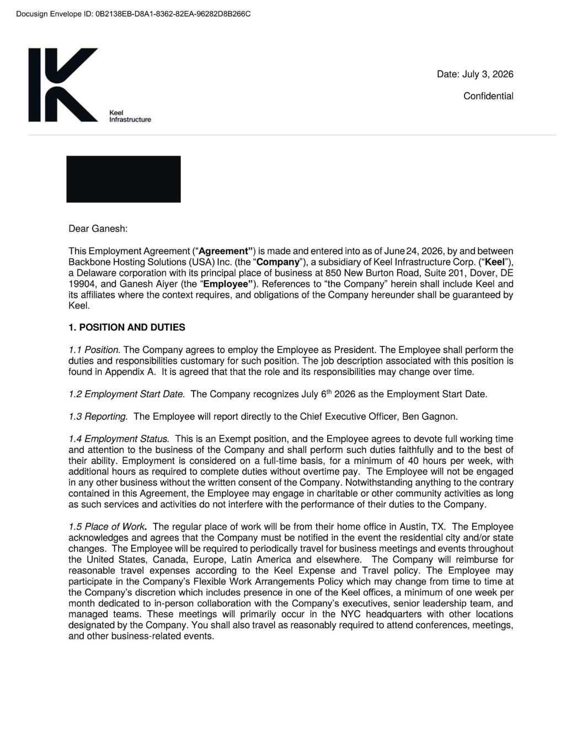
94 |  |  | Page

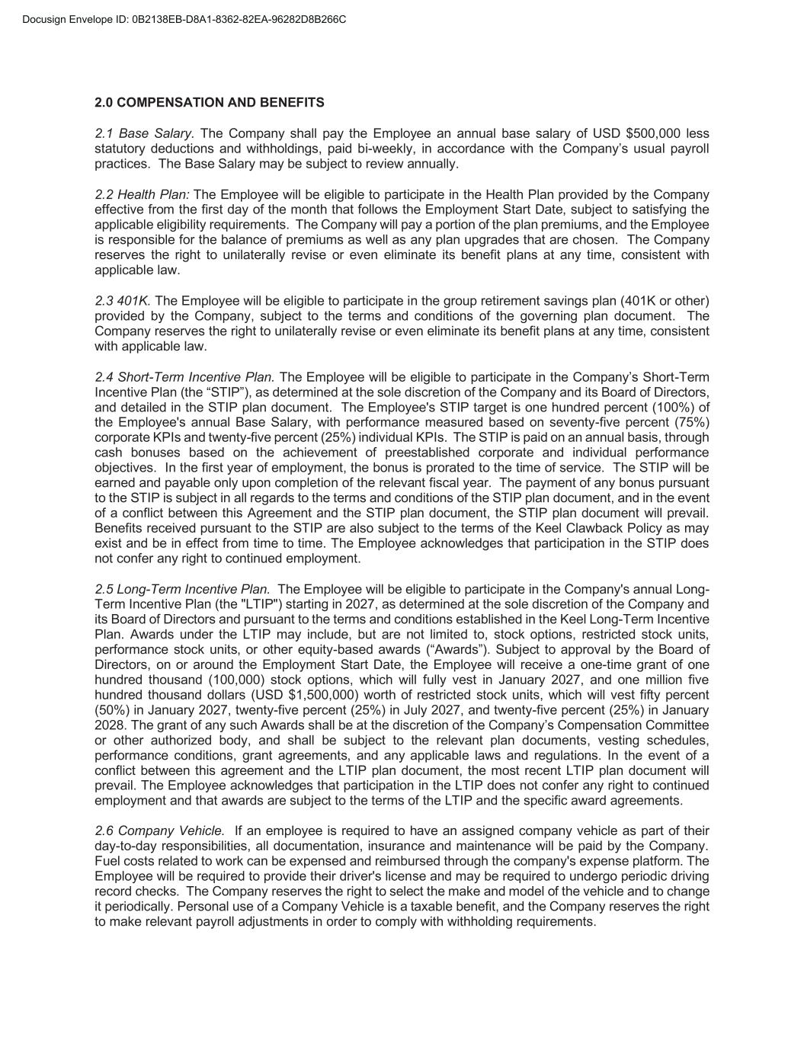
2.0 COMPENSATION AND BENEFITS 2.1 Base Salary. The Company shall pay the Employee an annual base salary of USD $500,000 less statutory deductions and withholdings, paid bi-weekly, in accordance with the Company’s usual payroll practices. The Base Salary may be subject to review annually. 2.2 Health Plan: The Employee will be eligible to participate in the Health Plan provided by the Company effective from the first day of the month that follows the Employment Start Date, subject to satisfying the applicable eligibility requirements. The Company will pay a portion of the plan premiums, and the Employee is responsible for the balance of premiums as well as any plan upgrades that are chosen. The Company reserves the right to unilaterally revise or even eliminate its benefit plans at any time, consistent with applicable law. 2.3 401K. The Employee will be eligible to participate in the group retirement savings plan (401K or other) provided by the Company, subject to the terms and conditions of the governing plan document. The Company reserves the right to unilaterally revise or even eliminate its benefit plans at any time, consistent with applicable law. 2.4 Short-Term Incentive Plan. The Employee will be eligible to participate in the Company’s Short-Term Incentive Plan (the “STIP”), as determined at the sole discretion of the Company and its Board of Directors, and detailed in the STIP plan document. The Employee's STIP target is one hundred percent (100%) of the Employee's annual Base Salary, with performance measured based on seventy-five percent (75%) corporate KPIs and twenty-five percent (25%) individual KPIs. The STIP is paid on an annual basis, through cash bonuses based on the achievement of preestablished corporate and individual performance objectives. In the first year of employment, the bonus is prorated to the time of service. The STIP will be earned and payable only upon completion of the relevant fiscal year. The payment of any bonus pursuant to the STIP is subject in all regards to the terms and conditions of the STIP plan document, and in the event of a conflict between this Agreement and the STIP plan document, the STIP plan document will prevail. Benefits received pursuant to the STIP are also subject to the terms of the Keel Clawback Policy as may exist and be in effect from time to time. The Employee acknowledges that participation in the STIP does not confer any right to continued employment. 2.5 Long-Term Incentive Plan. The Employee will be eligible to participate in the Company's annual Long- Term Incentive Plan (the "LTIP") starting in 2027, as determined at the sole discretion of the Company and its Board of Directors and pursuant to the terms and conditions established in the Keel Long-Term Incentive Plan. Awards under the LTIP may include, but are not limited to, stock options, restricted stock units, performance stock units, or other equity-based awards (“Awards”). Subject to approval by the Board of Directors, on or around the Employment Start Date, the Employee will receive a one-time grant of one hundred thousand (100,000) stock options, which will fully vest in January 2027, and one million five hundred thousand dollars (USD $1,500,000) worth of restricted stock units, which will vest fifty percent (50%) in January 2027, twenty-five percent (25%) in July 2027, and twenty-five percent (25%) in January 2028. The grant of any such Awards shall be at the discretion of the Company’s Compensation Committee or other authorized body, and shall be subject to the relevant plan documents, vesting schedules, performance conditions, grant agreements, and any applicable laws and regulations. In the event of a conflict between this agreement and the LTIP plan document, the most recent LTIP plan document will prevail. The Employee acknowledges that participation in the LTIP does not confer any right to continued employment and that awards are subject to the terms of the LTIP and the specific award agreements. 2.6 Company Vehicle. If an employee is required to have an assigned company vehicle as part of their day-to-day responsibilities, all documentation, insurance and maintenance will be paid by the Company. Fuel costs related to work can be expensed and reimbursed through the company's expense platform. The Employee will be required to provide their driver's license and may be required to undergo periodic driving record checks. The Company reserves the right to select the make and model of the vehicle and to change it periodically. Personal use of a Company Vehicle is a taxable benefit, and the Company reserves the right to make relevant payroll adjustments in order to comply with withholding requirements.

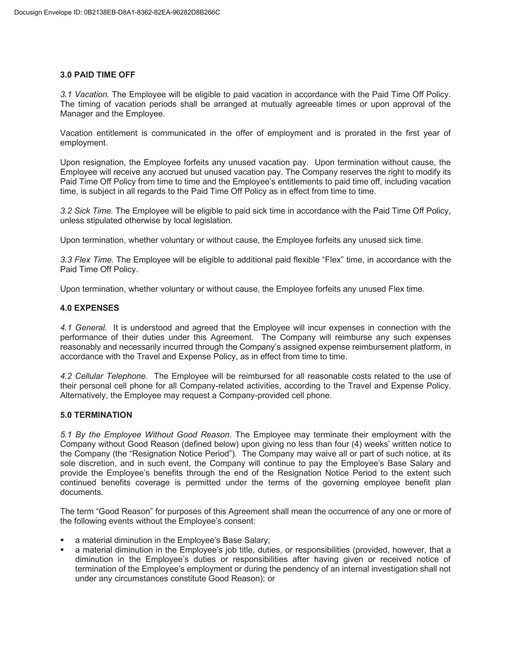
3.0 PAID TIME OFF 3.1 Vacation. The Employee will be eligible to paid vacation in accordance with the Paid Time Off Policy. The timing of vacation periods shall be arranged at mutually agreeable times or upon approval of the Manager and the Employee. Vacation entitlement is communicated in the offer of employment and is prorated in the first year of employment. Upon resignation, the Employee forfeits any unused vacation pay. Upon termination without cause, the Employee will receive any accrued but unused vacation pay. The Company reserves the right to modify its Paid Time Off Policy from time to time and the Employee’s entitlements to paid time off, including vacation time, is subject in all regards to the Paid Time Off Policy as in effect from time to time. 3.2 Sick Time. The Employee will be eligible to paid sick time in accordance with the Paid Time Off Policy, unless stipulated otherwise by local legislation. Upon termination, whether voluntary or without cause, the Employee forfeits any unused sick time. 3.3 Flex Time. The Employee will be eligible to additional paid flexible “Flex” time, in accordance with the Paid Time Off Policy. Upon termination, whether voluntary or without cause, the Employee forfeits any unused Flex time. 4.0 EXPENSES 4.1 General. It is understood and agreed that the Employee will incur expenses in connection with the performance of their duties under this Agreement. The Company will reimburse any such expenses reasonably and necessarily incurred through the Company’s assigned expense reimbursement platform, in accordance with the Travel and Expense Policy, as in effect from time to time. 4.2 Cellular Telephone. The Employee will be reimbursed for all reasonable costs related to the use of their personal cell phone for all Company-related activities, according to the Travel and Expense Policy. Alternatively, the Employee may request a Company-provided cell phone. 5.0 TERMINATION 5.1 By the Employee Without Good Reason. The Employee may terminate their employment with the Company without Good Reason (defined below) upon giving no less than four (4) weeks’ written notice to the Company (the “Resignation Notice Period”). The Company may waive all or part of such notice, at its sole discretion, and in such event, the Company will continue to pay the Employee’s Base Salary and provide the Employee’s benefits through the end of the Resignation Notice Period to the extent such continued benefits coverage is permitted under the terms of the governing employee benefit plan documents. The term “Good Reason” for purposes of this Agreement shall mean the occurrence of any one or more of the following events without the Employee’s consent: a material diminution in the Employee’s Base Salary; a material diminution in the Employee’s job title, duties, or responsibilities (provided, however, that a diminution in the Employee’s duties or responsibilities after having given or received notice of termination of the Employee’s employment or during the pendency of an internal investigation shall not under any circumstances constitute Good Reason); or

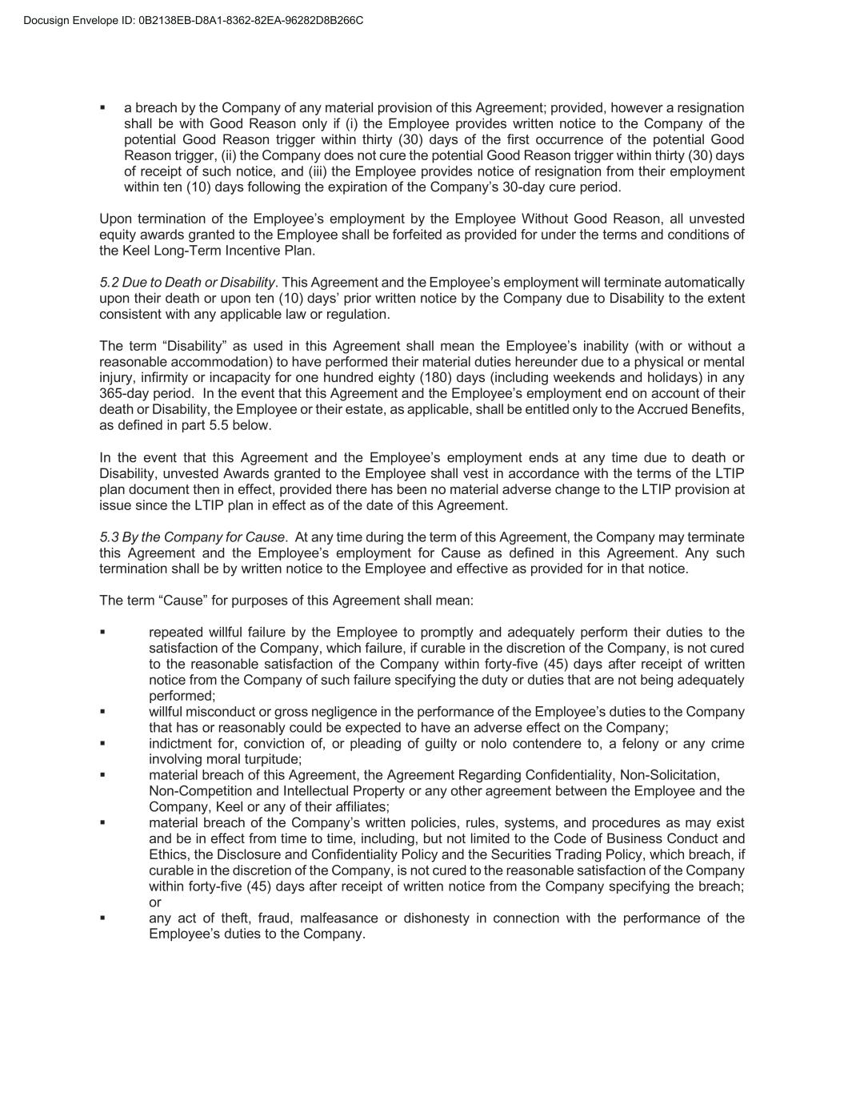
a breach by the Company of any material provision of this Agreement; provided, however a resignation shall be with Good Reason only if (i) the Employee provides written notice to the Company of the potential Good Reason trigger within thirty (30) days of the first occurrence of the potential Good Reason trigger, (ii) the Company does not cure the potential Good Reason trigger within thirty (30) days of receipt of such notice, and (iii) the Employee provides notice of resignation from their employment within ten (10) days following the expiration of the Company’s 30-day cure period. Upon termination of the Employee’s employment by the Employee Without Good Reason, all unvested equity awards granted to the Employee shall be forfeited as provided for under the terms and conditions of the Keel Long-Term Incentive Plan. 5.2 Due to Death or Disability. This Agreement and the Employee’s employment will terminate automatically upon their death or upon ten (10) days’ prior written notice by the Company due to Disability to the extent consistent with any applicable law or regulation. The term “Disability” as used in this Agreement shall mean the Employee’s inability (with or without a reasonable accommodation) to have performed their material duties hereunder due to a physical or mental injury, infirmity or incapacity for one hundred eighty (180) days (including weekends and holidays) in any 365-day period. In the event that this Agreement and the Employee’s employment end on account of their death or Disability, the Employee or their estate, as applicable, shall be entitled only to the Accrued Benefits, as defined in part 5.5 below. In the event that this Agreement and the Employee’s employment ends at any time due to death or Disability, unvested Awards granted to the Employee shall vest in accordance with the terms of the LTIP plan document then in effect, provided there has been no material adverse change to the LTIP provision at issue since the LTIP plan in effect as of the date of this Agreement. 5.3 By the Company for Cause. At any time during the term of this Agreement, the Company may terminate this Agreement and the Employee’s employment for Cause as defined in this Agreement. Any such termination shall be by written notice to the Employee and effective as provided for in that notice. The term “Cause” for purposes of this Agreement shall mean: repeated willful failure by the Employee to promptly and adequately perform their duties to the satisfaction of the Company, which failure, if curable in the discretion of the Company, is not cured to the reasonable satisfaction of the Company within forty-five (45) days after receipt of written notice from the Company of such failure specifying the duty or duties that are not being adequately performed; willful misconduct or gross negligence in the performance of the Employee’s duties to the Company that has or reasonably could be expected to have an adverse effect on the Company; indictment for, conviction of, or pleading of guilty or nolo contendere to, a felony or any crime involving moral turpitude; material breach of this Agreement, the Agreement Regarding Confidentiality, Non-Solicitation, Non-Competition and Intellectual Property or any other agreement between the Employee and the Company, Keel or any of their affiliates; material breach of the Company’s written policies, rules, systems, and procedures as may exist and be in effect from time to time, including, but not limited to the Code of Business Conduct and Ethics, the Disclosure and Confidentiality Policy and the Securities Trading Policy, which breach, if curable in the discretion of the Company, is not cured to the reasonable satisfaction of the Company within forty-five (45) days after receipt of written notice from the Company specifying the breach; or any act of theft, fraud, malfeasance or dishonesty in connection with the performance of the Employee’s duties to the Company.

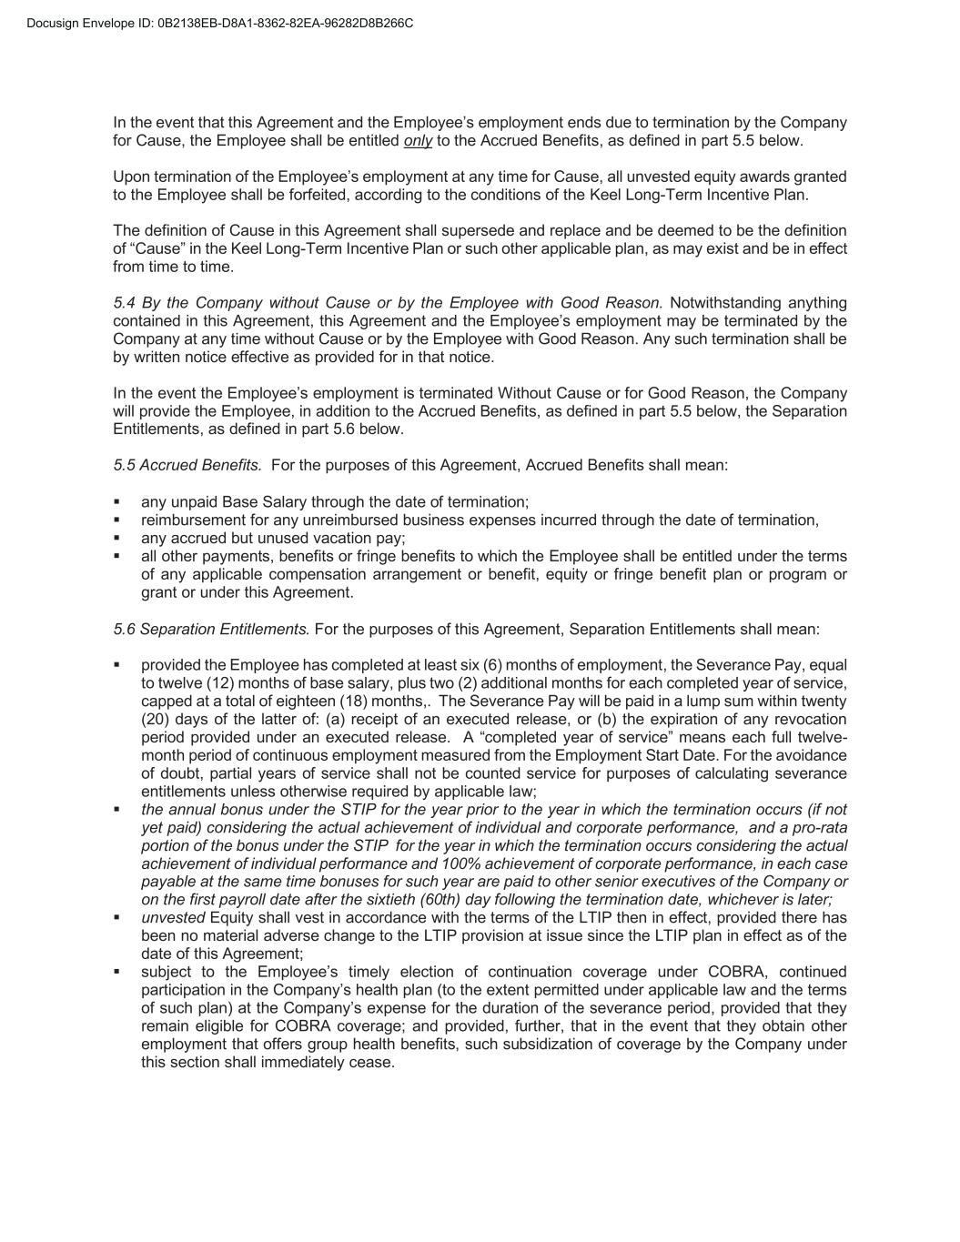
In the event that this Agreement and the Employee’s employment ends due to termination by the Company for Cause, the Employee shall be entitled only to the Accrued Benefits, as defined in part 5.5 below. Upon termination of the Employee’s employment at any time for Cause, all unvested equity awards granted to the Employee shall be forfeited, according to the conditions of the Keel Long-Term Incentive Plan. The definition of Cause in this Agreement shall supersede and replace and be deemed to be the definition of “Cause” in the Keel Long-Term Incentive Plan or such other applicable plan, as may exist and be in effect from time to time. 5.4 By the Company without Cause or by the Employee with Good Reason. Notwithstanding anything contained in this Agreement, this Agreement and the Employee’s employment may be terminated by the Company at any time without Cause or by the Employee with Good Reason. Any such termination shall be by written notice effective as provided for in that notice. In the event the Employee’s employment is terminated Without Cause or for Good Reason, the Company will provide the Employee, in addition to the Accrued Benefits, as defined in part 5.5 below, the Separation Entitlements, as defined in part 5.6 below. 5.5 Accrued Benefits. For the purposes of this Agreement, Accrued Benefits shall mean: any unpaid Base Salary through the date of termination; reimbursement for any unreimbursed business expenses incurred through the date of termination, any accrued but unused vacation pay; all other payments, benefits or fringe benefits to which the Employee shall be entitled under the terms of any applicable compensation arrangement or benefit, equity or fringe benefit plan or program or grant or under this Agreement. 5.6 Separation Entitlements. For the purposes of this Agreement, Separation Entitlements shall mean: provided the Employee has completed at least six (6) months of employment, the Severance Pay, equal to twelve (12) months of base salary, plus two (2) additional months for each completed year of service, capped at a total of eighteen (18) months,. The Severance Pay will be paid in a lump sum within twenty (20) days of the latter of: (a) receipt of an executed release, or (b) the expiration of any revocation period provided under an executed release. A “completed year of service” means each full twelve- month period of continuous employment measured from the Employment Start Date. For the avoidance of doubt, partial years of service shall not be counted service for purposes of calculating severance entitlements unless otherwise required by applicable law; the annual bonus under the STIP for the year prior to the year in which the termination occurs (if not yet paid) considering the actual achievement of individual and corporate performance, and a pro-rata portion of the bonus under the STIP for the year in which the termination occurs considering the actual achievement of individual performance and 100% achievement of corporate performance, in each case payable at the same time bonuses for such year are paid to other senior executives of the Company or on the first payroll date after the sixtieth (60th) day following the termination date, whichever is later; unvested Equity shall vest in accordance with the terms of the LTIP then in effect, provided there has been no material adverse change to the LTIP provision at issue since the LTIP plan in effect as of the date of this Agreement; subject to the Employee’s timely election of continuation coverage under COBRA, continued participation in the Company’s health plan (to the extent permitted under applicable law and the terms of such plan) at the Company’s expense for the duration of the severance period, provided that they remain eligible for COBRA coverage; and provided, further, that in the event that they obtain other employment that offers group health benefits, such subsidization of coverage by the Company under this section shall immediately cease.

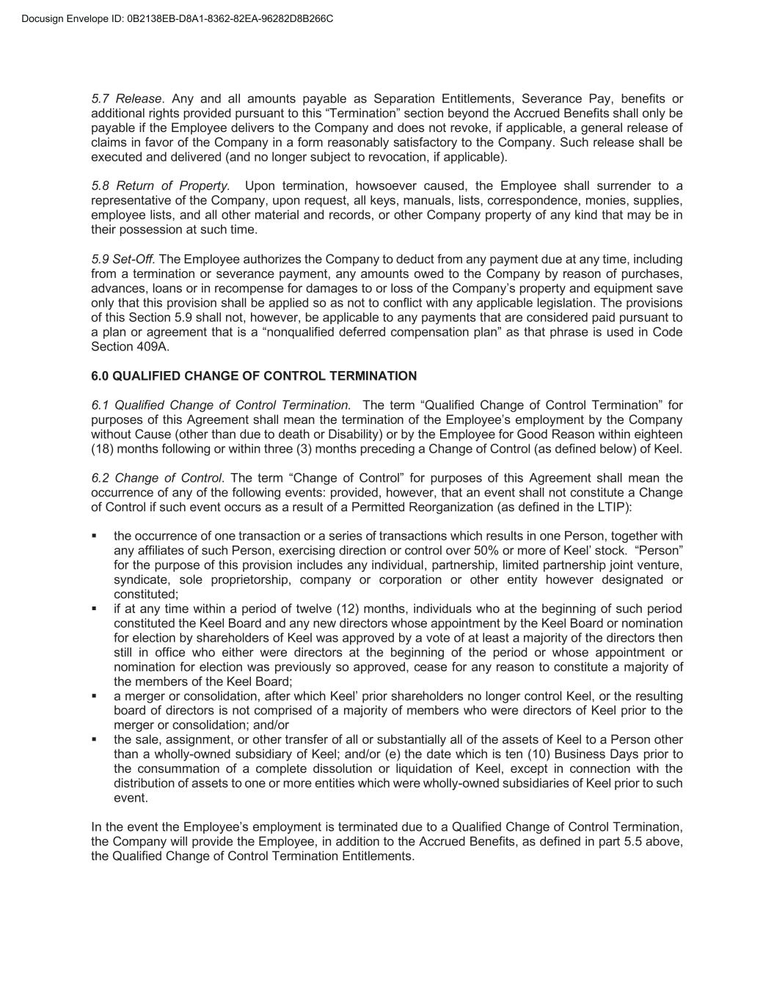
5.7 Release. Any and all amounts payable as Separation Entitlements, Severance Pay, benefits or additional rights provided pursuant to this “Termination” section beyond the Accrued Benefits shall only be payable if the Employee delivers to the Company and does not revoke, if applicable, a general release of claims in favor of the Company in a form reasonably satisfactory to the Company. Such release shall be executed and delivered (and no longer subject to revocation, if applicable). 5.8 Return of Property. Upon termination, howsoever caused, the Employee shall surrender to a representative of the Company, upon request, all keys, manuals, lists, correspondence, monies, supplies, employee lists, and all other material and records, or other Company property of any kind that may be in their possession at such time. 5.9 Set-Off. The Employee authorizes the Company to deduct from any payment due at any time, including from a termination or severance payment, any amounts owed to the Company by reason of purchases, advances, loans or in recompense for damages to or loss of the Company’s property and equipment save only that this provision shall be applied so as not to conflict with any applicable legislation. The provisions of this Section 5.9 shall not, however, be applicable to any payments that are considered paid pursuant to a plan or agreement that is a “nonqualified deferred compensation plan” as that phrase is used in Code Section 409A. 6.0 QUALIFIED CHANGE OF CONTROL TERMINATION 6.1 Qualified Change of Control Termination. The term “Qualified Change of Control Termination” for purposes of this Agreement shall mean the termination of the Employee’s employment by the Company without Cause (other than due to death or Disability) or by the Employee for Good Reason within eighteen (18) months following or within three (3) months preceding a Change of Control (as defined below) of Keel. 6.2 Change of Control. The term “Change of Control” for purposes of this Agreement shall mean the occurrence of any of the following events: provided, however, that an event shall not constitute a Change of Control if such event occurs as a result of a Permitted Reorganization (as defined in the LTIP): the occurrence of one transaction or a series of transactions which results in one Person, together with any affiliates of such Person, exercising direction or control over 50% or more of Keel’ stock. “Person” for the purpose of this provision includes any individual, partnership, limited partnership joint venture, syndicate, sole proprietorship, company or corporation or other entity however designated or constituted; if at any time within a period of twelve (12) months, individuals who at the beginning of such period constituted the Keel Board and any new directors whose appointment by the Keel Board or nomination for election by shareholders of Keel was approved by a vote of at least a majority of the directors then still in office who either were directors at the beginning of the period or whose appointment or nomination for election was previously so approved, cease for any reason to constitute a majority of the members of the Keel Board; a merger or consolidation, after which Keel’ prior shareholders no longer control Keel, or the resulting board of directors is not comprised of a majority of members who were directors of Keel prior to the merger or consolidation; and/or the sale, assignment, or other transfer of all or substantially all of the assets of Keel to a Person other than a wholly-owned subsidiary of Keel; and/or (e) the date which is ten (10) Business Days prior to the consummation of a complete dissolution or liquidation of Keel, except in connection with the distribution of assets to one or more entities which were wholly-owned subsidiaries of Keel prior to such event. In the event the Employee’s employment is terminated due to a Qualified Change of Control Termination, the Company will provide the Employee, in addition to the Accrued Benefits, as defined in part 5.5 above, the Qualified Change of Control Termination Entitlements.

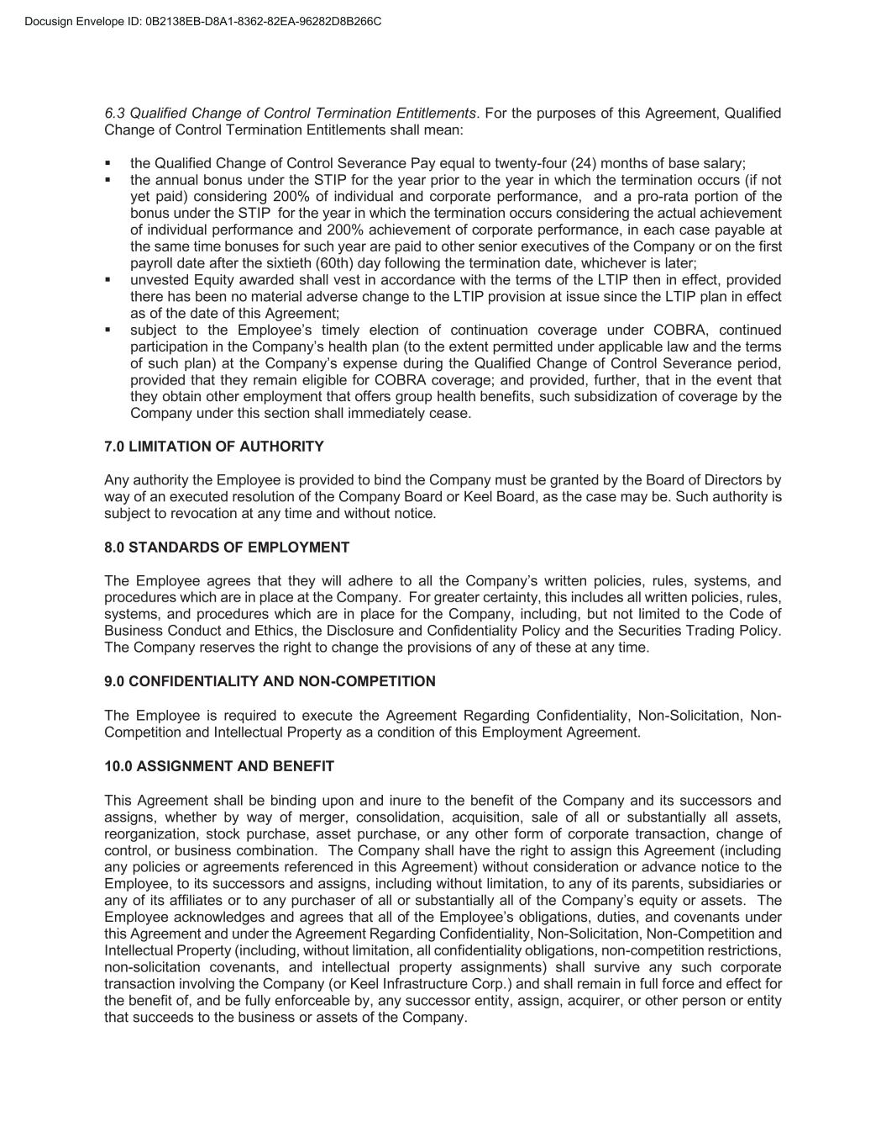
6.3 Qualified Change of Control Termination Entitlements. For the purposes of this Agreement, Qualified Change of Control Termination Entitlements shall mean: the Qualified Change of Control Severance Pay equal to twenty-four (24) months of base salary; the annual bonus under the STIP for the year prior to the year in which the termination occurs (if not yet paid) considering 200% of individual and corporate performance, and a pro-rata portion of the bonus under the STIP for the year in which the termination occurs considering the actual achievement of individual performance and 200% achievement of corporate performance, in each case payable at the same time bonuses for such year are paid to other senior executives of the Company or on the first payroll date after the sixtieth (60th) day following the termination date, whichever is later; unvested Equity awarded shall vest in accordance with the terms of the LTIP then in effect, provided there has been no material adverse change to the LTIP provision at issue since the LTIP plan in effect as of the date of this Agreement; subject to the Employee’s timely election of continuation coverage under COBRA, continued participation in the Company’s health plan (to the extent permitted under applicable law and the terms of such plan) at the Company’s expense during the Qualified Change of Control Severance period, provided that they remain eligible for COBRA coverage; and provided, further, that in the event that they obtain other employment that offers group health benefits, such subsidization of coverage by the Company under this section shall immediately cease. 7.0 LIMITATION OF AUTHORITY Any authority the Employee is provided to bind the Company must be granted by the Board of Directors by way of an executed resolution of the Company Board or Keel Board, as the case may be. Such authority is subject to revocation at any time and without notice. 8.0 STANDARDS OF EMPLOYMENT The Employee agrees that they will adhere to all the Company’s written policies, rules, systems, and procedures which are in place at the Company. For greater certainty, this includes all written policies, rules, systems, and procedures which are in place for the Company, including, but not limited to the Code of Business Conduct and Ethics, the Disclosure and Confidentiality Policy and the Securities Trading Policy. The Company reserves the right to change the provisions of any of these at any time. 9.0 CONFIDENTIALITY AND NON-COMPETITION The Employee is required to execute the Agreement Regarding Confidentiality, Non-Solicitation, Non- Competition and Intellectual Property as a condition of this Employment Agreement. 10.0 ASSIGNMENT AND BENEFIT This Agreement shall be binding upon and inure to the benefit of the Company and its successors and assigns, whether by way of merger, consolidation, acquisition, sale of all or substantially all assets, reorganization, stock purchase, asset purchase, or any other form of corporate transaction, change of control, or business combination. The Company shall have the right to assign this Agreement (including any policies or agreements referenced in this Agreement) without consideration or advance notice to the Employee, to its successors and assigns, including without limitation, to any of its parents, subsidiaries or any of its affiliates or to any purchaser of all or substantially all of the Company’s equity or assets. The Employee acknowledges and agrees that all of the Employee’s obligations, duties, and covenants under this Agreement and under the Agreement Regarding Confidentiality, Non-Solicitation, Non-Competition and Intellectual Property (including, without limitation, all confidentiality obligations, non-competition restrictions, non-solicitation covenants, and intellectual property assignments) shall survive any such corporate transaction involving the Company (or Keel Infrastructure Corp.) and shall remain in full force and effect for the benefit of, and be fully enforceable by, any successor entity, assign, acquirer, or other person or entity that succeeds to the business or assets of the Company.

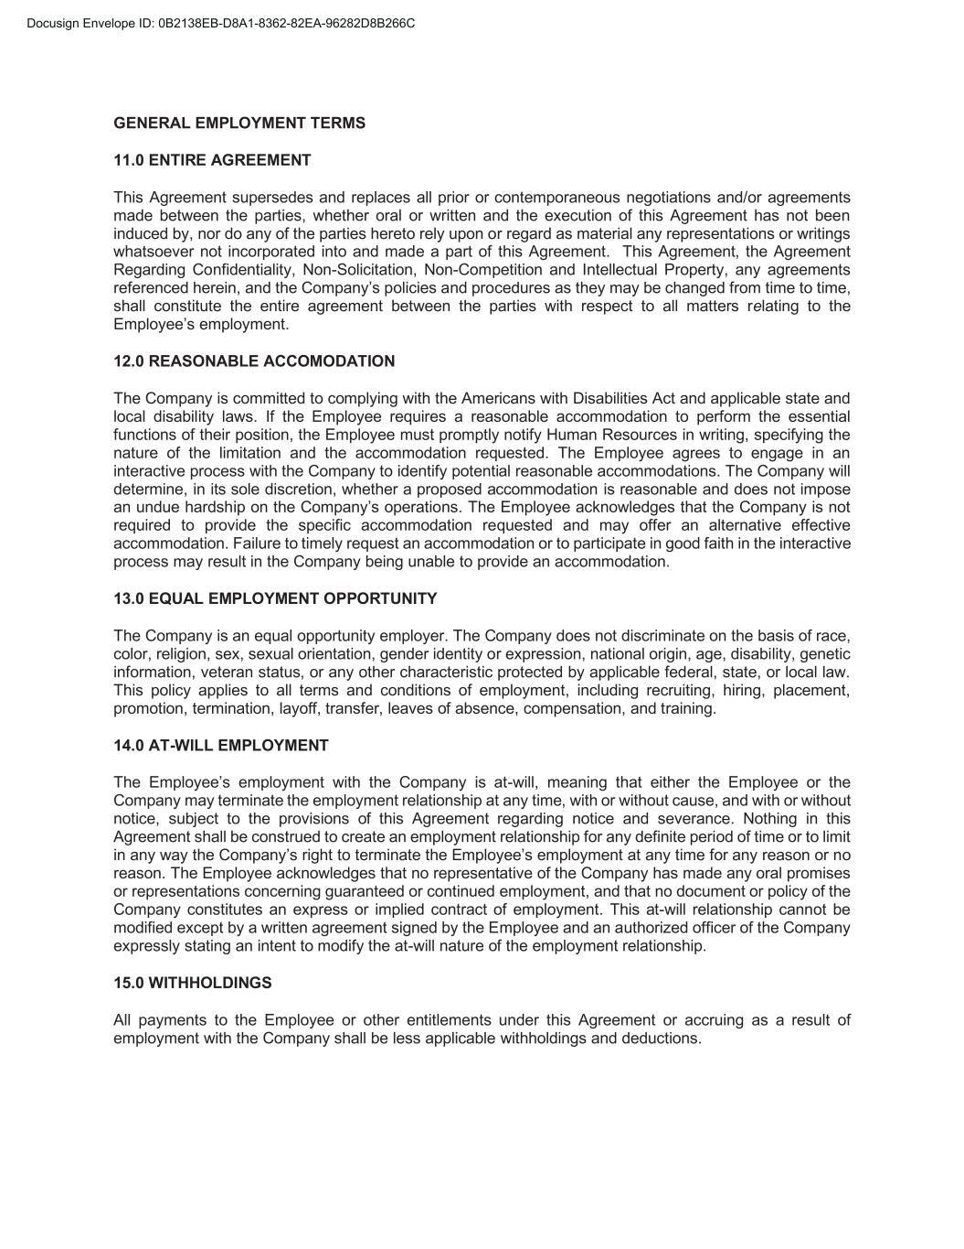
GENERAL EMPLOYMENT TERMS 11.0 ENTIRE AGREEMENT This Agreement supersedes and replaces all prior or contemporaneous negotiations and/or agreements made between the parties, whether oral or written and the execution of this Agreement has not been induced by, nor do any of the parties hereto rely upon or regard as material any representations or writings whatsoever not incorporated into and made a part of this Agreement. This Agreement, the Agreement Regarding Confidentiality, Non-Solicitation, Non-Competition and Intellectual Property, any agreements referenced herein, and the Company’s policies and procedures as they may be changed from time to time, shall constitute the entire agreement between the parties with respect to all matters relating to the Employee’s employment. 12.0 REASONABLE ACCOMODATION The Company is committed to complying with the Americans with Disabilities Act and applicable state and local disability laws. If the Employee requires a reasonable accommodation to perform the essential functions of their position, the Employee must promptly notify Human Resources in writing, specifying the nature of the limitation and the accommodation requested. The Employee agrees to engage in an interactive process with the Company to identify potential reasonable accommodations. The Company will determine, in its sole discretion, whether a proposed accommodation is reasonable and does not impose an undue hardship on the Company’s operations. The Employee acknowledges that the Company is not required to provide the specific accommodation requested and may offer an alternative effective accommodation. Failure to timely request an accommodation or to participate in good faith in the interactive process may result in the Company being unable to provide an accommodation. 13.0 EQUAL EMPLOYMENT OPPORTUNITY The Company is an equal opportunity employer. The Company does not discriminate on the basis of race, color, religion, sex, sexual orientation, gender identity or expression, national origin, age, disability, genetic information, veteran status, or any other characteristic protected by applicable federal, state, or local law. This policy applies to all terms and conditions of employment, including recruiting, hiring, placement, promotion, termination, layoff, transfer, leaves of absence, compensation, and training. 14.0 AT-WILL EMPLOYMENT The Employee’s employment with the Company is at-will, meaning that either the Employee or the Company may terminate the employment relationship at any time, with or without cause, and with or without notice, subject to the provisions of this Agreement regarding notice and severance. Nothing in this Agreement shall be construed to create an employment relationship for any definite period of time or to limit in any way the Company’s right to terminate the Employee’s employment at any time for any reason or no reason. The Employee acknowledges that no representative of the Company has made any oral promises or representations concerning guaranteed or continued employment, and that no document or policy of the Company constitutes an express or implied contract of employment. This at-will relationship cannot be modified except by a written agreement signed by the Employee and an authorized officer of the Company expressly stating an intent to modify the at-will nature of the employment relationship. 15.0 WITHHOLDINGS All payments to the Employee or other entitlements under this Agreement or accruing as a result of employment with the Company shall be less applicable withholdings and deductions.

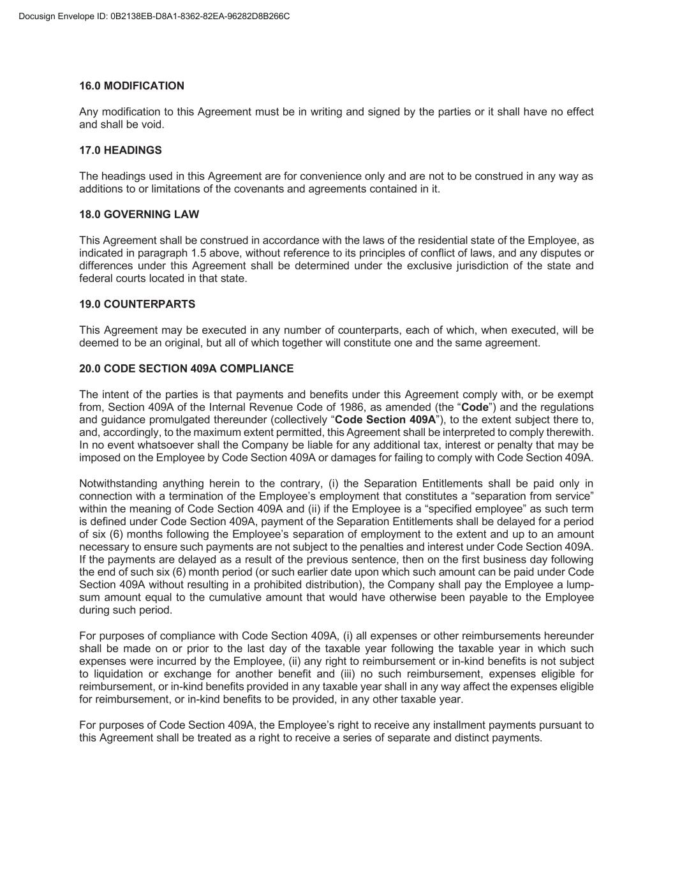
16.0 MODIFICATION Any modification to this Agreement must be in writing and signed by the parties or it shall have no effect and shall be void. 17.0 HEADINGS The headings used in this Agreement are for convenience only and are not to be construed in any way as additions to or limitations of the covenants and agreements contained in it. 18.0 GOVERNING LAW This Agreement shall be construed in accordance with the laws of the residential state of the Employee, as indicated in paragraph 1.5 above, without reference to its principles of conflict of laws, and any disputes or differences under this Agreement shall be determined under the exclusive jurisdiction of the state and federal courts located in that state. 19.0 COUNTERPARTS This Agreement may be executed in any number of counterparts, each of which, when executed, will be deemed to be an original, but all of which together will constitute one and the same agreement. 20.0 CODE SECTION 409A COMPLIANCE The intent of the parties is that payments and benefits under this Agreement comply with, or be exempt from, Section 409A of the Internal Revenue Code of 1986, as amended (the “Code”) and the regulations and guidance promulgated thereunder (collectively “Code Section 409A”), to the extent subject there to, and, accordingly, to the maximum extent permitted, this Agreement shall be interpreted to comply therewith. In no event whatsoever shall the Company be liable for any additional tax, interest or penalty that may be imposed on the Employee by Code Section 409A or damages for failing to comply with Code Section 409A. Notwithstanding anything herein to the contrary, (i) the Separation Entitlements shall be paid only in connection with a termination of the Employee’s employment that constitutes a “separation from service” within the meaning of Code Section 409A and (ii) if the Employee is a “specified employee” as such term is defined under Code Section 409A, payment of the Separation Entitlements shall be delayed for a period of six (6) months following the Employee’s separation of employment to the extent and up to an amount necessary to ensure such payments are not subject to the penalties and interest under Code Section 409A. If the payments are delayed as a result of the previous sentence, then on the first business day following the end of such six (6) month period (or such earlier date upon which such amount can be paid under Code Section 409A without resulting in a prohibited distribution), the Company shall pay the Employee a lump- sum amount equal to the cumulative amount that would have otherwise been payable to the Employee during such period. For purposes of compliance with Code Section 409A, (i) all expenses or other reimbursements hereunder shall be made on or prior to the last day of the taxable year following the taxable year in which such expenses were incurred by the Employee, (ii) any right to reimbursement or in-kind benefits is not subject to liquidation or exchange for another benefit and (iii) no such reimbursement, expenses eligible for reimbursement, or in-kind benefits provided in any taxable year shall in any way affect the expenses eligible for reimbursement, or in-kind benefits to be provided, in any other taxable year. For purposes of Code Section 409A, the Employee’s right to receive any installment payments pursuant to this Agreement shall be treated as a right to receive a series of separate and distinct payments.

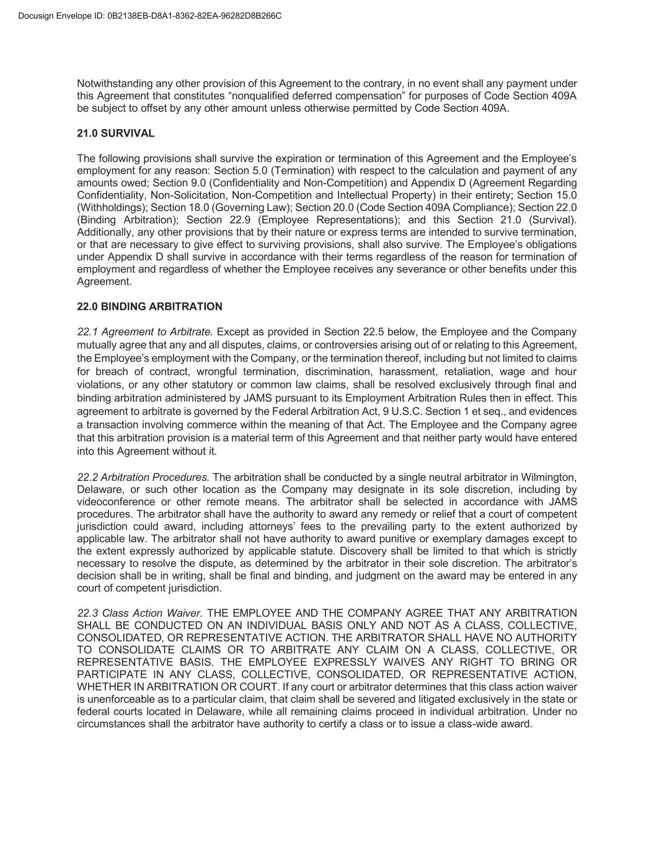
Notwithstanding any other provision of this Agreement to the contrary, in no event shall any payment under this Agreement that constitutes “nonqualified deferred compensation” for purposes of Code Section 409A be subject to offset by any other amount unless otherwise permitted by Code Section 409A. 21.0 SURVIVAL The following provisions shall survive the expiration or termination of this Agreement and the Employee’s employment for any reason: Section 5.0 (Termination) with respect to the calculation and payment of any amounts owed; Section 9.0 (Confidentiality and Non-Competition) and Appendix D (Agreement Regarding Confidentiality, Non-Solicitation, Non-Competition and Intellectual Property) in their entirety; Section 15.0 (Withholdings); Section 18.0 (Governing Law); Section 20.0 (Code Section 409A Compliance); Section 22.0 (Binding Arbitration); Section 22.9 (Employee Representations); and this Section 21.0 (Survival). Additionally, any other provisions that by their nature or express terms are intended to survive termination, or that are necessary to give effect to surviving provisions, shall also survive. The Employee’s obligations under Appendix D shall survive in accordance with their terms regardless of the reason for termination of employment and regardless of whether the Employee receives any severance or other benefits under this Agreement. 22.0 BINDING ARBITRATION 22.1 Agreement to Arbitrate. Except as provided in Section 22.5 below, the Employee and the Company mutually agree that any and all disputes, claims, or controversies arising out of or relating to this Agreement, the Employee’s employment with the Company, or the termination thereof, including but not limited to claims for breach of contract, wrongful termination, discrimination, harassment, retaliation, wage and hour violations, or any other statutory or common law claims, shall be resolved exclusively through final and binding arbitration administered by JAMS pursuant to its Employment Arbitration Rules then in effect. This agreement to arbitrate is governed by the Federal Arbitration Act, 9 U.S.C. Section 1 et seq., and evidences a transaction involving commerce within the meaning of that Act. The Employee and the Company agree that this arbitration provision is a material term of this Agreement and that neither party would have entered into this Agreement without it. 22.2 Arbitration Procedures. The arbitration shall be conducted by a single neutral arbitrator in Wilmington, Delaware, or such other location as the Company may designate in its sole discretion, including by videoconference or other remote means. The arbitrator shall be selected in accordance with JAMS procedures. The arbitrator shall have the authority to award any remedy or relief that a court of competent jurisdiction could award, including attorneys’ fees to the prevailing party to the extent authorized by applicable law. The arbitrator shall not have authority to award punitive or exemplary damages except to the extent expressly authorized by applicable statute. Discovery shall be limited to that which is strictly necessary to resolve the dispute, as determined by the arbitrator in their sole discretion. The arbitrator’s decision shall be in writing, shall be final and binding, and judgment on the award may be entered in any court of competent jurisdiction. 22.3 Class Action Waiver. THE EMPLOYEE AND THE COMPANY AGREE THAT ANY ARBITRATION SHALL BE CONDUCTED ON AN INDIVIDUAL BASIS ONLY AND NOT AS A CLASS, COLLECTIVE, CONSOLIDATED, OR REPRESENTATIVE ACTION. THE ARBITRATOR SHALL HAVE NO AUTHORITY TO CONSOLIDATE CLAIMS OR TO ARBITRATE ANY CLAIM ON A CLASS, COLLECTIVE, OR REPRESENTATIVE BASIS. THE EMPLOYEE EXPRESSLY WAIVES ANY RIGHT TO BRING OR PARTICIPATE IN ANY CLASS, COLLECTIVE, CONSOLIDATED, OR REPRESENTATIVE ACTION, WHETHER IN ARBITRATION OR COURT. If any court or arbitrator determines that this class action waiver is unenforceable as to a particular claim, that claim shall be severed and litigated exclusively in the state or federal courts located in Delaware, while all remaining claims proceed in individual arbitration. Under no circumstances shall the arbitrator have authority to certify a class or to issue a class-wide award.

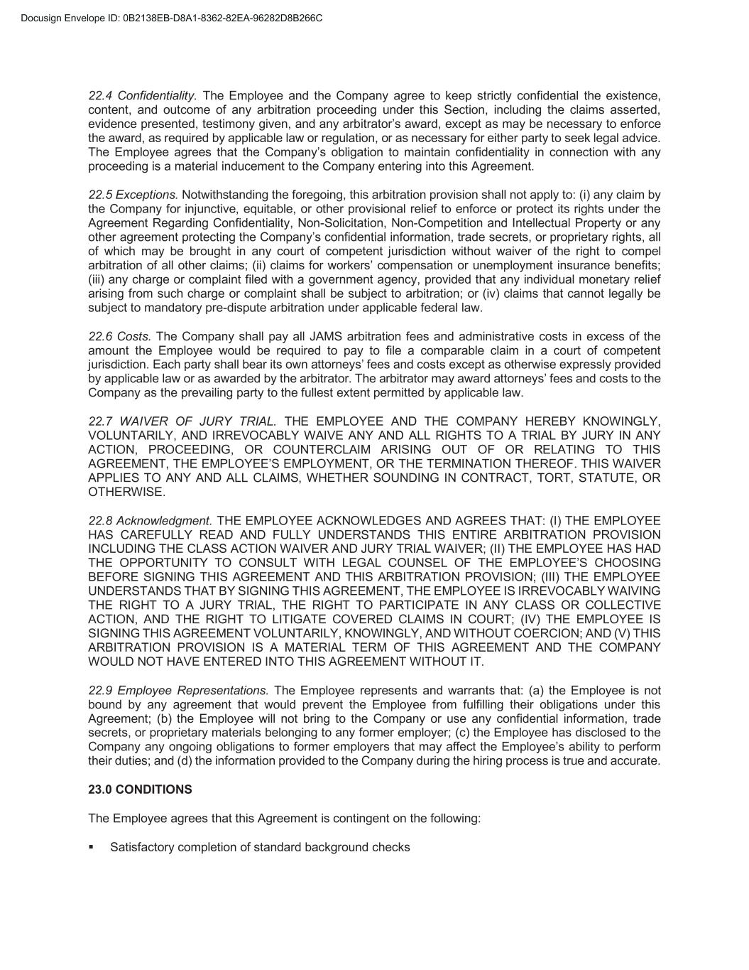
22.4 Confidentiality. The Employee and the Company agree to keep strictly confidential the existence, content, and outcome of any arbitration proceeding under this Section, including the claims asserted, evidence presented, testimony given, and any arbitrator’s award, except as may be necessary to enforce the award, as required by applicable law or regulation, or as necessary for either party to seek legal advice. The Employee agrees that the Company’s obligation to maintain confidentiality in connection with any proceeding is a material inducement to the Company entering into this Agreement. 22.5 Exceptions. Notwithstanding the foregoing, this arbitration provision shall not apply to: (i) any claim by the Company for injunctive, equitable, or other provisional relief to enforce or protect its rights under the Agreement Regarding Confidentiality, Non-Solicitation, Non-Competition and Intellectual Property or any other agreement protecting the Company’s confidential information, trade secrets, or proprietary rights, all of which may be brought in any court of competent jurisdiction without waiver of the right to compel arbitration of all other claims; (ii) claims for workers’ compensation or unemployment insurance benefits; (iii) any charge or complaint filed with a government agency, provided that any individual monetary relief arising from such charge or complaint shall be subject to arbitration; or (iv) claims that cannot legally be subject to mandatory pre-dispute arbitration under applicable federal law. 22.6 Costs. The Company shall pay all JAMS arbitration fees and administrative costs in excess of the amount the Employee would be required to pay to file a comparable claim in a court of competent jurisdiction. Each party shall bear its own attorneys’ fees and costs except as otherwise expressly provided by applicable law or as awarded by the arbitrator. The arbitrator may award attorneys’ fees and costs to the Company as the prevailing party to the fullest extent permitted by applicable law. 22.7 WAIVER OF JURY TRIAL. THE EMPLOYEE AND THE COMPANY HEREBY KNOWINGLY, VOLUNTARILY, AND IRREVOCABLY WAIVE ANY AND ALL RIGHTS TO A TRIAL BY JURY IN ANY ACTION, PROCEEDING, OR COUNTERCLAIM ARISING OUT OF OR RELATING TO THIS AGREEMENT, THE EMPLOYEE’S EMPLOYMENT, OR THE TERMINATION THEREOF. THIS WAIVER APPLIES TO ANY AND ALL CLAIMS, WHETHER SOUNDING IN CONTRACT, TORT, STATUTE, OR OTHERWISE. 22.8 Acknowledgment. THE EMPLOYEE ACKNOWLEDGES AND AGREES THAT: (I) THE EMPLOYEE HAS CAREFULLY READ AND FULLY UNDERSTANDS THIS ENTIRE ARBITRATION PROVISION INCLUDING THE CLASS ACTION WAIVER AND JURY TRIAL WAIVER; (II) THE EMPLOYEE HAS HAD THE OPPORTUNITY TO CONSULT WITH LEGAL COUNSEL OF THE EMPLOYEE’S CHOOSING BEFORE SIGNING THIS AGREEMENT AND THIS ARBITRATION PROVISION; (III) THE EMPLOYEE UNDERSTANDS THAT BY SIGNING THIS AGREEMENT, THE EMPLOYEE IS IRREVOCABLY WAIVING THE RIGHT TO A JURY TRIAL, THE RIGHT TO PARTICIPATE IN ANY CLASS OR COLLECTIVE ACTION, AND THE RIGHT TO LITIGATE COVERED CLAIMS IN COURT; (IV) THE EMPLOYEE IS SIGNING THIS AGREEMENT VOLUNTARILY, KNOWINGLY, AND WITHOUT COERCION; AND (V) THIS ARBITRATION PROVISION IS A MATERIAL TERM OF THIS AGREEMENT AND THE COMPANY WOULD NOT HAVE ENTERED INTO THIS AGREEMENT WITHOUT IT. 22.9 Employee Representations. The Employee represents and warrants that: (a) the Employee is not bound by any agreement that would prevent the Employee from fulfilling their obligations under this Agreement; (b) the Employee will not bring to the Company or use any confidential information, trade secrets, or proprietary materials belonging to any former employer; (c) the Employee has disclosed to the Company any ongoing obligations to former employers that may affect the Employee’s ability to perform their duties; and (d) the information provided to the Company during the hiring process is true and accurate. 23.0 CONDITIONS The Employee agrees that this Agreement is contingent on the following: Satisfactory completion of standard background checks


Executing the Agreements Regarding Confidentiality, Non-Solicitation, Non-Competition and Intellectual Property Agreement; and Proof of authorization to work in the United States. 24.0 ACCEPTANCE The parties agree that this Agreement may be executed electronically, and the use of electronic signatures shall be as legally binding and effective as original signatures, confirming their acceptance of the terms contained herein. In order to confirm acceptance, please sign as indicated. Sincerely, Edie Hofmeister Chair of the Board of Directors I have received a copy of this Agreement. I have read, considered, and understood and I hereby accept the terms and conditions of this Agreement. This Agreement and my employment hereunder have not been induced by any representations of the Company not contained herein. Date: ___________________________ Signature: ___________________________

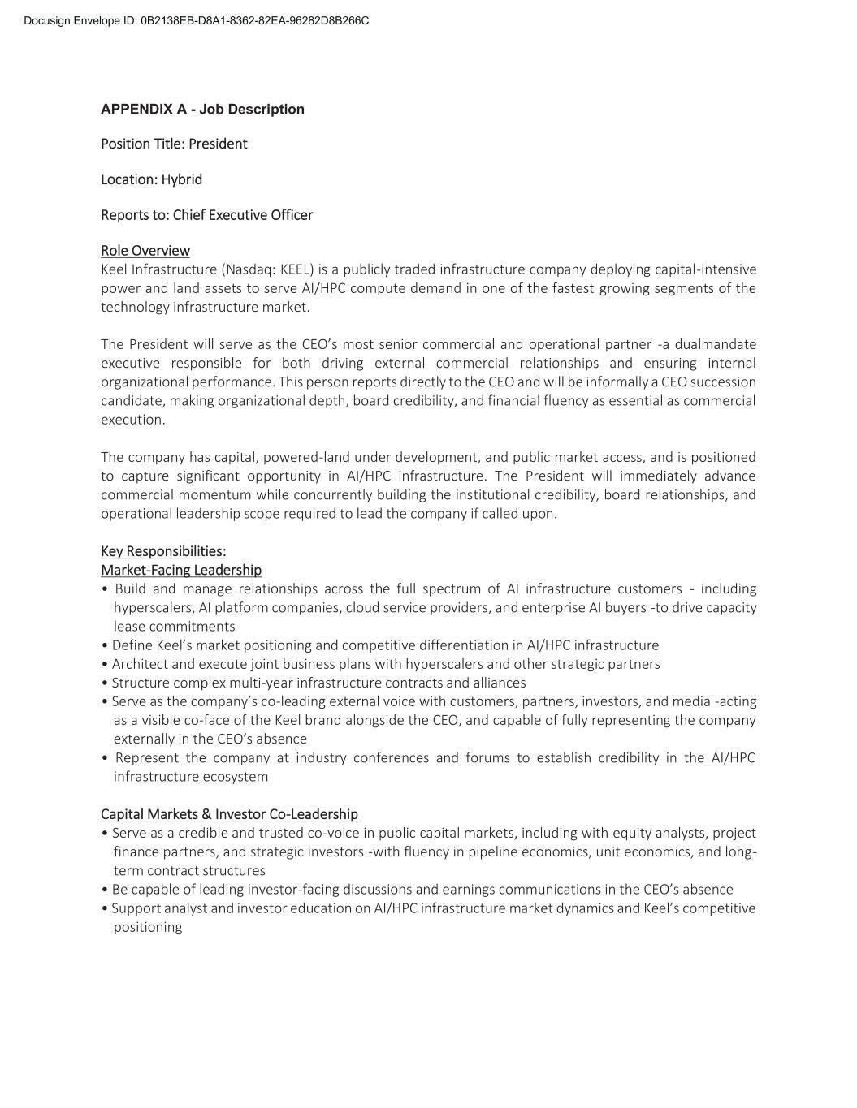
APPENDIX A - Job Description Position Title: President Location: Hybrid Reports to: Chief Executive Officer Role Overview Keel Infrastructure (Nasdaq: KEEL) is a publicly traded infrastructure company deploying capital-intensive power and land assets to serve AI/HPC compute demand in one of the fastest growing segments of the technology infrastructure market. The President will serve as the CEO’s most senior commercial and operational partner -a dualmandate executive responsible for both driving external commercial relationships and ensuring internal organizational performance. This person reports directly to the CEO and will be informally a CEO succession candidate, making organizational depth, board credibility, and financial fluency as essential as commercial execution. The company has capital, powered-land under development, and public market access, and is positioned to capture significant opportunity in AI/HPC infrastructure. The President will immediately advance commercial momentum while concurrently building the institutional credibility, board relationships, and operational leadership scope required to lead the company if called upon. Key Responsibilities: Market-Facing Leadership • Build and manage relationships across the full spectrum of AI infrastructure customers - including hyperscalers, AI platform companies, cloud service providers, and enterprise AI buyers -to drive capacity lease commitments • Define Keel’s market positioning and competitive differentiation in AI/HPC infrastructure • Architect and execute joint business plans with hyperscalers and other strategic partners • Structure complex multi-year infrastructure contracts and alliances • Serve as the company’s co-leading external voice with customers, partners, investors, and media -acting as a visible co-face of the Keel brand alongside the CEO, and capable of fully representing the company externally in the CEO’s absence • Represent the company at industry conferences and forums to establish credibility in the AI/HPC infrastructure ecosystem Capital Markets & Investor Co-Leadership • Serve as a credible and trusted co-voice in public capital markets, including with equity analysts, project finance partners, and strategic investors -with fluency in pipeline economics, unit economics, and long- term contract structures • Be capable of leading investor-facing discussions and earnings communications in the CEO’s absence • Support analyst and investor education on AI/HPC infrastructure market dynamics and Keel’s competitive positioning

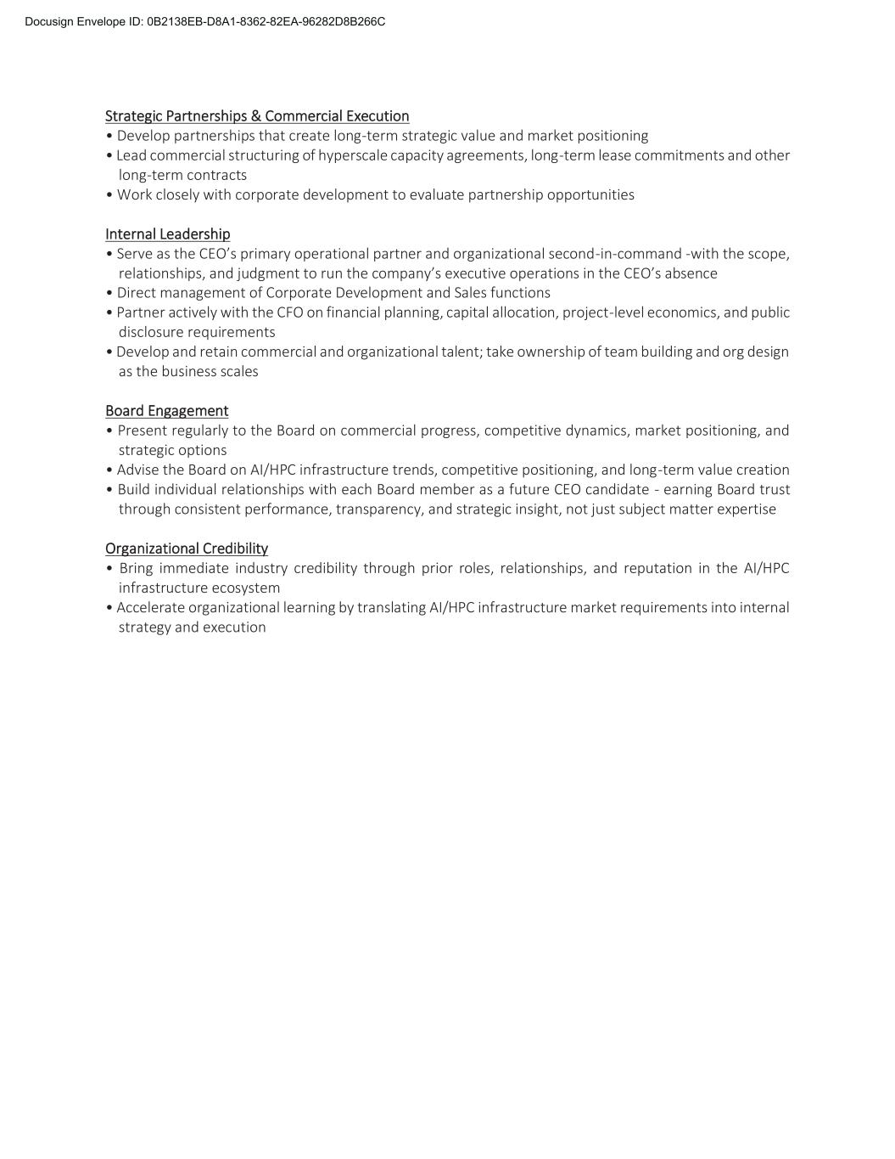
Strategic Partnerships & Commercial Execution • Develop partnerships that create long-term strategic value and market positioning • Lead commercial structuring of hyperscale capacity agreements, long-term lease commitments and other long-term contracts • Work closely with corporate development to evaluate partnership opportunities Internal Leadership • Serve as the CEO’s primary operational partner and organizational second-in-command -with the scope, relationships, and judgment to run the company’s executive operations in the CEO’s absence • Direct management of Corporate Development and Sales functions • Partner actively with the CFO on financial planning, capital allocation, project-level economics, and public disclosure requirements • Develop and retain commercial and organizational talent; take ownership of team building and org design as the business scales Board Engagement • Present regularly to the Board on commercial progress, competitive dynamics, market positioning, and strategic options • Advise the Board on AI/HPC infrastructure trends, competitive positioning, and long-term value creation • Build individual relationships with each Board member as a future CEO candidate - earning Board trust through consistent performance, transparency, and strategic insight, not just subject matter expertise Organizational Credibility • Bring immediate industry credibility through prior roles, relationships, and reputation in the AI/HPC infrastructure ecosystem • Accelerate organizational learning by translating AI/HPC infrastructure market requirements into internal strategy and execution

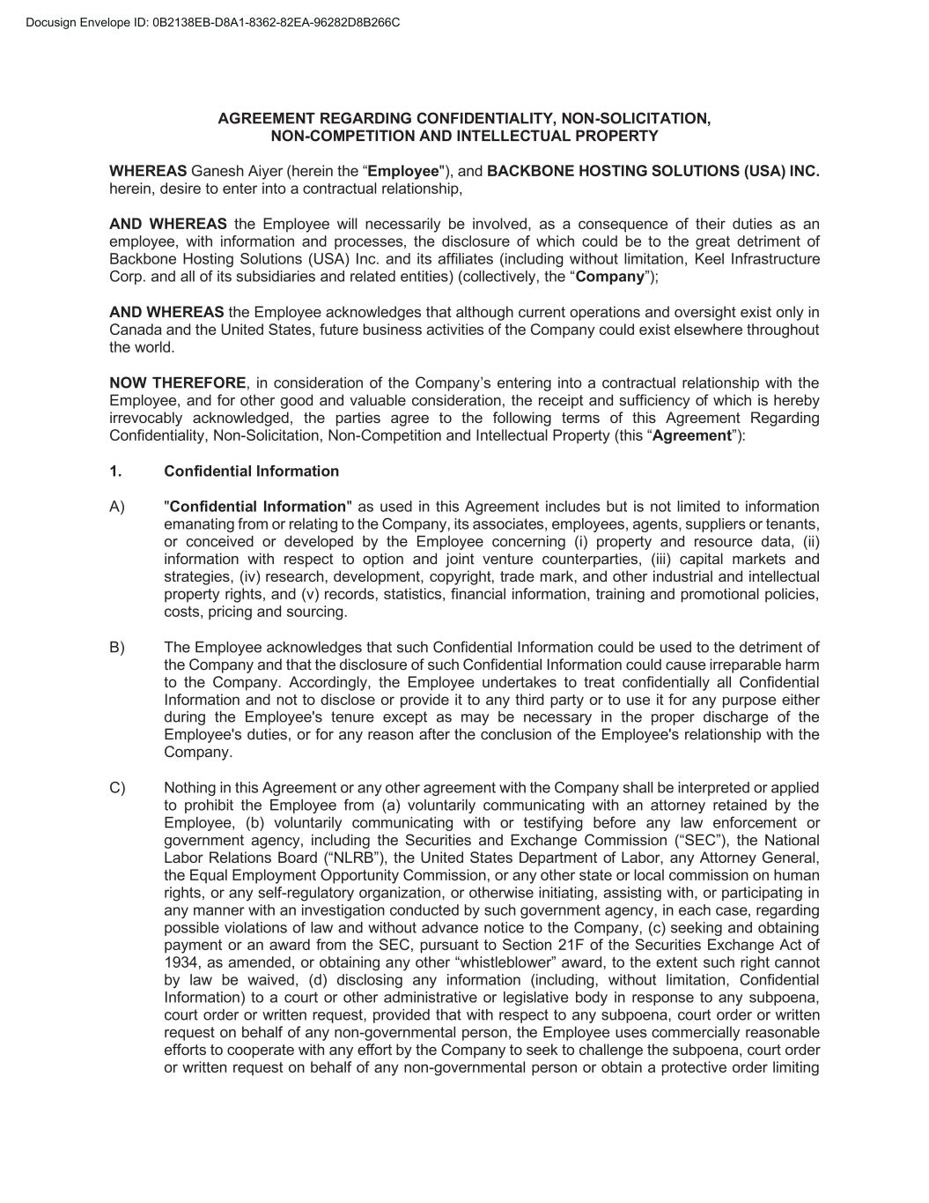
AGREEMENT REGARDING CONFIDENTIALITY, NON-SOLICITATION, NON-COMPETITION AND INTELLECTUAL PROPERTY WHEREAS Ganesh Aiyer (herein the “Employee"), and BACKBONE HOSTING SOLUTIONS (USA) INC. herein, desire to enter into a contractual relationship, AND WHEREAS the Employee will necessarily be involved, as a consequence of their duties as an employee, with information and processes, the disclosure of which could be to the great detriment of Backbone Hosting Solutions (USA) Inc. and its affiliates (including without limitation, Keel Infrastructure Corp. and all of its subsidiaries and related entities) (collectively, the “Company”); AND WHEREAS the Employee acknowledges that although current operations and oversight exist only in Canada and the United States, future business activities of the Company could exist elsewhere throughout the world. NOW THEREFORE, in consideration of the Company’s entering into a contractual relationship with the Employee, and for other good and valuable consideration, the receipt and sufficiency of which is hereby irrevocably acknowledged, the parties agree to the following terms of this Agreement Regarding Confidentiality, Non-Solicitation, Non-Competition and Intellectual Property (this “Agreement”): 1. Confidential Information A) "Confidential Information" as used in this Agreement includes but is not limited to information emanating from or relating to the Company, its associates, employees, agents, suppliers or tenants, or conceived or developed by the Employee concerning (i) property and resource data, (ii) information with respect to option and joint venture counterparties, (iii) capital markets and strategies, (iv) research, development, copyright, trade mark, and other industrial and intellectual property rights, and (v) records, statistics, financial information, training and promotional policies, costs, pricing and sourcing. B) The Employee acknowledges that such Confidential Information could be used to the detriment of the Company and that the disclosure of such Confidential Information could cause irreparable harm to the Company. Accordingly, the Employee undertakes to treat confidentially all Confidential Information and not to disclose or provide it to any third party or to use it for any purpose either during the Employee's tenure except as may be necessary in the proper discharge of the Employee's duties, or for any reason after the conclusion of the Employee's relationship with the Company. C) Nothing in this Agreement or any other agreement with the Company shall be interpreted or applied to prohibit the Employee from (a) voluntarily communicating with an attorney retained by the Employee, (b) voluntarily communicating with or testifying before any law enforcement or government agency, including the Securities and Exchange Commission (“SEC”), the National Labor Relations Board (“NLRB”), the United States Department of Labor, any Attorney General, the Equal Employment Opportunity Commission, or any other state or local commission on human rights, or any self-regulatory organization, or otherwise initiating, assisting with, or participating in any manner with an investigation conducted by such government agency, in each case, regarding possible violations of law and without advance notice to the Company, (c) seeking and obtaining payment or an award from the SEC, pursuant to Section 21F of the Securities Exchange Act of 1934, as amended, or obtaining any other “whistleblower” award, to the extent such right cannot by law be waived, (d) disclosing any information (including, without limitation, Confidential Information) to a court or other administrative or legislative body in response to any subpoena, court order or written request, provided that with respect to any subpoena, court order or written request on behalf of any non-governmental person, the Employee uses commercially reasonable efforts to cooperate with any effort by the Company to seek to challenge the subpoena, court order or written request on behalf of any non-governmental person or obtain a protective order limiting

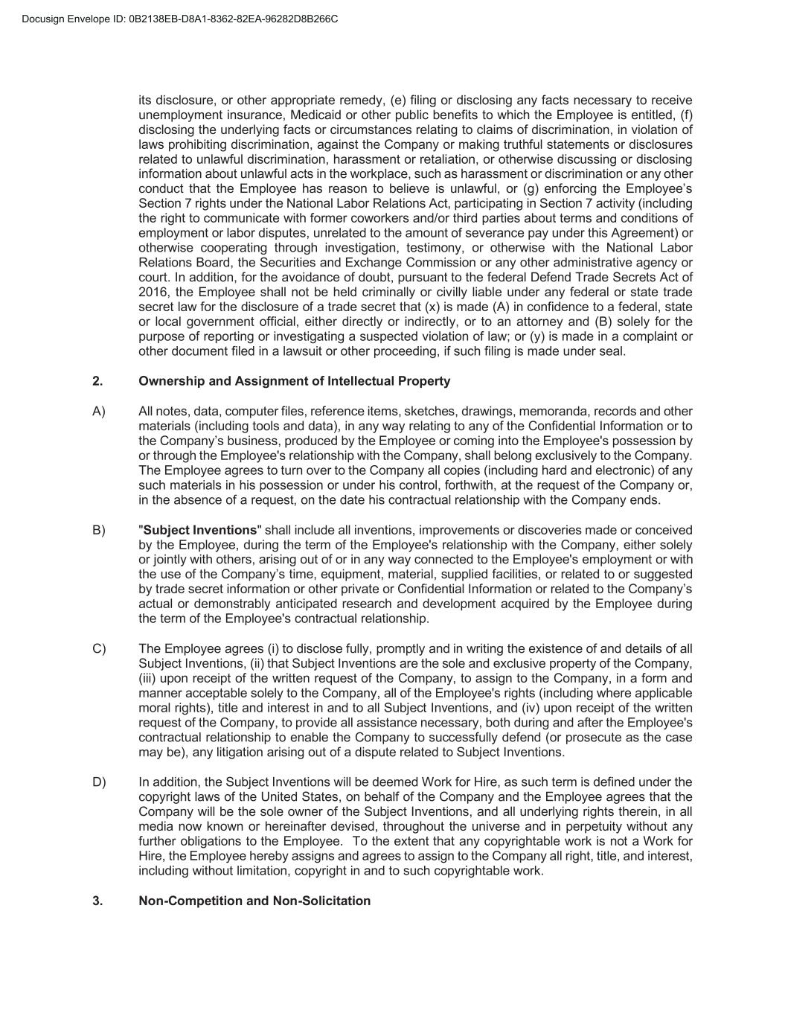
its disclosure, or other appropriate remedy, (e) filing or disclosing any facts necessary to receive unemployment insurance, Medicaid or other public benefits to which the Employee is entitled, (f) disclosing the underlying facts or circumstances relating to claims of discrimination, in violation of laws prohibiting discrimination, against the Company or making truthful statements or disclosures related to unlawful discrimination, harassment or retaliation, or otherwise discussing or disclosing information about unlawful acts in the workplace, such as harassment or discrimination or any other conduct that the Employee has reason to believe is unlawful, or (g) enforcing the Employee’s Section 7 rights under the National Labor Relations Act, participating in Section 7 activity (including the right to communicate with former coworkers and/or third parties about terms and conditions of employment or labor disputes, unrelated to the amount of severance pay under this Agreement) or otherwise cooperating through investigation, testimony, or otherwise with the National Labor Relations Board, the Securities and Exchange Commission or any other administrative agency or court. In addition, for the avoidance of doubt, pursuant to the federal Defend Trade Secrets Act of 2016, the Employee shall not be held criminally or civilly liable under any federal or state trade secret law for the disclosure of a trade secret that (x) is made (A) in confidence to a federal, state or local government official, either directly or indirectly, or to an attorney and (B) solely for the purpose of reporting or investigating a suspected violation of law; or (y) is made in a complaint or other document filed in a lawsuit or other proceeding, if such filing is made under seal. 2. Ownership and Assignment of Intellectual Property A) All notes, data, computer files, reference items, sketches, drawings, memoranda, records and other materials (including tools and data), in any way relating to any of the Confidential Information or to the Company’s business, produced by the Employee or coming into the Employee's possession by or through the Employee's relationship with the Company, shall belong exclusively to the Company. The Employee agrees to turn over to the Company all copies (including hard and electronic) of any such materials in his possession or under his control, forthwith, at the request of the Company or, in the absence of a request, on the date his contractual relationship with the Company ends. B) "Subject Inventions" shall include all inventions, improvements or discoveries made or conceived by the Employee, during the term of the Employee's relationship with the Company, either solely or jointly with others, arising out of or in any way connected to the Employee's employment or with the use of the Company’s time, equipment, material, supplied facilities, or related to or suggested by trade secret information or other private or Confidential Information or related to the Company’s actual or demonstrably anticipated research and development acquired by the Employee during the term of the Employee's contractual relationship. C) The Employee agrees (i) to disclose fully, promptly and in writing the existence of and details of all Subject Inventions, (ii) that Subject Inventions are the sole and exclusive property of the Company, (iii) upon receipt of the written request of the Company, to assign to the Company, in a form and manner acceptable solely to the Company, all of the Employee's rights (including where applicable moral rights), title and interest in and to all Subject Inventions, and (iv) upon receipt of the written request of the Company, to provide all assistance necessary, both during and after the Employee's contractual relationship to enable the Company to successfully defend (or prosecute as the case may be), any litigation arising out of a dispute related to Subject Inventions. D) In addition, the Subject Inventions will be deemed Work for Hire, as such term is defined under the copyright laws of the United States, on behalf of the Company and the Employee agrees that the Company will be the sole owner of the Subject Inventions, and all underlying rights therein, in all media now known or hereinafter devised, throughout the universe and in perpetuity without any further obligations to the Employee. To the extent that any copyrightable work is not a Work for Hire, the Employee hereby assigns and agrees to assign to the Company all right, title, and interest, including without limitation, copyright in and to such copyrightable work. 3. Non-Competition and Non-Solicitation

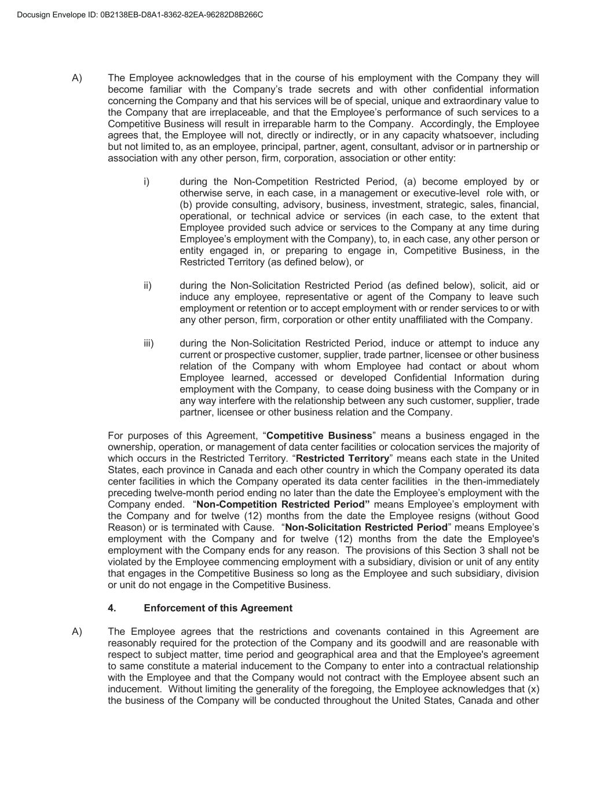
A) The Employee acknowledges that in the course of his employment with the Company they will become familiar with the Company’s trade secrets and with other confidential information concerning the Company and that his services will be of special, unique and extraordinary value to the Company that are irreplaceable, and that the Employee’s performance of such services to a Competitive Business will result in irreparable harm to the Company. Accordingly, the Employee agrees that, the Employee will not, directly or indirectly, or in any capacity whatsoever, including but not limited to, as an employee, principal, partner, agent, consultant, advisor or in partnership or association with any other person, firm, corporation, association or other entity: i) during the Non-Competition Restricted Period, (a) become employed by or otherwise serve, in each case, in a management or executive-level role with, or (b) provide consulting, advisory, business, investment, strategic, sales, financial, operational, or technical advice or services (in each case, to the extent that Employee provided such advice or services to the Company at any time during Employee’s employment with the Company), to, in each case, any other person or entity engaged in, or preparing to engage in, Competitive Business, in the Restricted Territory (as defined below), or ii) during the Non-Solicitation Restricted Period (as defined below), solicit, aid or induce any employee, representative or agent of the Company to leave such employment or retention or to accept employment with or render services to or with any other person, firm, corporation or other entity unaffiliated with the Company. iii) during the Non-Solicitation Restricted Period, induce or attempt to induce any current or prospective customer, supplier, trade partner, licensee or other business relation of the Company with whom Employee had contact or about whom Employee learned, accessed or developed Confidential Information during employment with the Company, to cease doing business with the Company or in any way interfere with the relationship between any such customer, supplier, trade partner, licensee or other business relation and the Company. For purposes of this Agreement, “Competitive Business” means a business engaged in the ownership, operation, or management of data center facilities or colocation services the majority of which occurs in the Restricted Territory. “Restricted Territory” means each state in the United States, each province in Canada and each other country in which the Company operated its data center facilities in which the Company operated its data center facilities in the then-immediately preceding twelve-month period ending no later than the date the Employee’s employment with the Company ended. “Non-Competition Restricted Period” means Employee’s employment with the Company and for twelve (12) months from the date the Employee resigns (without Good Reason) or is terminated with Cause. “Non-Solicitation Restricted Period” means Employee’s employment with the Company and for twelve (12) months from the date the Employee's employment with the Company ends for any reason. The provisions of this Section 3 shall not be violated by the Employee commencing employment with a subsidiary, division or unit of any entity that engages in the Competitive Business so long as the Employee and such subsidiary, division or unit do not engage in the Competitive Business. 4. Enforcement of this Agreement A) The Employee agrees that the restrictions and covenants contained in this Agreement are reasonably required for the protection of the Company and its goodwill and are reasonable with respect to subject matter, time period and geographical area and that the Employee's agreement to same constitute a material inducement to the Company to enter into a contractual relationship with the Employee and that the Company would not contract with the Employee absent such an inducement. Without limiting the generality of the foregoing, the Employee acknowledges that (x) the business of the Company will be conducted throughout the United States, Canada and other

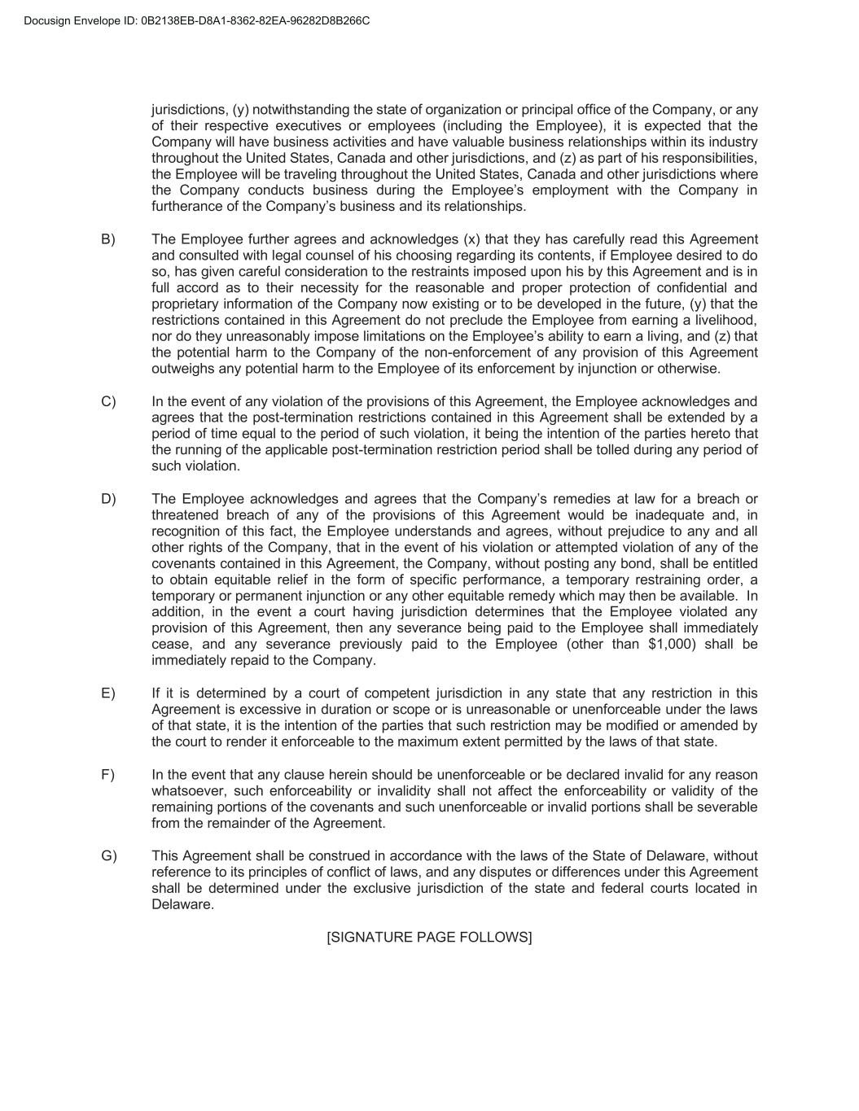
jurisdictions, (y) notwithstanding the state of organization or principal office of the Company, or any of their respective executives or employees (including the Employee), it is expected that the Company will have business activities and have valuable business relationships within its industry throughout the United States, Canada and other jurisdictions, and (z) as part of his responsibilities, the Employee will be traveling throughout the United States, Canada and other jurisdictions where the Company conducts business during the Employee’s employment with the Company in furtherance of the Company’s business and its relationships. B) The Employee further agrees and acknowledges (x) that they has carefully read this Agreement and consulted with legal counsel of his choosing regarding its contents, if Employee desired to do so, has given careful consideration to the restraints imposed upon his by this Agreement and is in full accord as to their necessity for the reasonable and proper protection of confidential and proprietary information of the Company now existing or to be developed in the future, (y) that the restrictions contained in this Agreement do not preclude the Employee from earning a livelihood, nor do they unreasonably impose limitations on the Employee’s ability to earn a living, and (z) that the potential harm to the Company of the non-enforcement of any provision of this Agreement outweighs any potential harm to the Employee of its enforcement by injunction or otherwise. C) In the event of any violation of the provisions of this Agreement, the Employee acknowledges and agrees that the post-termination restrictions contained in this Agreement shall be extended by a period of time equal to the period of such violation, it being the intention of the parties hereto that the running of the applicable post-termination restriction period shall be tolled during any period of such violation. D) The Employee acknowledges and agrees that the Company’s remedies at law for a breach or threatened breach of any of the provisions of this Agreement would be inadequate and, in recognition of this fact, the Employee understands and agrees, without prejudice to any and all other rights of the Company, that in the event of his violation or attempted violation of any of the covenants contained in this Agreement, the Company, without posting any bond, shall be entitled to obtain equitable relief in the form of specific performance, a temporary restraining order, a temporary or permanent injunction or any other equitable remedy which may then be available. In addition, in the event a court having jurisdiction determines that the Employee violated any provision of this Agreement, then any severance being paid to the Employee shall immediately cease, and any severance previously paid to the Employee (other than $1,000) shall be immediately repaid to the Company. E) If it is determined by a court of competent jurisdiction in any state that any restriction in this Agreement is excessive in duration or scope or is unreasonable or unenforceable under the laws of that state, it is the intention of the parties that such restriction may be modified or amended by the court to render it enforceable to the maximum extent permitted by the laws of that state. F) In the event that any clause herein should be unenforceable or be declared invalid for any reason whatsoever, such enforceability or invalidity shall not affect the enforceability or validity of the remaining portions of the covenants and such unenforceable or invalid portions shall be severable from the remainder of the Agreement. G) This Agreement shall be construed in accordance with the laws of the State of Delaware, without reference to its principles of conflict of laws, and any disputes or differences under this Agreement shall be determined under the exclusive jurisdiction of the state and federal courts located in Delaware. [SIGNATURE PAGE FOLLOWS]


THE EMPLOYEE'S SIGNATURE BELOW SIGNIFIES THE EMPLOYEE'S UNDERSTANDING AND IRREVOCABLE AGREEMENT OF THE TERMS SET OUT ABOVE. Date: Employee's Signature:

Exhibit 31.1

CERTIFICATION PURSUANT
TO RULE 13a-14(a) AND RULE 15d-14(a) UNDER THE SECURITIES EXCHANGE ACT OF 1934,
AS ADOPTED PURSUANT TO SECTION 302 OF THE SARBANES-OXLEY ACT OF 2002

I, Benjamin Gagnon, certify that:

1. I have reviewed this Form 10-Q of Keel Infrastructure Corp.;

2. Based on my knowledge, this report does not contain any untrue statement of a material fact or omit to state a material fact necessary to make the statements made, in light of the circumstances under which such statements were made, not misleading with respect to the period covered by this report;

3. Based on my knowledge, the financial statements, and other financial information included in this report, fairly present in all material respects the financial condition, results of operations and cash flows of the registrant as of, and for, the periods presented in this report;

4. The registrant’s other certifying officer and I are responsible for establishing and maintaining disclosure controls and procedures (as defined in Exchange Act Rules 13a-15(e) and 15d-15(e)) and internal control over financial reporting (as defined in Exchange Act Rules 13a-15(f) and 15d-15(f)) for the registrant and have:

(a) Designed such disclosure controls and procedures, or caused such disclosure controls and procedures to be designed under our supervision, to ensure that material information relating to the registrant, including its consolidated subsidiaries, is made known to us by others within those entities, particularly during the period in which this report is being prepared;

(b) Designed such internal control over financial reporting, or caused such internal control over financial reporting to be designed under our supervision, to provide reasonable assurance regarding the reliability of financial reporting and the preparation of financial statements for external purposes in accordance with generally accepted accounting principles;

(c) Evaluated the effectiveness of the registrant’s disclosure controls and procedures and presented in this report our conclusions about the effectiveness of the disclosure controls and procedures, as of the end of the period covered by this report based on such evaluation; and

(d) Disclosed in this report any change in the registrant’s internal control over financial reporting that occurred during the registrant’s most recent fiscal quarter (the registrant’s fourth fiscal quarter in the case of an annual report) that has materially affected, or is reasonably likely to materially affect, the registrant’s internal control over financial reporting; and

5. The registrant’s other certifying officer and I have disclosed, based on our most recent evaluation of internal control over financial reporting, to the registrant’s auditors and the audit committee of the registrant’s board of directors (or persons performing the equivalent functions):

(a) All significant deficiencies and material weaknesses in the design or operation of internal control over financial reporting which are reasonably likely to adversely affect the registrant’s ability to record, process, summarize and report financial information; and

(b) Any fraud, whether or not material, that involves management or other employees who have a significant role in the registrant’s internal control over financial reporting.

Date: August 10, 2026 |  |  | By: |  |  | /s/ Benjamin Gagnon
 |  |  | Name: |  |  | Benjamin Gagnon
 |  |  | Title: |  |  | Chief Executive Officer  (Principal Executive Officer)

Exhibit 31.2

CERTIFICATION PURSUANT
TO RULE 13a-14(a) AND RULE 15d-14(a) UNDER THE SECURITIES EXCHANGE ACT OF 1934,
AS ADOPTED PURSUANT TO SECTION 302 OF THE SARBANES-OXLEY ACT OF 2002

I, Jonathan Mir, certify that:

1. I have reviewed this Form 10-Q of Keel Infrastructure Corp.;

2. Based on my knowledge, this report does not contain any untrue statement of a material fact or omit to state a material fact necessary to make the statements made, in light of the circumstances under which such statements were made, not misleading with respect to the period covered by this report;

3. Based on my knowledge, the financial statements, and other financial information included in this report, fairly present in all material respects the financial condition, results of operations and cash flows of the registrant as of, and for, the periods presented in this report;

4. The registrant’s other certifying officer and I are responsible for establishing and maintaining disclosure controls and procedures (as defined in Exchange Act Rules 13a-15(e) and 15d-15(e)) and internal control over financial reporting (as defined in Exchange Act Rules 13a-15(f) and 15d-15(f)) for the registrant and have:

(a) Designed such disclosure controls and procedures, or caused such disclosure controls and procedures to be designed under our supervision, to ensure that material information relating to the registrant, including its consolidated subsidiaries, is made known to us by others within those entities, particularly during the period in which this report is being prepared;

(b) Designed such internal control over financial reporting, or caused such internal control over financial reporting to be designed under our supervision, to provide reasonable assurance regarding the reliability of financial reporting and the preparation of financial statements for external purposes in accordance with generally accepted accounting principles;

(c) Evaluated the effectiveness of the registrant’s disclosure controls and procedures and presented in this report our conclusions about the effectiveness of the disclosure controls and procedures, as of the end of the period covered by this report based on such evaluation; and

(d) Disclosed in this report any change in the registrant’s internal control over financial reporting that occurred during the registrant’s most recent fiscal quarter (the registrant’s fourth fiscal quarter in the case of an annual report) that has materially affected, or is reasonably likely to materially affect, the registrant’s internal control over financial reporting; and

5. The registrant’s other certifying officer and I have disclosed, based on our most recent evaluation of internal control over financial reporting, to the registrant’s auditors and the audit committee of the registrant’s board of directors (or persons performing the equivalent functions):

(a) All significant deficiencies and material weaknesses in the design or operation of internal control over financial reporting which are reasonably likely to adversely affect the registrant’s ability to record, process, summarize and report financial information; and

(b) Any fraud, whether or not material, that involves management or other employees who have a significant role in the registrant’s internal control over financial reporting.

Date: August 10, 2026 |  |  | By: |  |  | /s/ Jonathan Mir
 |  |  | Name: |  |  | Jonathan Mir
 |  |  | Title: |  |  | Chief Financial Officer  (Principal Financial Officer)

Exhibit 32.1

CERTIFICATION OF PRINCIPAL EXECUTIVE OFFICER PURSUANT TO
18 U.S.C. SECTION 1350, AS ADOPTED PURSUANT TO
SECTION 906 OF THE SARBANES-OXLEY ACT OF 2002

In connection with the Quarterly Report on Form 10-Q of Keel Infrastructure Corp. (the “Company”) for the period ended June 30, 2026 as filed with the Securities and Exchange Commission on the date hereof (the “Report”), I, Benjamin Gagnon, Chief Executive Officer of the Company, hereby certify, pursuant to 18 U.S.C. § 1350, as adopted pursuant to § 906 of the Sarbanes-Oxley Act of 2002, that, to the best of my knowledge:

1.The Report of the Company fully complies with the requirements of Section 13(a) or 15(d) of the Securities Exchange Act of 1934, as amended; and
2.The information contained in the Report fairly presents, in all material respects, the financial condition and results of operations of the Company.

Date: August 10, 2026 |  |  | By: |  |  | /s/ Benjamin Gagnon
 |  |  |  |  |  | Benjamin Gagnon
 |  |  |  |  |  | Chief Executive Officer
 |  |  |  |  |  | (Principal Executive Officer)

Exhibit 32.2

CERTIFICATION OF PRINCIPAL FINANCIAL OFFICER PURSUANT TO
18 U.S.C. SECTION 1350, AS ADOPTED PURSUANT TO
SECTION 906 OF THE SARBANES-OXLEY ACT OF 2002

In connection with the Quarterly Report on Form 10-Q of Keel Infrastructure Corp. (the “Company”) for the period ended June 30, 2026 as filed with the Securities and Exchange Commission on the date hereof (the “Report”), I, Jonathan Mir, Chief Financial Officer of the Company, hereby certify, pursuant to 18 U.S.C. § 1350, as adopted pursuant to § 906 of the Sarbanes-Oxley Act of 2002, that, to the best of my knowledge:

1.The Report of the Company fully complies with the requirements of Section 13(a) or 15(d) of the Securities Exchange Act of 1934, as amended; and

2.The information contained in the Report fairly presents, in all material respects, the financial condition and results of operations of the Company.

Date: August 10, 2026 |  |  | By: |  |  | /s/ Jonathan Mir
 |  |  |  |  |  | Jonathan Mir
 |  |  |  |  |  | Chief Financial Officer
 |  |  |  |  |  | (Principal Financial Officer)

