Filed by Riot Platforms, Inc.
Pursuant to Rule 425 under the Securities Act of 1933
Subject Company: Bitfarms Ltd.
(Commission File No. 001-40370)

On May 28, 2024, Jason Les, Chief Executive Officer of Riot Platforms, Inc., published the following posts on X (formerly known as Twitter) and LinkedIn:
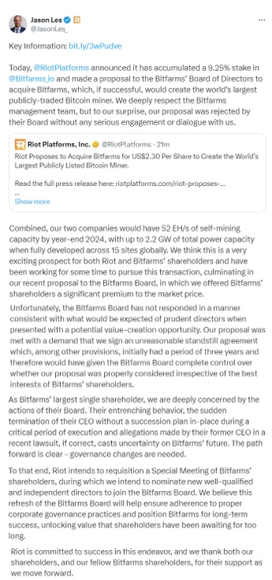

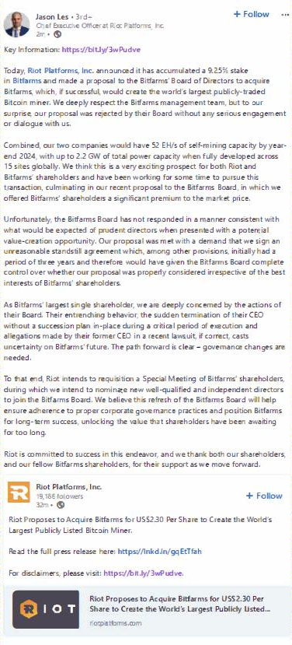

Non-Binding Proposal

Riot cautions Riot shareholders, Bitfarms shareholders and others considering trading in Riot securities or Bitfarms securities that the proposal referred to in this document is non-binding, does not constitute and should not be construed as an offer or intention to make an offer directly to Bitfarms shareholders, and there can be no assurance that any definitive offer will be made by Riot, that Bitfarms will accept any offer made by Riot, that any agreement will be entered into by Riot and Bitfarms or that the proposal or any other transaction will be approved or consummated. Riot does not undertake any obligation to provide any updates with respect to the proposed transaction, except as required by applicable law.

Cautionary Note Regarding Forward Looking Statements

Statements contained herein that are not historical facts constitute “forward-looking statements” and “forward-looking information” (together, “forward-looking statements”) within the meaning of applicable U.S. and Canadian securities laws that reflect management’s current expectations, assumptions, and estimates of future events, performance and economic conditions. Such forward-looking statements rely on the safe harbor provisions of Section 27A of the U.S. Securities Act of 1933 and Section 21E of the U.S. Securities Exchange Act of 1934 and the safe harbor provisions of applicable Canadian securities laws. Because such statements are subject to risks and uncertainties, actual results may differ materially from those expressed or implied by such forward-looking statements. Words and phrases such as “anticipate,” “believe,” “combined company,” “create,” “drive,” “expect,” “forecast,” “future,” “growth,” “intend,” “hope,” “opportunity,” “plan,” “potential,” “proposal,” “synergies,” “unlock,” “upside,” “will,” “would,” and similar words and phrases are intended to identify forward-looking statements. These forward-looking statements may include, but are not limited to, statements concerning: uncertainties as to whether any definitive offer will be made by Riot or Bitfarms will accept any offer made by Riot; whether Bitfarms will enter into discussions with Riot regarding the proposed combination of Riot and Bitfarms; the outcome of any such discussions, including the possibility that the terms of any such combination will be materially different from those described herein; the conditions to the completion of any combination, including the receipt of Bitfarms shareholder approval and the receipt of all required regulatory approvals; the future performance, results of operations, liquidity and financial position of each of Riot, Bitfarms and the company resulting from the combination of Riot and Bitfarms; the possibility that the combined company may be unable to achieve expected synergies and operating efficiencies within the expected timeframes or at all; the integration of Bitfarms’ operations with those of Riot and the possibility that such integration may be more difficult, timeconsuming and costly than expected or that operating costs and business disruption may be greater than expected in connection with the proposed transaction. Such forward-looking statements are not guarantees of future performance or actual results, and readers should not place undue reliance on any forward-looking statement as actual results may differ materially and adversely from forward-looking statements. Detailed information regarding the factors identified by the management of Riot, which they believe may cause actual results to differ materially from those expressed or implied by such forward-looking statements in this document, may be found in Riot’s filings with the U.S. Securities and Exchange Commission (the “SEC”), including the risks, uncertainties and other factors discussed under the sections entitled “Risk Factors” and “Cautionary Note Regarding Forward-Looking Statements” of Riot’s Annual Report on Form 10-K for the fiscal year ended December 31, 2023, filed with the SEC on February 23, 2024, and the other filings Riot has made or will make with the SEC after such date, copies of which may be obtained from the SEC’s website at www.sec.gov. All forward-looking statements contained herein are made only as of the date hereof, and Riot disclaims any intention or obligation to update or revise any such forward-looking statements to reflect events or circumstances that subsequently occur, or of which Riot hereafter becomes aware, except as required by applicable law.

No Offer or Solicitation

This document is for informational purposes only and is not intended to and does not constitute an offer to sell or the solicitation of an offer, or an intention to offer, to subscribe for or buy or an invitation to purchase or subscribe for any securities, nor shall there be any sale, issuance or transfer of securities in any jurisdiction in contravention of applicable law. Such an offer to purchase securities would only be made pursuant to a registration statement, prospectus, tender offer, takeover bid circular, management information circular or other regulatory filing filed by Riot with the SEC and available at www.sec.gov or filed with applicable Canadian securities regulatory authorities on SEDAR+ and available at www.sedarplus.ca. This document is not intended to, and does not, solicit a proxy from any shareholder of Bitfarms. Such a solicitation of proxies would only be made pursuant to a proxy circular filed with applicable Canadian securities regulatory authorities on SEDAR+ and available at www.sedarplus.ca or pursuant to an exemption from the proxy solicitation rules under applicable Canadian securities law.

Important Information for Investors

This communication relates to a proposal that Riot has made for a business combination transaction with Bitfarms. In furtherance of this proposal and subject to future developments, Riot (and, if applicable, Bitfarms) may file one or more registration statements, prospectuses, management information circulars, proxy statements, proxy circulars, tender offers, takeover bid circulars or other documents with the SEC and applicable Canadian securities regulatory authorities. This communication is not a substitute for any registration statement, prospectus, management information circular, proxy statement, proxy circular, tender offer, takeover bid circular or other document (collectively, “Regulatory Filings”) Riot and/or Bitfarms may file with the SEC and/or applicable Canadian securities regulatory authorities in connection with the proposed transaction. INVESTORS AND SECURITY HOLDERS OF RIOT AND BITFARMS ARE URGED TO READ EACH REGULATORY FILING WHEN AND IF FILED BY RIOT AND/OR BITFARMS WITH THE SEC AND/OR APPLICABLE CANADIAN SECURITIES REGULATORY AUTHORITIES CAREFULLY IN THEIR ENTIRETY IF AND WHEN THEY BECOME AVAILABLE AS THEY WILL CONTAIN IMPORTANT INFORMATION ABOUT RIOT, BITFARMS, THE PROPOSED TRANSACTION AND RELATED MATTERS. Any proxy circular, takeover bid circular, management information circular, prospectus or other applicable Regulatory Filing (if and when filed) will be mailed to shareholders of Bitfarms (if and when required to be mailed by applicable law). Investors and security holders will be able to obtain free copies of Regulatory Filings (if and when available) and other documents filed by Riot with the SEC and available at www.sec.gov, and on the “Investor Relations” page of Riot’s corporate website, www.Riotplatforms.com. Investors and security holders will be able to obtain free copies of any documents filed with applicable Canadian securities regulatory authorities by Riot on SEDAR+ at www.sedarplus.ca, and on the “Investor Relations” page of Riot’s corporate website, www.Riotplatforms.com.

This communication is neither a solicitation of a proxy nor a substitute for any proxy statement or other filings that may be made with the SEC or Canadian securities regulatory authorities. Nonetheless, Riot and its directors and executive officers and other members of management and employees may be deemed to be participants in the solicitation of proxies in respect of the proposed transaction. You can find information about Riot’s executive officers and directors in Riot’s Annual Report on Form 10-K for the year ended December 31, 2023. Additional information regarding the interests of such potential participants will be included in one or more Regulatory Filings filed with the SEC and Canadian securities regulatory authorities if and when they become available. These documents (if and when available) may be obtained free of charge from the SEC’s website at www.sec.gov, on SEDAR+ at www.sedarplus.ca and by visiting the “Investor Relations” page of Riot’s corporate website, www.Riotplatforms.com.

