Registration File No. 333-

As filed with the Securities and Exchange Commission on April 22, 2024

UNITED STATES

SECURITIES AND EXCHANGE COMMISSION

Washington, D.C. 20549

FORM S-8
REGISTRATION STATEMENT
UNDER
THE SECURITIES ACT OF 1933
Bitfarms Ltd.
(Exact name of registrant as specified in its charter)
Canada |  |  | N/A
(State or other jurisdiction of |  |  | (I.R.S. Employer
incorporation or organization) |  |  | Identification No.)
110 Yonge Street, Suite 1601
Toronto, Ontario, M5C 1T4
(Address of Principal Executive Offices)
Bitfarms Ltd. Long Term Incentive Plan
(Full title of the plan)
Cogency Global Inc.
122 E. 42nd Street, 18th Floor
New York, New York 10168
(Name and address of agent for service)

(800) 221-0102

(Telephone number, including area code, of agent for service)

Copies to:

Mark D. Wood

Alyse A. Sagalchik

Katten Muchin Rosenman LLP

525 W. Monroe Street

Chicago, IL 60661

(312) 902-5200

Indicate by check mark whether the registrant is a large accelerated filer, an accelerated filer, a non-accelerated filer, a smaller reporting company, or an emerging growth company. See the definitions of “large accelerated filer,” “accelerated filer,” “smaller reporting company,” and “emerging growth company” in Rule 12b-2 of the Exchange Act.

Large accelerated filer | ☐ | Accelerated filer | ☒
Non-accelerated filer | ☐ | Smaller reporting company | ☐
 |  | Emerging growth company | ☒

If an emerging growth company, indicate by check mark if the registrant has elected not to use the extended transition period for complying with any new or revised financial accounting standards provided pursuant to Section 7(a)(2)(B) of the Securities Act. ☐

PART I

INFORMATION REQUIRED IN THE SECTION 10(a) PROSPECTUS

The documents containing the information specified by Part I of Form S-8 (Plan Information and Registrant Information and Employee Annual Information) have been or will be delivered to each participant in the Bitfarms Ltd. Long Term Incentive Plan, effective May 18, 2021, as amended on March 3, 2022 and on January 15, 2024, and amended and restated on April 16, 2024, as specified in Rule 428(b)(1) promulgated by the Securities and Exchange Commission (the “Commission”) under the Securities Act of 1933, as amended (the “Securities Act”), and the instructions to Form S-8. This information has been omitted from this filing in accordance with the provisions of Rule 424 under the Securities Act and the introductory note to Part I of Form S-8. These documents and the documents incorporated by reference in this Registration Statement pursuant to Item 3 of Part II of this Registration Statement, taken together, constitute a prospectus that meets the requirements of Section 10(a) of the Securities Act.

1

PART II

INFORMATION REQUIRED IN THE REGISTRATION STATEMENT

Item 3. Incorporation of Documents by Reference

The following documents filed with the Commission are hereby incorporated by reference in this Registration Statement:

- The Registrant’s Annual Report on Form 40-F for the fiscal year ended December 31, 2023, filed with the Commission on March 7, 2024;

- Material Change Report dated January 2, 2024 (filed as Exhibit 99.1 to the Registrant’s Current Report on Form 6-K filed on January 2, 2024).

- Material Change Report dated January 24, 2024 (filed as Exhibit 99.1 to the Registrant’s Current Report on Form 6-K filed on January 24, 2024).

- Material Change Report dated February 1, 2024 (filed as Exhibit 99.1 to the Registrant’s Current Report on Form 6-K filed on February 1, 2024).

- At The Market Offering Agreement, by and between the Registrant and H.C. Wainwright & Co., LLC dated March 8, 2024 (filed as Exhibit 99.1 to the Registrant’s Current Report on Form 6-K filed on March 11, 2024).

- Material Change Report dated March 8, 2024 (filed as Exhibit 99.2 to the Registrant’s Current Report on Form 6-K filed on March 11, 2024).

- Material Change Report dated March 11, 2024 (filed as Exhibit 99.1 to the Registrant’s Current Report on Form 6-K filed on March 11, 2024).

- The information set forth under the heading “Changes to Executive Team” in the Registrant’s Current Report on Form 6-K filed on March 25, 2024.

- Material Change Report dated April 1, 2024 (filed as Exhibit 99.1 to the Registrant’s Current Report on Form 6-K filed on April 1, 2024).

- Material Change Report dated April 12, 2024 (filed as Exhibit 99.1 to the Registrant’s Current Report on Form 6-K filed on April 12, 2024).

- The description of the Registrant’s Common Shares contained in the Registrant’s Registration Statement on Form 40-F, filed with the Commission on April 28, 2021 and amended on June 16, 2021, and any amendments or reports filed with the Commission for the purpose of updating such description.

II-1

In addition, unless otherwise stated herein, all documents subsequently filed with the Commission by the Registrant pursuant to Sections 13(a), 13(c), 14 or 15(d) of the Exchange Act, including any report furnished on Form 6-K if and only to the extent that such report on Form 6-K provides, prior to the filing of a post-effective amendment to this registration statement which indicates that all securities offered hereby have been sold or which deregisters all securities then remaining unsold, shall be deemed to be incorporated by reference in this registration statement and to be a part hereof from the date of filing of such documents.

Any statement contained in a document incorporated or deemed to be incorporated by reference or deemed to be part of the registration statement shall be deemed to be modified or superseded for purposes of the registration statement to the extent that a statement contained in the registration statement or in any other subsequently filed document that also is, or is deemed to be, incorporated by reference or deemed to be part of the registration statement modifies or replaces such statement. Any such statement so modified or replaced shall not be deemed, except as so modified or replaced, to constitute a part of this Registration Statement.

Item 4. Description of Securities

Not applicable.

Item 5. Interests of Named Experts and Counsel

Not applicable.

Item 6. Indemnification of Directors and Officers

Section 136 of the Business Corporations Act (Ontario) (“OBCA”) provides for the indemnification of directors and officers of the Registrant. Under these provisions, the Registrant may indemnify a director or officer of the Registrant, a former director or officer, and may indemnify an individual who acts or acted at the Registrant’s request as a director or officer or in a similar capacity of another entity (each, an “Indemnified Person”) against all costs, charges and expenses, including an amount paid to settle an action or satisfy a judgment, reasonably incurred by the Indemnified Person in respect of any civil, criminal, administrative, investigative or other proceeding (other than in respect to an action by or on behalf of the Registrant to procure a judgment in its favor) in which the individual is involved because of that association with the Registrant or other entity, if the Indemnified Person fulfills the following two conditions: (a) he or she acted honestly and in good faith with a view to the best interests of the Registrant or in the best interests of such other entity as applicable and (b) in the case of a criminal or administrative action or proceeding that is enforced by a monetary penalty, he or she had reasonable grounds for believing that his or her conduct was lawful. In respect of an action by or on behalf of the Registrant or such other entity to procure a judgment in its favor, the Registrant, with the approval of a court, may indemnify an Indemnified Person against all costs, charges and expenses reasonably incurred by him or her in connection with such action if he or she fulfills the conditions set out in clauses (a) and (b) of the previous sentence. Notwithstanding the foregoing, an Indemnified Person is entitled to indemnification from the Registrant in respect of all costs, charges and expenses reasonably incurred by him or her in connection with the defense of any civil, criminal, administrative, investigative or other proceeding to which he or she is made a party by reason of his or her association with the Registrant or such other entity if he or she fulfills the conditions in clauses (a) and (b) of this paragraph and was not judged by the court or other competent authority to have committed any fault or omitted to do anything that the individual ought to have done.

II-2

A policy of directors’ and officers’ liability insurance is maintained by the Registrant that insures directors and officers against losses incurred as a result of claims against the directors and officers of the Registrant pursuant to the indemnity provisions under the Registrant’s articles and the OBCA.

Insofar as indemnification for liabilities arising under the Securities Act may be permitted to directors, officers or persons controlling the Registrant pursuant to the foregoing provisions, the Registrant has been informed that in the opinion of the Commission such indemnification is against public policy as expressed in the Securities Act and is therefore unenforceable.

Item 7. Exemption From Registration Claimed

Not applicable.

Item 8. | Exhibits
Exhibit No. |  |  | Description
4.1 |  |  | Articles of Bitfarms Ltd.
4.2 |  |  | Bylaws of Bitfarms Ltd.
4.3 |  |  | Bitfarms Ltd. Long Term Incentive Plan
5.1 |  |  | Opinion of Peterson McVicar LLP
23.1 |  |  | Consent of PricewaterhouseCoopers LLP
23.2 |  |  | Consent of Peterson McVicar LLP (included in Exhibit 5.1)
24.1 |  |  | Power of Attorney (included on the signature page of the Registrant to this Registration Statement on Form S-8)

- Filing Fee Table

Item 9. Undertakings

- The undersigned registrant hereby undertakes:

  - To file, during any period in which offers or sales are being made, a post-effective amendment to this registration statement:

    - to include any prospectus required by section 10(a)(3) of the Securities Act;

    - to reflect in the prospectus any facts or events arising after the effective date of the registration statement (or the most recent post-effective amendment thereof) which, individually or in the aggregate, represent a fundamental change in the information set forth in the registration statement. Notwithstanding the foregoing, any increase or decrease in volume of securities offered (if the total dollar value of securities offered would not exceed that which was registered) and any deviation from the low or high end of the estimated maximum offering range may be reflected in the form of a prospectus filed with the Commission pursuant to Rule 424(b) if, in the aggregate, the changes in volume and price represent no more than a 20% change in the maximum aggregate offering price set forth in the "Calculation of Registration Fee" table in the effective registration statement;

II-3

- to include any material information with respect to the plan of distribution not previously disclosed in the registration statement or any material change to such information in the registration statement;

provided, however, that the undertakings set forth in paragraphs (a)(1)(i) and (a)(1)(ii) of this section do not apply if the information required to be included in a post-effective amendment by those paragraphs is contained in reports filed with or furnished to the Commission by the Registrant pursuant to Section 13 or Section 15(d) of the Exchange Act that are incorporated by reference in the registration statement.

  - That, for the purpose of determining any liability under the Securities Act, each such post-effective amendment shall be deemed to be a new registration statement relating to the securities offered therein, and the offering of such securities at that time shall be deemed to be the initial bona fide offering thereof.

  - To remove from registration by means of a post-effective amendment any of the securities being registered which remain unsold at the termination of the offering.

- The undersigned registrant hereby undertakes that, for purposes of determining any liability under the Securities Act, each filing of the registrant's annual report pursuant to Section 13(a) or Section 15(d) of the Exchange Act (and, where applicable, each filing of an employee benefit plan's annual report pursuant to Section 15(d) of the Exchange Act) that is incorporated by reference in the registration statement shall be deemed to be a new registration statement relating to the securities offered therein, and the offering of such securities at that time shall be deemed to be the initial bona fide offering thereof.

- Insofar as indemnification for liabilities arising under the Securities Act may be permitted to directors, officers and controlling persons of the registrant pursuant to the foregoing provisions, or otherwise, the registrant has been advised that in the opinion of the Commission such indemnification is against public policy as expressed in the Securities Act and is, therefore, unenforceable. In the event that a claim for indemnification against such liabilities (other than the payment by the registrant of expenses incurred or paid by a director, officer or controlling person of the registrant in the successful defense of any action, suit or proceeding) is asserted by such director, officer or controlling person in connection with the securities being registered, the registrant will, unless in the opinion of its counsel the matter has been settled by controlling precedent, submit to a court of appropriate jurisdiction the question whether such indemnification by it is against public policy as expressed in the Securities Act and will be governed by the final adjudication of such issue.

II-4

SIGNATURES

Pursuant to the requirements of the Securities Act of 1933, the Registrant certifies that it has reasonable grounds to believe that it meets all of the requirements for filing on Form S-8 and has duly caused this Registration Statement to be signed on its behalf by the undersigned, thereunto duly authorized, in the city of Toronto, Province of Ontario, Canada, on April 22, 2024.
BITFARMS LTD.
By: /s/ L. Geoffrey Morphy
Name: L. Geoffrey Morphy
Title: President and Chief Executive Officer
POWER OF ATTORNEY

- KNOW ALL MEN BY THESE PRESENTS, that each person whose signature appears below constitutes and appoints Jeffrey Lucas and Patricia Osorio, or either of them, his or her true and lawful attorneys-in-fact and agents, each of whom may act alone, with full power of substitution and resubstitution, for him or her and in his or her name, place and stead, in any and all capacities, to sign any or all amendments to this Registration Statement, including post-effective amendments, and any and all additional registration statements (including amendments and post-effective amendments thereto) in connection with any increase in the amount of securities registered with the Commission, and to file the same, with all exhibits thereto, and other documents and in connection therewith, with the Commission, granting unto said attorneys-in-fact and agents, and each of them full power and authority to do and perform each and every act and thing requisite and necessary to be done in and about the premises, as fully to all intents and purposes as he or she might or could do in person, and hereby ratifies and confirms all his or her said attorneys-in-fact and agents or any of them or his substitute or substitutes may lawfully do or cause to be done by virtue hereof. This Power of Attorney may be executed in multiple counterparts, each of which shall be deemed an original, but which taken together shall constitute one instrument.

Pursuant to the requirements of the Securities Act of 1933, this Registration Statement has been signed by or on behalf of the following persons in the capacities indicated and on the dates indicated.

Signature |  | Title |  | Date
/s/ L. Geoffrey Morphy | Chief Executive Officer (Principal Executive |  |  | April 22, 2024
L. Geoffrey Morphy | Officer), President and Director
/s/ Jeffrey P. Lucas | Chief Financial Officer (Principal Financial |  |  | April 22, 2024
Jeffrey P. Lucas | Officer and Principal Accounting Officer)
/s/ Emiliano Joel Grodzki | Director and Founder |  |  | April 22, 2024
Emiliano Joel Grodzki
/s/ Nicolas Bonta | Chairman of the Board and Founder |  |  | April 22, 2024
Nicolas Bonta
/s/ Brian Howlett | Lead Director |  |  | April 22, 2024
Brian Howlett
/s/ Andrés Finkielsztain | Director |  |  | April 22, 2024
Andrés Finkielsztain
/s/ Edith M. Hofmeister | Director |  |  | April 22, 2024
Edith M. Hofmeister
 |  | II-5

AUTHORIZED REPRESENTATIVE

Pursuant to the requirements of Section 6(a) of the Securities Act of 1933, the undersigned has signed this Registration Statement, in the capacity of the duly authorized representative of the Registrant in the United States, on April 22, 2024.

Cogency Global Inc.
as authorized representative for Bitfarms Ltd.
By: /s/ Colleen A. De Vries
Name: Colleen A. De Vries
Title: Sr. Vice President on behalf of Cogency Global
Inc.

II-6

Exhibit 4.1
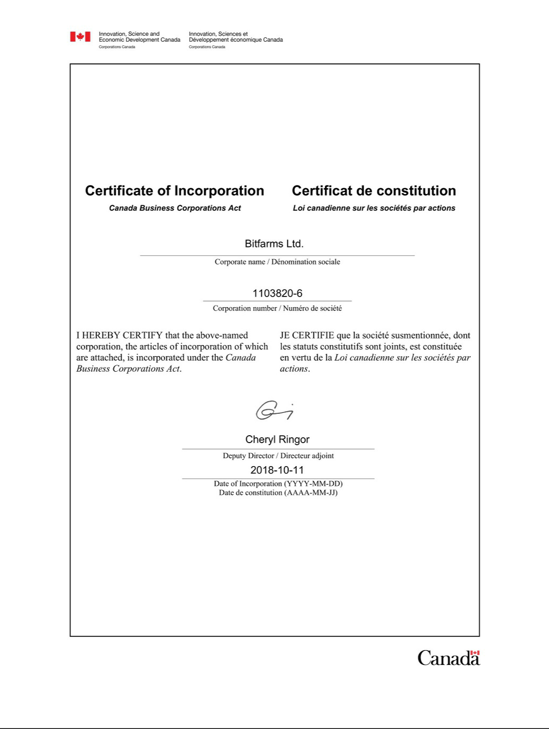

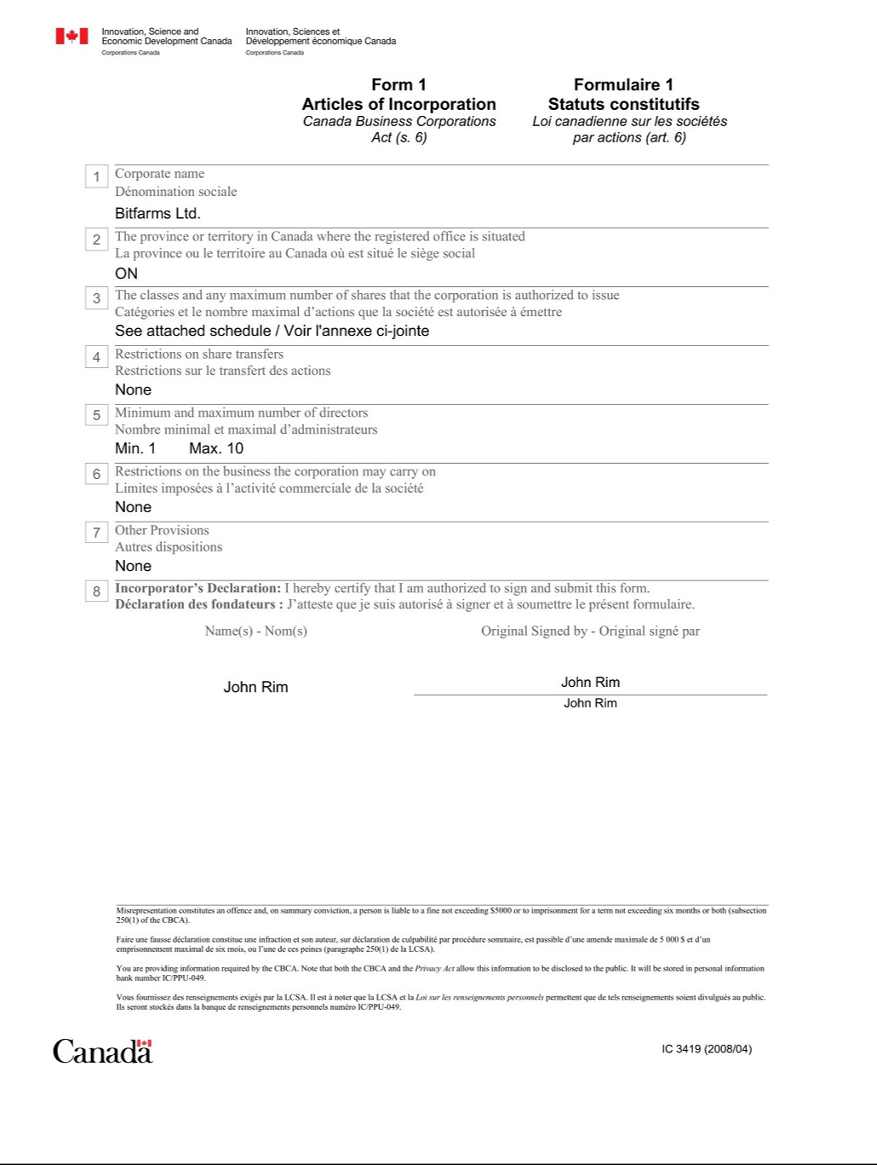

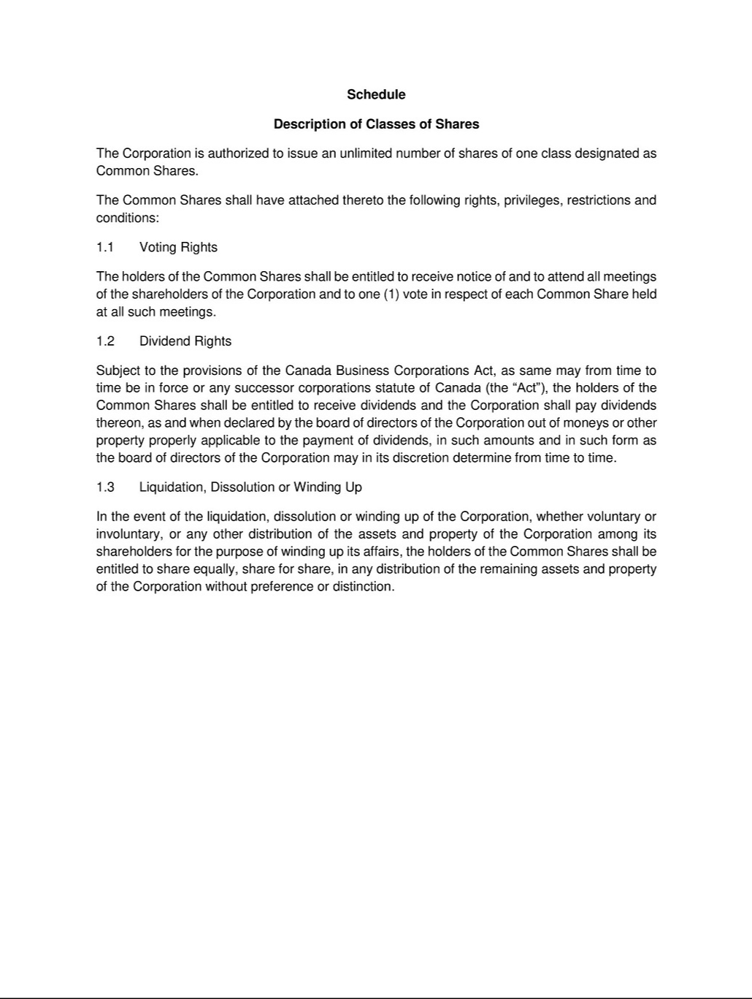

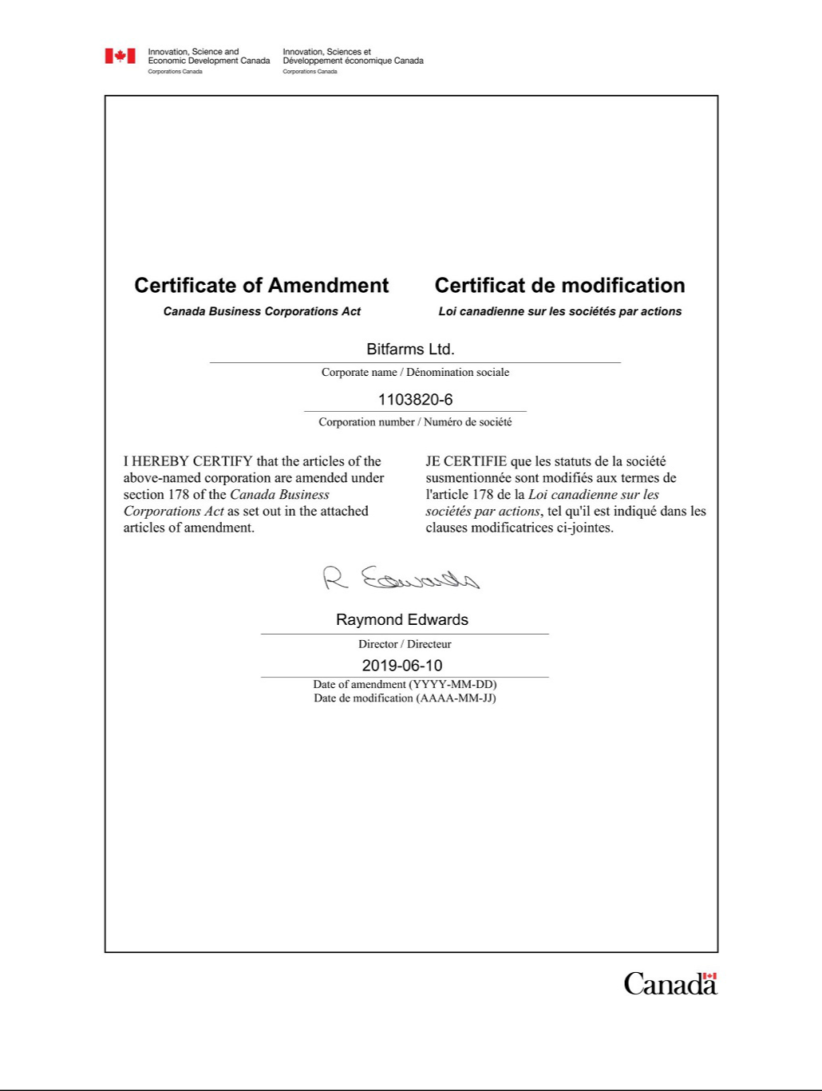



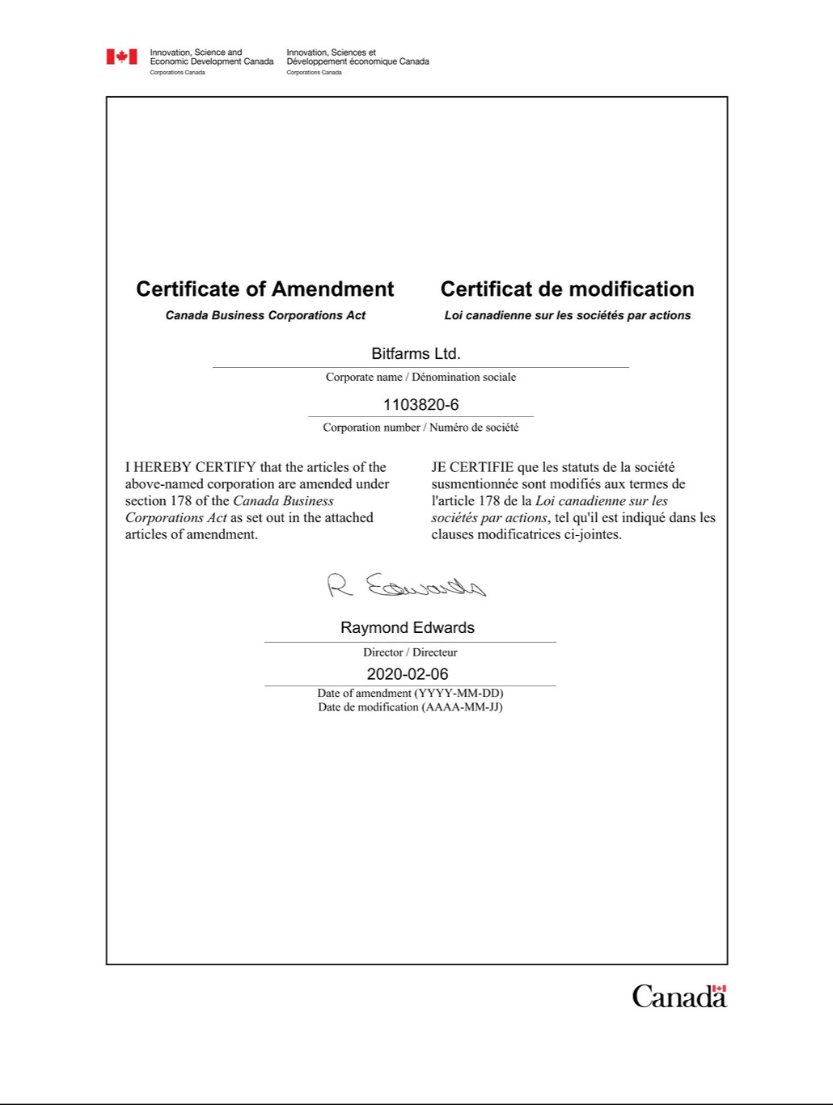

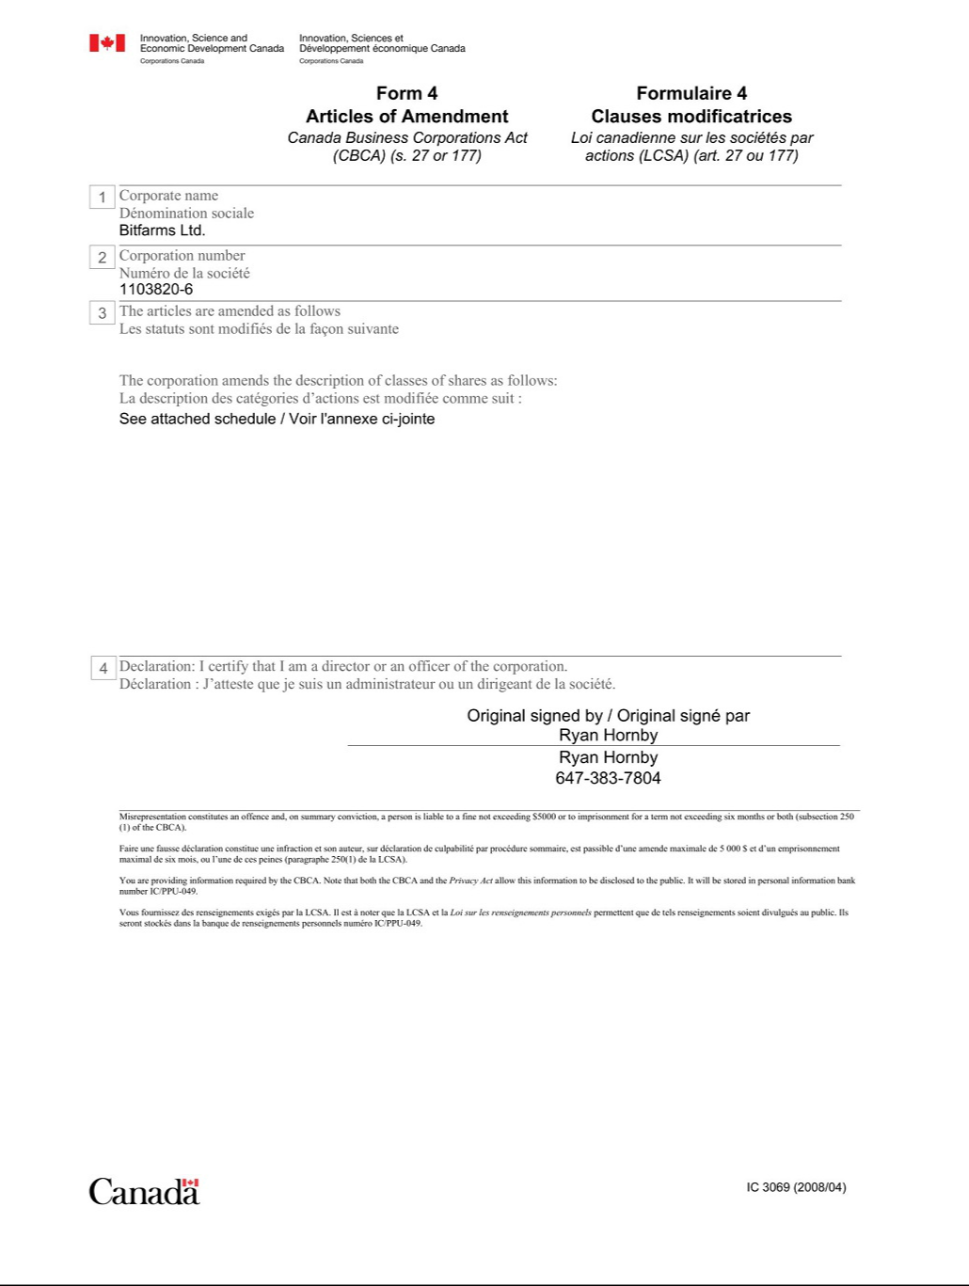

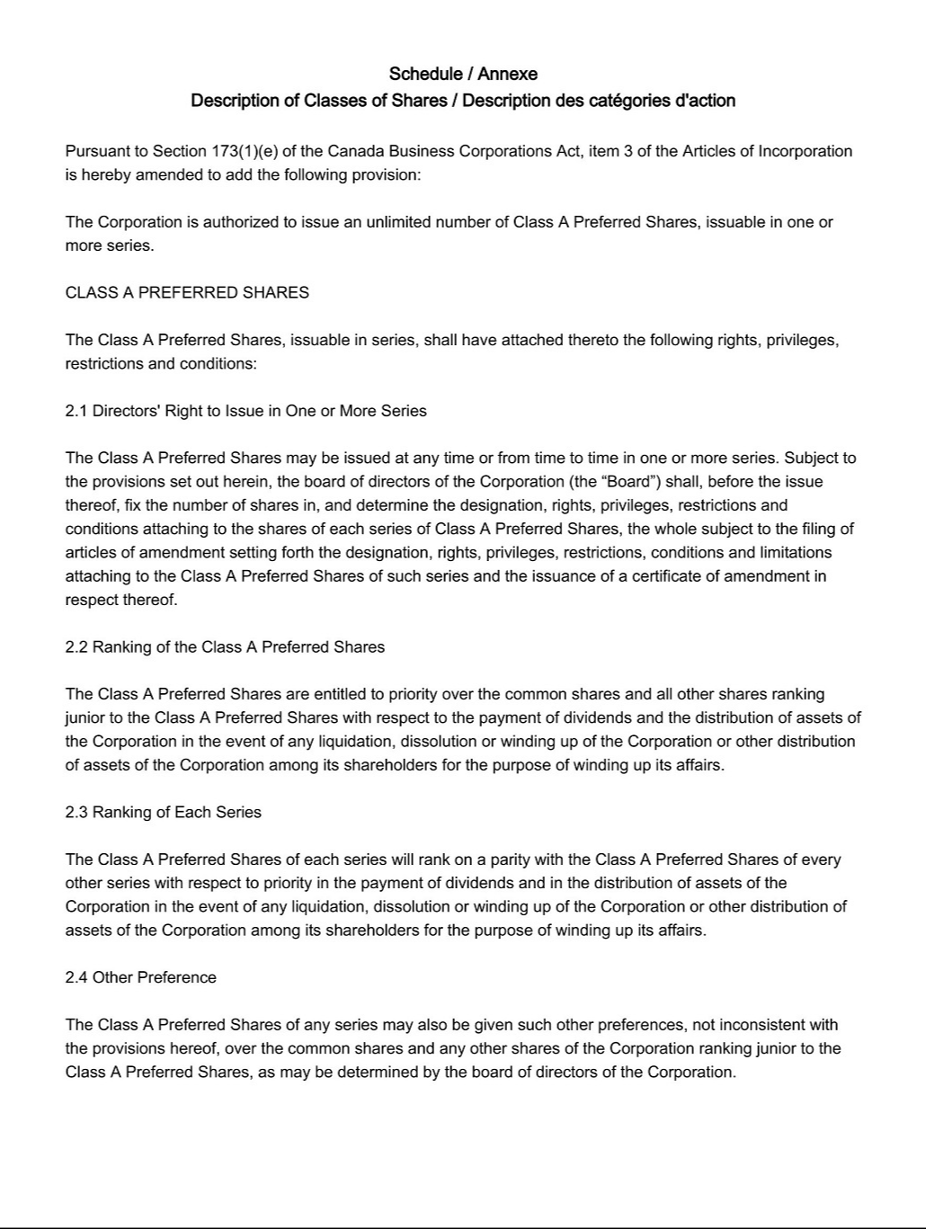

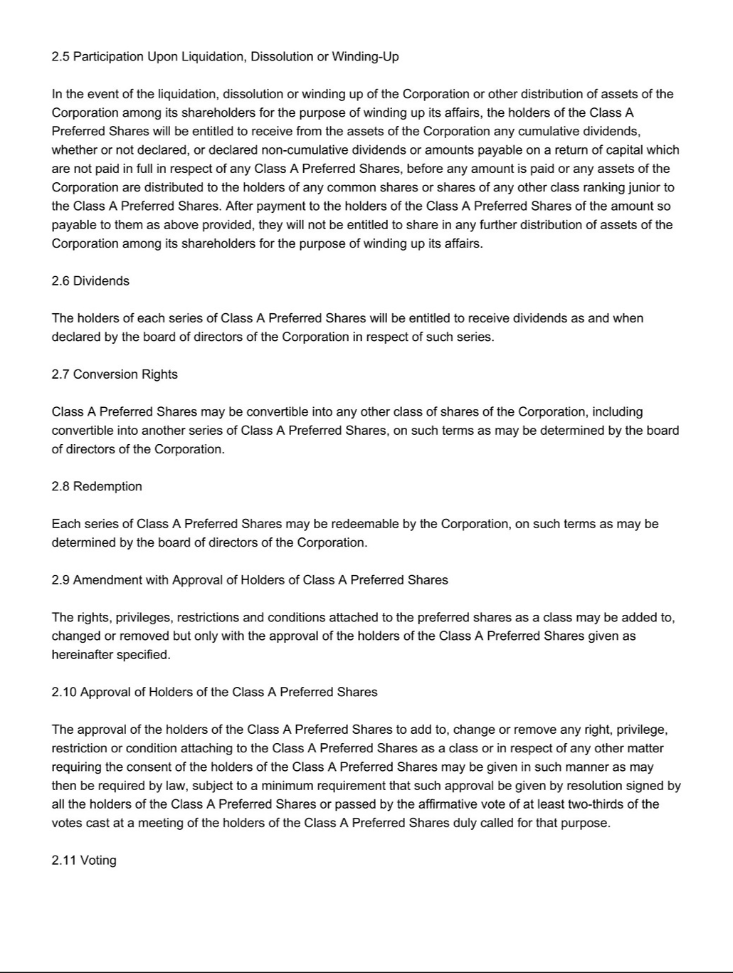



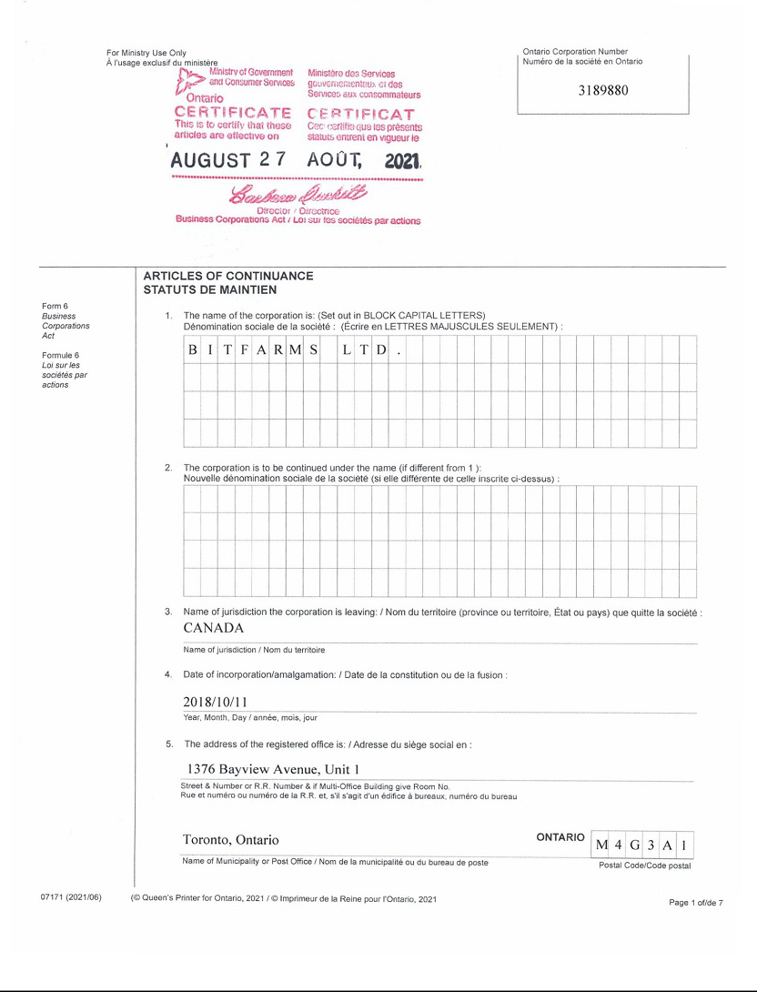

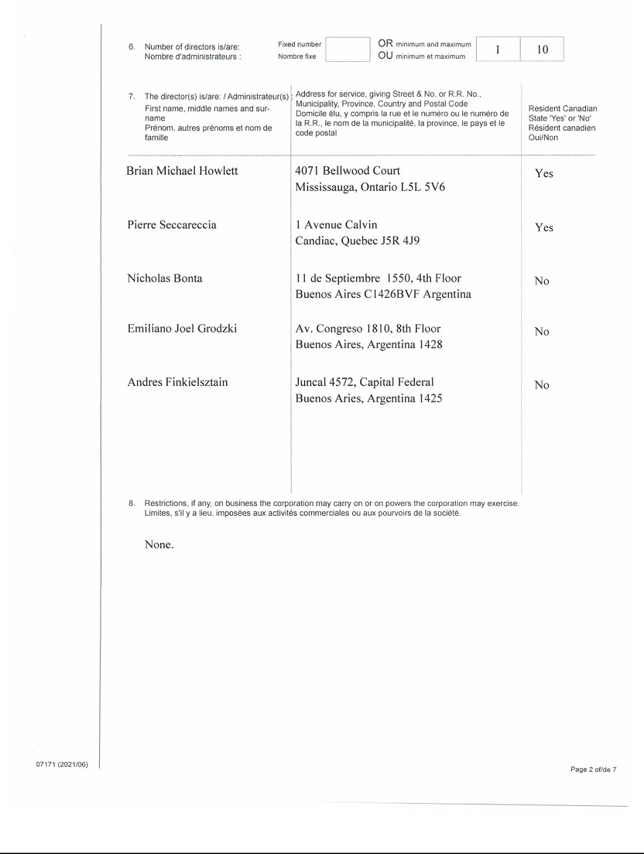







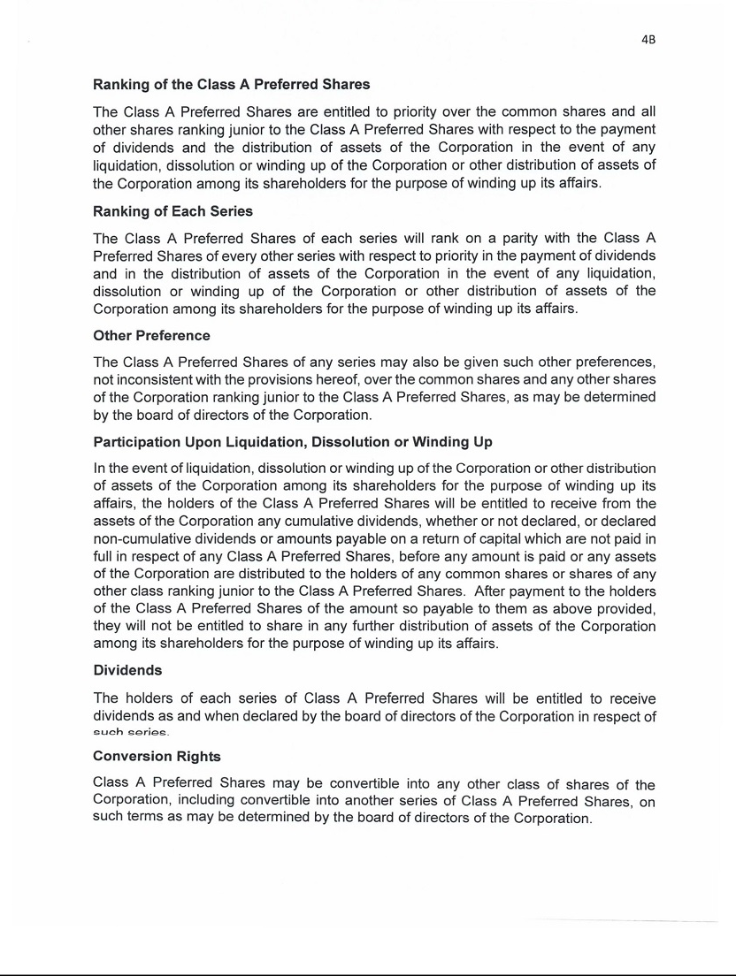

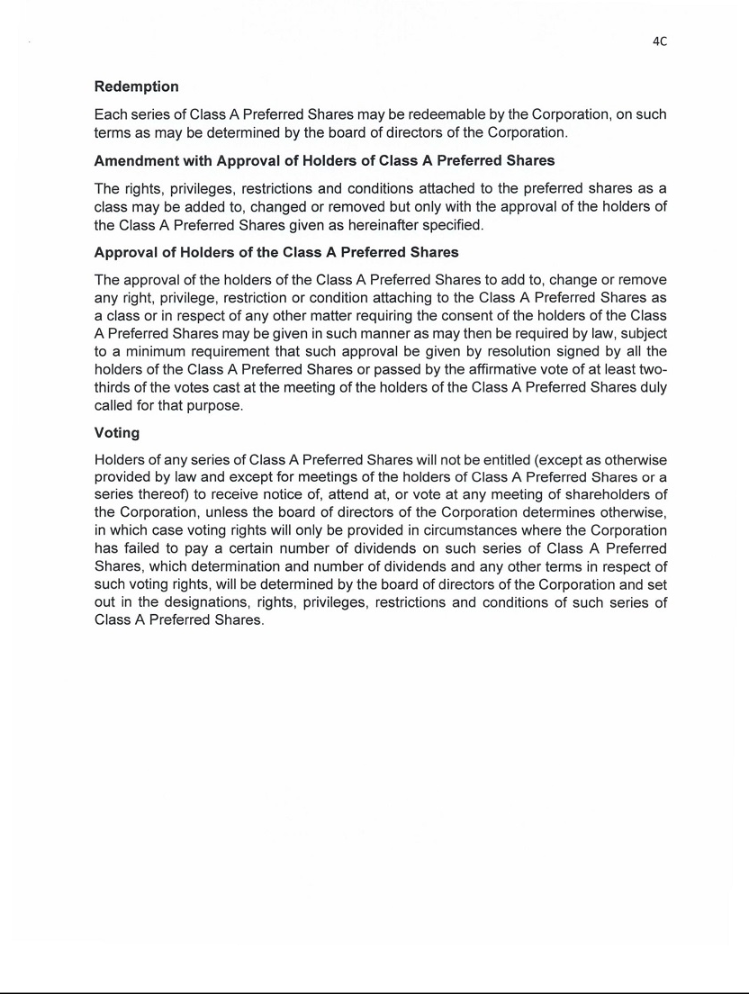





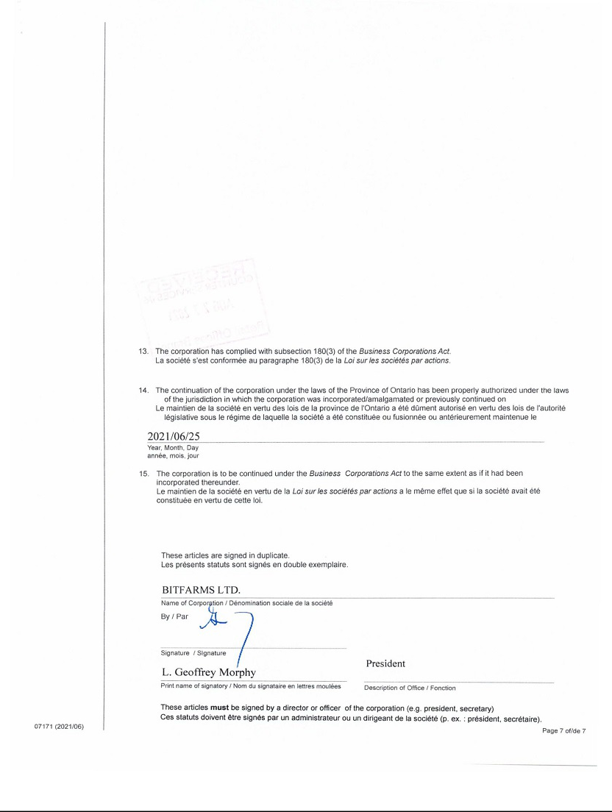

Exhibit 4.2

BY-LAW NO. 1

A by-law relating generally to the conduct of the business and affairs of

BITFARMS LTD.

(the “Corporation”)

C O N T E N T S

1. - Interpretation

- -General Business Matters

- -Meetings of Directors

- -Protection of Directors, Officers and Others

- -Meetings of Shareholders
8. | - | Shares
9. | - | Dividends
10. | - | Notices
- -Effective Date

BE IT ENACTED as a by-law of Bitfarms Ltd. as follows:

- INTERPRETATION

1.1 Definitions - In this by-law and all other by-laws and resolutions of the Corporation, unless the context otherwise requires:

“Act” means the Business Corporations Act (Ontario), including the Regulations made pursuant thereto, and any statute or regulations substituted therefor, as amended from time to time;

“appoint” includes “elect”, and vice versa

“articles” means the Articles of Incorporation and/or other constating documents of the Corporation as amended or restated from time to time;

“board” means the board of directors of the Corporation and “director” means a member of the board;

“by-laws” means this by-law and all other by-laws, including special by-laws, of the Corporation as amended from time to time and which are, from time to time, in force and effect;

“Corporation” means this Corporation, being the corporation to which the Articles pertain, and named “Bitfarms Ltd.”;

“meeting of shareholders” includes an annual meeting of shareholders and a special meeting of shareholders; “special meeting of shareholders” means a special meeting of all shareholders entitled to vote at an annual meeting of shareholders and a meeting of any class or classes of shareholders entitled to vote on the question at issue;

“recorded address” means, in the case of a shareholder, his address as recorded in the shareholders’ register; and in the case of joint shareholders, the address appearing in the shareholders’ register in respect of such joint holding or the first address so appearing if there is more than one; in the case of a director, officer, auditor or member of a committee of the board, his latest address as shown in the records of the Corporation or in the most recent notice filed under the Corporations Information Act, whichever is the more current. The secretary may change or cause to be changed the recorded address of any person in accordance with any information believed by him to be reliable.

1.2 Rules - In the interpretation of this by-law, unless the context otherwise requires, the following rules shall apply:

- Except where specifically defined herein, words, terms and expressions appearing in this by-law, including the terms “resident Canadian” and “unanimous shareholder agreement” shall have the meaning ascribed to them under the Act;

- Words importing the singular include the plural and vice versa;

- Words importing gender include the masculine, feminine and neuter genders;

- Words importing a person include an individual, sole proprietorship, partnership, unincorporated association, unincorporated syndicate, unincorporated organization, trust, body corporate, and a natural person in his capacity as trustee, executor, administrator, or other legal representative.

2

- GENERAL BUSINESS MATTERS

2.1 Registered Office - The shareholders may, by special resolution, from time to time change the municipality or geographic township within Ontario in which the registered office of the Corporation shall be located, but unless and until such special resolution has been passed, the registered office shall be where initially specified in the articles. The directors shall from time to time fix the location of the registered office within such municipality or geographic township.

2.2 Corporate Seal - The Corporation may, but need not, have a corporate seal; if adopted, such seal shall be in the form approved from time to time by the board.

2.3 Fiscal Year - Unless and until another date has been effectively determined, the fiscal year or financial year of the Corporation shall end on December 31st in each year.

2.4 Execution of Documents - Deeds, transfers, assignments, contracts, obligations and other instruments in writing requiring execution by the Corporation may be signed by any one officer or director.

Notwithstanding the foregoing, the board may from time to time direct the manner in which and the person or persons by whom a particular document or class of documents shall be executed. Any person authorized to sign any document may affix the corporate seal thereto.

2.5 Banking - All matters pertaining to the banking of the Corporation shall be transacted with such banks, trust companies or other financial organizations as the board may designate or authorize from time to time. All such banking business shall be transacted on behalf of the Corporation pursuant to such agreements, instructions and delegations of powers as may, from time to time, be prescribed by the board.

- DIRECTORS

3.1 Powers - Subject to the express provisions of a unanimous shareholder agreement, the directors shall manage or supervise the management of the business and affairs of the Corporation.

3.2 Transaction of Business - Business may be transacted by resolutions passed at meetings of directors or committees of directors at which a quorum is present or by resolution in writing, signed by all the directors entitled to vote on that resolution at a meeting of directors or a committee of directors. A copy of every such resolution in writing shall be kept with the minutes of the proceedings of the directors or committee of directors.

3.3 Number - Until changed in accordance with the Act, the board shall consist of that number of directors, being a minimum of one (1) and a maximum of ten (10), as determined from time to time by special resolution or, if the special resolution empowers the directors to determine the number, by resolution of the board.

3.4 Qualifications - Each director shall be an individual who is not less than 18 years of age. No person who is of unsound mind and has been so found by a court in Canada or elsewhere or who has the status of a bankrupt shall be a director. If a director acquires the status of a bankrupt or becomes of unsound mind and is so found, he shall thereupon cease to be a director. A director need not be a shareholder.

3

3.5 Election and Term - The election of directors shall take place at the first meeting of shareholders and at each annual meeting of shareholders and all the directors then in office shall retire, but, if qualified, shall be eligible for re-election. The number of directors to be elected at any such meeting shall be the number of directors then in office unless the directors or shareholders shall have otherwise determined in accordance with the Act. Where the shareholders adopt an amendment to the articles to increase the number or minimum number of directors, the shareholders may, at the meeting at which they adopt the amendment, elect the additional number of directors authorized by the amendment. The election shall be by resolution. If an election of directors is not held at the proper time, the incumbent directors shall continue in office until their successors are elected.

3.6 Resignation - A director who is not named in the articles may resign from office upon being giving a written resignation to the Corporation and such resignation becomes effective when received by the Corporation or at the time specified in the resignation, whichever is later. A director named in the articles shall not be permitted to resign his office unless at the time the resignation is to become effective a successor is elected or appointed.

3.7 Removal - Subject to the provisions of the Act, the shareholders may, by ordinary resolution passed at an annual or special meeting of shareholders, remove any director from office before the expiration of his term and may elect a qualified individual to fill the resulting vacancy for the remainder of the term of the director so removed, failing which such vacancy may be filled by the board. Notice of intention to pass such resolution shall be given in the notice calling the meeting.

3.8 Vacation of office - A director ceases to hold office when he dies, resigns, is removed from office by the shareholders, or becomes disqualified to serve as director.

3.9 Vacancies - Subject to the provisions of the Act, a vacancy on the board may be filled for the remainder of its term by a qualified individual by resolution of a quorum of the board. If there is not a quorum of directors or if a vacancy results from the failure to elect the number of directors required to be elected at any meeting of shareholders, the directors then in office shall forthwith call a special meeting of shareholders to fill the vacancy and, if they fail to call a meeting or if there are no directors then in office, the meeting may be called by any shareholder.

- MEETINGS OF DIRECTORS

4.1 Place of Meetings - Meetings of the board may be held at the registered office of the Corporation or at any other place within or outside of Ontario, and it is not necessary that, in any financial year of the Corporation, a majority of such meetings be held in Canada.

4.2 Participation by Telephone - With the unanimous consent of all of the directors present at or participating in the meeting, a director may participate in a meeting of the board or in a meeting of a committee of directors by means of such telephone, electronic or other communication facilities as permit all persons participating in the meeting to communicate with each other simultaneously and instantaneously, and a director participating in such a meeting by such means is deemed for the purposes of the Act and this by-law to be present at that meeting. A consent pursuant to this provision may be given before or after the meeting to which it relates and may be a “blanket” consent, relating to all meetings of the board and/or committees of the board and need not be in writing.

4

4.3 Calling of Meetings - In addition to any other provisions in the articles or by-laws of a Corporation for calling meetings of directors, a quorum of the directors may, at any time, call a meeting of any business, the general nature of which is specified in the notice calling the meeting. Where the Corporation has only one director, that director may constitute a meeting.

4.4 Notice of Meeting - Notice of the time and place for the holding of a meeting of the board shall be given to every director of the Corporation not less than two clear days (excluding Sundays and holidays as defined by the Interpretation Act) before the date of the meeting. Notwithstanding the foregoing, notice of a meeting shall not be necessary if all of the directors are present, and none objects to the holding of the meeting, or if those absent have waived notice of or have otherwise signified their consent to the holding of such meeting. Notice of an adjourned meeting is not required if the time and place of the adjourned meeting is announced at the original meeting.

4.5 First Meeting of New Board - Provided that a quorum of directors is present, a newly elected board may, without notice, hold its first meeting immediately following the meeting of shareholders at which such board is elected.

4.6 Regular Meetings - The board may appoint a day or days in any month or months for regular meetings of the board at a place and hour to be named. A copy of any resolution of the board fixing the place and time of such regular meetings of the board shall be sent to each director forthwith after being passed, but no other notice shall be required for any such regular meeting except where the Act requires the purpose thereof or the business to be transacted thereat to be specified.

4.7 Quorum - A majority of the directors elected to office constitutes a quorum at any meeting of the board.

4.8 Chairman - The Chairman of any meeting of the board shall be the first mentioned of such of the following officers as have been appointed and who is a director and is present at the meeting:

Chairman of the Board

President,

A Vice-President, or

Managing Director

If no such officer is present, the directors present shall choose one of their number to be Chairman of such meeting.

5

4.9 Votes to Govern - At all meetings of the board, every question shall be decided by a majority of the votes cast on the question; and in the case of an equality of votes, the Chairman of the meeting shall not be entitled to a second or casting vote.

4.10 Disclosure- Conflict of Interest - A director or officer of the Corporation who is a party to, or who is a director or an officer of, or has a material interest in any person who is a party to, a material contract or transaction or proposed material contract or transaction with the Corporation, shall disclose in writing to the Corporation or request to have entered in the minutes of meetings of directors the nature and extent of his interest. Disclosure, as aforesaid, shall be made at the time and in the manner required by the Act, and a director so having an interest in a contract or transaction shall, unless expressly permitted by the Act, not vote on any resolution to approve the contract or transaction.

4.11 Delegation by Directors (Committees) - The board may appoint from their number a managing director, or a committee of directors, and delegate to such managing director or committee any of the powers of the board except those which relate to matters over which a managing director or committee shall, pursuant to the Act, not have authority. Unless otherwise determined by the board, a committee shall have the power to fix its quorum at not less than a majority of its members, to elect its chairman and to regulate its procedure.

4.8 Remuneration and Expenses - Subject to the articles and any unanimous shareholder agreement, the board may fix the remuneration of the directors, which remuneration shall be in addition to any remuneration which may be payable to a director who serves the Corporation in any other capacity. The directors shall also be entitled to be reimbursed for travelling and other expenses properly incurred by them in attending meetings of the board, committees or shareholders and for such other out-of-pocket expenses incurred in respect of the performance of their duties as the board may from time to time determine.

- OFFICERS

5.1 Appointment - The board may from time to time designate the offices of the Corporation, appoint officers (and assistants to officers), specify their duties and, subject to the Act or the provisions of any unanimous shareholder agreement, delegate to such officers powers to manage the business and affairs of the Corporation. A director may be appointed to any office of the Corporation. Except for the chairman of the board and the managing director, an officer may but need not be a director. Two or more offices may be held by the same person.

5.2 Term of Office (Removal) - In the absence of a written agreement to the contrary, the board may remove, whether for cause or without cause, any officer of the Corporation. Unless so removed, an officer shall hold office until his successor is appointed or until his resignation, whichever shall first occur.

6

5.3 Terms of Employment, Duties and Remuneration - The terms of employment and remuneration of all officers elected or appointed by the board shall be determined from time to time and may be varied from time to time by the board. The fact that any officer or employee is a director or shareholder of the Corporation shall not disqualify him from receiving such remuneration as may be determined. All officers, in the absence of agreement to the contrary, shall be subject to removal by resolution of the Board of Directors at any time, with or without cause.

5.4 Description of Offices - Unless otherwise specified by the board (which may, subject to the Act, modify, restrict or supplement such duties and powers), the offices of the Corporation, if designated and if officers are appointed thereto, shall have the following duties and powers associated therewith:

- Chairman of the Board - The chairman of the board, if one is to be appointed, shall be a director. The board may assign to him any of the powers and duties which, pursuant to the by-laws, are capable of being assigned to the managing director or to the president. During the absence or disability of the Chairman of the Board, the President shall assume all his powers and duties.

- Managing Director - The managing director, if one is to be appointed, shall exercise such powers and have such authority as may be delegated to him by the Board in accordance with the provisions of Section 127 of the Act.

- President - The President shall be the chief executive officer of the Corporation unless otherwise determined by resolution of the Board of Directors and shall have responsibility for the general management and direction of the business and affairs of the Corporation, subject to the authority of the Board of Directors. Where no Chairman of the Board is elected or during the absence or inability to act of Chairman of the Board, the President, when present, shall preside at all meetings of shareholders, and if he is a director, at all meetings of the Board of Directors or meetings of a committee of directors;

- Vice-President - During the absence or inability of the President, his duties may be performed and his powers may be exercised by the Vice-President, or if there are more than one, by the Vice-President in order of seniority (as determined by the Board of Directors) save that no Vice-President shall preside at a meeting of the Board of Directors or at a meeting of shareholders who is not qualified to attend the meeting as a director or shareholder, as the case may be. A Vice-President shall also perform such duties and exercise such powers as the President may from time to time delegate to him or as the Board of Directors may prescribe;

- General Manager - The General Manager, if one be appointed, shall have the responsibility for the general management, and direction, subject to the authority of the Board of Directors and the supervision of the President, of the Corporation’s business and affairs and the power to appoint and remove any and all officers, employees and agents of the Corporation not appointed directly by the Board of Directors and to settle the terms of their employment and remuneration.

7

- Secretary - The secretary, when in attendance, shall be the secretary of all meetings of the board, shareholders and committees of the board and, whether or not he attends, the secretary shall enter or cause to be entered in the Corporation’s minute book, minutes of all proceedings at such meetings; he shall give, or cause to be given, as and when instructed, notices to shareholders, directors, auditors and members of committees; he shall be the custodian of the corporate seal as well as all books, papers, records, documents and other instruments belonging to the Corporation. He shall perform such other duties as may from time to time be prescribed by the Board of Directors;

- Treasurer - The treasurer shall be responsible for the maintenance of proper accounting records in compliance with the Act as well as the deposit of money, the safekeeping of securities and the disbursement of funds of the Corporation; whenever required, he shall render to the board an account of his transactions as treasurer and of the financial position of the Corporation.

The duties of all other officers of the Corporation shall be such as the terms of their engagement call for or the board requires of them. Any of the powers and duties of an officer to whom an assistant has been appointed may be exercised and performed by such assistant, unless the board otherwise directs.

5.5 Vacancies - If the office of the Chairman of the Board, Managing Director, President, Vice-President, Secretary, Assistant Secretary, Treasurer, Assistant Secretary, or any one of such offices, or any other office shall be or become vacant by reason of death, resignation, disqualification or otherwise, the Board of Directors by resolution shall in the case of the President or Secretary, and may in the case of any other office, appoint a person to fill such vacancy.

5.6 Agents and Attorneys - The board shall have power from time to time to appoint agents or attorneys for the Corporation in or out of Ontario with such powers of management, administration or otherwise (including the power to sub-delegate) as the board considers fit.

5.7 Disclosure- Conflict of Interest - An officer shall have the same duty to disclose his interest in a material contract or transaction or proposed material contract or transaction with the Corporation, as is, pursuant to the provisions of the Act and the by-laws, imposed upon directors.

8

- PROTECTION OF DIRECTORS, OFFICERS AND OTHERS

6.1 Standard of Care - Every director and officer of the Corporation in exercising his powers and discharging his duties shall act honestly and in good faith with a view to the best interests of the Corporation and shall exercise the care, diligence and skill that a reasonably prudent person would exercise in comparable circumstances. Every director and officer of the Corporation shall comply with the Act, the regulations, articles, by-laws and any unanimous shareholder agreement.

6.2 Limitation of Liability - Provided that the standard of care required of him has been satisfied, no director or officer shall be liable for the acts, receipts, neglects or defaults of any other director or officer or employee, or for joining in any receipt or other act for conformity, or for any loss, damage or expense happening to the Corporation through the insufficiency or deficiency of title to any property acquired for or on behalf of the Corporation, or for the insufficiency or deficiency of any security in or upon which any of the monies of the Corporation shall be invested, or for any loss or damage arising from the bankruptcy, insolvency or tortious acts of any person with whom any of the monies, securities or effects of the Corporation shall be deposited, or for any loss occasioned by any error of judgment or oversight on his part, or for any other loss, damage or misfortune which shall happen in the execution of the duties of his office or in relation thereto, unless the same are occasioned by his own willful neglect or default.

6.3 Indemnity of Directors and Officers - Subject to the Act, the Corporation shall indemnify a director or officer of the Corporation, a former director of officer of the Corporation or a person who acts or acted at the Corporation’s request as a director or officer of a body corporate of which the Corporation is or was a shareholder or creditor, and their heirs and legal representatives, against all costs, charges and expenses, including an amount paid to settle an action or satisfy a judgment, reasonably incurred by him in respect of any civil, criminal administrative, investigative or other action or proceeding to which he is made a party by reason of being or having been a director or officer of such corporation or body corporate if,

- they acted honestly and in good faith with a view to the best interests of the Corporation; and

- in the case of a criminal or administrative action or proceeding that is enforced by a monetary penalty, he had reasonable grounds for believing that his conduct was lawful.

The Corporation shall indemnify such person in all such other matters, actions, proceedings and circumstances as may be permitted by the Act or the law.

6.4 Insurance - Subject to the Act, the Corporation may purchase and maintain such insurance for the benefit of any person entitled to be indemnified by the Corporation pursuant to the immediately preceding section as the board may from time to time determine.

9

- MEETINGS OF SHAREHOLDERS

7.1 Annual Meetings - The board shall call, at such date and time as it determines, the first annual meeting of shareholders not later than eighteen months after the Corporation comes into existence and thereafter not later than fifteen months after holding the last preceding annual meeting, so as to consider the financial statements and reports required by the Act to be presented thereat, to elect directors, appoint auditors and to transact such other business as may properly be brought before the meeting.

7.2 Special Meetings - The board, the chairman of the board, the managing director or the president may at any time call a special meeting of shareholders for the transaction of any business which may properly be brought before such meeting of shareholders.

7.3 Place of Meetings - Meetings of shareholders shall be held at such place in or outside Ontario as the board determines or, in the absence of such a determination, at the place where the registered office of the Corporation is located.

7.4 Special Business - All business transacted at a special meeting or an annual meeting of shareholders, except consideration of the minutes of an earlier meeting, the financial statements and auditor’s report, election of directors and reappointment of the incumbent auditor constitutes special business.

7.5 Notice of Meetings - Notice of the time and place of a meeting of shareholders shall be sent not less than 10 days, or if the Corporation is an offering corporation, not less than twenty-one (21) days, but in either case not more than 50 days before the date of the meeting:

- to each shareholder entitled to vote at the meeting (according to the records of the Corporation at the close of business on the day preceding the giving of the notice);

- to each director; and

- to the auditor of the Corporation.

A meeting of shareholders may be held at any time without notice if all the shareholders entitled to vote thereat are present or represented by proxy and do not object to the holding of the meeting or those not so present by proxy have waived notice, if all the directors are present or have waived notice of or otherwise consent to the meeting and if the auditor, if any, is present or has waived notice of or otherwise consents to the meeting.

Notice of a meeting of shareholders at which special business is to be transacted shall state:

- the nature of that business in sufficient detail to permit the shareholder to form a reasoned judgment thereon; and

- the text of any special resolution or by-law to be submitted to the meeting.

In the event of the adjournment of a meeting, notice, if any is required, shall be given in accordance with the provisions of the Act.

7.6 Waiving Notice - A shareholder and any other person entitled to attend a meeting of shareholders may in any manner and at any time waive notice of a meeting of shareholders, and attendance of any such person at a meeting of shareholders is a waiver of notice of the meeting, except where such person attends a meeting for the express purpose of objecting to the transaction of any business on the grounds that the meeting is not lawfully called.

10

7.7 Persons Entitled to be Present - The only persons entitled to be present at a meeting of shareholders shall be those entitled to vote thereat, the directors and the auditor of the Corporation, if any and such other persons who are entitled or required under any provision of the Act, articles or by-laws of the Corporation to be present at the meeting. Any other person may be admitted only on the invitation of the chairman of the meeting or with the consent of the meeting.

7.8 Quorum - Two holders of shares entitled to vote at a meeting of shareholders, whether present in person or represented by proxy, constitute a quorum for the transaction of business at any meeting of shareholders. If a quorum is present at the opening of a meeting of shareholders, the shareholders present may proceed with the business of the meeting even if a quorum is not present throughout the meeting. If the Corporation has only one shareholder, or only one holder of any class or series of shares, the shareholder present in person or by proxy constitutes a meeting.

7.9 Right to Vote - Unless the articles otherwise provide, each share of the Corporation entitles the holder thereof to one vote at a meeting of shareholders. At each meeting of shareholders every shareholder shall be entitled to vote who is entered on the books of the Corporation as a holder of one or more shares carrying the right to vote at such meeting in accordance with a shareholder list which, in the case of a record date, shall be a list of those registered at the close of business on that record date, and where there is no record date, at the close of business on the day immediately preceding the day on which notice is given or, where no notice is given, those registered on the day on which the meeting is held. When a share or shares have been mortgaged or hypothecated, the person who mortgaged or hypothecated such share or shares (or his proxy) may nevertheless represent the shares at meetings and vote in respect thereof unless in the instrument creating the mortgage or hypothec, he has expressly empowered the holder of such mortgage or hypothec to vote thereon, in which case such holder (or his proxy) may attend meetings to vote in respect of such shares upon filing with the Secretary of the meeting sufficient proof of the terms of such instrument.

7.10 Representatives - An executor, administrator, committee of a mentally incompetent person, guardian or trustee and where a Corporation is such executor, administrator, committee, guardian or trustee, any person duly a proxy appointed for such corporation, upon filing with the secretary of the meeting sufficient proof of his appointment, shall represent the shares in his or its hands at all meetings of the shareholders of the Corporation and may vote accordingly as a shareholder in the same manner and to the same extent as the shareholder of record. Where two or more persons hold the same share or shares jointly, any one of such persons present at a meeting of shareholders has the right, in the absence of the other or others, to vote in respect of such share or shares but if more than one of such persons are present or represented by proxy and vote, they shall vote together as one on the share or shares jointly held by them.

7.11 Scrutineers - At each meeting of shareholders one or more scrutineers may be appointed by a resolution of the meeting or by the Chairman with the consent of the meeting to serve at the meeting. Such scrutineers need not be shareholders of the Corporation.

11

7.12 Proxies - Every shareholder entitled to vote at a meeting of shareholders may by means of a proxy appoint a proxyholder or one or more alternate proxyholders who need not be shareholders, as the shareholder’s nominee to attend and act at the meeting in the manner, to the extent and with the authority conferred by the proxy. A proxy shall be in writing, shall be executed by the shareholder or by his attorney authorized in writing or, if the shareholder is a body corporate, by an officer or attorney thereof duly authorized, and shall cease to be valid after the expiration of one year from the date thereof. The instrument appointing a proxy shall comply with the provisions of the Act and regulations thereto and shall be in such form as the Board of Directors may from time to time prescribe or in such other form as the Chairman of the meeting may accept as sufficient and shall be deposited with the Secretary of the meeting before any vote is cast under its authority, or at such earlier time and in such manner as the Board of Directors may prescribe in accordance with the Act.

7.13 Time for Deposit of Proxies - The Corporation shall recognize a proxy only if it has been deposited with the Corporation and it shall be so deposited before any vote is taken under its authority, or at such earlier time as the board, in compliance with the Act, prescribes and which has been specified in the notice calling the meeting.

7.14 Corporate Shareholders and Associations - As an alternative to depositing a proxy, a body corporate or an association may deposit a certified copy of a resolution of its directors or governing body authorizing an individual to represent it at meetings of shareholders of the Corporation.

7.15 Joint Shareholders - Where two or more persons hold shares jointly, one of those holders present at a meeting of shareholders may in the absence of the others vote the shares, but if two or more of those persons are present, in person or by proxy, they shall vote as one on the shares jointly held by them.

7.16 Votes to Govern - Subject to the Act, the articles, the by-laws and any unanimous shareholder agreement, all questions proposed for the consideration of the shareholders shall be determined by a majority of the votes cast thereon and, in case of an equality of votes, the chairman of the meeting shall not have a second or casting vote.

7.17 Show of Hands - Except where a ballot is demanded as hereafter set out, voting on any question proposed for consideration at a meeting of shareholders shall be by show of hands, and a declaration by the chairman as to whether or not the question or motion has been carried and an entry to that effect in the minutes of the meeting shall, in the absence of evidence to the contrary, be evidence of the fact without proof of the number or proportion of the votes recorded in favour of or against the motion.

7.18 Ballots - For any question proposed for consideration at a meeting of shareholders, either before or after a vote by show of hands has been taken, the chairman, or any shareholder or proxyholder may demand a ballot, in which case the ballot shall be taken in such manner as the chairman directs and the decision of the shareholders on the question shall be determined by the result of such ballot.

12

7.19 Resolution in Lieu of Meeting - Except where, pursuant to the Act, a written statement is submitted to the Corporation by a director or representations in writing are submitted to the Corporation by an auditor:

- a resolution in writing signed by all the shareholders entitled to vote on that resolution at a meeting of shareholders is as valid as if it had been passed at a meeting of the shareholders; and

- a resolution in writing dealing with all matters required by the Act to be dealt with at a meeting of shareholders, and signed by all the shareholders entitled to vote at that meeting, satisfies all the requirements of the Act relating to that meeting of shareholders.

7.20 One Shareholder - Where the Corporation has only one shareholder, all business which the Corporation may transact at an annual or special meeting of shareholders shall be transacted in the manner provided for in paragraph 7.19 hereof.

7.21 Adjournment - The Chairman of the meeting of shareholders may, with the consent of the meeting and subject to such conditions as the meeting may decide, or where otherwise permitted under the provisions of the Act, adjourn the meeting from time to time and from place to place.

- SHARES

8.1 Allotment - Subject to the Act, the articles and any unanimous shareholder agreement, the board may from time to time issue, allot or grant options to purchase the whole or any part of the authorized and unissued shares of the Corporation, at such times and to such persons and for such consideration as the board shall determine, provided that no share shall be issued until it is fully paid as provided by the Act.

8.2 Share Certificates - Share certificates and the form of stock transfer power shall be in such form as the board shall from time to time approve and shall be signed by the Chairman of the Board or the President or a Vice-President and the Secretary or Assistant Secretary holding office at the time of signing. Every shareholder of the Corporation is entitled upon request to a share certificate or to a non-transferable written acknowledgment of his right to obtain a share certificate in respect of the shares held by him.

Unless otherwise provided in the Articles, the Board may provide by resolution that all or any classes and series of shares or other securities shall be uncertified securities, provided that such resolution shall not apply to securities represented by a certificate until such certificate is surrendered to the Corporation.

13

The signature of the Chairman of the Board, the Vice-Chairman of the Board, the President or a Vice-President may be printed, engraved, lithographed or otherwise mechanically reproduced upon certificates for shares of the Corporation. Certificates so signed shall be deemed to have been manually signed by the Chairman of the Board, the Vice-Chairman of the Board, the President or the Vice-President whose signature is so printed, engraved, lithographed or otherwise mechanically reproduced thereon and shall be as valid to all intents and purposes as if they had been signed manually. Where the Corporation has appointed a trustee, registrar, transfer agent, branch transfer agent or other authenticating agent, for the shares of the Corporation the signature of the Secretary or Assistant Secretary may also be printed, engraved, lithographed or otherwise mechanically reproduced on certificates representing the shares (or the shares of the class or classes in respect of which any such appointment has been made) of the Corporation and when countersigned by or on behalf of a trustee, registrar, transfer agent, branch transfer agent or other authenticating agent such certificates so signed shall be as valid to all intents and purposes as if they had been signed manually. A share certificate containing the signature of a person which is printed, engraved, lithographed or otherwise mechanically reproduced thereon may be issued notwithstanding that the person has ceased to be an officer of the Corporation and shall be as valid as if he were an officer at the date of its issue.

8.3 Joint Shareholders - If two or more persons are registered as joint holders of any share, it shall be sufficient for the Corporation to issue one certificate in respect thereof and it shall also be sufficient for the Corporation to accept, from any one of such persons, receipts for the certificate or for any dividend, bonus, return of capital or other money payable or warrant issuable in respect of such share.

8.4 Deceased Shareholders - In the event of the death of a shareholder, the Corporation shall not be required to make an entry in its records in respect of such death and nor shall it be required to make any dividend or other payment in respect of such shares until such documents have been produced to the Corporation as are required by the Act and the law and as are reasonably required by the Corporation and its transfer agents.

8.5 Replacement of Share Certificates - Subject to the Act, the board may prescribe, either generally or for a particular instance, the conditions upon which a new share certificate may be issued to replace a share certificate which has been or is claimed to have been defaced, lost, stolen or destroyed.

8.6 Payment of Commission - The board may, from time to time, authorize the Corporation to pay a reasonable commission to any person in consideration of his purchasing or agreeing to purchase shares of the Corporation from the Corporation or from any other person, or for procuring or agreeing to procure purchasers for any such shares.

8.7 Lien for Indebtedness - Subject to the Act, the Corporation has a lien on shares registered in the name of a shareholder or his legal representative for a debt of that shareholder to the Corporation which lien may be enforced, subject to the articles and to any unanimous shareholder agreement, by the sale of such shares or by any other proceeding or remedy available by law to the Corporation and, until such indebtedness has been satisfied, the Corporation may refuse to register a transfer of any such shares.

8.8 Central Securities Register - A securities register and the register of transfers of the Corporation shall be kept at the registered office of the Corporation or such other office or place in Ontario as may from time to time be designated by resolution of the Board of Directors and a branch securities register or registers of transfers may be kept at such office or offices of the Corporation or other place or places, either in or outside Ontario, as may from time to time be designated by resolution of the Board of Directors.

8.9 Transfer of Securities - No transfer of shares shall be recorded or registered unless or until the certificate representing the shares to be transferred has been surrendered and cancelled.

14

- DIVIDENDS

9.1 Declaration - Subject to the Act, the articles and any unanimous shareholder agreement, the board may declare and the Corporation may pay dividends to the shareholders according to their respective rights and interests in the Corporation. Any such dividend may be paid by issuing fully paid shares of the Corporation or options or rights to acquire fully paid shares of the Corporation or, subject to the Act, the Corporation may pay a dividend in money or property.

9.2 Payment - A dividend payable in money shall be paid by cheque to the order of each registered holder of shares of the class or series in respect of which it has been declared and, unless the shareholder otherwise directs, mailed by prepaid ordinary mail to such registered holder at his last address appearing on the records of the Corporation. In the case of joint shareholders, unless they otherwise direct, the cheque shall be made payable to the order of all of such joint holders and mailed by prepaid ordinary mail to them at the address appearing on the records of the Corporation for them or, if addresses appear for more than one such joint holder, it shall be mailed to the first address so appearing. The mailing of such cheque as aforesaid, unless it is not honoured on presentation, shall satisfy and discharge the liability for the dividend to the extent of the aggregate of the sum represented by such cheque plus the amount of any tax which the Corporation is required to and does withhold. The board may prescribe, either generally or for a particular instance, the terms as to indemnity, reimbursement of expenses and evidence of non-receipt, upon which a replacement cheque may be issued to a person to whom a dividend cheque was sent and who claims that such cheque was not received or has been defaced, lost, stolen or destroyed.

- NOTICES

10.1 Method of Giving Notices - Any notice, communication or other document required to be given by the Corporation to a shareholder, director, officer, member of a committee of the board or auditor of the Corporation pursuant to the Act, the regulations, the articles or by-laws or otherwise shall be sufficiently given to such person if:

- delivered personally to him, in which case it shall be deemed to have been given when so delivered;

- delivered to his recorded address, in which case it shall be deemed to have been given when so delivered;

15

- mailed to him at his recorded address by prepaid ordinary mail, in which case it shall be deemed to have been given on the fifth day after it is deposited in a post office or public letter box; or

- sent to him at his recorded address by any means of prepaid transmitted or recorded communication, in which case it shall be deemed to have been given when dispatched or delivered to the appropriate communication company or agency or its representative for dispatch.

If a notice or document is sent to a shareholder by prepaid mail in accordance with this paragraph and the notice or document is returned on three consecutive occasions because the shareholder cannot be found, it shall not be necessary to send any further notices or documents to the shareholder until he informs the Corporation in writing of his new address.

10.2 Notice to Joint Shareholders - Notice required to be given to a shareholder where two or more persons are registered as joint holders of any share shall be sufficiently given to all of them if given to any one of them.

10.3 Notices Given to Predecessors - Every person who by transfer, death of a shareholder, operation of law or otherwise becomes entitled to shares, is bound by every notice in respect of such shares which was duly given to the registered holder of such shares from whom his title is derived prior to entry of his name and address in the records of the Corporation and prior to his providing to the Corporation the proof of authority or evidence of his entitlement as prescribed by the Act.

10.4 Computation of Time - In computing the date when notice must be given under any provision requiring a specified number of days’ notice of any meeting or other event, the date of giving the notice and the date of the meeting or other event shall be excluded.

10.5 Omissions and Errors - The accidental omission to give any notice to any shareholder, director, officer, member of a committee of the board or auditor, or the non-receipt of any notice by any such person or any error in any notice not affecting its substance shall not invalidate any action taken at any meeting to which the notice pertained or otherwise founded on such notice.

10.6 Waiver of Notice - Any shareholder, proxyholder, director, officer, member of a committee of the board or auditor may waive or abridge the time for any notice required to be given him, and such waiver or abridgement, whether given before or after the meeting or other event of which notice is required to be given shall cure any default in the giving or in the time of such notice, as the case may be. Any such waiver or abridgement shall be in writing except a waiver of notice of a meeting of shareholders or of the board or of a committee of the board, which may be given in any manner.

16

- EFFECTIVE DATE

11.1 Effective Date - Subject to its being confirmed by the shareholders, this by-law shall come into force when enacted by the board, subject to the provisions of the Act.

* * * * *

The foregoing by-law is hereby enacted by the directors of the Corporation as evidenced by the respective signatures hereto of all of the directors of the Corporation in accordance with the provisions of section 129(1) of the Business Corporations Act (Ontario).

Enacted by the board on this 27th day of August, 2021.
 | “Emiliano Joel Grodzki” |  |  |  | “Nicolas Bonta”
 | Emiliano Joel Grodzki |  |  |  | Nicolas Bonta
 |  |  | “Brian Howlett”
 |  |  | Brian Howlett
 | “Pierre Seccareccia” |  |  |  | “Andres Finkielsztain”
 | Pierre Seccareccia |  |  |  | Andres Finkielsztain
Confirmed by the shareholders of the Corporation on the 25th day of June, 2021.
 |  |  |  |  | “Emiliano Joel Grodzki”
 |  |  |  |  | Emiliano Joel Grodzki
 |  |  |  |  | Chief Executive Officer
17

AMENDED AND RESTATED BY-LAW NO. 2

A by-law respecting the borrowing of money,

the issuing of securities and the securing of liabilities by

BITFARMS LTD.

(herein called the “Corporation”)

BE IT ENACTED as a by-law of the Corporation as follows:

- Borrowing Powers - Without limiting the borrowing powers of the Corporation as set forth in the Act, the board may, subject to the articles and any unanimous shareholder agreement, from time to time, on behalf of the Corporation, without the authorization of the shareholders:

  - borrow money on the credit of the Corporation;

  - issue, re-issue, sell, pledge or hypothecate debt obligations of the Corporation, whether secured or unsecured;

  - give a guarantee on behalf of the Corporation to secure performance of an obligation of any person; and

  - mortgage, hypothecate, pledge or otherwise create a security interest in all or any property of the Corporation, owned or subsequently acquired, to secure any obligation of the Corporation or of any person.

- Delegation of Powers - The articles, the by-laws and any unanimous shareholder agreement, the board may, from time to time, delegate any or all of the powers hereinbefore specified, to a director, a committee of directors or one or more officers of the Corporation.

- Effective Date - Subject to its being confirmed by the shareholders, this by-law shall come into force when enacted by the board, subject to the provisions of the Act.

* * * * *

18

The foregoing by-law is hereby enacted by the directors of the Corporation as evidenced by the respective signatures hereto of all of the directors of the Corporation in accordance with the provisions of section 129(1) of the Business Corporations Act (Ontario).

Enacted by the board on this 27th day of August, 2021.
 | “Emiliano Joel Grodzki” |  |  |  | “Nicolas Bonta”
 | Emiliano Joel Grodzki |  |  |  | Nicolas Bonta
 |  |  | “Brian Howlett”
 |  |  | Brian Howlett
 | “Pierre Seccareccia” |  |  |  | “Andres Finkielsztain”
 | Pierre Seccareccia |  |  |  | Andres Finkielsztain
Confirmed by the shareholders of the Corporation on the 25th day of June, 2021.
 |  |  |  |  | “Emiliano Joel Grodzki”
 |  |  |  |  | Emiliano Joel Grodzki
 |  |  |  |  | Chief Executive Officer
19

BY-LAW NO. 3

BITFARMS LTD.

(the “Corporation”)

BY-LAW NO. 3

Advance Notice Requirement

for the Nomination of Directors

The purpose of this By-Law No. 3 is to ensure that shareholder meetings are conducted in an orderly and efficient manner and that all shareholders have access to the same information pertaining to all directors nominated for election so they may cast an informed vote. This section imposes certain deadlines by which shareholders submitting a nominee must provide the required information for such nomination to be eligible for election at a general or special meeting of shareholders.

BE IT ENACTED as a by-law of Bitfarms Ltd. (the “Corporation”) as follows:

- In this by-law:

  - “Act” means the Business Corporations Act (Ontario), and the regulations thereunder, as amended from time to time;

  - “Affiliate” means, in respect of any person, any other person that, directly or indirectly, controls, is controlled by or is under common control with the first mentioned person; and “control” means, with respect to the definition of “Affiliate”, the possession, directly or indirectly, by a person or group of persons acting in concert of the power to direct or cause the direction of the management and policies of another person, whether through the ownership of voting securities, contract, as a partner or general partner, or otherwise;

  - “Applicable Securities Laws” means the applicable securities legislation of each province and territory of Canada, as amended from time to time, the rules and regulations made or promulgated under any such statute, and the national instruments, multilateral instruments, policies, bulletins and notices of the securities commissions and similar regulatory authorities of each province and territory of Canada;

  - “Articles” means the articles attached to the Articles of Incorporation, as amended or restated from time to time;

  - “Board” means the board of directors of the Corporation;

  - “Business Day” means any day except Saturday, Sunday, any statutory holiday in the Province of Ontario, or any other day on which the principal chartered banks in the City of Toronto are closed for business.

  - “NI 54-101” means National Instrument 54-101 Communication with Beneficial Owners of Securities of a Reporting Issuer, as amended, supplemented, restated or replaced from time to time;

  - “Notice Date” means the date the Public Announcement of an annual shareholder meeting or special shareholder meeting (which is not also an annual shareholder meeting), as applicable, is made; and

  - “Public Announcement” means the filing under the Corporation’s profile on the System for Electronic Document Analysis and Retrieval at www.sedar.com of the notification of meeting and record date required by section 2.2 of NI 54-101.

20

- Subject only to the Act, the Articles and any other by-law of the Corporation, only persons who are nominated in accordance with this by-law shall be eligible for election as directors of the Corporation.

- At any annual meeting of shareholders or any special meeting of shareholders (where one of the purposes for which such special meeting was called was the election of directors), nominations of persons for election to the Board may be made:

  - by or at the direction of the Board or an authorized officer of the Corporation;

  - by one or more shareholders pursuant to a “proposal” made in accordance with the provisions of the Act, or a requisition by one or more of the shareholders made in accordance with the provisions of the Act; or

  - by any person (a “Nominating Shareholder”) who at the close of business on the date of the giving of the notice provided for below and at the close of business on the record date for notice of such meeting, is a registered or beneficial holder of one or more shares carrying the right to vote at such meeting, and who complies with the timing and notice procedures set forth below in this by-law.

- In addition to any other requirements under applicable law, the Articles and any other by-law of the Corporation, for a nomination to be made by a Nominating Shareholder, the Nominating Shareholder must have given notice thereof that is both timely (in accordance with section 5) and in proper written form (in accordance with section 6) to the Secretary of the Corporation.

- To be timely, a Nominating Shareholder’s notice to the Secretary of the Corporation must be made:

  - in the case of an annual meeting of shareholders, not fewer than 30 days nor more than 65 days prior to the date of the annual meeting of shareholders (but in any event, not prior to the Notice Date); provided, however, that in the event such meeting is called for a date that is fewer than 50 days after the Notice Date, notice by the Nominating Shareholder must be made not later than the close of business on the 10th day following the Notice Date; or

  - in the case of a special meeting of shareholders (which is not also an annual shareholder meeting) called for the purpose of electing directors (whether or not also called for other purposes), not later than the close of business on the 15th day following the Notice Date.

- To be in proper written form, a Nominating Shareholder’s notice to the Secretary of the Corporation must set forth:

  - as to each person whom the Nominating Shareholder proposes to nominate for election as a director: (i) the name, age, citizenship, business address and residential address of the person; (ii) the principal occupation or employment of the person; (iii) the class or series and number of shares in the capital of the Corporation which are controlled or directed or which are owned beneficially, directly or indirectly, or of record by the person as of the record date for notice of the meeting of shareholders (if such date shall have occurred) and as of the date of such notice; and (iv) any other information relating to the person that would be required to be disclosed in a dissident’s proxy circular in connection with solicitations of proxies for election of directors pursuant to the Act and Applicable Securities Laws; and

  - as to the Nominating Shareholder (which, for the purpose of this subsection (a), includes the Nominating Shareholder’s Affiliates): (i) the class or series and number of shares in the capital of the Corporation which are controlled or directed or which are owned beneficially, directly or indirectly, or of record by the Nominating Shareholder as of the record date for notice of the meeting of shareholders (if such date shall have occurred) and as of the date of such notice; (ii) full particulars regarding any proxy, contract, agreement, arrangement, understanding or relationship pursuant to which such Nominating Shareholder has a right to vote any shares of the Corporation; (iii) full particulars of any derivatives, hedges or other economic or voting interests (including short positions) relating to the Nominating Shareholder’s interest in shares in the capital of the Corporation; and (iv) any other information relating to such Nominating Shareholder that would be required to be made in a dissident’s proxy circular in connection with solicitations of proxies for election of directors pursuant to the Act and Applicable Securities Laws.

21

The Corporation may require any proposed nominee to furnish such other information as may reasonably be required by the Corporation to determine the eligibility of such proposed nominee to serve as a director of the Corporation or that could be material to a reasonable shareholder’s understanding of the independence, or lack thereof, of such proposed nominee. The Corporation may also require any proposed nominee to provide the Corporation with a written consent to be named as a nominee and to act as a director, if elected.

- No person shall be eligible for election as a director of the Corporation unless nominated in accordance with the provisions of this by-law; provided, however, that nothing in this by-law shall be deemed to preclude discussion by a shareholder (as distinct from nominating directors) at a meeting of shareholders of any matter that is properly before such meeting pursuant to the provisions of the Act or the discretion of the Chairman of the meeting.

- The Chairman of the meeting shall have the power and duty to determine whether a nomination was made in accordance with the procedures set forth in this by-law and, if any proposed nomination is not in compliance with the procedures set forth in this by-law, to declare that such defective nomination shall be disregarded.

- Notice given to the Secretary of the Corporation pursuant to this by-law may only be given by personal delivery, facsimile or email (at such fax number or email address as set forth on the Corporation’s profile on the System for Electronic Document Analysis and Retrieval at www.sedar.com), and shall be deemed to have been given and made (i) if personally delivered, only at the time it is served by personal delivery to the Secretary of the Corporation at the principal executive office of the Corporation or (ii) if transmitted by facsimile or email, if sent before 5:00 p.m. (Toronto time) on a Business Day, on such Business Day, and otherwise on the next Business Day.

- Notwithstanding the foregoing, the Board may, in its sole discretion, waive any requirement in this by-law.

- This by-law shall come into force when enacted by the Board in accordance with the Act.

* * * * *

Enacted by the board on this 27th day of August, 2021
 | “Emiliano Joel Grodzki” |  |  |  | “Nicolas Bonta”
 | Emiliano Joel Grodzki |  |  |  | Nicolas Bonta
 |  |  | “Brian Howlett”
 |  |  | Brian Howlett
 | “Pierre Seccareccia” |  |  |  | “Andres Finkielsztain”
 | Pierre Seccareccia |  |  |  | Andres Finkielsztain
Confirmed by the shareholders of the Corporation on the 25th day of June, 2021.
 |  |  |  |  | “Emiliano Joel Grodzki”
 |  |  |  |  | Emiliano Joel Grodzki
 |  |  |  |  | Chief Executive Officer
22

BY-LAW NO. 4

BITFARMS LTD.

(the “Corporation”)

By-Law No. 4

Forum Requirements for Complaints under the U.S. Securities Act of 1933

The purpose of this By-Law No. 4 is to provide that the federal district courts of the United States of America will be the exclusive forum for resolving any complaint asserting a cause of action arising under the Securities Act or the rules and regulations thereunder. Section 27 of the Exchange Act creates exclusive jurisdiction of the federal district courts of the United States of America over all suits brought to enforce any duty or liability created by the Exchange Act or the rules and regulations thereunder (including the general anti-fraud provisions thereof and thereunder), whereas Section 22 of the Securities Act creates concurrent jurisdiction for United States federal and state courts over all suits brought to enforce any duty or liability created by the Securities Act or the rules and regulations thereunder.

BE IT ENACTED as a by-law of Bitfarms Ltd. (the “Corporation”) as follows:

- Unless the Corporation consents in writing to the selection of an alternative forum, the federal district courts of the United States of America shall be the exclusive forum for the resolution of any complaint asserting a cause of action arising under the U.S. Securities Act of 1933, as amended, or any of the rules and regulations thereunder. Any person or entity purchasing or otherwise acquiring any interest in any security of the Corporation shall be deemed to have notice of and consented to this provision.

- This by-law shall come into force when enacted by the Board in accordance with the Act.

* * * * *

Enacted by the board on this 27th day of August, 2021.

 | “Emiliano Joel Grodzki” |  |  |  | “Nicolas Bonta”
 | Emiliano Joel Grodzki |  |  |  | Nicolas Bonta
 |  |  | “Brian Howlett”
 |  |  | Brian Howlett
 | “Pierre Seccareccia” |  |  |  | “Andres Finkielsztain”
 | Pierre Seccareccia |  |  |  | Andres Finkielsztain
Confirmed by the shareholders of the Corporation on the 25th day of June, 2021.
 |  |  |  |  | “Emiliano Joel Grodzki”
 |  |  |  |  | Emiliano Joel Grodzki
 |  |  |  |  | Chief Executive Officer
23

Exhibit 4.3

BITFARMS LTD.

LONG TERM INCENTIVE PLAN

Adopted: |  |  | May 18, 2021
Revised and Updated: |  |  | March 3, 2022
 |  |  | January 15, 2024
 |  |  | April 16, 2024

 | TABLE OF CONTENTS
 |  | Page
SECTION 1 DEFINITIONS AND INTERPRETATION |  | 1
1.1 | Definitions | 1
1.2 | Choice of Law | 7
1.3 | Headings | 7
SECTION 2 GRANT OF AWARDS |  | 7
2.1 | Grant of Awards | 7
2.2 | Record of Awards Granted | 7
2.3 | Effect of Plan | 7
SECTION 3 PURPOSE AND PARTICIPATION |  | 8
3.1 | Purpose of Plan | 8
3.2 | Participation in Plan | 8
3.3 | Limits on Option Grants | 8
3.4 | Limits on RSU Grants | 9
3.5 | Notification of Grant | 9
3.6 | Copy of Plan | 9
3.7 | Limitation on Service | 9
3.8 | No Obligation to Exercise | 9
3.9 | Agreement | 10
3.10 | Notice | 10
3.11 | Representation to the Exchange | 10
SECTION 4 NUMBER OF SHARES UNDER PLAN |  | 10
4.1 | Board to Approve Issuance of Shares | 10
4.2 | Number of Shares | 10
4.3 | Fractional Shares | 10
SECTION 5 TERMS AND CONDITIONS OF OPTIONS |  | 11
5.1 | Exercise Period of Option | 11
5.2 | Number of Shares Under Option | 11
5.3 | Exercise Price of Option | 11
5.4 | Termination of Option | 12
5.5 | Vesting of Option and Acceleration | 13
5.6 | Additional Terms | 13
SECTION 6 TRANSFERABILITY OF AWARDS |  | 14
6.1 | Non-transferable | 14
6.2 | Death of Award Holder | 14
6.3 | Disability of Award Holder | 14
6.4 | Disability and Death of Option Holder | 15
6.5 | Vesting | 15
6.6 | Deemed Non-Interruption of Employment or Engagement | 16
SECTION 7 EXERCISE OR SETTLEMENT OF AWARD |  | 16
7.1 | Exercise or Settlement of Award | 16
7.2 | Issue of Share Certificates | 16
7.3 | No Rights as Shareholder | 16
SECTION 8 RESTRICTED SHARE UNITS |  | 17
8.1 | Eligibility and Participation | 17
8.2 | Restrictions | 17
8.3 | Vesting | 17
8.4 | Change of Control | 17
8.5 | Death | 17
8.6 | Termination of Employment or Service | 18
8.7 | Disability | 18
8.8 | Cessation of directorship | 19
8.9 | Settlement of Award | 19

i

SECTION 9 ADMINISTRATION |  | 19
9.1 | Board or Committee | 19
9.2 | Appointment of Committee | 19
9.3 | Quorum and Voting | 20
9.4 | Powers of Committee | 20
9.5 | Administration by Committee | 21
9.6 | Interpretation | 21
9.7 | Foreign Award Recipients | 22
SECTION 10 APPROVALS AND AMENDMENT |  | 22
10.1 | Shareholder Approval of Plan | 22
10.2 | Amendment of Option or RSU or Plan | 23
SECTION 11 CONDITIONS PRECEDENT TO GRANTING AWARDS AND ISSUING SHARES |  | 24
11.1 | Compliance with Laws | 24
11.2 | Obligation to Obtain Regulatory Approvals | 24
11.3 | Inability to Obtain Regulatory Approvals | 25
SECTION 12 ADJUSTMENTS AND TERMINATION |  | 25
12.1 | Termination of Plan | 25
12.2 | No Grant During Suspension of Plan | 25
12.3 | Alteration in Capital Structure | 25
12.4 | Triggering Events | 26
12.5 | Notice of Termination by Triggering Event | 26
12.6 | Determinations to be Made by Committee | 27
SECTION 13 GENERAL TERMS APPLICABLE TO AWARDS |  | 27
13.1 | Forfeiture Events | 27
13.2 | Awards May be Granted Separately or Together | 27
13.3 | Non-transferability of Awards | 27
13.4 | Conditions and Restrictions upon Shares Subject to Awards | 27
13.5 | Share Certificates | 28
13.6 | Conformity to Plan | 28
13.7 | Performance Evaluation; Adjustment of Goals | 28
13.8 | Adjustment of Performance-based Awards | 28
SECTION 14 MISCELLANEOUS |  | 29
14.1 | No Right as Shareholder | 29
14.2 | No Trust or Fund Created | 29
14.3 | No Representations or Covenants with Respect to Tax Qualification; Section 409A | 29

Appendix A UNITED STATES SUBPLAN PLAN PROVISIONS APPLICABLE TO US TAXPAYERS | A-1
Appendix B BITFARMS LTD. LONG TERM INCENTIVE PLAN - OPTION CERTIFICATE | B-1

ii

BITFARMS LTD.

LONG TERM INCENTIVE PLAN

SECTION 1

DEFINITIONS AND INTERPRETATION

1.1 Definitions

As used herein, unless there is something in the subject matter or context inconsistent therewith, the following terms shall have the meanings set forth below (special definitions applicable to US Taxpayers (as defined in Appendix A attached hereto) may be found in Appendix A):

- “Administrator” means such Executive or Employee of the Company as may be designated as Administrator by the Committee from time to time, if any.

- “Associate” means, where used to indicate a relationship with any person:

  - any relative, including the spouse of that person or a relative of that person’s spouse, where the relative has the same home as the person;

  - any partner, other than a limited partner, of that person;

  - any trust or estate in which such person has a substantial beneficial interest or as to which such person serves as trustee or in a similar capacity; and

  - any corporation of which such person beneficially owns or controls, directly or indirectly, voting securities carrying more than ten percent (10%) of the voting rights attached to all outstanding voting securities of the corporation.

- “Award” means any award of Restricted Share Units or Options granted under this Plan.

- “Award Agreement” means any written agreement, contract, or other instrument or document, including an electronic communication, as may from time to time be designated by the Company as evidencing any Award granted under this Plan.

- “Award Holder” means Option Holder or RSU Holder, as applicable.

- “Black-Out” means a restriction imposed by the Company on all or any of its directors, officers, employees, Insiders or persons in a special relationship whereby they are to refrain from trading in the Company’s securities until the restriction has been lifted by the Company.

- “Board” means the board of directors of the Company.

- “Cause” means, with respect to any Participant, “Cause” (or any conceptually similar term) as defined in any individual agreement between the Company or a Subsidiary and the Participant or, if there is no such agreement or if such agreement does not define Cause, “Cause” means any act or omission of the Participant that would permit the Company to terminate the employment or services of such Participant without notice or payment in lieu of notice, and shall include, as applicable:

  - repeated willful failure by the Participant to promptly and adequately perform their duties to the satisfaction of the Company, which failure, if curable in the discretion of the Company, is not cured to the reasonable satisfaction of the Company within forty-five (45) days after receipt of written notice from the Company of such failure specifying the duty or duties that are not being adequately performed;

  - willful misconduct or gross negligence in the performance of the Participant’s duties to the Company that has or reasonably could be expected to have an adverse effect on the Company;

  - indictment for, conviction of, or pleading of guilty or nolo contendere to, a felony or any crime involving moral turpitude;

  - material breach of the employment or services agreement between the Company and the Participant including, if applicable, the confidentiality/non-competition agreement included therein, or any other agreement between the Participant and the Company or any Subsidiary;

  - material breach of the Company’s written policies, rules, systems, and procedures that apply to the Participant, as may exist and be in effect from time to time, including, but not limited to, the Code of Business Conduct and Ethics, the Disclosure and Confidentiality Policy and the Securities Trading Policy, which breach, if curable in the discretion of the Company, is not cured to the reasonable satisfaction of the Company within forty-five (45) days after receipt of written notice from the Company specifying the breach;

  - any act of theft, fraud, malfeasance or dishonesty in connection with the performance of the Participant’s duties to the Company; and

  - conduct that brings or is reasonably likely to bring the Company or a Subsidiary negative publicity or into public disgrace, embarrassment, or disrepute.

- “Change of Control” means an occurrence when either:

  - a Person or Entity, other than the current “control person” of the Company (as that term is defined in the Securities Act), becomes a “control person” of the Company; or

  - a majority of the directors elected at any annual or extraordinary general meeting of shareholders of the Company are not individuals nominated by the Company’s then-incumbent Board.

- “Clawback Policy” means the clawback policy of the Company adopted by the Board on November 29, 2023.

2

- “Committee” means a committee of the Board appointed in accordance with this Plan or if no such committee is appointed, the Board itself.

- “Company” means Bitfarms Ltd.

- “Consultant” means an individual who:

  - is engaged to provide, on an ongoing bona fide basis, consulting, technical, management or other services to the Company or any Subsidiary other than services provided in relation to a “distribution” (as that term is described in the Securities Act);

  - provides the services under a written contract between the Company or any Subsidiary and the individual;

  - in the reasonable opinion of the Company, spends or will spend a significant amount of time and attention on the affairs and business of the Company or any Subsidiary;

  - has a relationship with the Company or any Subsidiary that enables the individual to be knowledgeable about the business and affairs of the Company or is otherwise permitted by applicable Regulatory Rules to be granted Options as a Consultant or as an equivalent thereof; and

  - shall only include those persons who may participate in an “Employee Benefit Plan” as set forth in Rule 405 of the United States Securities Act of 1933, as amended.

- “Disability” means a medically determinable physical or mental impairment expected to result in death or to last for a continuous period of not less than twelve (12) months, and which causes an individual to be unable to engage in any substantial gainful activity, or any other condition of impairment that the Committee, acting reasonably, determines constitutes a disability.

- “Disinterested Shareholder Approval” means the approval of a majority of shareholders of the Company voting at a duly called and held meeting of such shareholders, excluding votes of Insiders to whom Options may be granted under the Plan.

- “Employee” means:

  - an individual who works full-time or part-time for the Company or any Subsidiary and such other individual as may, from time to time, be permitted by applicable Regulatory Rules to be granted Options or RSUs as an employee or as an equivalent thereto; or

  - an individual who works for the Company or any Subsidiary either full-time or on a continuing and regular basis for a minimum amount of time per week providing services normally provided by an employee and who is subject to the same control and direction by the Company or any Subsidiary over the details and methods of work as an employee of the Company or any Subsidiary, but for whom income tax deductions are not made at source and who receives at least fifty percent (50%) of their income in a calendar year from the Company.

3

- “Exchange” means the TSX or Toronto Stock Exchange, being the stock exchange on which the Shares may be listed from time to time.

- “Exchange Act” means the United States Securities Exchange Act of 1934, as amended.

- “Executive” means an individual who is a director or officer of the Company.

- “Exercise Notice” means the written notice of the exercise of an Option, in the form set out as Schedule “B” of Appendix B hereto with respect to Options granted to Employees, Executives and Consultants in Canada, duly executed by the Option Holder.

- “Exercise Period” means the period during which a particular Option may be exercised and is the period from and including the Grant Date through to and including the Expiry Time on the Expiry Date, provided, however, that no Option can be exercised unless and until all necessary Regulatory Approvals have been obtained.

- “Exercise Price” means the price at which an Option is exercisable as determined in accordance with Section 5.3.

- “Expiry Date” means the date the Option or RSU, as applicable, expires as set out in the Option Certificate or Award Agreement or as otherwise determined in accordance with Sections 5.4, 6.2, 6.3, 6.4 or 12.4.

- “Expiry Time” means the time the Option or RSU, as applicable, expires on the Expiry Date, which is 5:00 p.m. local time in Toronto, Ontario on the Expiry Date.

- “Grant Date” means the date on which the Committee grants a particular Option or RSU, which is the date the Option or RSU comes into effect, provided, however, that no Option or RSU can be exercised unless and until all necessary Regulatory Approvals have been obtained.

- “Insider” means an insider as that term is defined in the Securities Act;

- “Market Value” means the market value of the Shares as determined in accordance with Section 5.3.

- “Option” means an incentive share purchase option granted pursuant to this Plan entitling the Option Holder to purchase Shares of the Company and any options to purchase Shares of the Company granted under any subplan.

- “Option Certificate” means the certificate, in substantially the form set out as Schedule “A” of Exhibit B hereto, evidencing the Option with respect to Options granted to Employees, Executives and Consultants located in Canada.

4

- “Option Holder” means a Participant who holds an unexercised and unexpired Option or, where applicable, the Personal Representative of such Participant.

- “Outstanding Issue” means the number of Shares that are outstanding (on a non-diluted basis) immediately prior to the Share issuance or grant of Option or RSU in question.

- “Participant” means any Employee, Executive or Consultant eligible to receive an Award under this Plan.

- “Person or Entity” means an individual, natural person, corporation, government or political subdivision or agency of a government, and where two or more persons act as a partnership, limited partnership, syndicate or other group for the purpose of acquiring, holding or disposing of securities of an issuer, such partnership, limited partnership, syndicate or group shall be deemed to be a Person or Entity.

- “Personal Representative” means:

  - in the case of a deceased Option Holder or RSU Holder, the executor or administrator of the deceased duly appointed by a court or public authority having jurisdiction to do so; and

  - in the case of an Option Holder or RSU Holder who for any reason is unable to manage his, her or its affairs, the person entitled by law to act on behalf of such Option Holder or RSU Holder.

- “Plan” means this Long Term Incentive Plan, as from time to time amended.

- “Regulatory Approvals” means any necessary approvals of the Regulatory Authorities as may be required from time to time for the implementation, operation or amendment of this Plan or the Options or RSUs granted from time to time hereunder.

- “Regulatory Authorities” means all organized trading facilities on which the Shares are listed, and all securities commissions or similar securities regulatory bodies having jurisdiction over the Company, this Plan or the Options or RSUs granted from time to time hereunder.

- “Regulatory Rules” means all corporate and securities laws, regulations, rules, policies, notices, instruments and other orders of any kind whatsoever which may, from time to time, apply to the implementation, operation or amendment of this Plan or the Options or RSUs granted from time to time hereunder including, without limitation, those of the applicable Regulatory Authorities.

- “Restricted Share Unit” or “RSU” means a right awarded to a Participant to receive a payment in Shares as provided in Section 8 hereof and subject to the terms and conditions of this Plan and the applicable Award Agreement.

- “Restriction Period” means the time period between the Grant Date and the date of Vesting of an Award of RSUs specified by the Board in the applicable Award Agreement, which period shall not be less than twelve (12) months, provided the Board may, in its discretion, permit earlier Vesting, no sooner than quarterly, of the RSUs.

5

- “RSU Holder” means a Participant who holds an unexercised and unexpired RSU or, where applicable, the Personal Representative of such Participant.

- “Securities Act” means the Securities Act (Ontario), R.S.O. 1990, c. S.5, as from time to time amended.

- “Share” or “Shares” means, as the case may be, one or more common shares without par value in the capital stock of the Company.

- “Subsidiary” means a wholly-owned or controlled subsidiary corporation of the Company.

- “Termination Date” means the effective date of a Participant’s termination of employment or service with the Company or a Subsidiary.

- “Triggering Event” means the consummation of any one of the following:

  - the dissolution, liquidation or wind-up of the Company;

  - a merger, amalgamation, arrangement or reorganization of the Company with one (1) or more corporations as a result of which, immediately following such event, the shareholders of the Company as a group, as they were immediately prior to such event, are expected to hold less than a majority of the outstanding capital stock of the surviving corporation;

  - the acquisition of all or substantially all of the issued and outstanding Shares of the Company by one (1) or more Persons or Entities;

  - a Change of Control of the Company;

  - the sale or other disposition of all or substantially all of the assets of the Company; or

  - a material alteration of the capital structure of the Company which, in the opinion of the Committee, is of such a nature that it is not practical or feasible to make adjustments to this Plan or to the Options or RSUs granted hereunder to permit the Plan and Options or RSUs granted hereunder to stay in effect.

- “Vest,” “Vesting” or “Vested” means that a portion of the Option or RSU granted to the Option Holder or RSU Holder will or have become exercisable by the Option Holder or RSU Holder pursuant to the terms of the Option Certificate or Award Agreement issued in respect of the Option or RSU.

6

1.2 Choice of Law

The Plan is established under, and the provisions of the Plan shall be subject to and interpreted and construed in accordance with, the laws of the Province of Ontario. The Company and each Option Holder and RSU Holder hereby attorn to the jurisdiction of the Courts of Ontario.

1.3 Headings

The headings used herein are for convenience only and are not to affect the interpretation of the Plan.

SECTION 2

GRANT OF AWARDS

2.1 Grant of Awards

The Committee shall, from time to time in its sole discretion, grant Options or RSUs to such Employees, Executives or Consultants and on such terms and conditions as are permitted under this Plan.

2.2 Record of Awards Granted

The Committee shall be responsible to maintain a record of all Options and RSUs granted under this Plan and such record shall contain, in respect of each

Option and RSU:

- the name and address of the Option Holder or RSU Holder;

- the category (Executive, Employee or Consultant) under which the Option or RSU was granted to him, her or it;

- the Grant Date and Expiry Date of the Option or RSU;

- the number of Shares which may be acquired on the exercise of the Option or settlement of the RSU and, if applicable, the Exercise Price of the Option;

- the Vesting and other additional terms, if any, attached to the Option or RSU; and

- the particulars of each and every time the Option or RSU is exercised or settled.

2.3 Effect of Plan

All Options and RSUs granted pursuant to the Plan shall be subject to the terms and conditions of the Plan notwithstanding the fact that the Option Certificates or Award Agreements issued in respect thereof do not expressly contain such terms and conditions but instead incorporate them by reference to the Plan. The Option Certificates and Award Agreements will be issued for convenience only and in the case of a dispute with regard to any matter in respect thereof, the provisions of the Plan and the records of the Company shall prevail over the terms and conditions in the Option Certificate or Award Agreement, save and except as noted below. Each Option or RSU will also be subject to, in addition to the provisions of the Plan, the terms and conditions contained in the schedules, if any, attached to the Option Certificate or Award Agreement for such Option or RSU, as applicable, and any subplans applicable to such Award. Should the terms and conditions contained in such schedules or subplans be inconsistent with the provisions of the Plan, such terms and conditions will supersede the provisions of the Plan.

7

SECTION 3

PURPOSE AND PARTICIPATION

3.1 Purpose of Plan

The purpose of the Plan is to provide the Company with a share-related mechanism to attract, retain and motivate qualified Executives, Employees and Consultants, to incentivize such individuals to contribute toward the long-term goals of the Company, and to encourage such individuals to acquire Shares of the Company as long-term investments.

3.2 Participation in Plan

The Committee shall, from time to time and in its sole discretion, determine those Executives, Employees and Consultants, if any, to whom Options and RSUs are to be granted.

3.3 Limits on Option Grants

If the Company is listed on the Exchange, the following limitations shall apply to the Plan and all Options thereunder so long as such limitations are required by the Exchange:

- the aggregate number of Shares for which Options may be granted to any one (1) Option Holder under the Plan within any twelve (12) month period shall not exceed five percent (5%) of the Outstanding Issue (unless the Company has obtained Disinterested Shareholder Approval as required by the Exchange);

- with respect to Section 5.1, the Expiry Date of an Option shall be no later than the tenth anniversary of the Grant Date of such Option;

- the aggregate number of Shares for which Options which may be granted to any one (1) Consultant within any twelve (12) month period shall not exceed two percent (2%) of the Outstanding Issue;

- the aggregate number of Shares for which Options may be granted within any twelve (12) month period to Employees or Consultants engaged in investor relations activities shall not exceed two percent (2%) of the Outstanding Issue and such Options must Vest in stages over twelve (12) months with no more than twenty-five (25%) of the Options Vesting in any three (3) month period;

- The aggregate number of Shares issued to Insiders within any twelve (12) month period, or issuable to Insiders at any time, under the Plan and any other security-based compensation arrangement of the Company, shall not exceed ten percent (10%) of the total number of issued and outstanding Shares during such period of time; and

such limitation will not be an amendment to this Plan requiring the Option Holders’ consent under Section 10.2 of this Plan.

8

3.4 Limits on RSU Grants

With respect to RSUs:

- The total number of Shares issuable pursuant to RSUs to any Participant under this Plan shall not exceed one and one half percent (1.5%) of the issued and outstanding Shares at the time of the Award;

- The total number of Shares issuable pursuant to RSUs to any Participant under this Plan shall not, in the aggregate, exceed two and one half percent (2.5%) of the issued and outstanding Shares in any twelve (12) month period; and

- The aggregate number of Shares issuable pursuant to RSUs under this Plan shall not exceed ten million (10,000,000) at any one time; and

- Employees, Executives and Consultants performing investor relations activities may receive only Options as Awards under this Plan.

3.5 Notification of Grant

Following the granting of an Award, the Administrator shall, within a reasonable period of time, notify the Option Holder or RSU Holder in writing of the grant and shall enclose with such notice the Option Certificate or Award Agreement representing the Option or RSU, as applicable, so granted. In no case will the Company be required to deliver an Option Certificate or Award Agreement to an Option Holder or RSU Holder until such time as the Company has obtained all necessary Regulatory Approvals for the grant of the Option or RSU.

3.6 Copy of Plan

Each Option Holder and RSU Holder, concurrently with the notice of the grant of the Option or RSU, shall be provided with a copy of the Plan. A copy of any amendment to the Plan shall be promptly provided by the Administrator to each Option Holder and RSU Holder.

3.7 Limitation on Service

The Plan does not give any Option Holder or RSU Holder that is an Executive the right to serve or continue to serve as an Executive of the Company or any Subsidiary, nor does it give any Option Holder or RSU Holder that is an Employee or Consultant the right to be or to continue to be employed or engaged by the Company or any Subsidiary.

3.8 No Obligation to Exercise

Option Holders shall be under no obligation to exercise Options granted under this Plan.

9

3.9 Agreement

The Company and every Option Holder and RSU Holder granted an Option or RSU hereunder shall be bound by and subject to the terms and conditions of this Plan. By accepting an Option or RSU granted hereunder, the Option Holder or RSU Holder has expressly agreed with the Company to be bound by the terms and conditions of this Plan. In the event that the Option Holder or RSU Holder receives their Options or RSUs pursuant to an oral or written agreement with the Company or a Subsidiary, whether such agreement is an employment agreement, consulting agreement or any other kind of agreement of any kind whatsoever, the Option Holder or RSU Holder acknowledges that in the event of any inconsistency between the terms relating to the grant of such Options and RSUs in that agreement and the terms attaching to the Options or RSUs as provided for in this Plan, the terms provided for in this Plan shall prevail and the other agreement shall be deemed to have been amended accordingly.

3.10 Notice

Any notice, delivery or other correspondence of any kind whatsoever to be provided by the Company to an Option Holder or RSU Holder shall be deemed to have been provided if provided to the last home address, fax number or email address of the Option Holder or RSU Holder in the records of the Company and the Company shall be under no obligation to confirm receipt or delivery.

3.11 Representation to the Exchange

As a condition precedent to the granting of an Option or RSU, the Company must be able to represent to the Exchange as of the Grant Date that the Option Holder or RSU Holder, as applicable, is a bona fide Executive, Employee or Consultant of the Company or any Subsidiary. Both the Company and the Option Holder or RSU Holder are responsible for confirming that the Option Holder or RSU Holder is a bona fide Employee, Executive or Consultant, as the case may be.

SECTION 4

NUMBER OF SHARES UNDER PLAN

4.1 Board to Approve Issuance of Shares

The Board shall approve by resolution the issuance of all Shares to be issued to Option Holders or RSU Holders upon the exercise of Options or settlement of RSUs, such authorization to be deemed effective as of the Grant Date of such Options or RSUs regardless of when it is actually done. The Board shall be entitled to approve the issuance of Shares in advance of the Grant Date, retroactively after the Grant Date, or by a general approval of this Plan.

4.2 Number of Shares

Subject to adjustment as provided for herein, the aggregate number of Shares which will be available for the grant of Awards pursuant to this Plan and any other incentive plan of the Company pursuant to which common shares may be issued, shall not exceed ten percent (10%) of the issued and outstanding Shares as at the time of grant. If any Option or RSU expires or otherwise terminates for any reason without having been exercised in full, the number of unissued Shares in respect of such expired or terminated Option or RSU shall again be available for the purposes of granting Options or RSUs pursuant to this Plan.

4.3 Fractional Shares

No fractional Shares shall be issued upon the exercise or settlement of any Option or RSU and, if as a result of any adjustment, an Option Holder or RSU Holder would become entitled to a fractional Share, such Option Holder or RSU Holder shall have the right to acquire only the next lowest whole number of Shares and no payment or other adjustment shall be made for the fractional interest.

10

SECTION 5

TERMS AND CONDITIONS OF OPTIONS

5.1 Exercise Period of Option

Subject to Sections 5.4, 6.2, 6.3, 6.4 and 12.4, the Grant Date and the Expiry Date of an Option shall be the dates fixed by the Committee at the time the Option is granted and shall be set out in the Option Certificate or Award Agreement issued in respect of such Option.

5.2 Number of Shares Under Option

The number of Shares which may be purchased pursuant to an Option shall be determined by the Committee and shall be set out in the Option Certificate or Award Agreement issued in respect of the Option.

5.3 Exercise Price of Option

The Exercise Price at which an Option Holder may purchase a Share upon the exercise of an Option shall be determined by the Committee and shall be set out in the Option Certificate or Award Agreement issued in respect of the Option. The Exercise Price shall not be less than the Market Value of the Shares as of the Grant Date. The Market Value of the Shares for a particular Grant Date shall be determined as follows:

- for each organized trading facility on which the Shares are listed, the Market Value shall be the closing trading price of the Shares on the day immediately preceding the Grant Date, and may be less than this price if it is within the discounts permitted by the applicable Regulatory Authorities;

- if the Shares are listed on more than one organized trading facility, the Market Value shall be the Market Value as determined in accordance with Section 5.3(a) above for the primary organized trading facility on which the Shares are listed, as determined by the Committee, subject to any adjustments as may be required to secure all necessary Regulatory Approvals;

- if the Shares are listed on one or more organized trading facilities but have not traded during the ten (10) trading days immediately preceding the Grant Date, then the Market Value shall be, subject to any adjustments as may be required to secure all necessary Regulatory Approvals, such value as is determined by the Committee; and

11

- if the Shares are not listed on any organized trading facility, then the Market Value shall be, subject to any adjustments as may be required to secure all necessary Regulatory Approvals, such value as is determined by the Committee to be the fair value of the Shares, taking into consideration all factors that the Committee deems appropriate, including, without limitation, recent sale and offer prices of the Shares in private transactions negotiated at arms’ length.

Notwithstanding anything else contained herein, in no case will the Market Value be less than the minimum prescribed by each of the organized trading facilities that would apply to the Company on the Grant Date in question. Special provisions applicable to US Taxpayers may be found in Appendix A.

5.4 Termination of Option

Subject to such other terms or conditions that may be attached to Options granted hereunder, an Option Holder may exercise an Option in whole or in part at any time and from time to time during the Exercise Period. Any Option or part thereof not exercised within the Exercise Period shall terminate and become null, void and of no effect as of the Expiry Time on the Expiry Date. The Expiry Date of an Option shall be the earlier of the date so fixed by the Committee at the time the Option is granted as set out in the Option Certificate or Award Agreement and the date established, if applicable, in Sections 5.4(a) to (d) below or Sections 6.2, 6.3, 6.4 or 12.4 of this Plan:

- Ceasing to Hold Office – Subject to subsection 5.4(b), in the event that the Option Holder holds his, her or its Option as an Executive and such Option Holder ceases to hold such position other than for Cause or by reason of death or Disability, unless otherwise determined by the Committee and expressly provided for in the Option Certificate or Award Agreement:

  - Any Vested Options held by the Participant at the time of such termination shall expire on the date that is the earlier of: (A) the date that is one (1) year following the Termination Date; and (B) the Expiry Date; and

  - any unvested Options held by the Participant at the time of such termination shall be cancelled and forfeited upon the Termination Date;

- Ceasing to Hold Office for Cause - In the event that an Option Holder holds his, her or its Option as an Executive and such Option Holder ceases to hold such position for Cause, resigns his/her position as a result of the act or omission for which Cause is asserted, or ceases to remain as an Executive by order made by any Regulatory Authority having jurisdiction to so order, any Vested Options or unvested Options held by the Participant at the time of such termination shall be cancelled and forfeited upon the Termination Date.

12

- Termination of Employee or Consultant without Cause - In the event that the Option Holder holds his, her or its Option as an Employee or Consultant and such Option Holder ceases to hold such position other than for Cause or by reason of death or Disability, unless otherwise determined by the Committee and expressly provided for in the Option Certificate or Award Agreement:

  - any Vested Options held by the Participant at the time of such termination shall expire on the date that is the earlier of: (A) the date that is ninety (90) days following the Termination Date; and (B) the Expiry Date; and

  - any unvested Options held by the Participant at the time of such termination shall be cancelled and forfeited upon the Termination Date;

- Termination of Employee or Consultant for Cause - In the event that an Option Holder holds his, her or its Option as an Employee or Consultant and is terminated for Cause, resigns their position as a result of the act or omission for which Cause is asserted, or ceases to remain as an Employee or Consultant by order made by any Regulatory Authority having jurisdiction to so order, any Vested Options or unvested Options held by the Participant at the time of such termination shall be cancelled and forfeited upon the Termination Date.

- In the event that the Option Holder ceases to hold the position of Executive, Employee or Consultant for which the Option was originally granted, but comes to hold a different position as an Executive, Employee or Consultant prior to the expiry of the Option, the Committee may, in its sole discretion, choose to permit the Option to stay in place for that Option Holder with such Option then to be treated as being held by that Option Holder in his, her or its new position and such will not be considered to be an amendment to the Option in question requiring the consent of the Option Holder under Section 10.2 of this Plan. Notwithstanding the foregoing, in no case will the Expiry Date of such Option be extended.

- Options granted hereunder shall also be subject to the Clawback Policy, which may provide for the adjustment, termination or recoupment of an Award of Options in accordance with the terms thereof.

- Special provisions applicable to US Taxpayers may be found in Appendix A.

5.5 Vesting of Option and Acceleration

The Vesting schedule for an Option, if any, shall be determined by the Committee and shall be set out in the Option Certificate or Award Agreement issued in respect of the Option. The Committee may elect, at any time, to accelerate the Vesting schedule of one or more Options including, without limitation, on a Triggering Event, and such acceleration will not be considered an amendment to the Option in question requiring the consent of the Option Holder under Section 10.2 of this Plan. The treatment of Options in the event of a Triggering Event may be found in Sections 12.4 and 12.5 of the Plan.

5.6 Additional Terms

Subject to all applicable Regulatory Rules and all necessary Regulatory Approvals, the Committee may attach additional terms and conditions to the grant of a particular Option, such terms and conditions to be set out in a schedule attached to the Option Certificate or Award Agreement. The Option Certificates and Award Agreements will be issued for convenience only and, in the case of a dispute with regard to any matter in respect thereof, the provisions of this Plan and the records of the Company shall prevail over the terms and conditions in the Option Certificate or Award Agreement, save and except as noted below. Each Option will also be subject to, in addition to the provisions of the Plan, the terms and conditions contained in the schedules, if any, attached to the Option Certificate or Award Agreement for such Option. Should the terms and conditions contained in such schedules be inconsistent with the provisions of the Plan, such terms and conditions will supersede the provisions of the Plan.

13

5.7 Cessation of Eligibility Upon Termination

Upon termination of an Option Holder’s employment with the Company or a Subsidiary, or upon termination of a Consultant’s contract, the Option Holder’s eligibility to receive further grants of Awards of Options under this Plan shall cease as of the Termination Date.

SECTION 6

TRANSFERABILITY OF AWARDS

6.1 Non-transferable

Except as provided otherwise in this Section 6, Awards are non-assignable and non-transferable.

6.2 Death of Award Holder

In the event of the death of an Option Holder, any Options held by such Option Holder shall pass to the Personal Representative of the Option Holder and:

- Any Vested Options shall be exercisable by the Personal Representative on or before the date which is the earlier of: (A) one (1) year following the date of death; and (B) the applicable Expiry Date; and

- any unvested Options shall continue to Vest during the period following the date of death and, upon such Vesting, may be exercised by the Personal Representative on or before the date which is the earlier of: (A) one (1) year following the date of death; and (B) the applicable Expiry Date.

The treatment of Vested and unvested RSUs upon the death of an RSU Holder may be found in Section 8.5 of the Plan. Special provisions applicable to US Taxpayers may be found in Appendix A.

6.3 Disability of Award Holder

If the employment or engagement of an Option Holder as an Employee or Consultant or the position of an Option Holder as a director or officer of the

Company or a Subsidiary is terminated by the Company by reason of Disability of the Option Holder:

- Any Vested Options held by such Option Holder shall be exercisable by such Option Holder or by the Personal Representative on or before the date which is the earlier of: (A) one (1) year following the Termination Date; and (B) the applicable Expiry Date; and

14

- any unvested Options shall be cancelled and forfeited immediately, unless the Option Holder has a Personal Representative capable of acting on behalf of the Option Holder, in which case the Options shall continue to Vest during the period following Disability of the Option Holder and, upon such Vesting, may be exercised by the Personal Representative on or before the date which is the earlier of: (A) one (1) year following the Termination Date; and (B) the applicable Expiry Date.

The treatment of Vested and unvested RSUs upon the termination of an RSU Holder’s employment or engagement by the Company or a Subsidiary by reason of Disability of the RSU Holder may be found in Section 8.7 of the Plan. Special provisions applicable to US Taxpayers may be found in Appendix A.

6.4 Disability and Death of Option Holder

If an Option Holder has ceased to be employed, engaged or appointed as a director or officer of the Company or a Subsidiary by reason of such Option Holder’s Disability and such Option Holder dies within one (1) year after the termination of such engagement:

- Any Vested Options held by such Option Holder that could have been exercised immediately prior to the date of death shall pass to the Personal Representative of such Option Holder and shall be exercisable by the Personal Representative on or before the date which is the earlier of: (A) one
(1) year following the date of death; and (B) the applicable Expiry Date; and

- any unvested Options shall continue to Vest during the period following the date of death and, upon such Vesting, may be exercised by the Personal Representative on or before the date which is the earlier of: (A) one (1) year following the date of death; and (B) the applicable Expiry Date.

Special provisions applicable to US Taxpayers may be found in Appendix A.

6.5 Vesting

Unless the Committee determines otherwise, Options held by or exercisable by a Personal Representative shall, during the period prior to the applicable Expiry Date or other date determined pursuant to Sections 6.2, 6.3 or 6.4 of the Plan, as applicable, continue to Vest in accordance with any Vesting schedule to which such Options are subject.

Unless the Committee determines otherwise, as set forth in the applicable Option Certificate or Award Agreement, Options granted pursuant to the Plan are generally subject to the following Vesting schedule: (i) one third (1/3) of an Option shall vest upon the Grant Date; (ii) one third (1/3) of an Option shall vest upon the first anniversary of the Grant Date; and (iii) one third (1/3) of an Option shall vest upon the second anniversary of the Grant Date.

The Vesting of RSUs may be found in Section 8 of the Plan.

15

6.6 Deemed Non-Interruption of Employment or Engagement

Employment or engagement by the Company or a Subsidiary shall be deemed to continue intact during any military or sick leave or other bona fide leave of absence if the period of such leave does not exceed ninety (90) days or, if longer, for so long as the Award Holder’s right to re-employment or re-engagement by the Company is guaranteed either by statute or by contract. If the period of such leave exceeds ninety (90) days and the Award Holder’s re-employment or re-engagement is not so guaranteed, then his, her or its employment or engagement shall be deemed to have terminated on the ninety-first (91st) day of such leave.

SECTION 7

EXERCISE OR SETTLEMENT OF AWARD

7.1 Exercise or Settlement of Award

An Option may be exercised only by, and an RSU may be settled only for, the Award Holder or the Personal Representative of any Award Holder. Subject to Sections 6.2, 6.3 and 6.4 of the Plan, an Award Holder or the Personal Representative of any Award Holder may exercise an Option in whole or in part at any time and from time to time during the Exercise Period up to the Expiry Time on the Expiry Date by delivering to the Administrator the required Exercise Notice and, if applicable, the applicable Option Certificate or Award Agreement and a certified cheque or bank draft payable to the Company in an amount equal to the aggregate Exercise Price of the Shares then being purchased pursuant to the exercise of the Option. Notwithstanding anything else contained herein, Options may not be exercised during Black-Outs unless the Committee determines otherwise.

7.2 Issue of Share Certificates

As soon as reasonably practicable following the receipt of the Exercise Notice, the Administrator shall cause to be delivered to the Award Holder a certificate for the Shares so purchased. If the number of Shares so purchased is less than the number of Shares subject to the Option Certificate or Award Agreement surrendered, the Administrator shall also provide a new Option Certificate for the balance of Shares available under the Option to the Award Holder concurrent with delivery of the Share Certificate.

7.3 No Rights as Shareholder

Until the date of the issuance of the certificate for the Shares acquired pursuant to the exercise or settlement of an Award, no right to vote or receive dividends or any other rights as a shareholder shall exist with respect to such Shares, notwithstanding the exercise or settlement of the Award, unless the Committee determines otherwise. In the event of any dispute over the date of the issuance of the certificates, the decision of the Committee shall be final, conclusive and binding.

16

SECTION 8

RESTRICTED SHARE UNITS

8.1 Eligibility and Participation

Subject to the provisions of this Plan and such other terms and conditions as the Board may prescribe, the Board may, from time to time, grant RSUs to eligible RSU Holders. RSUs granted to an RSU Holder shall be credited, as of the Grant Date, to the RSU Holder’s account. The number of RSUs to be credited to each RSU Holder’s account shall be determined by the Committee in its sole discretion in accordance with this Plan. Each RSU shall, contingent upon the lapse of any restrictions, represent one (1) Share. The number of RSUs granted pursuant to an Award and the Restriction Period in respect of such RSUs shall be specified in the applicable Award Agreement.

8.2 Restrictions

RSUs shall be subject to such restrictions as the Committee, in its sole discretion, may establish in the applicable Award Agreement, which restrictions may lapse separately or in combination at such time or times and on such terms, conditions and satisfaction of objectives as the Committee may, in its discretion, determine at the time an Award is granted.

8.3 Vesting

RSUs granted pursuant to the Plan will Vest at the end of the applicable Restriction Period when all restrictions specified in the applicable Award Agreement have lapsed.

8.4 Change of Control

Unless otherwise provided in an Award Agreement, notwithstanding any provision of the Plan to the contrary, in the event of a Change of Control, all restrictions upon any RSUs shall lapse immediately and all such RSUs shall become fully Vested and shall be settled in accordance with Section 8.9 hereof.

The treatment of RSUs in the event of any other Triggering Event may be found in Sections 12.4 and 12.5 of the Plan.

8.5 Death

Other than as may be set forth in the applicable Award Agreement, upon the death of an RSU Holder, any RSUs granted to such RSU Holder that, prior to the RSU Holder’s death, had not Vested, shall immediately terminate without payment or settlement, be forfeited and cancelled and shall be of no further force or effect as of the date of death, and the RSU Holder or his, her or its Personal Representative, as the case may be, shall have no right, title or interest therein whatsoever. Any RSUs granted to such RSU Holder that, prior to the RSU Holder’s death, had Vested pursuant to the terms of the applicable Award Agreement shall be settled in accordance with Section 8.9 hereof.

17

8.6 Termination of Employment or Service

- Termination of Employee or Consultant without Cause - In the event that an RSU Holder holds his, her or its RSU as an Employee or Consultant and such RSU Holder ceases to hold such position other than for Cause or by reason of death or Disability, unless otherwise determined by the Committee and expressly provided for in the Award Agreement, any unvested RSUs held by the RSU Holder at the time of such termination shall be cancelled and forfeited upon the Termination Date, and any RSUs granted to such RSU Holder that, prior to the RSU Holder’s termination without Cause (which, for the avoidance of doubt, includes voluntary termination and retirement), had Vested pursuant to the terms of the applicable Award Agreement shall be settled in accordance with Section 8.9 hereof.

- Termination of Employee or Consultant for Cause - In the event that an RSU Holder holds his, her or its RSU as an Employee or Consultant and is terminated for Cause, resigns their position as a result of the act or omission for which Cause is asserted, or ceases to remain as an Employee or Consultant by order made by any Regulatory Authority having jurisdiction to so order, all RSUs granted, whether Vested or unvested, to the RSU Holder under this Plan will immediately terminate without payment or settlement, be forfeited and cancelled and shall be of no further force or effect as of the Termination Date.

- Upon termination of an RSU Holder’s employment with the Company or a Subsidiary, or upon termination of a Consultant’s contract, the RSU Holder’s eligibility to receive further grants of Awards of RSUs under this Plan shall cease as of the Termination Date.

- In the event that the RSU Holder ceases to hold the position of Executive, Employee or Consultant for which the RSU was originally granted, but comes to hold a different position as an Executive, Employee or Consultant prior to the expiry of the RSU, the Committee may, in its sole discretion, choose to permit the RSU to stay in place for that RSU Holder with such RSU then to be treated as being held by that RSU Holder in his, her or its new position and such will not be considered to be an amendment to the RSU in question requiring the consent of the RSU Holder under Section 10.2 of this Plan. Notwithstanding the foregoing, in no case will the Expiry Date of such RSU be extended.

8.7 Disability

Where, in the case of Employees or Consultants, an RSU Holder becomes afflicted by a Disability, all RSUs granted to the RSU Holder under this Plan will continue to Vest in accordance with the terms of the applicable Award Agreement, provided, however, that no RSUs may be settled during a leave of absence. Where, in the case of Employees or Consultants, an RSU Holder’s employment or consulting contract is terminated due to Disability, all RSUs granted to the RSU Holder under this Plan that, prior to the RSU Holder’s termination due to Disability, had not Vested shall, unless the applicable Award Agreement provides otherwise and subject to the provisions below, immediately terminate without payment or settlement, be forfeited and cancelled and shall be of no further force or effect as of the Termination Date, and any RSUs granted to such RSU Holder that, prior to the RSU Holder’s termination due to Disability, had Vested pursuant to terms of the applicable Award Agreement shall be settled in accordance with Section 8.9 hereof.

18

8.8 Cessation of being an Executive

Where, in the case of Executives, an RSU Holder ceases to be an Executive for any reason, any RSUs granted to the RSU Holder under this Plan that, prior to the cessation date, had not yet Vested shall, unless the applicable Award Agreement provides otherwise and subject to the provisions below, immediately terminate without payment or settlement, be forfeited and cancelled and shall be of no further force or effect as of the cessation date, and any RSUs granted to such RSU Holder that, prior to the cessation date, had Vested pursuant to the terms of the applicable Award Agreement shall be settled in accordance with Section 8.9 hereof.

8.9 Settlement of Award

As soon as practicable after each Vesting date of an Award of RSUs, and subject to the terms and conditions of the applicable Award Agreement, the Company shall issue from treasury to the RSU Holder, or if Section 8.5 applies, to the RSU Holder’s Personal Representative, a number of Shares equal to the number of RSUs credited to the RSU Holder’s account that may be settled on the Vesting date. As of the settlement date, the RSUs in respect of which such Shares are issued shall be cancelled and no further Shares shall be issued to the RSU Holder under this Plan in relation to such RSUs.

8.10 Clawback Policy

RSUs granted hereunder may also be subject to the Clawback Policy, which may provide for the adjustment, termination or recoupment of an Award of RSUs in accordance with the terms thereof.

SECTION 9

ADMINISTRATION

9.1 Board or Committee

The Plan shall be administered by the Board, by a Committee of the Board appointed in accordance with Section 9.2 below, or by an Administrator appointed in accordance with Section 9.4(b).

9.2 Appointment of Committee

The Board may at any time appoint a Committee, consisting solely of two or more non-employee directors of the Board to administer the Plan on behalf of the Board in accordance with such terms and conditions as the Board may prescribe, consistent with this Plan. The Board shall have discretion whether or not it intends to comply with the exemption requirements of the Exchange Act Rule 16b-3. However, if the Board intends to satisfy such exemption requirements, with respect to any Insider subject to Section 16 of the Exchange Act, the Committee shall be a compensation committee of the Board that at all times consists solely of two or more non-employee directors. Within the scope of such authority, the Board or the Committee may delegate to a committee of one or more members of the Board who are not non-employee directors the authority to grant Awards to eligible persons who are not then subject to Section 16 of the Exchange Act. Once appointed, the Committee shall continue to serve until otherwise directed by the Board. From time to time, the Board may increase the size of the Committee and appoint additional members, remove members (with or without Cause) and appoint new members in their place, fill vacancies however caused, or remove all members of the Committee and thereafter directly administer the Plan.

19

9.3 Quorum and Voting

A majority of the members of the Committee shall constitute a quorum and, subject to the limitations in this Section 9, all actions of the Committee shall require the affirmative vote of members who constitute a majority of such quorum. Members of the Committee may vote on any matters affecting the administration of the Plan or the grant of Options or RSUs pursuant to the Plan, except that no such member shall act upon the granting of an Option or RSU to themselves (but any such member may be counted in determining the existence of a quorum at any meeting of the Committee during which action is taken with respect to the granting of Options or RSUs to that member). The Committee may approve matters by written resolution signed by a majority of the quorum.

9.4 Powers of Committee

The Committee (or the Board if no Committee is in place) shall have the authority to do the following:

- administer the Plan in accordance with its terms;

- appoint or replace the Administrator from time to time;

- hire an employee or engage a consultant to administrate the Plan;

- determine all questions arising in connection with the administration, interpretation and application of the Plan, including all questions relating to the Market Value of the Shares;

- correct any defect, supply any information or reconcile any inconsistency in the Plan in such manner and to such extent as shall be deemed necessary or advisable to carry out the purposes of the Plan;

- prescribe, amend, and rescind rules and regulations relating to the administration of the Plan;

- adopt terms and conditions, rules, and/or procedures (including the adoption of any subplan under this Plan) relating to the operation and administration of the Plan to accommodate requirements of local law and procedures for Employees, Executives and Consultants located in countries other than Canada or to qualify Awards for special tax treatment under laws of jurisdictions other than Canada;

- determine the duration and purposes of leaves of absence from employment or engagement by the Company which may be granted to Option Holders or RSU Holders without constituting a termination of employment or engagement or cessation of service for purposes of the Plan;

20

- do the following with respect to the granting of Options or RSUs, as applicable:

  - determine the Executives, Employees or Consultants to whom Options or RSUs shall be granted, based on the eligibility criteria set out in this Plan;

  - determine the terms of the Option or RSU to be granted to an Option Holder or RSU Holder including, without limitation, the Grant Date, Expiry Date, Exercise Price and Vesting schedule, as applicable (which need not be identical with the terms of any other Option or RSU);

  - subject to any necessary Regulatory Approvals and Section 10.2, amend the terms of any Options or RSUs;

  - determine when Options or RSUs shall be granted; and

  - determine the number of Shares subject to each Option or RSU;

- accelerate the Vesting schedule of any Option or RSU previously granted; and

- make all other determinations necessary or advisable, in its sole discretion, for the administration of the Plan.

9.5 Administration by Committee

All determinations made by the Committee in good faith shall be final, conclusive and binding upon all persons. The Committee shall have all powers necessary or appropriate to accomplish its duties under this Plan.

9.6 Interpretation

The interpretation by the Committee of any of the provisions of the Plan and any determination by it pursuant thereto shall be final, conclusive and binding and shall not be subject to dispute by any Option Holder or RSU Holder. No member of the Committee or any person acting pursuant to authority delegated by it hereunder shall be personally liable for any action or determination in connection with the Plan made or taken in good faith and each member of the Committee and each such person shall be entitled to indemnification with respect to any such action or determination in the manner provided for by the Company.

21

9.7 Foreign Award Recipients

Notwithstanding any provision of the Plan to the contrary, in order to comply with the provisions of local laws, regulations and practices and policies in countries other than Canada in which the Company and its Subsidiaries operate or have Employees, Executives or Consultants eligible for Awards, the Committee, in its sole discretion, will have the power and authority to: (a) determine which Subsidiaries will be covered by the Plan; (b) determine which individuals located in countries other than Canada are eligible to participate in the Plan; (c) as necessary or advisable under the circumstances, modify the terms and conditions of any Award granted to individuals located in countries other than Canada or foreign nationals located in Canada to comply with applicable foreign laws, policies, customs, and practices; (d) establish subplans and modify exercise procedures, Vesting conditions, and other terms and procedures to the extent the Committee determines such actions to be necessary or advisable (and such subplans and/or modifications shall be attached to this Plan as appendices, if necessary); and (e) take any action, before or after an Award is made, that the Committee determines to be necessary or advisable to obtain approval or comply with any local governmental regulatory exemptions or approvals. Notwithstanding the foregoing, the Committee may not take any actions hereunder, and no Awards shall be granted, that would violate any applicable Canadian securities law or any other applicable Canadian governing statute or law. The Committee’s decision to grant Awards to Employees, Executives or Consultants located in countries other than Canada or to establish subplans is entirely voluntary, and at the complete discretion of the Committee. The Committee may amend, modify or terminate any subplans at any time, and such amendment, modification or termination may be made without prior notice to the Participants. The Company and members of the Committee shall not incur any liability of any kind to any Participant as a result of any change, amendment or termination of any subplan at any time. The benefits and rights provided under any subplan or by any Award (x) are wholly discretionary and, although provided by the Company, do not constitute regular or periodic payments and (y) except as otherwise required under applicable laws, are not to be considered part of the Participant’s salary or compensation under the Participant’s employment with the Company or a Subsidiary for purposes of calculating any severance, resignation, redundancy or other end-of-service payments, vacation, bonuses, long-term service awards, indemnification, pension or retirement benefits, or any other payments, benefits or rights of any kind.

SECTION 10

APPROVALS AND AMENDMENT

10.1 Shareholder Approval of Plan

If required by a Regulatory Authority or by the Committee, this Plan may be made subject to the approval of a majority of the votes cast at a meeting of the shareholders of the Company or by a majority of votes cast by disinterested shareholders at a meeting of shareholders of the Company. If shareholder approval is required, any Options or RSUs granted under this Plan prior to such time will not be exercisable, settled or binding on the Company unless and until such shareholder approval is obtained.

22

10.2 Amendment of Option or RSU or Plan

Subject to any requisite shareholder approval and any Regulatory Approvals set forth under Section 10.2(a) and (b) below, the Committee may from time to time amend or revise the terms of the Plan or may discontinue the Plan at any time; provided, however, that no such amendment or revision may, without the consent of the Option Holder or RSU Holder, in any manner adversely affect his, her or its rights under any Option or RSU theretofore granted under the Plan.

- The Committee may, subject to receipt of requisite shareholder approval and Regulatory Approvals, make the following amendments to the Plan:

  - any amendment to the number of Shares issuable under the Plan, including an increase to a fixed maximum number of Shares or a change from a fixed maximum number of Shares to a fixed maximum percentage. A change to a fixed maximum percentage which was previously approved by shareholders will not require additional shareholder approval;

  - an extension of the term of an Option or RSU held by or benefiting an Insider;

  - any change to the definition of the qualified Executives, Employees or Consultants which would have the potential of broadening or increasing Insider participation;

  - the addition of any form of financial assistance;

  - any amendment to a financial assistance provision which is more favourable to qualified Executives, Employees and Consultants;

  - the addition of a deferred or restricted share unit or any other provision which results in qualified Executives, Employees and Consultants receiving Shares while no cash consideration is received by the Company;

  - a discontinuance of the Plan; and

  - any other amendments that may lead to significant or unreasonable dilution in the Company’s outstanding Shares or may provide additional benefits to qualified Executives, Employees and Consultants, especially Insiders of the Company, at the expense of the Company and its existing shareholders.

- The Committee may, subject to receipt of requisite Regulatory Approvals, where required, in its sole discretion make all other amendments to the Plan that are not of the type contemplated in Section 10.2(a) above including, without limitation:

  - amendments of a “housekeeping” or clerical nature;

  - a change to the Vesting provisions of an Award or the Plan;

  - amendments to reflect any requirements of any Regulatory Authorities to which the Company is subject, including the Exchange and the Nasdaq Stock Market;

  - a change to the termination provisions of an Award or the Plan which does not entail an extension beyond the original Expiry Date;

23

- a change in the Exercise Price of Options, provided that at least six (6) months have elapsed since the later of the date of commencement of the term of the Option, the date the Shares commenced trading on the Exchange or the date the Exercise Price of the Option was last amended, and provided that Disinterested Shareholder Approval is obtained for any reduction in the Exercise Price if the Option Holder is an Insider (as such term is defined by the Exchange) of the Company at the time of such proposed reduction;

- amendments to Section 5.5 and the definitions of Change of Control and Triggering Event;

- the addition of a cashless exercise feature, payable in cash or Shares, which provides for a full deduction of the number of underlying Shares from the Plan reserve; and

- amendments to reflect changes to applicable laws or regulations.

- Notwithstanding the provisions of Section 10.2(b), the Company shall additionally obtain requisite shareholder approval in respect of amendments to the Plan that are contemplated pursuant to Section 10.2(b), to the extent such approval is required by any applicable laws or regulations.

SECTION 11

CONDITIONS PRECEDENT TO GRANTING AWARDS AND ISSUING SHARES

11.1 Compliance with Laws

An Option or RSU shall not be granted, exercised or settled, and Shares shall not be issued pursuant to the exercise or settlement of any Option or RSU, unless the grant and exercise or settlement of such Option or RSU and the issuance and delivery of such Shares comply with all applicable Regulatory Rules, and such Options and RSUs and Shares will be subject to all applicable trading restrictions in effect pursuant to such Regulatory Rules and the Company shall be entitled to legend the Option Certificates or Award Agreements and the certificates representing such Shares accordingly.

11.2 Obligation to Obtain Regulatory Approvals

In administering this Plan, the Committee will seek any Regulatory Approvals which may be required. The Committee will not permit any Options or RSUs to be granted without first obtaining the necessary Regulatory Approvals unless such Options or RSUs are granted conditional upon such Regulatory Approvals being obtained. The Committee will make all filings required with the Regulatory Authorities in respect of the Plan and each grant of Options or RSUs hereunder. No Option or RSU granted will be exercisable, settled or binding on the Company unless and until all necessary Regulatory Approvals have been obtained. The Committee shall be entitled to amend this Plan and the Options and RSUs granted hereunder in order to secure any necessary Regulatory Approvals and such amendments will not require the consent of the Option Holders and RSU Holders under Section 10.2 of this Plan.

24

11.3 Inability to Obtain Regulatory Approvals

The Company’s inability to obtain Regulatory Approval from any applicable Regulatory Authority, which Regulatory Approval is deemed by the Committee to be necessary to complete the grant of Options or RSUs hereunder, the exercise or settlement of such Options or RSUs or the lawful issuance or sale of any Shares pursuant to such Options or RSUs, shall relieve the Company of any liability with respect to the failure to complete such transactions.

SECTION 12

ADJUSTMENTS AND TERMINATION

12.1 Termination of Plan

Subject to any necessary Regulatory Approvals, the Committee may terminate or suspend the Plan. Unless earlier terminated as provided in this Section 12, the Plan shall terminate on, and no more Options or RSUs shall be granted under the Plan after, the tenth (10th) anniversary of the effective date of the Plan.

12.2 No Grant During Suspension of Plan

No Option or RSU may be granted during any suspension, or after termination, of the Plan. Suspension or termination of the Plan shall not, without the consent of the Option Holder or RSU Holder, alter or impair any rights or obligations under any Option or RSU previously granted.

12.3 Alteration in Capital Structure

If there is a material alteration in the capital structure of the Company and the Shares are consolidated, subdivided, converted, exchanged, reclassified or in any way substituted for, the Committee shall make such adjustments to this Plan and to the Options and RSUs then outstanding under this Plan as the Committee determines to be appropriate and equitable under the circumstances, so that the proportionate interest of each Option Holder and RSU Holder shall, to the extent practicable, be maintained as before the occurrence of such event. Such adjustments may include, without limitation:

- a change in the number of Shares or kind of securities of the Company covered by such Options or RSUs; and

- a change in the Exercise Price payable per Share; provided, however, that the aggregate Exercise Price applicable to the unexercised portion of existing Options shall not be altered, it being intended that any adjustments made with respect to such Options shall apply only to the Exercise Price per Share and the number of Shares subject thereto.

For purposes of this Section 12.3, and without limitation, neither:

- the issuance of additional securities of the Company in exchange for adequate consideration (including services); nor

- the conversion of outstanding securities of the Company into Shares shall be deemed to be material alterations of the capital structure of the Company.

25

Any adjustment made to any Options or RSUs pursuant to this Section 12.3 shall not be considered an amendment requiring the Option Holder’s or RSU Holder’s consent, as applicable, for the purposes of Section 10.2 of this Plan.

12.4 Triggering Events

Subject to the Company complying with Section 12.5 and any necessary Regulatory Approvals and notwithstanding any other provisions of this Plan or any Option Certificate or Award Agreement, the Committee may, without the consent of the Award Holder in question:

- cause all or a portion of any of the Options or RSUs granted under the Plan to terminate upon the occurrence of a Triggering Event;

- cause all or a portion of any of the Options or RSUs granted under the Plan to be exchanged for incentive stock options of another corporation upon the occurrence of a Triggering Event in such ratio and at such exercise price as the Committee deems appropriate, acting reasonably; or

- provide that a Participant’s outstanding Awards shall terminate upon or immediately prior to such Triggering Event and that such Participant shall receive, in exchange therefor, a cash payment equal to the amount (if any) by which (A) the value of the per share consideration received by holders of Shares in the Triggering Event, or, in the event that the Triggering Event is a transaction that does not result in direct receipt of consideration by holders of Shares, the value of the deemed per share consideration received, in each case as determined by the Committee in its sole discretion, multiplied by the number of Shares subject to such outstanding Awards (to the extent then Vested and exercisable or whether or not then Vested and exercisable, as determined by the Committee in its sole discretion) exceeds (B) if applicable, the respective aggregate Exercise Price for such Awards.

Such termination or exchange shall not be considered an amendment requiring the Option Holder’s or RSU Holder’s consent for the purpose of Section 10.2 of the Plan. For the avoidance of doubt, nothing in this Section 12 requires all outstanding Awards to be treated similarly.

12.5 Notice of Termination by Triggering Event

In the event that the Committee decides to cause all or a portion of any of the Options or RSUs granted under this Plan to terminate on the occurrence of a Triggering Event, it must give written notice to the Option Holders or RSU Holders in question not less than ten (10) days prior to the consummation of the Triggering Event so as to permit, in the case of Options, the Option Holders the opportunity to exercise the Vested portion of their Options prior to such termination. Upon the giving of such notice and subject to any necessary Regulatory Approvals, all Options and RSUs or portions thereof granted under the Plan which the Company proposes to terminate shall become immediately Vested notwithstanding any contingent Vesting provision to which such Options or RSUs may have otherwise been subject.

26

12.6 Determinations to be Made by Committee

Adjustments and determinations under this Section 12 shall be made by the Committee, whose decisions as to what adjustments or determination shall be made, and the extent thereof, shall be final, binding, and conclusive.

SECTION 13

GENERAL TERMS APPLICABLE TO AWARDS

13.1 Forfeiture Events

The Board shall specify in an Award Agreement at the time of the Award that the Participant’s rights, payments and benefits with respect to an Award shall be subject to reduction, cancellation, forfeiture or recoupment upon the occurrence of certain specified events, in addition to any otherwise applicable Vesting or performance conditions of an Award. Such events may include, but shall not be limited to, termination of employment or service for Cause, violation of material Company policies, fraud, breach of noncompetition, confidentiality or other restrictive covenants that may apply to the Participant or other conduct by the Participant that is detrimental to the business or reputation of the Company, or any reduction, cancellation, forfeiture or recoupment in accordance with the terms of the Clawback Policy.

13.2 Awards May be Granted Separately or Together

Awards may, in the discretion of the Board, be granted either alone or in addition to, in tandem with, or in substitution for any other Award. Awards granted in addition to or in tandem with other Awards may be granted either at the same time as or at a different time from the grant of such other Awards.

13.3 Non-transferability of Awards

Except as otherwise provided in an Award Agreement, no Award and no right under any such Award, shall be assignable, alienable, saleable, or transferable by a Participant otherwise than by will or by the laws of descent and distribution. No Award and no right under any such Award, may be pledged, alienated, attached, or otherwise encumbered, and any purported pledge, alienation, attachment, or encumbrance thereof shall be void and unenforceable against the Company. The Company does not intend to make Awards assignable or transferable, except where required by law or in certain estate proceedings described herein.

13.4 Conditions and Restrictions upon Shares Subject to Awards

The Board may provide that the Shares issued pursuant to an Award shall be subject to such further agreements, restrictions, conditions or limitations as the Board in its sole discretion may specify, including without limitation, conditions on Vesting or transferability and forfeiture or repurchase provisions or provisions on payment of taxes arising in connection with an Award. Without limiting the foregoing, such restrictions may address the timing and manner of any resales by the Participant or other subsequent transfers by the Participant of any Shares issued pursuant to an Award, including without limitation:

- restrictions under an insider trading policy or pursuant to applicable law; (B) restrictions designed to delay and/or coordinate the timing and manner of sales by Participants; (C) restrictions as to the use of a specified brokerage firm for such resales or other transfers; and (D) provisions requiring Shares to be sold on the open market or to the Company in order to satisfy tax withholding or other obligations.

27

13.5 Share Certificates

All Shares issued pursuant to an Award shall be subject to such stop transfer orders and other restrictions as the Board may deem advisable under this Plan or the rules, regulations, and other requirements of any securities commission, the Exchange, and any applicable securities legislation, regulations, rules, policies or orders, and the Board may cause a legend or legends to be put on any such certificates to make appropriate reference to such restrictions.

13.6 Conformity to Plan

In the event that an Award is granted with terms that do not conform in all particulars with the provisions of this Plan, or purports to grant an Award on terms different from those set out in this Plan, the Award shall not be in any way void or invalidated, but the Award shall be adjusted by the Board to become, in all respects, in conformity with this Plan.

13.7 Performance Evaluation; Adjustment of Goals

At the time that a performance-based Award is first granted, the Board, in the Award Agreement or in another written document, may specify whether performance will be evaluated, including or excluding the effect of any of the following events that occur during the Restriction Period, as the case may be:
- judgments entered or settlements reached in litigation; (B) the write down of assets; (C) the impact of any reorganization or restructuring; (D) the impact of changes in tax laws, accounting principles, regulatory actions or other laws affecting reported results; (E) extraordinary non-recurring items as may be described in the Company’s management’s discussion and analysis of financial condition and results of operations for the applicable financial year;

- the impact of any mergers, acquisitions, spin-offs or other divestitures; and (G) foreign exchange gains and losses.

13.8 Adjustment of Performance-based Awards

The Board shall have the sole discretion to adjust the determinations of the degree of attainment of the pre-established performance criteria or restrictions, as the case may be, as may be set out in the applicable Award Agreement evidencing the relevant performance-based Award. Notwithstanding any provision herein to the contrary, the Board may not make any adjustment or take any other action with respect to any performance-based Award that will increase the number of Shares subject to any such Award, other than any such increase permitted under Section 12.3 of the Plan. The Board shall retain the sole discretion to adjust performance-based Awards downward or to otherwise reduce the number of Shares issuable with respect to any performance-based Award, except as otherwise provided herein.

28

SECTION 14

MISCELLANEOUS

14.1 No Right as Shareholder

Neither the Participant nor the Participant’s Personal Representative shall have any rights whatsoever as shareholders in respect of any Shares subject to such Participant’s Award until the date of issuance of a share certificate to such Participant or such Participant’s Personal Representative for such Shares.

14.2 No Trust or Fund Created

Neither this Plan nor any Award shall create or be construed to create a trust or separate fund of any kind or a fiduciary relationship between the Company and a Participant or any other person. To the extent that any Employee, Executive or Consultant acquires a right to purchase or own Shares or receive payments from the Company pursuant to an Award, such right shall be no greater than the right of any unsecured creditor of the Company.

14.3 No Representations or Covenants with Respect to Tax Qualification; Section 409A

- Although the Company may, in its discretion, endeavour to (i) qualify an Award for favourable Canadian tax treatment or (ii) avoid adverse tax treatment (including, without limitation, adverse tax treatment pursuant to Section 409A (as defined in Appendix A attached hereto) in respect of US Taxpayers), the Company makes no representation to that effect and expressly disavows any covenant to maintain favourable or avoid unfavourable tax treatment. The Company shall be unconstrained in its corporate activities without regard to the potential negative tax impact on Award Holders under this Plan.

- Notwithstanding the foregoing, neither the Company nor the Committee, nor any of the Company’s directors, officers or employees shall have any liability to any person in the event that any Award results in adverse tax consequences for the Participant or any of his, her or its beneficiaries or transferees.

* * * * *

29

Appendix A

UNITED STATES SUBPLAN

PLAN PROVISIONS APPLICABLE TO US TAXPAYERS

- General.

The provisions of this Appendix A apply to Awards held by a US Taxpayer (as defined below) to the extent such Awards are subject to U.S. taxation. The following provisions apply, notwithstanding anything to the contrary in the Plan. All capitalized terms used in this Appendix A and not defined herein, shall have the meaning attributed to them in the Plan.

- Definitions.

  - “Change of Control” means a “change of control” within the meaning of Section 409A.

  - “Code” means the United States Internal Revenue Code of 1986, as amended, and any applicable United States Treasury Regulations and other binding regulatory guidance thereunder.

  - “Incentive Stock Option” means a US Stock Option that is intended to meet the requirements of Section 422 of the Code.

  - “Non-Qualified Stock Option” means any US Stock Option that is not an Incentive Stock Option.

  - “Section 409A” means Section 409A of the Code.

  - “Separation from Service” means, with respect to any Award that constitutes deferred compensation within the meaning of Section 409A, a “separation from service” as defined in United States Treasury Regulation Section 1.409A-1(h).

  - “Specified Employee” means a US Taxpayer who meets the definition of “specified employee,” as defined in Section 409A(a)(2)(B)(i) of the

Code.

  - “Ten Percent Shareholder” means a US Taxpayer who, at the time a US Stock Option is granted, owns or is deemed to own (by reason of the attribution rules of Section 424(d) of the US Code) more than ten percent (10%) of the voting rights attached to all outstanding voting securities of the Company or any parent or subsidiary corporation, within the meaning of Section 422(b)(6) of the Code.

  - “US Stock Option” means any Option granted to US Taxpayers pursuant to Section III(a) of this Appendix A.

  - “US Taxpayer” means a Participant whose compensation from the Company is subject to taxation in the United States.

A-1

- Awards

  - Options. The Company may grant Incentive Stock Options or Non-Qualified Stock Options to eligible US Taxpayers. The Award Agreement for each US Stock Option granted under the Plan will identify the US Stock Option as an Incentive Stock Option or a Non-Qualified Stock Option. To the extent that any US Stock Option does not qualify as an Incentive Stock Option, it shall be deemed a Non-Qualified Stock Option. The Exercise Price for a US Stock Option granted to a US Taxpayer shall not be less than the Market Value of the Shares as of the Grant Date. The “Market Value” with respect to Shares, as of any date, shall mean the closing sale price at the regular trading session reported for such Shares on the Nasdaq Stock Market on such date or, if no closing sale price is reported on such date, the closing sale price reported on the next succeeding date on which a closing sale price is reported; provided, however, that if the Shares are not listed on the Nasdaq Stock Market, the Market Value shall be determined in accordance with Section 5.3(a) of the Plan and Section 409A. If a US Taxpayer disposes of Shares acquired upon exercise of an Incentive Stock Option within two (2) years from the Grant Date or one (1) year after such Shares were acquired pursuant to exercise of such Option, the US Taxpayer shall notify the Company in writing of such disposition and the price realized upon the sale of such Shares.

  - RSUs. The Committee may grant RSUs to US Taxpayers in such amounts and subject to such terms and conditions as determined by the Committee. Any grant of RSU are intended to be exempt from, or in compliance with, Section 409A.

  - Special Requirement for Options Intended to Qualify as Incentive Stock Options. An Option granted to a US Taxpayer that is intended to qualify as an “incentive stock option” within the meaning of Section 422 of the Code shall be subject to the following requirements:

    - The aggregate number of Shares that may be issued pursuant to Incentive Stock Options under the Plan shall not exceed 37,569,388 Shares.

    - An Incentive Stock Option may be granted only to Employees (including a director or officer who is also an Employee) of the Company (or of any parent or subsidiary corporation). For purposes of this Appendix A, the terms “parent corporation” and “subsidiary corporation” shall have the meanings set forth in Sections 424(e) and 424(f) of the Code, respectively. At all times beginning on the Grant Date and ending on the day three (3) months before the date of exercise of the Incentive Stock Option, the Option Holder must be an Employee (including a director or officer who is also an Employee) of the Company (or of any parent or subsidiary corporation) (except in the event of the Option Holder’s death or permanent and total disability, in which case longer periods apply, as provided below).

    - The aggregate Market Value (determined as of the Grant Date) of the Shares with respect to which Incentive Stock Options (granted under the Plan and all other plans of the Company and of any parent or subsidiary corporation) that become exercisable for the first time by any US Taxpayer during any calendar year shall not exceed US$100,000 or any limitation subsequently set forth in Section 422(d) of the Code. The US Stock Options or portions thereof that exceed such limit (according to the order in which they were granted) or otherwise do not comply with such rules will be treated as Non-Qualified Stock Options, notwithstanding any contrary provision of the applicable Award Agreement(s).

A-2

- When determining the Exercise Price for any Incentive Stock Option, the “Market Value” shall be determined in the manner defined in Section III(a) of this Appendix A provided, however, that in the case of the grant of an Incentive Stock Option to a US Taxpayer who, at the time such Incentive Stock Option is granted, is a Ten Percent Shareholder, the Exercise Price shall be not less than one hundred and ten percent (110%) of the Market Value of a Share on the Grant Date of such Incentive Stock Option.

- An Incentive Stock Option shall terminate and no longer be exercisable no later than ten (10) years after the Grant Date of such Incentive Stock Option; provided, however, that in the case of a grant of an Incentive Stock Option to a US Taxpayer who, at the time such Incentive Stock Option is granted, is a Ten Percent Shareholder, such Incentive Stock Option shall terminate and no longer be exercisable no later than five (5) years after the Grant Date of such Incentive Stock Option. The foregoing term limits shall apply even if the Expiry Date falls within a Black-Out, notwithstanding anything to the contrary in the Plan.

- If a US Taxpayer who has been granted Incentive Stock Options ceases to be employed by the Company (or by any parent or subsidiary corporation) for any reason, whether voluntary or involuntary, other than death, permanent and total disability, or Cause, such Incentive Stock Option shall be exercisable by the US Taxpayer (to the extent such Incentive Stock Option was Vested as of the Termination Date) at any time prior to the earlier of (A) the date that is three (3) months after the Termination Date or (B) the Expiry Date.

If a US Taxpayer who has been granted Incentive Stock Options ceases to be employed by the Company (or by any parent or subsidiary corporation) because of the death or permanent and total disability of such US Taxpayer, such US Taxpayer, such US Taxpayer’s Personal Representative, or any person or persons to whom such Incentive Stock Option is transferred by will or the applicable laws of descent and distribution, may exercise such Incentive Stock Option (to the extent such Incentive Stock Option was Vested as of the date of death or permanent and total disability, as the case may be) at any time prior to the earlier of: (A) the date that is one (1) year after the date of death or permanent and total disability, as the case may be; and (ii) the Expiry Date.

If a US Taxpayer who has been granted Incentive Stock Options ceases to be employed by the Company (or by any parent or subsidiary corporation) for Cause, the right to exercise such Incentive Stock Option will terminate on the Termination Date, unless otherwise determined by the Committee. For purposes of this Appendix A, the term “permanent and total disability” has the meaning assigned to that term in Section 22(e)(3) of the Code.

A-3

- An Incentive Stock Option granted to a US Taxpayer may be exercised during such person’s lifetime only by such US Taxpayer.

- An Incentive Stock Option granted to a US Taxpayer may not be transferred, assigned or pledged by such US Taxpayer, except by will or by the laws of descent and distribution.

- No Incentive Stock Option shall be granted more than ten (10) years after the earlier of the date the Plan is adopted by the Board or the date the Plan is approved by the shareholders of the Company.

The Company cannot guarantee that a US Stock Option will be treated as an Incentive Stock Option if the Option Holder continues to provide services to the Company (or any parent or subsidiary corporation) after such Option Holder’s employment terminates, if the Option Holder otherwise exercises the US Stock Option more than three (3) months after the date his or her employment terminates, or if the Option otherwise fails to qualify as an Incentive Stock Option.

- Payment of Taxes; Tax Withholding. Each US Taxpayer is solely responsible and liable for the satisfaction of all taxes and penalties that may be imposed on or for the account of such US Taxpayer in connection with the Plan or any other plan maintained by the Company (including any taxes and penalties under Section 409A), and neither the Company nor any parent or subsidiary corporation shall have any duty or obligation to minimize the tax consequences of a US Stock Option to such US Taxpayer or to indemnify or otherwise hold such US Taxpayer or any other party harmless from any or all of such taxes or penalties. A US Taxpayer shall be required to pay to the Company, and the Company shall have the right and is hereby authorized to withhold, from any cash or other compensation payable under the Plan, or from any other compensation or amounts owing to the US Taxpayer, the amount of any required withholding taxes in respect of amounts paid under the Plan and to take such other action as may be necessary in the opinion of the Company to satisfy all obligations for the payment of such withholding and taxes. A US Taxpayer shall be required to pay to the Company, and the Company shall have the right and is hereby authorized to withhold, from any cash or other compensation payable under the Plan, or from any other compensation or amounts owing to the US Taxpayer, the amount of any required withholding taxes in respect of amounts paid under the Plan and to take such other action as may be necessary in the opinion of the Company to satisfy all obligations for the payment of such withholding and taxes.

- Amendments. In addition to the provisions of Sections 10 and 12 of the Plan, to the extent determined by the Board to be required either by the Code to ensure that Incentive Stock Options granted under the Plan are qualified under Section 422 of the Code or otherwise, Plan amendments as they relate to or affect US Taxpayers shall be subject to approval by the Company shareholders entitled to vote at a meeting of shareholders. An amendment to increase the aggregate number of Shares which may be issued pursuant to the Plan and which may be made subject to Incentive Stock Options as set forth in Section III(c) of this Appendix A must be approved by shareholders within twelve (12) months of adoption of such amendment. Notwithstanding the provisions of Sections 10 and 12 of the Plan, no amendment in respect of a US Stock Option granted to a US Taxpayer shall be made without the consent of such US Taxpayer if the result of such amendment would be to cause the US Stock Option to violate the requirements of Section 409A.

A-4

- Adjustments. Notwithstanding Section 12 of the Plan, in the event that an adjustment pursuant to Section 12 of the Plan is determined by the Committee to be appropriate, the Committee shall appropriately and proportionately adjust the number of Shares subject to, and the Exercise Price of, outstanding Options, and the number of Shares subject to the limit on Incentive Stock Options set forth in Section III(c) of this Appendix A in a manner that complies with Sections 422 and 409A of the Code, as applicable. Unless the Committee specifically determines that such adjustments are in the best interests of the Company, the Committee shall, in the case of Incentive Stock Options, ensure that any adjustments will not constitute a modification, extension or renewal of the Incentive Stock Options within the meaning of Section 424(h)(3) of the Code and, in the case of Non-Qualified Stock Options, ensure that any adjustments will not constitute a modification of such Non-Qualified Stock Options within the meaning of Section 409A. The Committee will make such adjustments, and its determination will be final, binding and conclusive.

- Priority. Except as specifically provided in this Appendix A, the provisions of the Plan and the Award Agreement shall govern. For an Option Holder who is a US Taxpayer, in the event of any inconsistency or conflict between the provisions of (i) the Plan and/or the Award Agreement, and (ii) this Appendix A, the terms of this Appendix A shall prevail.

- Section 409A. For US Taxpayers, the Plan is intended to be exempt from or administered in a manner consistent with the requirements, where applicable, of Section 409A. Where reasonably possible and practicable, the Plan shall be administered in a manner to avoid the imposition on Participants of immediate tax recognition and additional taxes pursuant to Section 409A. To the extent that an Award or the payment, settlement or deferral thereof is subject to Section 409A, the Award shall be granted, paid, settled or deferred in a manner that will comply with Section 409A, except as otherwise determined by the Committee. If a Participant is a Specified Employee and should any portion of the Award that would otherwise be payable under such Award be determined to be a payment that is not exempt from Section 409A, such payment will not be made or commence until the earlier of (i) the expiration of the six (6) month period measured from the Participant’s Separation from Service, or (ii) the date of Participant’s death following such a Separation from Service; provided, however, that such deferral will only be effected to the extent required to avoid adverse tax treatment to the Participant including, without limitation, the additional tax for which the Participant would otherwise be liable under Section 409A(a)(1)(B) in the absence of such a deferral. For purposes of Section 409A, each instalment payment provided under this Agreement shall be treated as a separate payment.

A-5

Appendix B

BITFARMS LTD.

LONG TERM INCENTIVE PLAN - OPTION CERTIFICATE

This Option Certificate is issued pursuant to the provisions of the Long Term Incentive Plan (the “Plan”) of Bitfarms Ltd. (the “Company”) and evidences that <insert name of Option Holder> is the holder (the “Option Holder”) of an option (the “Option”) to purchase up to ● common shares (the “Shares”) in the capital stock of the Company at a purchase price of CAD$● per Share (the “Exercise Price”). This Option may be exercised at any time and from time to time from and including the following Grant Date through to and including up to 5:00 p.m. local time in Toronto, Ontario (the “Expiry Time”) on the following Expiry Date:

- the Grant Date of this Option is ●, 20___; and

- subject to Sections 5.4, 6.2, 6.3, 6.4 and 12.4 of the Plan, the Expiry Date of this Option is ●, 20___.

This Option Certificate and the Option evidenced hereby is not assignable, transferable or negotiable and is subject to the detailed terms and conditions contained in the Plan. This Option Certificate is issued for convenience only and in the case of any dispute with regard to any matter in respect hereof, the provisions of the Plan and the records of the Company shall prevail. This Option is also subject to the terms and conditions contained in the schedules, if any, attached hereto, and to the terms of the Company’s Securities Trading Policy (the “Policy”).

From time to time, the Company may partner with a third-party administrative agent to facilitate the Option Holder to exercise their Options in a cashless manner. If such administrative agent is available, to exercise this Option, the Option Holder must, following the approval of the Clearance Committee, as defined in the Policy, log into the administrative agent account and proceed to complete the instructions as per the process established by the administrative agent.

In case the Company ceases to offer the services of an administrative agent, to exercise this Option, the Option Holder must deliver to the Administrator of the Plan, prior to the Expiry Time on the Expiry Date, an Exercise Notice, in the form provided in the Plan, which is incorporated by reference herein, together with the original of this Option Certificate and a certified cheque or bank draft payable to the Company in an amount equal to the aggregate of the Exercise Price of the Shares in respect of which this Option is being exercised.

This Option was granted to the Option Holder in his, her or its capacity as a ● [pick one: Director, Officer, Employee, Consultant] of the Company, and shall continue in effect should his, her or its status change and he, she or it continues in a new capacity as a Director, Officer, Employee or Consultant of the Company.

BITFARMS LTD.

Per:

Director

B-1

The Option Holder acknowledges receipt of a copy of the Plan and represents to the Company that the Option Holder is familiar with the terms and conditions of the Plan, and hereby accepts this Option subject to all of the terms and conditions of the Plan. The Option Holder agrees to execute, deliver, file and otherwise assist the Company in filing any report, undertaking or document with respect to the awarding of the Option and exercise of the Option, as may be required by the Regulatory Authorities.

Signature of Option Holder:

Date signed:
Signature

Print Name

Address

B-2

OPTION CERTIFICATE – SCHEDULE “A”

[Complete the following additional terms and any other special terms, if applicable, or remove the inapplicable terms or this schedule entirely.]

The additional terms and conditions attached to the Option represented by this Option Certificate are as follows:

- The Options will not be exercisable unless and until they have vested and then only to the extent that they have vested. The Options will vest in accordance with the following:

  - ● Shares (●%) will vest and be exercisable on or after the Grant Date;

  - ● additional Shares (●%) will vest and be exercisable on or after ● [date];

  - ● additional Shares (●%) will vest and be exercisable on or after ● [date];

  - ● additional Shares (●%) will vest and be exercisable on or after ● [date];

- Upon the Option Holder ceasing to hold a position with the Company, other than as a result of the events set out in Sections 5.4(a) to 5.4(e) of the Plan, the Expiry Date of the Option shall be <if applicable, insert date desired that is longer or shorter than the standard 90 days set out in the Plan> following the date the Option Holder ceases to hold such position.

* * * * *

B-3

SCHEDULE “B”

LONG TERM INCENTIVE PLAN

NOTICE OF EXERCISE OF OPTION

TO: The Administrator, Long Term Incentive Plan

BITFARMS LTD.

18 King Street East, Suite 902

Toronto, Ontario M5C 1C4

(or such other address as the Company may advise)

The undersigned hereby irrevocably gives notice, pursuant to the Long Term Incentive Plan (the “Plan”) of Bitfarms Ltd. (the “Company”), of the exercise of the Option to acquire and hereby subscribes for (cross out inapplicable item):

- all of the Shares; or

- ________________ of the Shares;

which are the subject of the Option Certificate attached hereto (attach your original Option Certificate).

The undersigned tenders herewith a certified cheque or bank draft (circle one) payable to “●” in an amount equal to the aggregate Exercise Price of the aforesaid Shares and directs the Company to issue the certificate evidencing said Shares in the name of the undersigned to be mailed to the undersigned at the following address (provide full complete address):

The undersigned acknowledges the Option is not validly exercised unless this Notice is completed in strict compliance with this form and delivered to the required address with the required payment prior to 5:00 p.m. local time in Toronto, Ontario on the Expiry Date of the Option.

DATED the ____________ day of _______________________, 20_____.

Signature of Option Holder

B-4

Exhibit 5.1


April 22, 2024

Dear Sirs / Mesdames:

RE: Bitfarms Ltd. – Registration Statement on Form S-8

We have acted as Canadian counsel to Bitfarms Ltd. (the “Company”), in connection with the registration of up to 37,569,388 common shares, no par value per Common Share, of the Company (the “Common Shares”) reserved for issuance pursuant to the Company’s long term incentive plan effective May 18, 2021, as amended on March 3, 2022 and January 15, 2024, and amended and restated on April 16, 2024 (the “LTIP”), pursuant to a registration statement on Form S-8 (the “Registration Statement”) filed on April 22, 2024 with the United States Securities and Exchange Commission under the Securities Act of 1933, as amended, relating to the registration of the Common Shares.

We have examined the Registration Statement, the LTIP, and the form of Option Certificate (as defined in the LTIP) and all such corporate and public records, statutes and regulations and have made such investigations and have reviewed such other documents as we have deemed relevant and necessary and have considered such questions of law as we have considered relevant and necessary in order to give the opinion hereinafter set forth. As to various questions of fact material to such opinions which were not independently established, we have relied upon a certificate of an officer of the Company.

In reviewing the foregoing documents and in giving this opinion, we have assumed the legal capacity of all individuals, the genuineness of all signatures, the veracity of the information contained therein, the authenticity of all documents submitted to us as originals and the conformity to authentic or original documents of all documents submitted to us as certified, conformed, electronic, photostatic or facsimile copies.

We are qualified to practice law in the Province of Ontario and this opinion is rendered solely with respect to the laws of the Province of Ontario and the federal laws of Canada applicable therein.

On the basis of the foregoing, we are of the opinion that the Common Shares have been authorized for issuance pursuant to the terms of the LTIP and, (x) in the case of RSUs (as defined in the LTIP) when issued in accordance with the terms of the LTIP and the applicable award agreement or (y) in the case of Options (as defined in the LTIP) when issued and paid for in accordance with the terms of the LTIP and the applicable Option Certificate, the Common Shares will be validly issued, fully paid and non-assessable.

We hereby consent to the filing of this opinion as an exhibit to the Registration Statement.

Yours truly,

/s/ “Peterson McVicar LLP”

Peterson McVicar LLP

Exhibit 23.1


Consent of Independent Registered Public Accounting Firm

We hereby consent to the incorporation by reference in this Registration Statement on Form S-8 of Bitfarms Ltd. of our report dated March 6, 2024 relating to the consolidated financial statements of Bitfarms Ltd., which appears in Exhibit 99.2 to Bitfarms Ltd.’s Annual Report on Form 40-F for the year ended December 31, 2023.

We also consent to reference to us under the heading “Interests of Experts,” which appears in the Annual Information Form filed as Exhibit 99.1 of the Bitfarm Ltd.’s Annual Report on Form 40-F for the year ended December 31, 2023, which is incorporated by reference in such Registration Statement.

/s/ PricewaterhouseCoopers LLP

Chartered Professional Accountants, Licensed Public Accountants

Toronto, Canada

April 22, 2024

PricewaterhouseCoopers LLP

PwC Tower, 18 York Street, Suite 2500, Toronto, Ontario, Canada M5J 0B2

- +1 416 863 1133, F: +1 416 365 8215, ca_toronto_18_york_fax@pwc.com, www.pwc.com/ca “PwC” refers to PricewaterhouseCoopers LLP, an Ontario limited liability partnership.

 |  |  |  |  |  |  |  |  |  |  |  |  |  |  |  |  |  |  |  | Exhibit 107
 |  |  |  |  | Calculation of Filing Fee Table
 |  |  |  |  |  |  | S-8
 |  |  |  |  |  |  | (Form Type)
 |  |  |  |  |  |  | Bitfarms Ltd.
 |  |  | (Exact Name of Registrant as Specified in its Charter)
 |  |  |  |  | Table 1: Newly Registered Securities
 |  |  |  |  |  |  |  |  |  | Proposed
 |  |  |  |  |  |  |  |  |  | Maximum
 |  |  |  | Fee |  |  |  |  |  | Offering |  |  |  | Maximum
Security |  |  |  | Calculation |  |  | Amount |  |  | Price Per |  |  |  | Aggregate |  |  |  |  |  | Amount of
Type |  | Security Class Title |  | Rule |  |  | Registered (1) |  |  | Unit (2) Offering Price (2) |  |  |  |  |  | Fee Rate |  |  | Registration Fee
Equity |  | Common Shares issuable pursuant to |  | 457(c) and
 |  | awards granted under the Bitfarms Ltd. |  | 457(h)
 |  | Long Term Incentive Plan |  |  |  |  | 37,569,388 US$ |  |  | 1.92 US$ |  |  |  | 72,133,225 |  | 0.00014760 |  | US$ |  | 10,646.86
 |  | Total Offering Amounts |  |  |  |  |  |  |  |  | US$ |  |  | 72,133,225 |  | -- |  | US$ |  | 10,646.86
 |  | Total Fee Offsets |  |  |  |  |  |  |  |  |  |  |  | -- |  | -- |  |  |  | --
 |  | Net Fee Due |  |  |  |  |  |  |  |  |  |  |  | -- |  | -- |  | US$ |  | 10,646.86

- Bitfarms Ltd. (the “Registrant”) is filing this Registration Statement to register 37,569,388 common shares, no par value (“Common Shares”), available for issuance under the Bitfarms Ltd. Long Term Incentive Plan, effective May 18, 2021, as amended on March 3, 2022 and on January 15, 2024, and amended and restated on April 16, 2024 (the “LTIP”). This amount includes Common Shares underlying restricted stock units and options issuable under the LTIP. The LTIP sets the number of Common Shares issuable under the LTIP at a maximum of 10% of the aggregate Common Shares issued and outstanding on a non-diluted basis at the time of any grant under the LTIP. Pursuant to Rule 416 promulgated under the Securities Act of 1933, as amended (the “Securities Act”), this registration statement (the “Registration Statement”) also covers an additional and indeterminate number of Common Shares as may become issuable pursuant to the provisions of the LTIP relating to adjustments resulting from any share dividend, share split, recapitalization or similar change.

- Estimated for the purpose of calculating the registration fee in accordance with Rules 457(c) and 457(h) under the Securities Act, based on the average of the high and low prices of the Common Shares reported on the Nasdaq Global Market on April 19, 2024, which was US$1.92 per share.

